1 Home Page

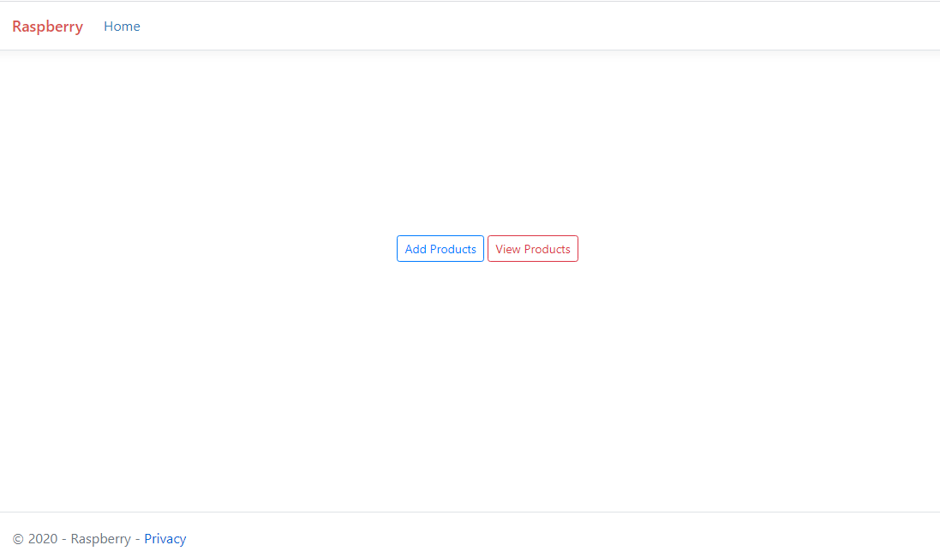

2 Add Products

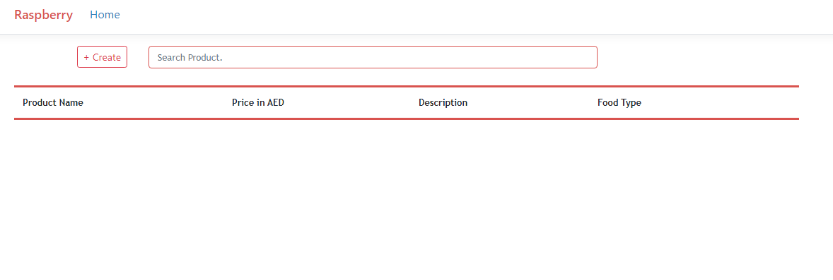

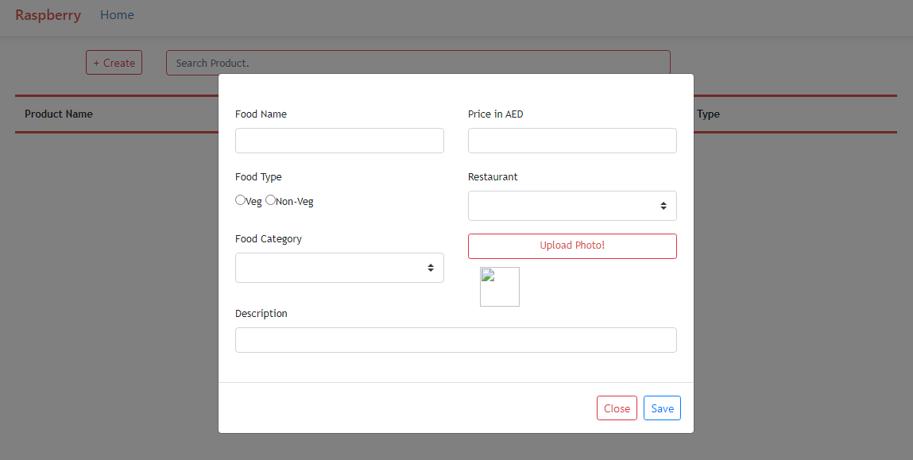

3 Client side Validations on save

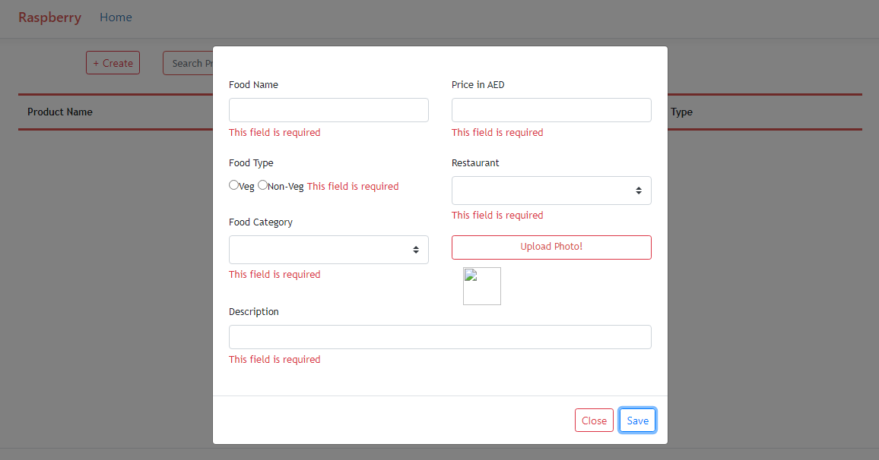

4 Add Products and upload image

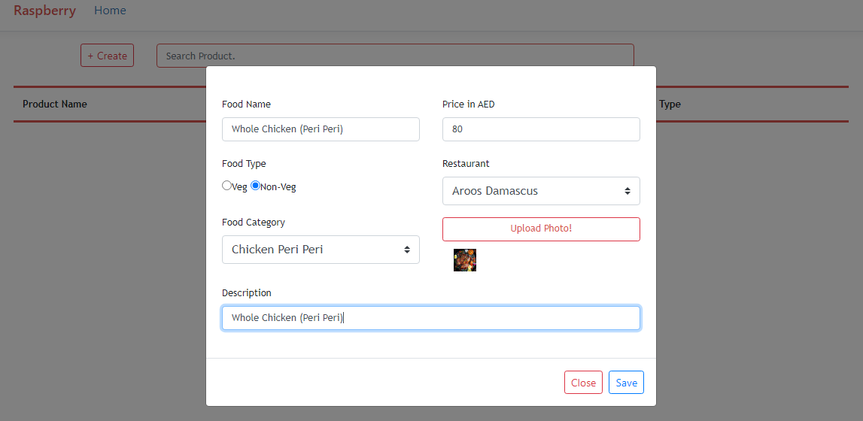

5. Grid loaded after save

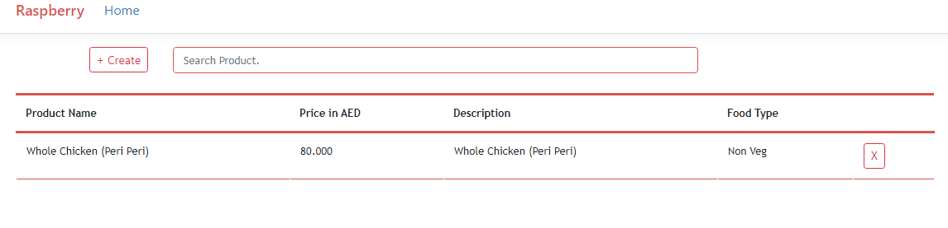

6 Double click to update

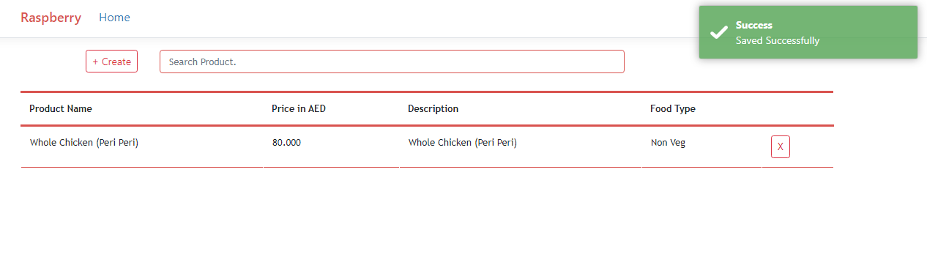

7 Delete a record

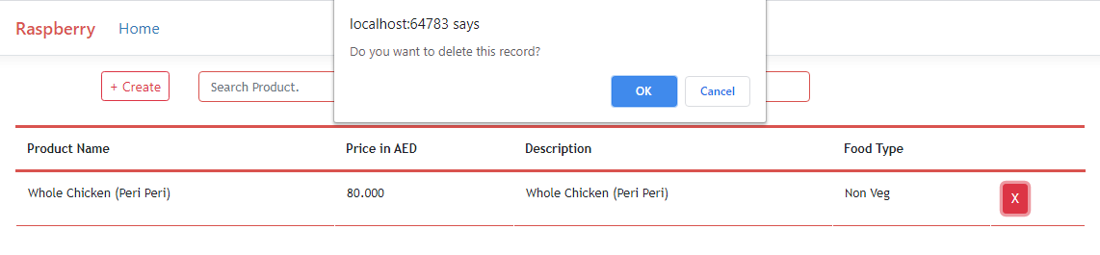

8. Search by press key enter

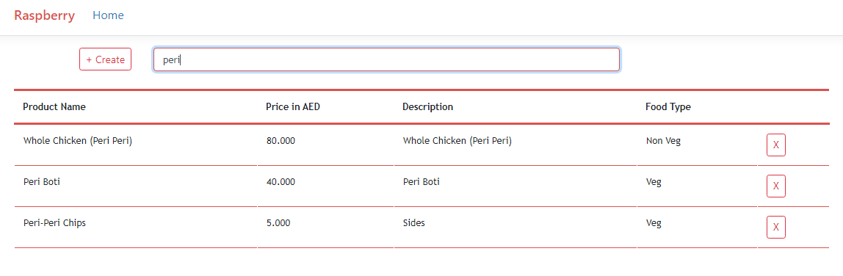

9. Report

