The CDGnet tool consists of an evidence-based network approach for recommending targeted cancer therapies. It is currently hosted at <http://epiviz.cbcb.umd.edu/shiny/CDGnet/>, with the code being available at <https://github.com/SiminaB/CDGnet>. A preprint describing it within the scientific context is available at <https://www.biorxiv.org/content/10.1101/605261v1>. Its goal is to **prioritize targeted therapy assigned for cancer patients using drug-gene networks.** These networks include information from biological pathways, specially by looking at targets downstream of oncogenes (genes which are constitutively activated in cancer.) This is because once an oncogene is activated, it may only make sense to target and block genes and proteins that are found downstream of it, as upstream targeting may be ineffective.

Please note that this tool is for research purposes only. It is not intended for clinical care.

1. **Necessary inputs**

The assumption for users of this tool is that they will have:

* a **file with the molecular alterations** found in an individual tumor
* the individual’s **cancer type** (currently restricted to cancer types that have existing KEGG pathways).

Users may either use the example molecular profile or input their own tsv or csv file with the same column headings. The landing page for CDGnet is shown below, with the example/allowable input format highlighted:

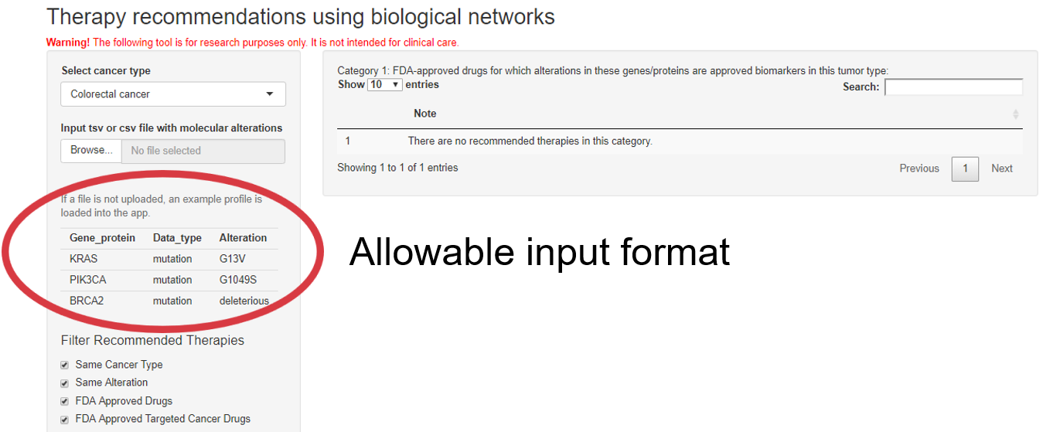

We also provide an example for a tumor that is ER+ and has overexpression of FGFR1 (both csv and tsv files) at <https://github.com/SiminaB/CDGnet/tree/master/data>; this example is also used in the preprint for a putative breast cancer patient. After deciding to use the example profile or loading a data file, users also need to select a cancer type if it is something besides the default “Colorectal cancer.”

1. **Categories of therapies for a patient with a given molecular profile**

CDGnet provides 4 categories of targeted therapies:

1. 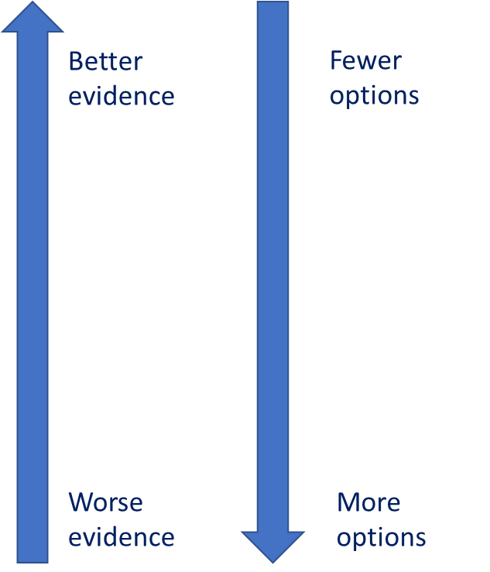FDA-approved drugs for which the patient’s alterations/genes/proteins are biomarkers in their tumor type
2. FDA-approved drugs for which the patient’s alterations/genes/proteins are biomarkers in other tumor types
3. Drugs which have as targets these alterations/genes/proteins or as biomarkers/targets others that are downstream of input oncogenes when considering the pathway corresponding to this tumor type.*
4. Drugs which have as targets/biomarkers either these alterations/genes/proteins or as biomarkers/targets others that are downstream of input oncogenes when considering the pathways corresponding to other tumor types.*

* Could be targeted drugs prescribed for their tumor type or other tumor types OR any FDA-approved drug OR any drug in DrugBank.

From category 1 to 4, the quality of evidence decreases, but the number of options decreases. Thus, category 1 therapies provide the highest level of evidence as they consist of FDA-approved therapies for which one or more of the alterations represent approved biomarkers. However, if there are no category 1 therapies, it may be necessary to move to the next categories.

1. **Choosing therapy categories within the CDGnet tool**

Each of these 4 categories corresponds to a combination of the first 2 checkboxes in the CDGnet webtool:

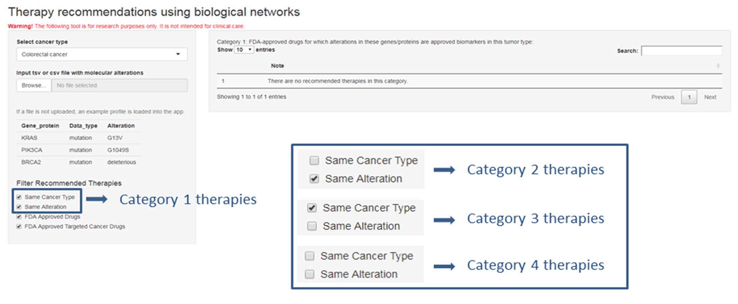

Additionally, for Categories 3 and 4, users may choose to display only FDA-approved drugs or only FDA-approved targeted cancer drugs vs. all drugs in DrugBank:

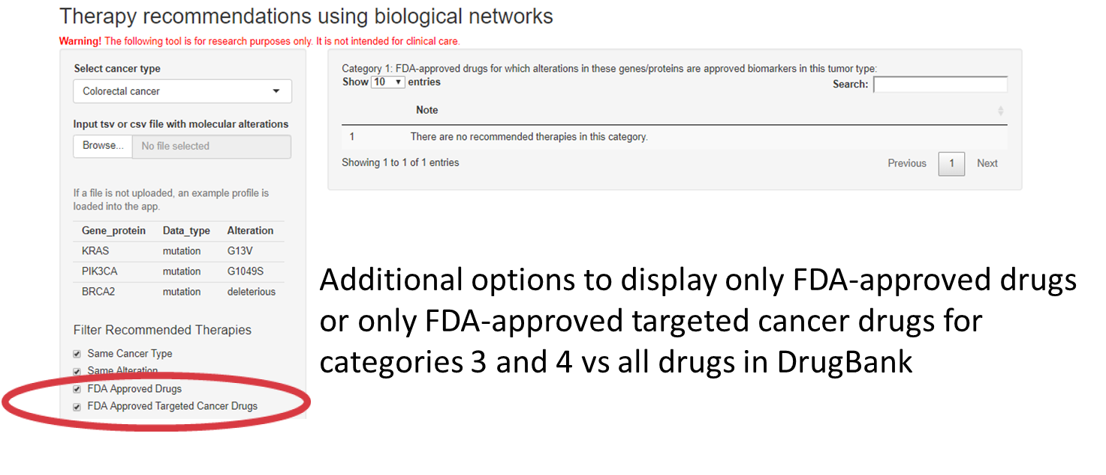

1. **Step-by-step analysis for built-in example**

We now show the results for the different categories for the built-in example, of a patient with colorectal cancer and a G13V mutation in KRAS, a G1049S mutation PIK3CA, and a deleterious mutation in BRCA2. Note that there are no recommended Category 1 therapies for this patient:

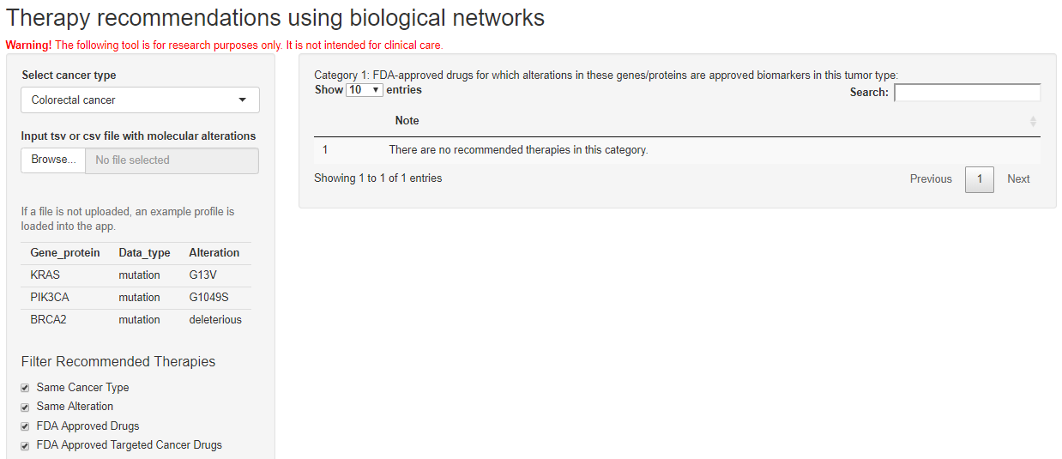

We observe that there are a number of recommended Category 2 therapies, which are approved for deleterious BRCA2 mutations in breast, ovarian, fallopian tube, or primary peritoneal cancers. We note that g.mutation stands for “germline mutation:”

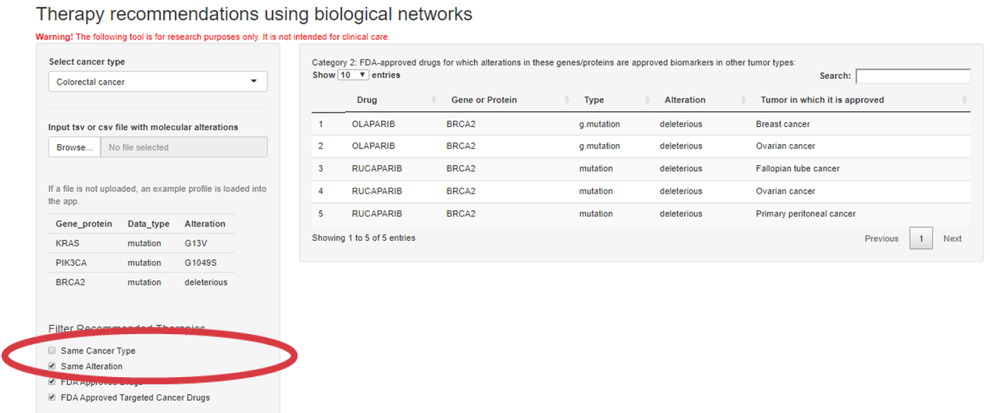

Moving on to Category 3 therapies, we can now also see a visualization of our network-based approach using a Sankey diagram, which provides PubChem links for selected therapies, as well as the ability to mouse over the edges to obtain information on how they connect the nodes. Category 3 therapies have targets downstream of the input oncogenes, considering only the KEGG pathway corresponding to the input cancer type. In this scenario, the recommended therapies include BRAF and MEK inhibitors:

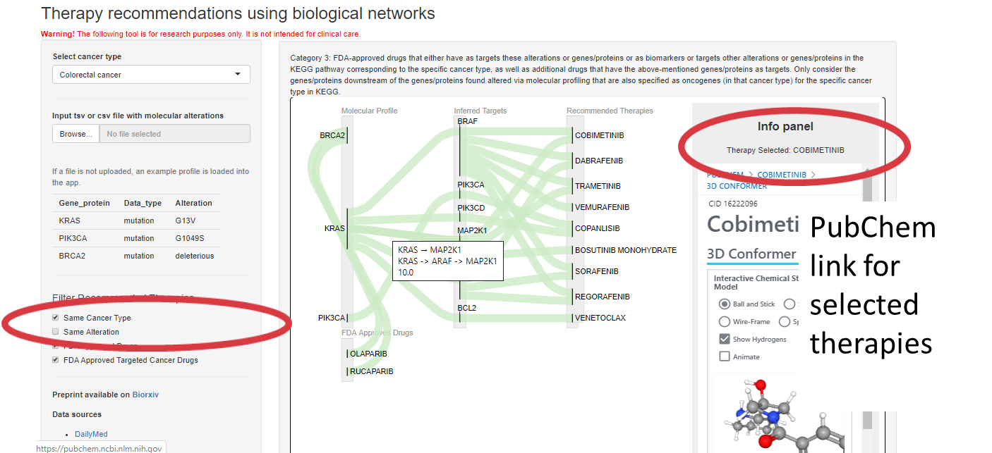

We can also explore the results for Categories 3 and 4 in more detail via a sortable and searchable table:

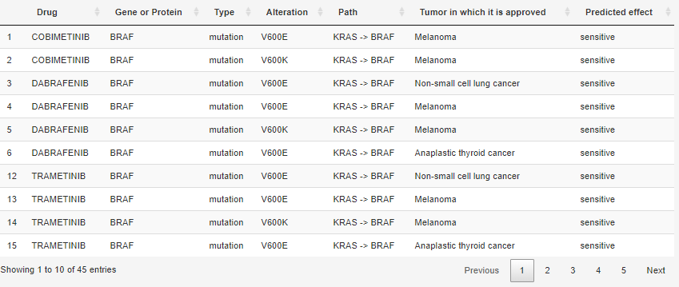

If instead we look at all FDA-approved drugs, the number of therapies increases rapidly:

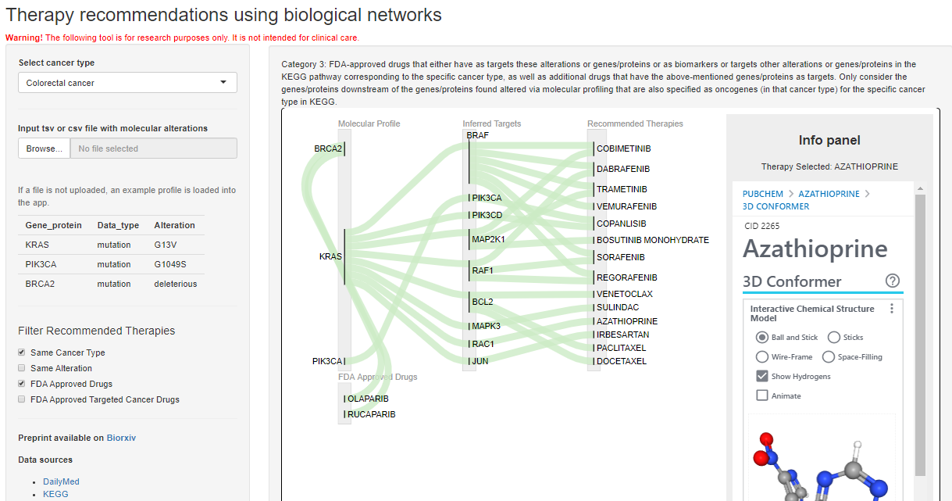

We can also expand further to all drugs in DrugBank:

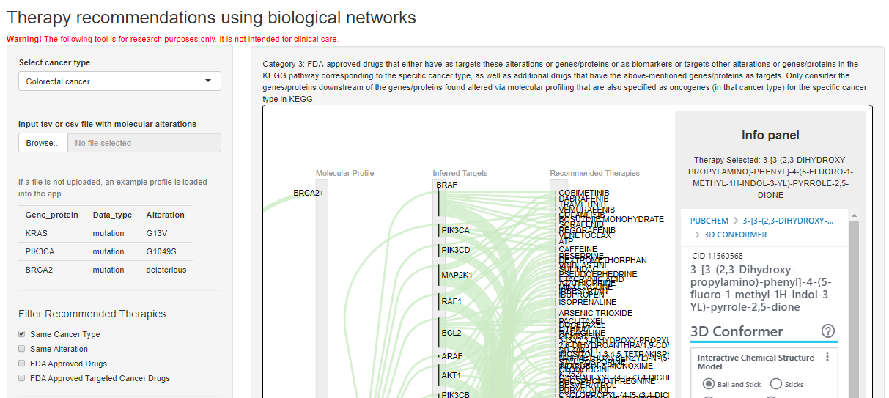

Finally, we can look at Category 4 therapies. These are based on targets downstream of the input oncogenes using all the KEGG cancer pathways, not just the pathway corresponding to the input cancer type:

