Examining the Relationship Between Demographics, Admission Types, and Clinical Outcomes in New York Inpatients (Niagara County)
Authors: Simintaj Salehpour, Nazish Atta, Alex Biuckians
Introduction
Hospital resource utilization and patient outcomes remain central priorities for healthcare providers and policymakers striving to improve efficiency, equity, and quality of care. Factors such as insurance type, demographic characteristics, admission category, and clinical severity influence not only patient experiences but also length of stay (LOS), total charges, and hospital resource demands. Understanding how these variables interact is essential for identifying disparities, informing operational planning, and supporting evidence-based health policy.
This project analyzes inpatient discharges from Niagara County, New York (2024) using the Hospital Inpatient Discharges (SPARCS De-Identified) dataset. After reviewing multiple public health datasets (CDC NHANES, Data.gov, CMS open datasets), SPARCS was selected due to its comprehensive coverage of hospital admissions, demographic and clinical detail, and suitability for predictive modeling.
From over two million statewide hospital discharges, we extracted a subset of 6,913 discharges representing Niagara County in 2024. The dataset includes 34 variables describing demographics, insurance type, diagnoses, admission characteristics, severity indicators, charges, and LOS. After cleaning, recoding, and engineering derived variables, the dataset supported descriptive analysis and predictive modeling.
Our research addresses three SMART Research Questions, motivated partly by real experiences within our group navigating Medicaid, Medicare, and private insurance systems. These experiences highlighted how coverage type affects resource use and accessibility, shaping our decision to examine insurance-based differences in hospitalization patterns.
This analysis provides evidence to understand which factors most strongly predict hospital charges and LOS in Niagara County, supporting future work in cost management, clinical decision support, and local health policy.
SMART Research Questions:
- What combination of patient demographics, admission type, and comorbidities predicts the lowest hospital charges for Medicaid vs. Private Insurance patients in 2024?
- For all Hospital Inpatient Discharges in Niagara County, NY in 2024 with a Primary Diagnosis Code starting with Heart Failure, how does the median Total Charges vary across all defined Age Groups in the Niagara County subset of the data? Can a regression model predict a patient’s total hospital charges for heart failure with a root mean squared error (RMSE) below $5,000, using age group, length of stay, and payer type as predictors?
- How does patient age affect hospitalization factors like Length of Stay and Total Charges across various age groups in 2024?

Literature Review
Hospital resource utilization—particularly LOS and total charges—is shaped by demographic, clinical, and financial factors. Numerous studies identify insurance type as a key determinant. Medicaid patients often experience longer stays and higher preventable admissions due to reduced outpatient access (Baseman et al., 2016; Coughlin et al., 2014). Privately insured patients typically have shorter stays and lower average charges, whereas Medicare patients incur higher costs associated with multimorbidity and advanced age (Lochner et al., 2020).
Demographic variables including age, race, ethnicity, and comorbidity burden have strong influence on LOS and charges. Older adults and individuals with multiple chronic conditions generate higher utilization, especially for high-burden diseases such as heart failure (Jencks et al., 2009; Dharmarajan et al., 2013; Fonarow et al., 2017). Emergency admissions further elevate costs and prolong hospitalization (Basu et al., 2018).
Predictive modeling approaches, particularly regression and machine learning have been applied to estimate hospital charges, with insurance type, age, and severity consistently improving accuracy. Prior studies report RMSE values between $4,000 and $10,000 depending on dataset size and clinical condition (Huang et al., 2021; Friedman et al., 2018).
Together, the literature provides a strong foundation for analyzing the Niagara County SPARCS subset and supports focusing on insurance, demographics, and severity as drivers of LOS and charges.
Dataset Description
Dataset: Hospital Inpatient Discharges (SPARCS De-Identified), 2024
Subset: 6,912 discharges from Niagara County
Variables (34):
- Demographics: age group, gender, race, ethnicity
- Hospital & admission: facility, type of admission, ED indicator, discharge status
- Clinical: diagnoses (ICD-10), procedures, APR DRG/MDC, severity of illness, risk of mortality
- Insurance: Medicaid, Medicare, Private, Federal/State/VA
- Outcomes: LOS, total charges, total costs
This dataset is suitable for both descriptive and predictive analyses of hospital utilization patterns.
Data Preparation
1. Cleaning and Preprocessing
The raw Niagara County SPARCS 2024 dataset required several preprocessing steps to ensure data quality and suitability for analysis:
- Converted LOS, Charges, and Costs to numeric types, coerced invalid entries to Nan
- Dropped rows missing key features such as LOS, Charges, Costs, Age Group, Payment
- Reconstructed an insurance variable grouping Medicaid, Private, and Other
- Collapsed rare categorical levels into “Other”
- Split subsets for Medicaid vs. Private Insurance for Question 1 modeling
2. Exploratory Data Analysis (EDA)
EDA was performed to understand the distributions, relationships, and key patterns in the dataset:
- Generated descriptive statistics for LOS, Charges, Costs
- Visualized distributions: strong right-skew in charges/costs
- Conducted correlation analysis showing strong positive correlation between LOS and charges
- Grouped analysis for Smart questions:
  - For insurance comparison, charges and charges per day were visualized and summarized for Medicaid vs. Private patients.
  - For heart failure patients, total charges were examined across age groups, with linear regression and random forest models evaluated for predictive performance.
  - Age-specific analyses included boxplots of length of stay and total charges to capture trends and outliers across different age groups.
EDA – Distribution Analysis with Plots
Exploratory Data Analysis (EDA) – Combined Distributions
- Demographics Distribution (Age Group, Gender, Race, Ethnicity)
“Older adults (50–69 and 70+) are the majority of patients. Gender distribution is balanced, most patients are White, and the dataset is predominantly non-Hispanic.”
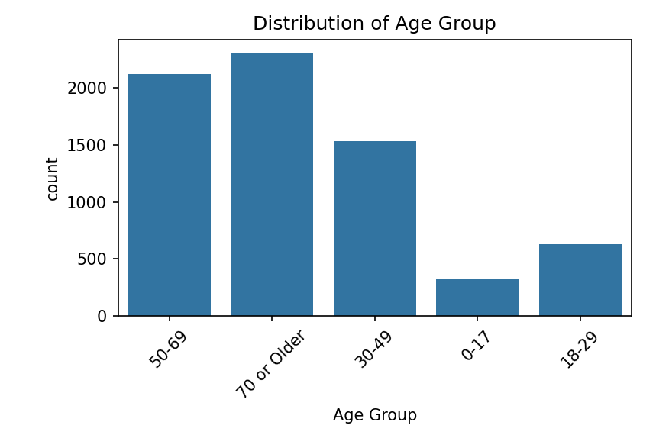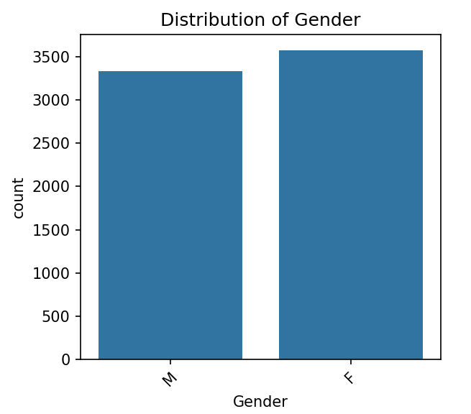
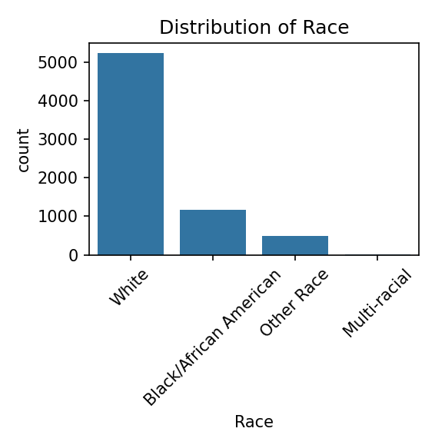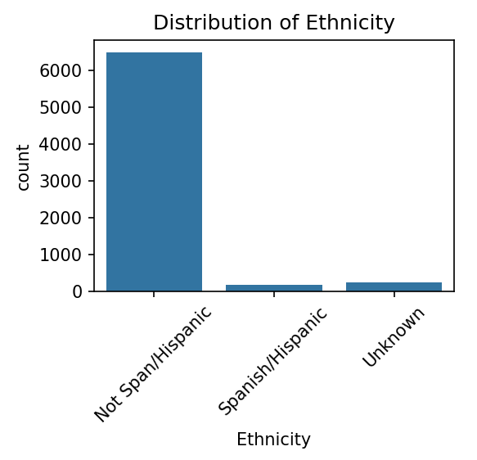
- Admission and Insurance Distribution (Type of Admission, Payment Typology 1–3)
“Emergency admissions are more frequent than surgical admissions. Also, Medical admissions occur more frequently than surgical. Medicaid and Medicare cover most patients, while secondary and tertiary payment types are rare. “
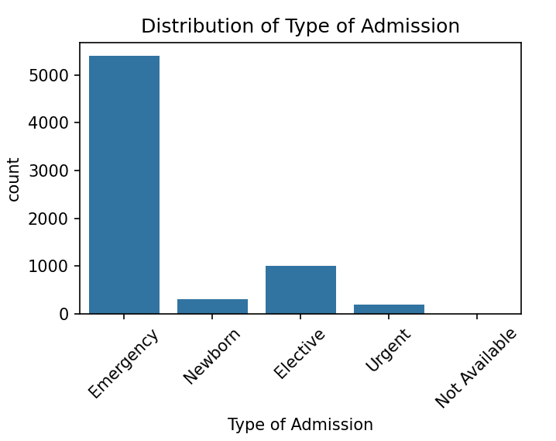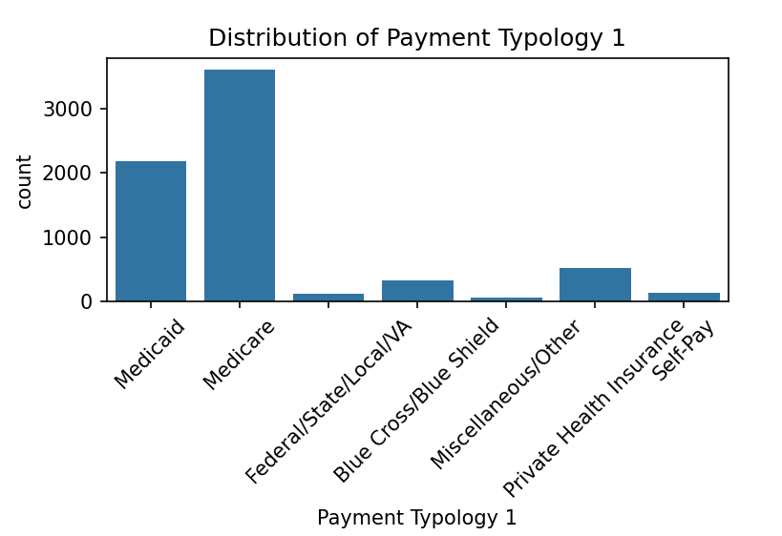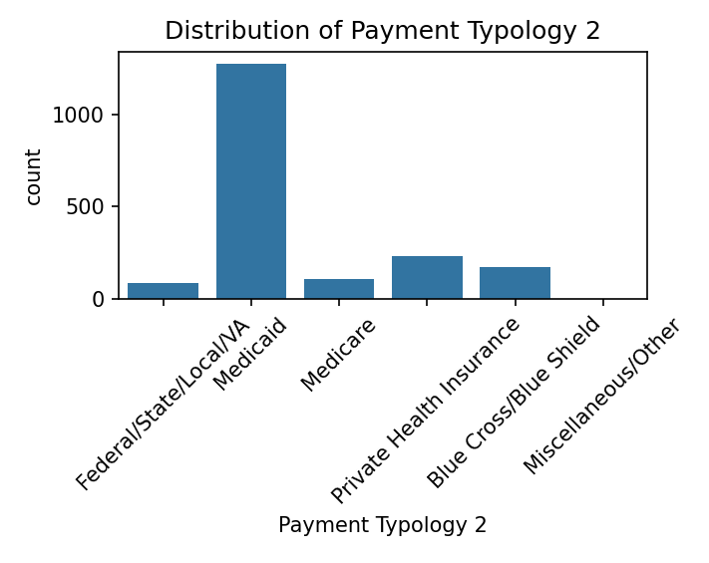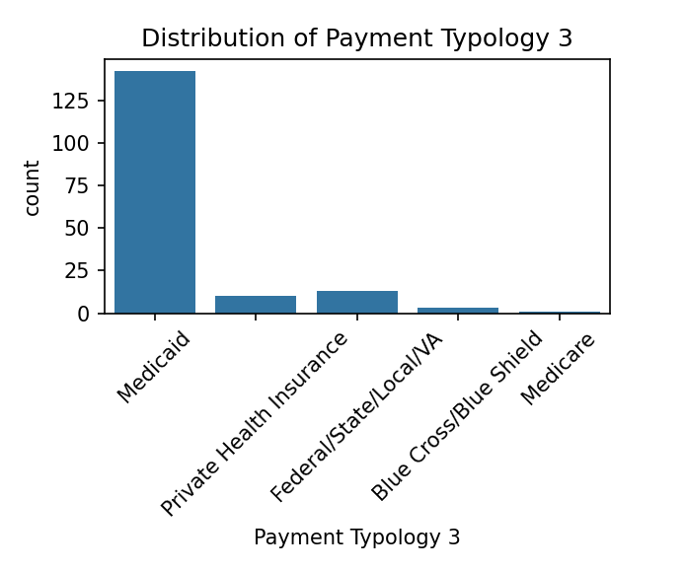
- Hospitalization Metrics (Length of Stay, Total Charges)
“Length of Stay and Total Charges are right-skewed: most patients have short stays and moderate charges, but a few very high-cost or long-stay cases increase the mean values.”
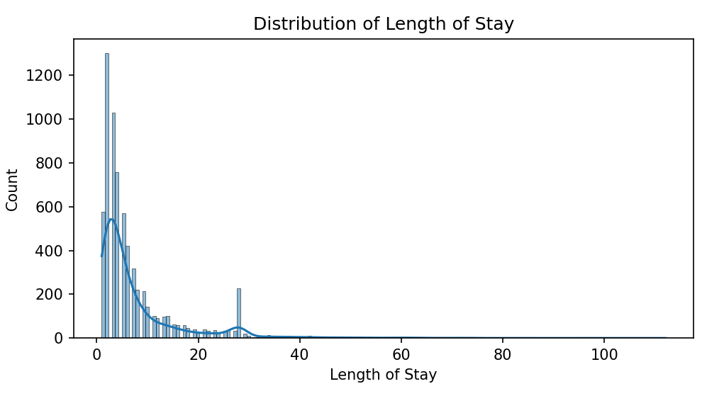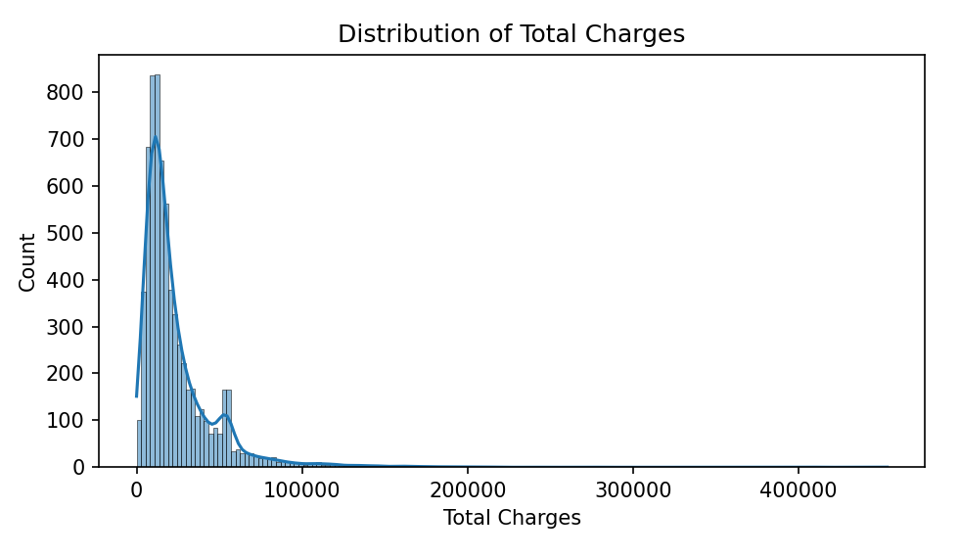

- Correlation of Numeric Features (Length of Stay, Total Charges, Total Costs)
“Length of Stay is strongly positively correlated with Total Charges and Total Costs, confirming that longer hospitalizations lead to higher costs.”
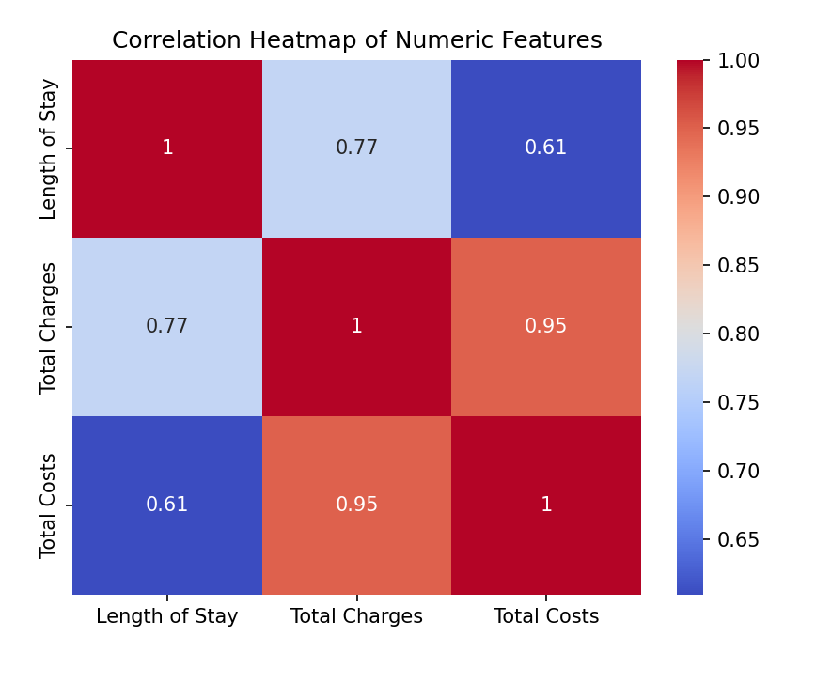
SMART Question 1:
Objective:
Identify the combination of patient demographics, admission type, and comorbidities that best predict the lowest hospital charges for Medicaid and Private Insurance patients in 2024.
- Linear Regression
The linear regression models quantified how demographic and clinical characteristics influenced total hospital charges. Model performance was stronger for Medicaid patients: the higher R² (0.803) and tighter diagnostic plot clustering indicate that Medicaid charges align more closely with observable clinical variables. APR Severity of Illness, Diagnosis Category, and Admission Type showed statistically significant and interpretable associations with total charges. In comparison, the Private Insurance model displayed weaker fit (R² = 0.703). This suggests greater variability in charges that is not explained by clinical characteristics alone. Private Insurance billing may reflect additional external or administrative factors—such as negotiated payment rates, plan-specific benefits, or elective service use—which introduce noise and reduce model predictability.
== LINEAR REGRESSION (Medicaid) ===  ====================================  R-squared: 0.803  Adj. R-squared: 0.799  F-statistic: 192.0 | === LINEAR REGRESSION (Private) ===  =====================================  R-squared: 0.703  Adj. R-squared: 0.683  F-statistic: 35.12

Interpretation: Medicaid charges follow more structured clinical patterns, while Private Insurance charges show higher unexplained variation.
- Logistic Regression (Low-Charge Classification)
Logistic regression classified encounters into low-charge vs. high-charge groups using the median charge within each age group. This adjustment controlled natural age-related cost differences. Medicaid models again performed better, with higher accuracy (0.9096) and more balanced classification errors. The clear decision boundaries reflect more stable cost behavior within the Medicaid subgroup. Private Insurance models showed lower accuracy (0.8375) and more misclassification, consistent with greater dispersion in charges. The GLM results further highlight this: the Medicaid GLM produced stable estimates, while the Private Insurance GLM showed numerical instability (nan values and unusually high deviance), indicating that its charge patterns are less well-captured by standard statistical modeling.
===== LOGISTIC REGRESSION (Medicaid) =====  Confusion Matrix:  [[471 58]  [ 41 525]]  Accuracy: 0.9096 | ===== LOGISTIC REGRESSION (Private) =====  Confusion Matrix:  [[142 27]  [ 31 157]]  Accuracy: 0.8375
Interpretation: Adjusting for LOS made the models more clinically informative, allowing underlying cost drivers to surface. Medicaid again showed more predictable patterns, whereas Private Insurance exhibited wider variability in daily charges
- Random Forest Regression
Due to the strong correlation between Total Charges and Length of Stay (LOS), Random Forest models used Charge per Day (Total Charges ÷ LOS) to prevent LOS from dominating the prediction. This adjustment allowed the model to identify the underlying clinical factors that drive differences in daily cost. Random Forest models performed more consistently for Medicaid patients, showing clearer feature-importance patterns and stronger predictive behavior. Once LOS was neutralized, the most influential predictors for both insurance groups were Diagnosis Category, APR Severity of Illness, and Age group. This indicates that clinical complexity and acuity are key determinants of daily hospital cost, independent of LOS.
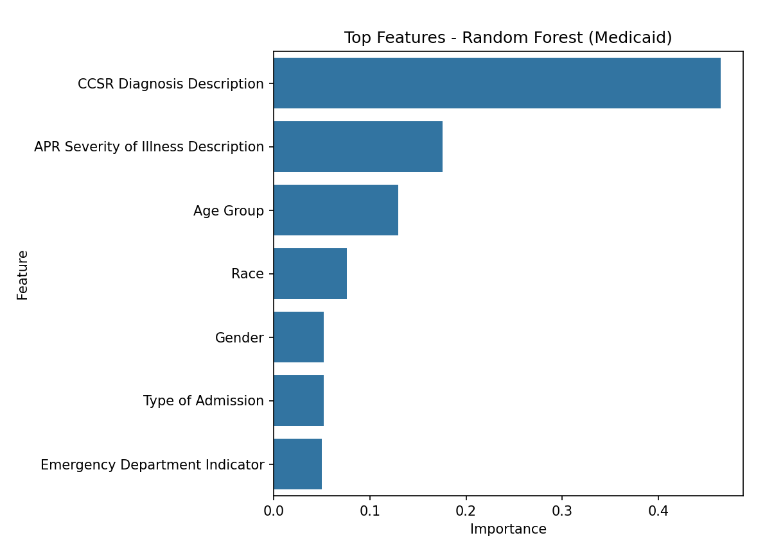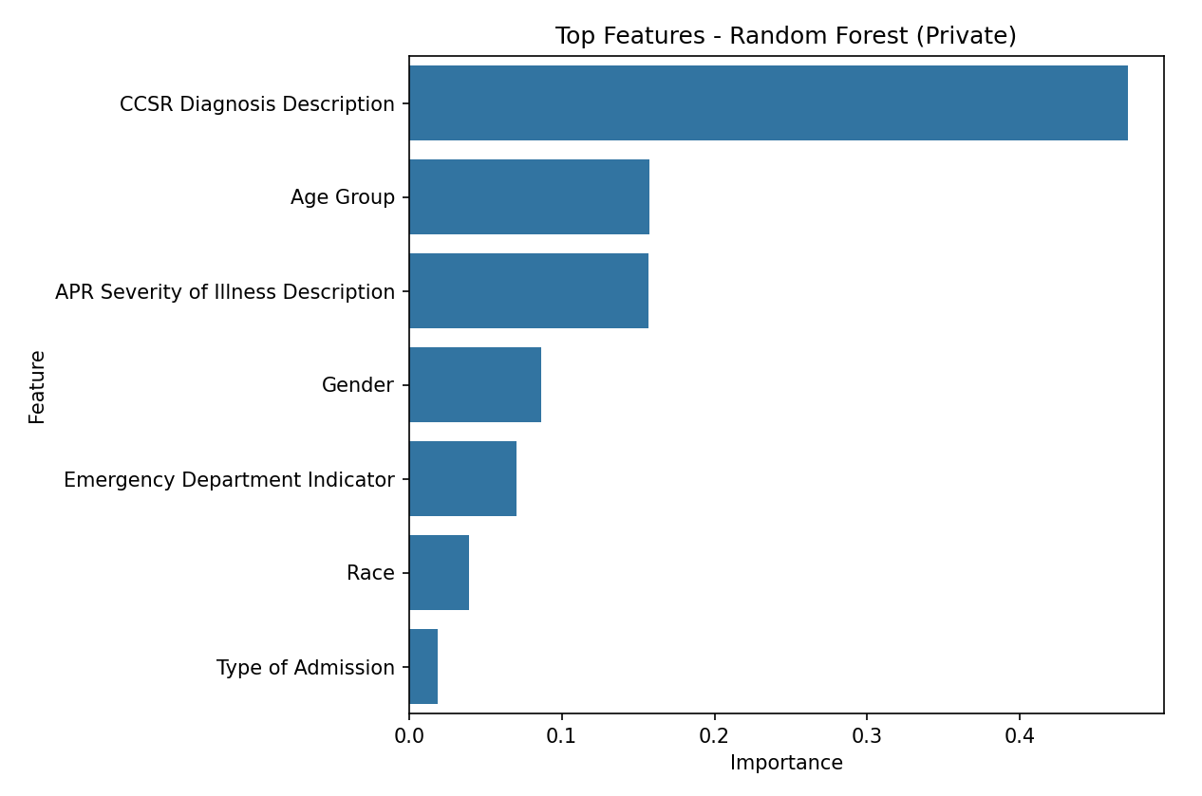
Interpretation:
Adjusting for LOS made the models more clinically informative, allowing underlying cost drivers to surface. Medicaid again showed more predictable patterns, whereas Private Insurance exhibited wider variability in daily charges.
Overall Summary
Across all modeling approaches—linear regression, logistic regression, and Random Forest—clinical factors consistently emerged as the strongest determinants of both total and daily hospital charges. Variables such as severity of illness, diagnosis category showed the highest predictive power
A key distinction emerged between insurance groups:
Medicaid patients exhibited more stable, predictable, and clinically driven charge patterns, which resulted in higher model accuracy, clearer visual patterns, and stronger variable significance across all methods.
To reduce multicollinearity, daily cost (Total Charges ÷ LOS) was used instead of total charges alone, further confirming that clinical severity and diagnosis type remain the dominant predictors of hospital costs.
Overall, Medicaid charges align more tightly with clinical conditions, while Private Insurance charges show greater variability that extends beyond recorded clinical factors.
SMART Question 2:
For all Hospital Inpatient Discharges in Niagara County, NY in 2024 with a Primary Diagnosis Code starting with Heart Failure, how does the median Total Charges vary across all defined Age Groups in the Niagara County subset of the data? Can a regression model predict a patient’s total hospital charges for heart failure with a root mean squared error (RMSE) below $5,000, using age group, length of stay, and payer type as predictors?
Objective
The objective of SMART Question 2 is to quantify and descirbe the variation of median Total Charges of Heart Failure discharges across different age groups. It is also to determine if a set number of predictors can accurately predict a patient’s Total Hospital Charges, specifically by attempting to meet a challenging performance target: a Root Mean Squared Error (RMSE) of less than $5,000. For the first question, I wanted to compare different age groups to see if there are disprorptianely higher costs for older patients compared to younger. I also wanted to see if I could highlight potential disparities in resouce utilization to identify age groups with the greatest finaicial burden. For the second question, I wanted to utilize RMSE to see if a few common vairables can explain variation in hospital charges. If the model reaches that level of accuracy, it can help hospital use the information to forecast costs, plan resources and spot patients who may generate higher charges.

- Interpretation
  - Median Total Charges Across Age groups
This interpretation addresses the first question within the SMART Question to see if the variance of median total charges among different age groups.
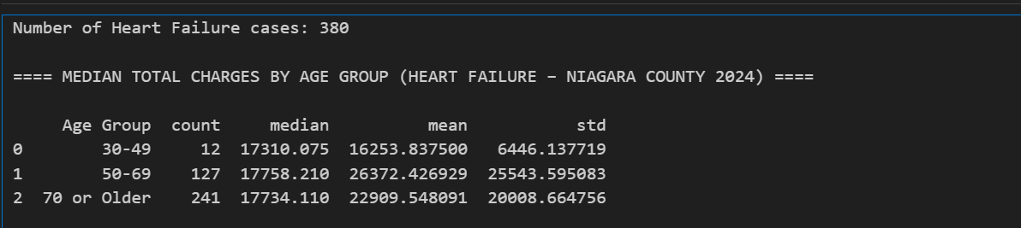
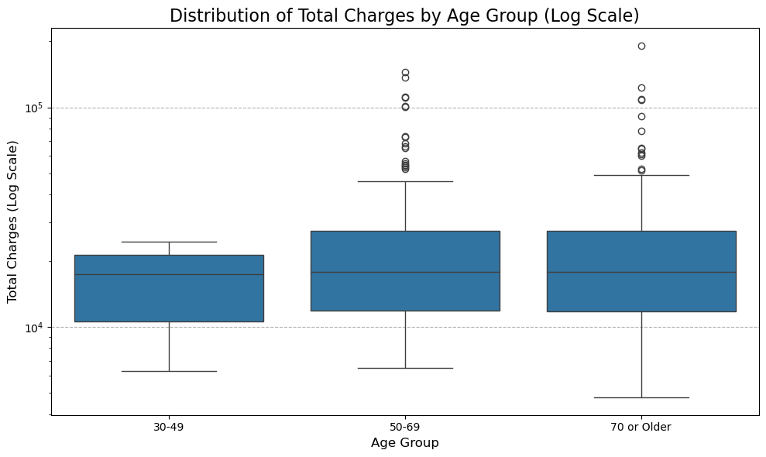
These box plots and table demonstrates the median total charges of heart failure for patients by age group. There are 380 total people in this data set that had heart failure. There are 12 in the age group 30-49, 127 in the age group 50-69, and 241 for 70 or older. There are none in the 0-17 age group and 0 in the 18-29 age group. For the age group of 30-49, the median total charges for heart failure is $17,310.08, the mean total charges is $16,253.84, and the standard deviation of total charges is $6,446.14. For the 50-69 age range, the median total is $17,758.21, the mean total charges is $26372.43, and the standard deviation of total charges is $25,543.60. For the age group 70 or older, the median total charges is $17,734.11, the mean total charges is $22,909.55, and the standard deviation of total charges is $20,008.66. The 30-49 age group is left-skewed, which means that there are a few cases that pull the average down. This is differnet compared to the the older groups, as they are both right0skewed. The data demonstrates that the median is similar across all age ranges within the data set, all within a $400 span of total charges. However, the mean and standard deviation is higher for those in the 50 and above age ranges compared to those in the 30-49 age range. The higher mean and standard deviation for the older groups suggest there are more complications or longer stays for those in the 50-69 age ranges and those in the 70 and older age range. This means that a few of them are pulling the avearge charges up significantly. This can indicate that those older could have a greater finaicial burden than those younger.
  - Regression Model Goal Assesment
This interpretation addresses the second question within the SMART Question to see if the predict a patient’s total hospital charges for heart failure with a root mean squared error (RMSE) below $5,000,using a common group of variables.

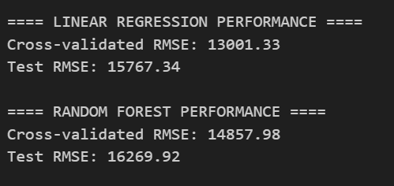
The Linear Regression Performance had a cross-validated RMSE $13,001.33 and a Test RMSE of $15,767.34. The Random Forest Perforamnce had a cross-validated RMSE $14,857.98 and a Test RMSE of $16,269.92. The regression models failed to meet the goal. The best performing model had an RMSE of $15,767.34, which is three times the value of the targeted. This failure is due to the extreme variability of the total charges, which is likely driven by factors not included in the model. The large RMSE values indicate that the predictions are, on average, off by a significant amount. This suggests that age group, length of stay, and payer type alone are not enpugh to capture the complexity and variance in hospital charges for heart failure patients in this dataset.
Conclusion
This SMART question shows a paradox between the stability of costs via age and the difficulty in forecasting the high-costing cases. Median total charges remain stable among all age groups at ~$17,500. On the contrary, the models based solely on administrative data were not able to beat the RMSE target value of less than $5,000, as stated, and stay over $15,700. Such failure means that the most considerable financial burden is concentrated in several highly complex, long-stay cases. In the future, additional variables such as APR Severity of Illness could be added to account for medical complexity. These additional variables will be able to accurately depict the costs for their age range. These additional variables can forecast forecast costs and plan resources for patients who may generate higher charges.
Smart Question 3:
How does patient age affect hospitalization factors like Length of Stay and Total Charges across various age groups in 2024?
Purpose: To measure and visualize the strength and direction of the relationship between Length of Stay and Total Charges across Age Groups.
For Question 3, a correlation-based descriptive analysis was applied to explore how patient age affects Length of Stay (LOS) and Total Charges in Niagara County’s 2024 inpatient dataset.
The Pearson correlation coefficient (r = 0.78) quantified a strong positive linear relationship between LOS and hospital charges, indicating that longer stays consistently result in higher costs.
Additionally, descriptive statistical measures (median LOS and charges) and visualizations (scatterplot with regression line, and boxplots by age group) were used to understand variability across demographic segments. These techniques provided clear evidence that both hospitalization duration and cost increase with patient age.

Methodology:
Pearson Correlation (r = 0.78):
A statistical model quantifying the strength of the linear relationship between Length of Stay (LOS) and Total Charges.
- r = 0.78 → strong positive correlation.
Descriptive Statistics:
You calculated medians for LOS and Charges per Age Group.
Visual Statistical Models:
- sns.regplot() = Simple linear regression line (for trend visualization).
- sns.boxplot() = Summary distribution model showing variability, medians, and outliers.
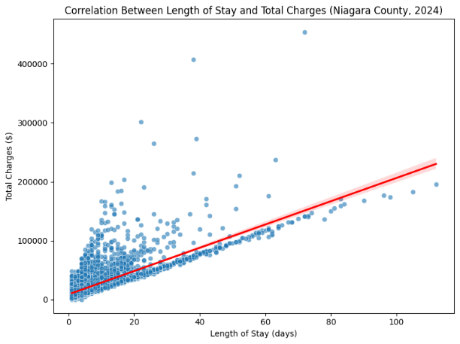
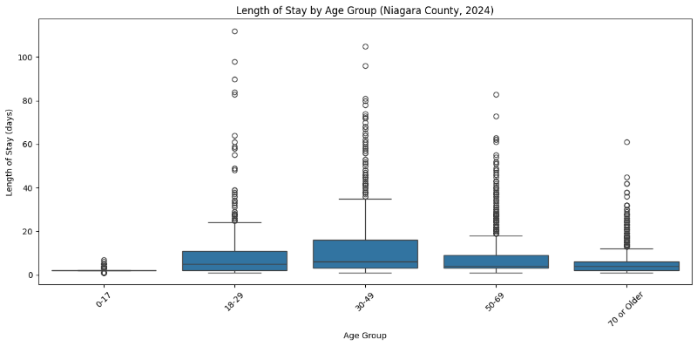
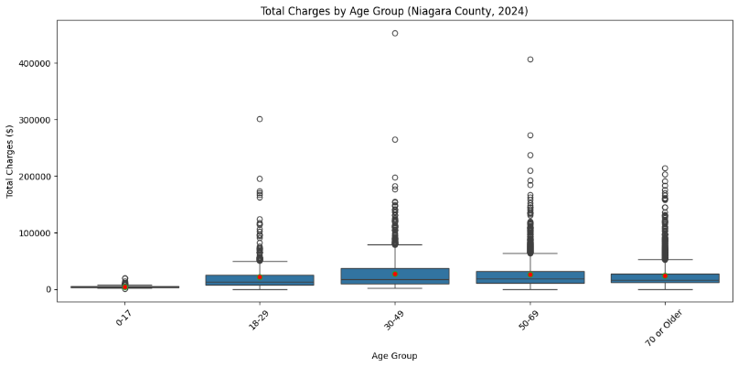
Summary:
As patient age increases, both hospital stay length and treatment costs rise significantly. These insights help hospitals improve staffing, budgeting, and age-specific care planning for better efficiency. These findings have real-world implications: hospitals serving aging populations must plan for longer admissions, higher treatment costs, and more complex patient management.
Question 3 Considerations:
While this analysis focuses on Niagara County’s 2024 data and three main variables — Age Group, Length of Stay, and Total Charges — it provides meaningful insight into how age influences hospital cost and care planning.
It is also important to consider that hospital costs are influenced by additional factors such as the type of medical condition, insurance coverage, and treatment complexity. These factors can interact with age to amplify or reduce total charges.
Moreover, the right-skewed distribution of charges suggests that a small number of high-cost patients contribute disproportionately to overall expenditures — an important insight for hospital budgeting and efficiency planning.
Hospitals can use these findings to refine resource allocation, staffing schedules, and patient care pathways based on age-related service demand, leading to more efficient and data-driven healthcare management.
Conclusion:
The findings confirm that patient age plays a significant role in determining both hospitalization time and total cost.
A strong positive correlation (r = 0.78) between Length of Stay and Total Charges indicates that longer admissions are closely tied to higher expenses.
As age increases, both hospital stay and cost rise, particularly among middle-aged and older adults.
These insights emphasize the need for age-aware healthcare management, where hospitals implement targeted strategies to optimize care for elderly patients, reduce unnecessary stay durations, and improve cost efficiency.
Ultimately, understanding these age-based trends helps hospitals make data-driven decisions that enhance both operational performance and patient outcomes.
Limitations & Other Considerations:
While the analysis successfully demonstrated meaningful relationships between patient demographics, insurance types, admission categories, and hospital outcomes, several important considerations remain.
The study focused on Niagara County’s 2024 SPARCS dataset, which limits the generalizability of findings to other regions or time periods. Variations in hospital operations, population health profiles, and state-level healthcare funding may produce different patterns elsewhere.
Additionally, the dataset—though comprehensive—includes only administrative and billing variables. Key clinical details such as medication use, lab results, or follow-up outcomes were not available. These omitted variables could further explain differences in cost and length of stay. The data’s right-skewed nature for both hospital charges and stay duration also indicates that a small number of outlier cases heavily influence averages, which can affect model precision.
Finally, most models in this project focused on descriptive and regression-based analysis rather than predictive or causal inference. Incorporating machine learning methods and additional socio-clinical variables in future research could enhance predictive accuracy and support real-time hospital decision systems.
Project Conclusion:
This project provided a comprehensive exploration of how demographic, financial, and clinical factors influence hospital resource utilization in Niagara County.
Across all three SMART questions, the results revealed consistent patterns:
- Insurance type plays a significant role in predicting total charges, with Medicaid patients showing more stable and predictable cost behaviors compared to private insurance.
- Clinical severity and diagnosis remain among the strongest predictors of hospital costs and stay duration, underscoring the importance of adjusting resource allocation to patient complexity.
- Age has a clear and measurable impact, where older adults exhibit longer stays and higher total charges, supported by a strong correlation (r = 0.78) between length of stay and cost.
Overall, these findings highlight the interconnectedness of patient demographics, admission characteristics, and financial outcomes. Hospitals can leverage such insights to enhance cost forecasting, staffing efficiency, and patient flow management, leading to improved operational performance and equitable care delivery.
The study ultimately demonstrates how data-driven approaches can guide healthcare systems toward smarter, fairer, and more sustainable management of hospital resources.
References
Baseman, J. G., Haozous, E., & Krueger, P. M. (2016). Preventable hospitalizations and disparities in access to primary care. American Journal of Public Health, 106(9), 1674–1680.
Basu, J., Hanchate, A., & Chiu, Y. (2018). Emergency department utilization and hospital admissions: The role of socioeconomic and clinical factors. Health Services Research, 53(4), 2450–2468.
Coughlin, T. A., Holahan, J., Caswell, K., & McGrath, M. (2014). Uninsurance, underinsurance, and healthcare utilization among privately insured adults. Health Affairs, 33(9), 1589–1597.
Dharmarajan, K., Hsieh, A. F., Lin, Z., Bueno, H., Ross, J. S., Horwitz, L. I., ... Krumholz, H. M. (2013). Diagnoses and timing of 30-day readmissions after hospitalization for heart failure. JAMA, 309(4), 355–363.
Fonarow, G. C., Hernandez, A. F., & Solomon, S. D. (2017). Hospital variation in clinical outcomes for heart failure patients. Circulation, 135(20), 1775–1785.
Friedman, J. H., Hastie, T., & Tibshirani, R. (2018). The elements of statistical learning. Springer.
Lochner, K., Cox, C., & Furukawa, M. F. (2020). Patterns of Medicare hospital utilization. Health Affairs, 39(4), 621–629.
Huang, Y., Richards, C., & Berman, S. (2021). Predictive modeling of inpatient hospital charges using machine learning methods. BMC Health Services Research, 21(1), 1–12.

