# Setup Run Simio Schedule

Complete these steps to setup RunSimioSchedule:

1. Copy the contents of RunSimioSchedule.zip into C:\Users\Public\Documents\Simio\Examples\RunSimioSchedule
2. Edit mode location in C:\Users\Public\Documents\Simio\Examples\RunSimioSchedule \RunSimioSchedule.exe.config
3. Open a command prompt as Administrator
4. Navigate to “C:\Windows\Microsoft.NET\Framework\v4.0.30319> “
5. Enter “InstallUtil C:\Users\Public\Documents\Simio\Examples\RunSimioSchedule\ RunSimioSchedule.exe”. This will install the RunSimioSchedule as a windows service.

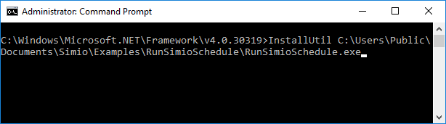

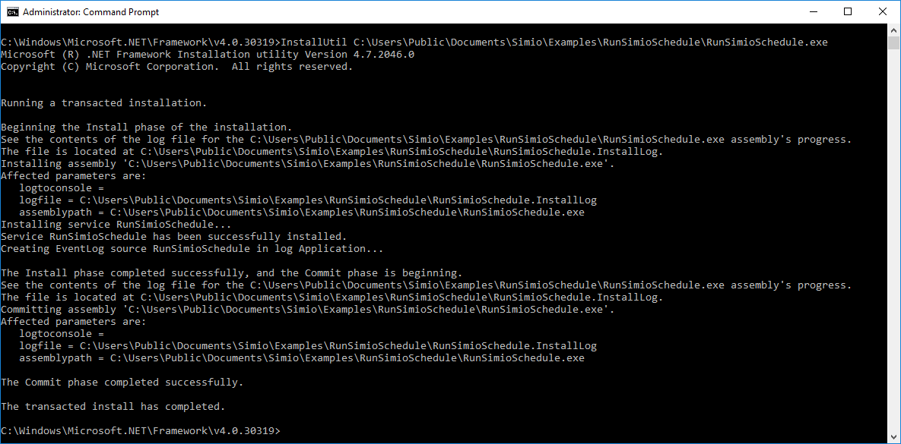

1. Next, start the service from Services.

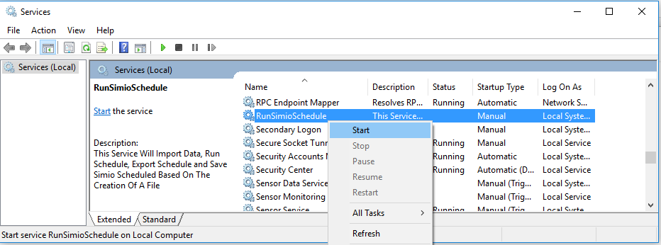

1. Copy SchedulingDiscretePartProductionWithOnRunEndingExport.spfx and Event.csv into C:\Users\Public\Documents\Simio\Examples. The Event.csv will initiate the run. It will also can be used to add downtime to resources (open file to see structure). Once read, it will be deleted immediately and Status.txt will be created. Once the schedule run is completed, the model will be saved and the schedule output will be placed in ScheduleOutput.txt.

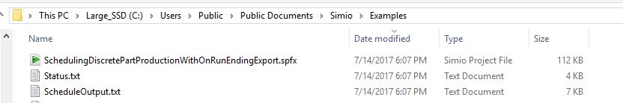

1. Copy Event.txt again into C:\Users\Public\Documents\Simio\Examples. This will generate a new set of results.

