|  |  |  |
| --- | --- | --- |
| Project Name | | Confidentiality Level |
| Contract Management System | | For Recipients’ Reference Only |
| Project ID | Version | Document Code |
| BP | 1.0 | Project ID_RA_001 |

|  |  |  |  |
| --- | --- | --- | --- |
| Prepared by |  | Date | yyyy-mm-dd |
| Reviewed by |  | Date | yyyy-mm-dd |
| Approved by |  | Date | yyyy-mm-dd |

**Copyright Restricted and No Reproduction Allowed** Copyright © Ruankosoft Technologies(Shenzhen), Co., Ltd.



Contract Management System Software Requirements Specification

. All Rights Reserved

**Catalog**

1. Introduction 3
   1. Purpose 3
   2. Scope 3
2. General Description 3
   1. Software perspective 3
   2. Software function 3
   3. User characteristics 4
   4. Assumptions & Dependencies 4



1. Specific Requirements 5
   1. System use case 5
   2. Register 6
   3. Login 6
      1. Login 6
      2. Logout 7
   4. Contract management 7
      1. Draft Contract 7
      2. Countersign Contract 9
      3. Finalize Contract 10
      4. Approve Contract 11
      5. Sign Contract 12
   5. Query 12
      1. Query Contract Info 12
      2. Query Contract Process 12
   6. Fundamental data management 12
      1. Contract Info 13
      2. Customer Info 13
   7. System management 13
      1. Assign Contract 13
      2. Authorize 15
      3. System Log 15
   8. Data Information 15
2. Interface Requirements 15
   1. User Interface 15
   2. Software Interface 15
   3. Communication Interface 15
3. Overall Design Constraints 15
   1. Hardware Limitations 15
   2. Technology Limitations 16
4. Software Quality Attributes 17
   1. Reliability 17
   2. Usability 17
5. Requirements Classification 18

**1 Introduction**

**1.1 Purpose**

This manual describes user requirements for functions and performance of the Contract Management System. The intended audience includes:

Users

Project administrators



Testers

Designers Developers

The manual focuses on function requirements of Contract Management System; clarifies mandatory functions, performance and interfaces of the developed software; assists system

analysts and software developers in user demand-orientation.

**1.2 Scope**

This manual describes function requirements, data information, interface requirements of System.

**2 General Description**

**2.1 Software perspective**

This software is a web application. The system uses the b/s (Browser/Server)structure, Users only

need to access the website through the browser.The operation of the server side need to configure the application environment(JDK1.6), this system need Installation of MySQL database.

**2.2 Software function**

System function structure:

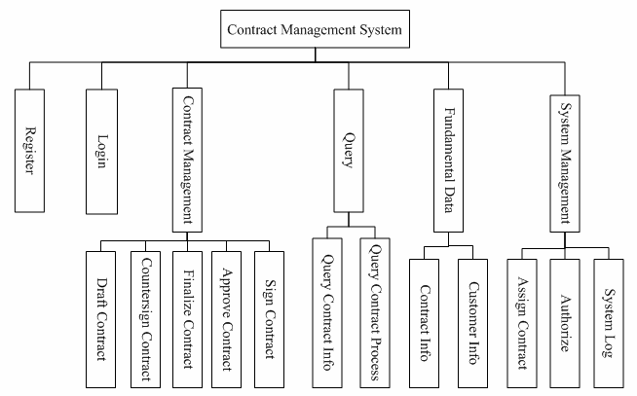

System is divided into 6 modules:

Register, Login, Contract Management, Query, Fundamental Data Management, System Management.

**2.3 User characteristics**

1, administrator: focuses on the management of system, Has the supreme right to maintain normal

operation of the system.

2, operator: focuses on the management of the contract process.

3, new user: has no right at all, waiting for the contract administrator to configure permission.

**2.4 Assumptions & Dependencies**

The development language of system is Java. Using MySQL for data storage, The system uses the

b/s (Browser/Server)structure, Users only need to access the website through the browser.

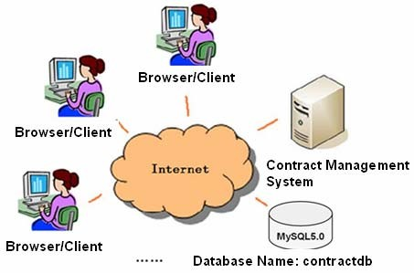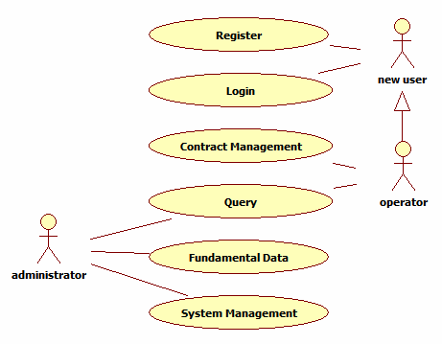

1. **Specific Requirements**
   1. **System use case**

When the user is registered, become the system new user, he can only use the contract managment system after the administrator assign permission for him.Contract operator can manage contract operation process; Administrator can manage system, assign the contract, follows the contract process and status and so on.

* 1. **Register**

Fill in register information: user name and password in register page, confirm the password (consistent with the password), then register.

The required registration information cannot be empty, the tip information is given when the registration failed, jump to the login page when registration successful.

The register page is as follow:

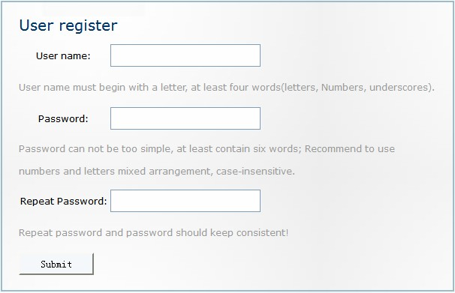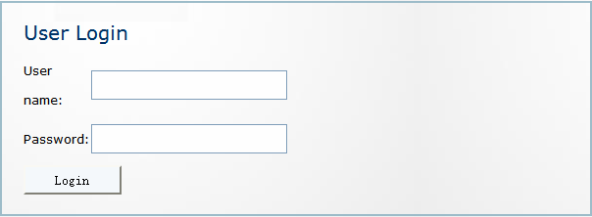

**3.3 Login**

**3.3.1 Login**

Fill in the user name, password in the login page, click “Login” button to log in.

The required login information cannot be empty, the tip information is given when login failed, jump to the new user page when login successful, and display the information of user name.

The login page is as follow:

### 3.3.2 Logout

The user who already logged in, click “logout” link in the new user page, clear the user’s login status, return to the login page.

**3.4 Contract management**

#### 1. Introduction

After the contract operator log in, can draft a contract, which can based on the assigned, and carry

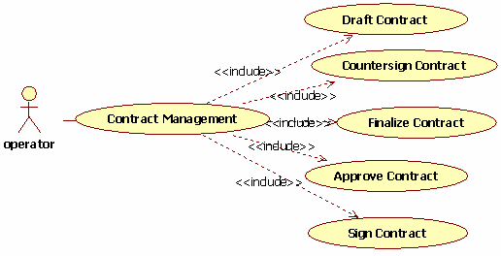

on the corresponding countersignature, approval and sign operations.

**2. Contract management use case**

**3.4.1 Draft Contract**

**1. Introduction**

User in operator role has the right to draft contract. Drafting can be made after operator logs on system.

Write content of information named contract name, start time, end time, content(required) and customer on drafting page.

After drafting is successfully made, the status of contract turns to Draft, which is the sign for the administrator to distribute.

the status of contract:

the status of contract

|  |  |
| --- | --- |
| the status of contract | Brief descriptions |
| draft | contract has drafted |
| countersigned | contract has countersigned |

|  |  |
| --- | --- |
| finalized | contract has finalized |
| approved | contract has approved |
| signed | contract has signed |

The daft contract page is as follow:

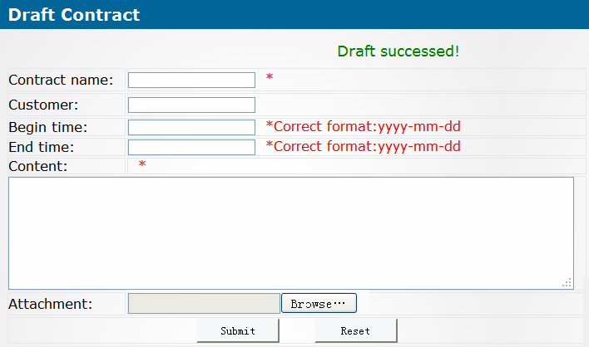

**2. Input**

Write following data on page.

Contract name, start time, end time, content(required), customer.

**3. Process**

1. The verification data is required. The format of Start time and End time should satisfy the requirement. If the content is not completed or the date format is wrong, prompting message shall be given.
2. Save contract data in t_contract, and save its status data in t_contract_state at the same time. The status is Draft. Return contract drafting page to inform the user. Keep the previous drafting

contract data in table.

#### 4. Output

1. Drafting succeeded

Prompt user of the message “Drafting Succeeded!” on page.

1. Drafting failed

① Prompt user of the message “Contract data is required. Incorrect date format.”

② Prompt user of the message “Drafting failure!”

1. If system error occurs, jump to exception page.

### 3.4.2 Countersign Contract

#### 1.Introduction

The countersigner checks the list of contracts to be countersigned; choose one contract content to check, and input the countersignature opinions and then countersign.

The contract list page to be countersigned is as follow:

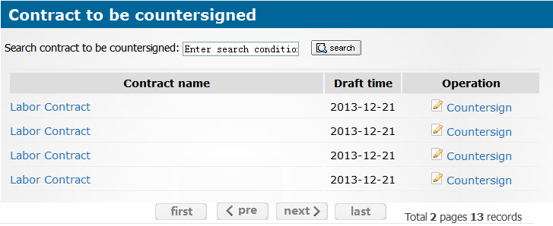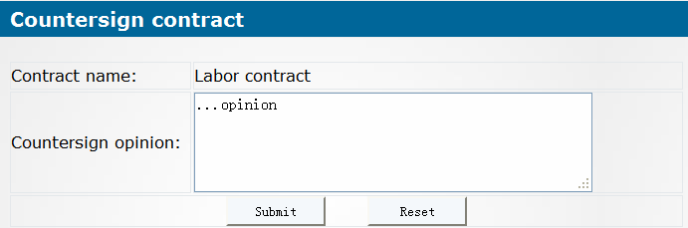

The countersignure page is as follow:

**2.Input**

id of contract id of user

Countersignature opinion

#### 3.Process

1. data validation

The inputted countersignature opinion cannot be empty.

1. dispose process

Enquire list information of contracts to be countersigned, and display on contract list to be countersigned page.

#### Preview the contract

Enquire the details contract information; pass to the detailed page of contract to display.

#### Countersign the contract

Enquire the contract information to be countersigned, pass to the countersignature contract page to display..

According to the countersignature page to fill in the countersigned opinion, update the information of the contract process.

If all the countersigner have Countersigned, then save the completed information status of countersignature contract.



**4.Output**

1. Contract detail.
2. Contract to be countersigned.
3. Updated process information.
4. Contract status information.
5. List of contracts to be countersigned.

**3.4.3 Finalize Contract**

**1.Introduction**

Drafter check the list of contracts to be finalized, choose one contract content to check it’s countersignature opinion, and amend the contract to finalize.

**2.Input**

conId: id of contract to be finalized. userId: id of the drafter.

content: contract content to be updated.

**3.Process**

1. data validation

The inputted countersignature content cannot be empty.

1. dispose process

Enquire list information of contracts to be finalized, and display on contract list to be finalized page.

#### Enquire countersignature opinion

Enquire the countersignature information of contract, pass to the countersignure opinion page to display.

#### Finalize contract

Enquire the contract information to be finalized, pass to finalization page to display.

Get contract data to be updated, and update contract information.

After the contract is finalized, save the completed information status of finalized.

#### 4.Output

1. Countersignature opinion of contract.
2. Contract to be finalized.
3. Updated contract information.
4. Contract status information.
5. List of contracts to be finalized.



**3.4.4 Approve Contract**

**1.Introduction**

Approver checks the list of approved contract; choose one contract content to review, and fill in the approval opinion to approve.

**2.Input**

conId: id of contract to be approved. userId: id of the approver.

content: approval opinion.

approved operation: pass or refuse.

**3.Processing**

1. data validation

The inputted approval opinion cannot be empty.

1. dispose process

Enquire list information of contract to be approved, and display on contract list to be approved page.

Enquire the contract information to be approved, pass to the approval page to display.

Based on the approved operation and approval opinion, update the information of the contract process.

If all approvers have approved and passed, then save the completed information status of approval

contract.

#### 4.Output

1. Contract details.
2. Contract to be approved.
3. Updated process information.
4. Contract status information.
5. List of contracts to be approved.

### 3.4.5 Sign Contract

#### 1.Introduction

after the contract is approved, when the assigned signer logins the system and views contract list to be Signed, he can select a contract and open it to review the content, and then, perform the signature operation to a specific contract.

#### 2.Input

conId: id of contract to be signed.



userId: id of the signer.

content: signature opinion.

**3.Process**

1. data validation

The inputted signature information cannot be empty.

1. dispose process

Enquire list information of contract to be signed, and display on contract list to be signed page. Enquire contract information to be singed, pass to the sign page to display.

According to the signed information, save the completed information status of the signed contract.

**4.Output**

1. Contract details.
2. Contract to be signed.
3. Updated process information.
4. Contract status information.
5. List of contracts to be signed.

**3.5 Query**

The administrator can enquire and search the basic information of contract, and follows the contract process and status.

### Query Contract Info

According to the contract numbers and names, enquire the contract.

### Query Contract Process

According to the status of contract enquire the contract.

* 1. **Fundamental data management**

Administrator can manage the contract information and customer information.

### Contract Info

The contract information to add, enquire, modify and delete operations.

Add contract corresponds to draft contract module; Modify contract corresponds to finalize contract module.

### Customer Info

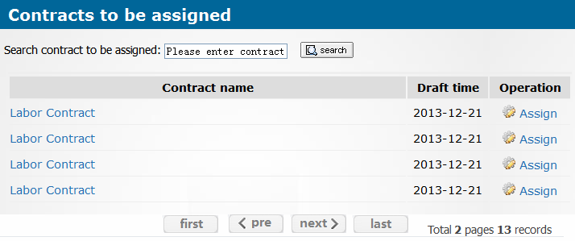

The customer information to add, enquire, modify and delete operations.

**3.7 System management**

Administrator can assign the contract, authorization management and log management and so on.

**3.7.1 Assign Contract**

**1.Introduction**

Administrator chooss the contract to be assigned which the status is “draft”, Assign people who involves in countersignature, approval and signment. so as to complete the operation of assigning. The contract list page to be assigned is as follow:

The assignment page is as follow:

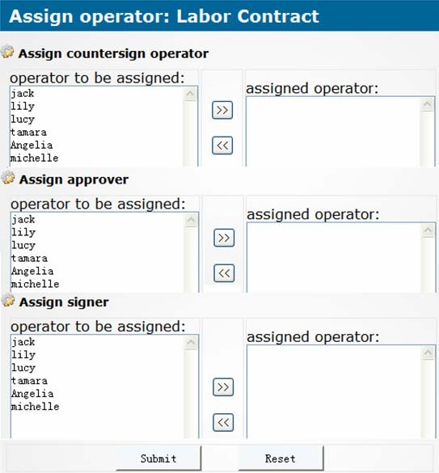

**2.Input**

conId: id of contract to be assigned.

user ids of designated person which take part in countersign, approval, and signment.

**3.Processing**

(1) data validation

All the people who take responsibilities for countersign, approval, and signment need to be

assigned.

(2) dispose process

Enquire list information of contract to be assigned, and display on contract list to be assigned page.

Enquire the contract information to be assigned, pass to the assign page to display. Save the assignment information of the contract operation process.

#### 4.Output

1. Contract to be assigned.
2. List of people who may be assigned with contracts.
3. Information of contract assigned.
4. List of contract to be assigned.

### 3.7.2 Authorize

Authorization management includs user management, role management, function operation, permission configuration and permission validation. The administrator can assign and manage the permission.



**3.7.3 System Log**

The user's operation has a corresponding logging in the system, the administrator can manage log.

**3.8 Data Information**

Describe the data information of the system.

**4 Interface Requirements**

**4.1 User Interface**

For most users, screens are larger than 17 inches, the resolution is 1024x768 (it is 600x800 in a

few cases), and software interfaces should adapt to the screen dimension.

**4.2 Software Interface**

This is a web application program with MySQL5.x.

## 4.3 Communication Interface

To communicate using the HTTP protocol.

# Overall Design Constraints

## Hardware Limitations

Minimum configuration on a computer: CPU: 1 GHZ

Memory: 128 MB

## Technology Limitations

File format: text mode file or binary mode file format. Coding standard: Java Coding standard



# Software Quality Attributes

## Reliability

Adaptability: New services and functions can be easily added to the system on the basis of its basic functions, without affecting the architecture of the original website system. The system can adapt to browsers of multiple versions.

Fault tolerance: In the case of system crashes, memory insufficient, it will not cause the system



failure and the system can normally power off & restart.

Recoverability: The system should be able to run properly after a fault is resolved.

**6.2 Usability**

Usability: The interface design should be reasonable, concentrating system functions and making

the system user-friendly. The system should block users' illegal input data or operations, provide wizards and notes for complex processing, and provide users with handy help information.



Importance of requirements is classified as following:

1. Mandatory: absolutely essential features, without which the product development will be canceled.
2. Important: unessential features that may affect the viability of the product.
3. Nice to have: desired features, the absence of which will not affect the product viability.

# Requirements Classification

|  |  |  |
| --- | --- | --- |
| **Requirement ID** | **Requirement Name** | **Classification** |
| 3.2 | Register | A |
| 3.3 | Login | A |
| 3.4.1 | Draft Contract | A |
| 3.4.2 | Countersign Contract | A |
| 3.4.3 | Finalize Contract | A |
| 3.4.3 | Approve Contract | A |
| 3.4.4 | Sign Contract | A |
| 3.5.1 | Query Contract Info | B |
| 3.5.2 | Query Contract Process | B |
| 3.6.1 | Contract Info | B |
| 3.6.2 | Customer Info | B |
| 3.7.1 | Assign Contract | A |
| 3.7.2 | Authorize | A |
| 3.7.3 | System Log | C |