**Project in Embedded Systems (15 hp)**

# Electron gun vacuum system control

**Microcontroller based control system interfaced**

**with industrial grade electronics**

Simon Gollbo

# Background

A control system can be achieved by simply having a human read off sensor readings and then controlling actuators or performing some action accordingly to achieve some wanted effect. This simple control system, while easy to implement, does come with substantial limitations in terms of speed, cost and rate of error when compared to an electronic control system.

A prevalent type of control system is the so called Proportional-Integrating-Differentiating controller or PID controller for short. The PID controller is useful because it can treat the system being controlled as a black box, meaning that the system dynamics need not be known for the PID control to be applied. This is done by feeding the system output back into the controller and comparing it to some desired reference value that constitutes the input to the controller. The difference between the system output and the reference signal is called the error signal and the controller attempts to drive the error signal to zero. To make the PID controller control the system in a satisfactory manner, each of the proportional, integrating and differentiating parts have a gain associated to them, essentially deciding how much of the error signal should be put through the separate parts. The gains have to be tuned to the specific system to ensure satisfactory control being applied.

Controllers are typically implemented on some type of microcontroller or other computer system. Most often, a microcontroller or computer system cannot withstand high voltages and currents associated with industrial systems. When interfacing a control system to industrial grade electronics, it is therefore often necessary to insulate the control unit from the rest of the system, while still allowing communication of control signals to the system.

This project aims to create a microcontroller-based control system to be interfaced with industrial grade electronics. The control system will implement a touch display with a graphical user interface for interacting with the system.

# Objective(s)

The objective of this project is to design a universal PID-controller and apply a simple version of it to control an electron gun vacuum system in the Ångström laboratory clean room.

In addition the project aims to design a graphical user interface for manual interaction and control of the various parts of the electron gun vacuum system. The graphical user interface is to be implemented on an LCD touch screen. The graphical user interface should also give the user the ability to manipulate the PID-controller gains.

# Overview of system

An overview of the electron gun vacuum system is provided in Fig. 3.1. The electron gun resides within the vacuum chamber and is used to deposit metal onto a substrate.

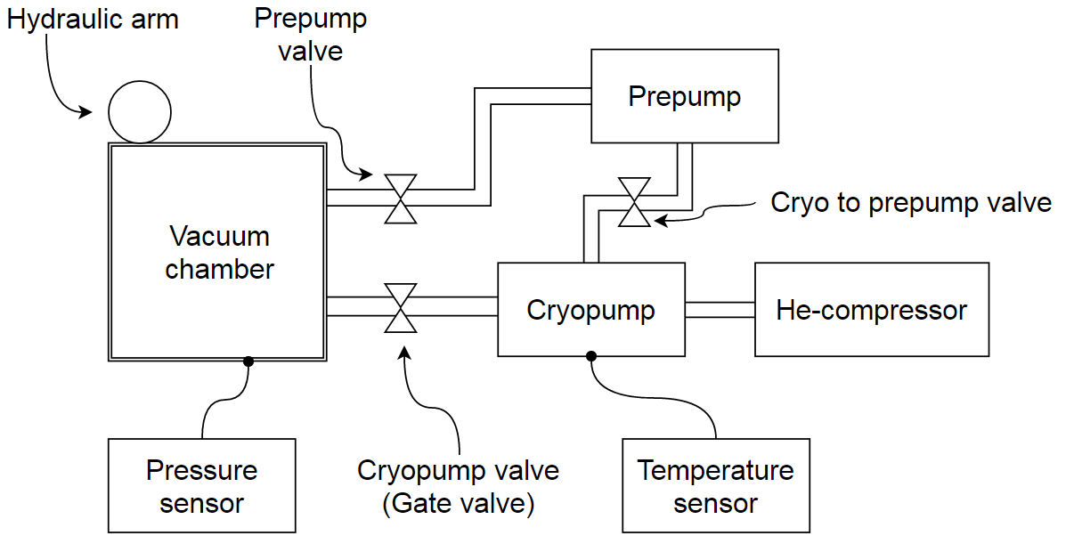

Fig. .1: Overview of the electron gun vacuum system.

Using the terminology of Fig. 3.1, an overview of the control system is provided in Fig. 3.2. The *0-10V Analog* inputs can be connected to temperature or pressure sensors already present in the system.

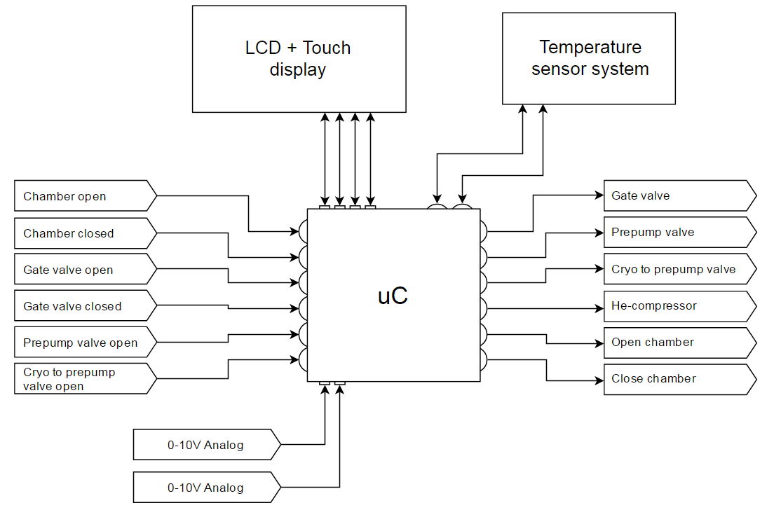

Fig. 3.2: Overview of the control system. The round connections points of the uC are digital, while the square connection points are analog.

# Preliminary tasks and work distribution

The preliminary tasks to be completed are as follows:

* Design and testing of the graphical user interface
* Design and testing of software logic for the control system (logic checks to allow or disallow actions based on the system state)
* Design and testing of the universal PID-controller
* Connecting and testing of prototype board
* Design of PCB. Mounting of components on PCB. Testing of PCB functionality.

As a large part of the intended functionality relies on the graphical user interface, this part should probably be prioritized and worked on first, at least to the point where it can be used for user interaction. Next, the software logic allowing or disallowing actions based on the system state can be designed alongside the universal PID-controller. Connection and testing of the prototype board should have to be partially done while implementing the graphical user interface. This part should be completed to test the software implementations of the logic and PID-controller parts. Finally, when the prototype can be considered working, design of the PCB should be performed. As a general principle, testing should be carried out in close proximity to development.

# Suggestion of grading criteria and grade to be achieved

1. Basic 2-level output controller functioning on prototype board. Prototype board implementation can control the vacuum system via graphical user interface.
2. In addition to grade 3, a universal PID-controller is functioning on prototype board. The PID-controller gains can be modified via the graphical user interface.
3. A fully functioning PCB is constructed with a universal PID-controller. The graphical user interface can be used to control the vacuum system and/or the PID-controller gains.

**Grade to be achieved: 5.**

# Preliminary time schedule

|  |  |
| --- | --- |
| Week | Main work content |
| 2 | Prepare project outline |
| 3 | Design and testing of graphical user interface. Prototype board started. |
| 4 | Design and testing of software logic for the control system, additional graphical user interface work. Prototype board continued. Start laying PCB design groundwork. |
| 5 | Design and testing of universal PID-controller. Continue PCB design. |
| 6 | Finalize prototype board, finalize PCB design. |
| 7 | Testing of PCB functionality. Final polish. |
| 8 | Focus on report writing |