**Database Coursework**

**Business Rules and Operations**

|  |
| --- |
| Tutor |
| BO1 | Add a new student record |
| BO2 | Update a student record |
| BO3 | View student record |
| BO4 | Add a new course record |
| BO5 | Update a course record |
| BO6 | View course record |
| BO7 | Add a new quiz record |
| BO8 | Update a quiz record |
| BO9 | View quiz record |
| BO10 | Add a new resource record |
| BO11 | Update a resource record |
| BO12 | View a resource record |
| Student |
| BO13 | Add a new student record |
| BO14 | Update a student record |
| BO15 | View a student record |
| BO16 | Add a new student course record |
| BO17 | View a student course record |
| BO18 | View course resources record |
| BO19 | View quiz resources record |
| BO20 | View quiz results record |
| BO21 | Add international record |
| BO22 | Update international record |
| BO23 | View international record |
| BO24 | View course record |
| Admin |
| BO25 | Add a new course record |
| BO26 | Update course record |
| BO27 | View course record |
| BO28 | Delete course record |
| BO29 | Add a new tutor record |
| BO30 | Update a tutor record |
| BO31 | View tutor record |
| BO32 | Delete tutor record |
| BO33 | Add a new student record |
| BO34 | Update a student record |
| BO35 | View student record |
| BO36 | Delete student record |
| BO37 | Add a new course record |
| BO38 | Update a course record |
| BO39 | View course record |
| BO40 | Add a new quiz record |
| BO41 | Update a quiz record |
| BO42 | View quiz record |
| BO43 | Delete quiz record |
| BO44 | Add a new resource record |
| BO45 | Update a resource record |
| BO46 | View a resource record |
| BO47 | Delete resource record |
| BO48 | Add new fees record |
| BO49 | Update fees record |
| BO50 | View fees record |
| BO51 | Delete fees record |

|  |
| --- |
| Tutor |
| BR1 | Not Update student id, Name, Address, Next Of Kin, fees paid, dob, email for Student |
| BR2 | Not delete a Student details |
| BR | Not view fees paid, dob on Student |
| BR3 | Not view admin details |
| BR4 | Not delete admin details |
| BR5 | Not add admin details |
| BR6 | Not update admin details |
| BR7 | Not view International details |
| BR8 | Not delete International details |
| BR9 | Not add International details |
| BR10 | Not update International details |
| BR11 | Not view Address, Next of kin, dob, national insurance on Tutor details |
| BR12 | Not delete Tutor details |
| BR13 | Not add Tutor details |
| BR14 | Not update Quiz results details |
| BR16 | Not delete Quiz results details |
| Student |
| BR17 | Not Update student id, Name, fees paid, dob, for Student |
| BR18 | Not delete a Student details |
| BR19 | Not view admin details |
| BR20 | Not delete admin details |
| BR21 | Not add admin details |
| BR22 | Not update admin details |
| BR23 | Not delete International details |
| BR24 | Not update StudentID for International |
| BR25 | Not view Address, Next of kin, dob, national insurance on Tutor details |
| BR23 | Not add Tutor details |
| BR27 | Not update Tutor details |
| BR28 | Not delete Tutor details |
| BR29 | Not view QuizID on Quiz results |
| BR30 | Not delete Quiz results details |
| BR31 | Not add Quiz results details |
| BR32 | Not update Quiz results details |
| BR33 | Not view national insurance , on Course details |
| BR34 | Not delete Course details |
| BR35 | Not add Course details |
| BR36 | Not update Course details |
| BR37 | Not view QuizID Quiz Resources details |
| BR38 | Not delete Quiz Resources details |
| BR39 | Not add Quiz Resources details |
| BR40 | Not update Quiz Resources details |
| BR41 | Not view national insurance on Course resources |

**Conceptual design**

|  |  |  |
| --- | --- | --- |
| Entity | Attributes | Relationships |
| Student | Student ID, Name, Address, Next Of Kin, course(s), fees paid, dob, email | Quiz Scores, Tutor, Course, international |
| international | visa expiry, passport number. | student |
| Tutor | Name, Address, Next of kin, Office number, extension, dob, email, national insurance. | Admin, Student, Course, Course Resources, Quiz resources |
| Admin | Name, Address, Next of kin, Office number, extension, dob, email, national insurance. | Tutor |
| Course | Course ID, Course name, tutor, room, | Tutor, Student, Quiz Resources, Course Resources |
| Course resources | Course ID, Course name, availability, tutor, | Tutor, Course |
| Quiz Resources | Quiz ID, Quiz name, Course name, quiz type, | Tutor, Course, Quiz Scores |
| Quiz Results | Quiz ID, Quiz name, Student name, score. | Student, Quiz Resource |

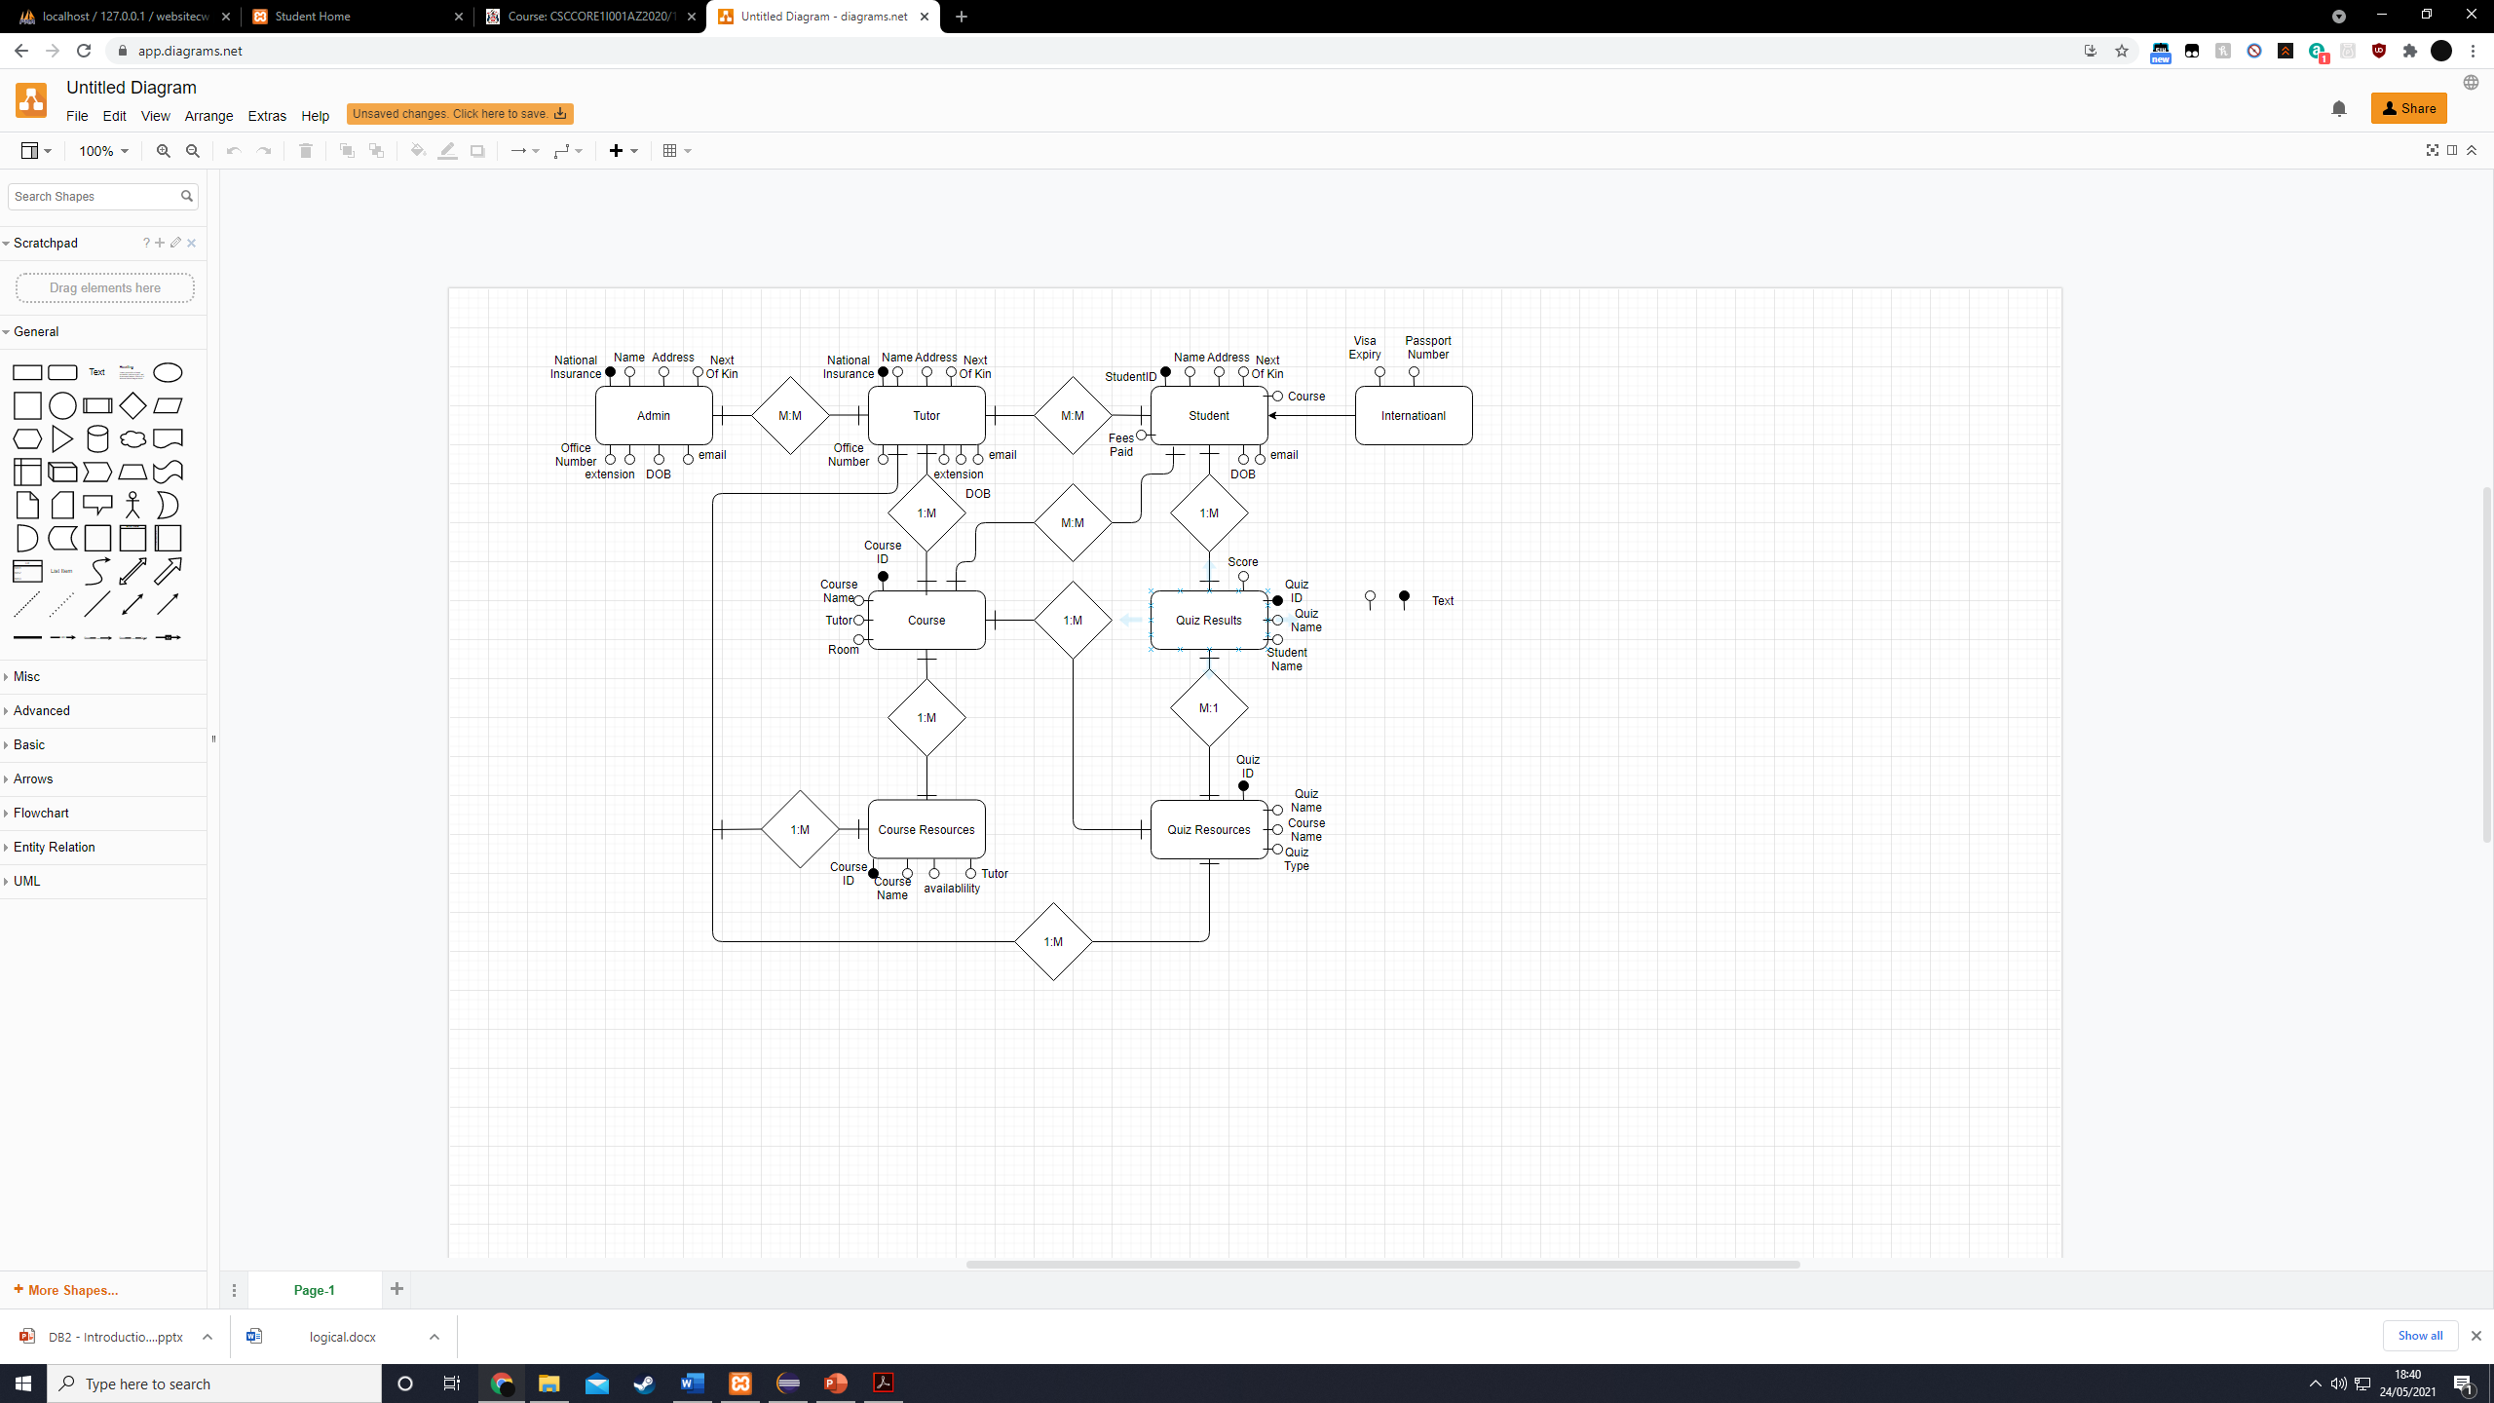

**Logical design**

Admin(**NationalInsuranceNumber**, Name, Address, Next of kin, Office number, extension, dob,

email)

Tutor(**NationalInsuranceNumber**, Name, Address, Next of kin, Office number, extension, dob, email)

Student(**Student ID**, Name, Address, Next Of Kin, course, fees paid, dob, email)

TutorStudent(**Student ID, NationalInsuranceNumber**)

FK Student ID → Student UPDATE CASCADE, DELETE RESTRICT

FK NationalInsuranceNumber → Tutor UPDATE CASCADE, DELETE RESTRICT

International(**Student ID,** visa expiry, passport number)

FK Student ID → Student UPDATE CASCADE, DELETE RESTRICT

Course(**Course ID**, **NationalInsuranceNumber**, Course name, tutor, room)

FK NationalInsuranceNumber → Tutor UPDATE CASCADE, DELETE RESTRICT

CourseResources(**Course ID**, **NationalInsuranceNumber,**  Course name, availability, tutor)

FK NationalInsuranceNumber → Tutor UPDATE CASCADE, DELETE RESTRICT

CourseStudent(**Course ID, Student ID**)

FK Course ID → Course UPDATE CASCADE, DELETE RESTRICT

FK Student ID → Student UPDATE CASCADE, DELETE RESTRICT

CourseResources(**Course ID**, **NationalInsuranceNumber,** Availability)

FK NationalInsuranceNumber → Tutor UPDATE CASCADE, DELETE RESTRICT

CourseResources(**Course ID**, **NationalInsuranceNumber,**  Course name, availability, tutor)

FK NationalInsuranceNumber → Tutor UPDATE CASCADE, DELETE RESTRICT

QuizResources(**Quiz ID**, **Student ID,** Quiz name, Course name, quiz type)

FK StudentID → Student UPDATE CASCADE, DELETE RESTRICT

QuizResults(**Quiz ID**, **NationalInsuranceNumber** , Quiz name, Student name, score)

FK NationalInsuranceNumber→ Tutor UPDATE CASCADE, DELETE RESTRICT

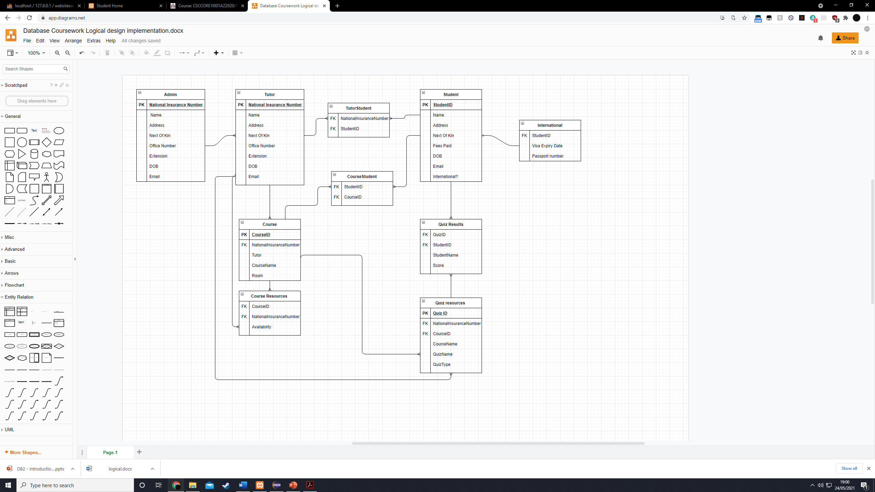

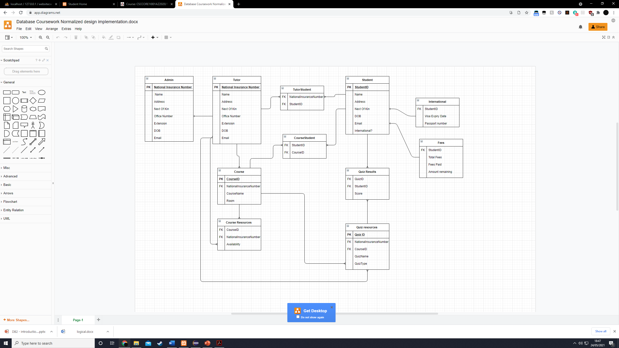**Normalized Design**

**Physical Design**

tblAdmin

|  |  |  |  |  |  |
| --- | --- | --- | --- | --- | --- |
| Field Name | Data Type | Field Size | Key Type | Index | Required |
| National Insurance Number | Varchar | 9 | Primary Key | Yes(No Duplicates) | Yes |
| Name | Varchar | 30 |  |  | Yes |
| Address | Varchar | 30 |  |  | Yes |
| NextOfKin | Varchar | 30 |  |  | Yes |
| OfficeNumber | Varchar | 10 |  |  | Yes |
| Extension | Integer | 15 |  |  | Yes |
| DOB | Date | 10 |  |  | Yes |
| Email | Varchar | 30 |  |  | Yes |

tblTutor

|  |  |  |  |  |  |
| --- | --- | --- | --- | --- | --- |
| Field Name | Data Type | Field Size | Key Type | Index | Required |
| National Insurance Number | Varchar | 9 | Primary Key | Yes(No Duplicates) | Yes |
| Name | Varchar | 30 |  |  | Yes |
| Address | Varchar | 30 |  |  | Yes |
| NextOfKin | Varchar | 30 |  |  | Yes |
| OfficeNumber | Varchar | 10 |  |  | Yes |
| Extension | Integer | 15 |  |  | Yes |
| DOB | Date | 10 |  |  | Yes |
| Email | Varchar | 30 |  |  | Yes |

tblStudent

|  |  |  |  |  |  |
| --- | --- | --- | --- | --- | --- |
| Field Name | Data Type | Field Size | Key Type | Index | Required |
| StudentID | Varchar | 30 | Primary Key | Yes(No Duplicates) | Yes |
| Name | Varchar | 30 |  |  | Yes |
| Address | Varchar | 30 |  |  | Yes |
| NextOfKin | Varchar | 30 |  |  | Yes |
| International | Integer | 1 |  |  | Yes |
| DOB | Date | 10 |  |  | Yes |
| Email | Varchar | 30 |  |  | Yes |

tblInternational

|  |  |  |  |  |  |
| --- | --- | --- | --- | --- | --- |
| Field Name | Data Type | Field Size | Key Type | Index | Required |
| StudentID | Varchar | 30 | Foreign Key | Yes(Duplicates OK) | Yes |
| VisaExpiryDate | Date | 10 |  |  | Yes |
| PassportNumber | Varchar | 10 |  |  | Yes |

tblFees

|  |  |  |  |  |  |
| --- | --- | --- | --- | --- | --- |
| Field Name | Data Type | Field Size | Key Type | Index | Required |
| StudentID | Varchar | 30 | Foreign Key | Yes(Duplicates OK) | Yes |
| TotalFees | Integer | 10 |  |  | Yes |
| FeesPaid | Integer | 10 |  |  | Yes |
| AmountRemaining | Integer | 10 |  |  | Yes |

tblTutorStudent

|  |  |  |  |  |  |
| --- | --- | --- | --- | --- | --- |
| Field Name | Data Type | Field Size | Key Type | Index | Required |
| StudentID | Varchar | 30 | Foreign Key | Yes(Duplicates OK) | Yes |
| National Insurance Number | Varchar | 9 | Foreign Key | Yes(Duplicates OK) | Yes |

tblCourse

|  |  |  |  |  |  |
| --- | --- | --- | --- | --- | --- |
| Field Name | Data Type | Field Size | Key Type | Index | Required |
| CourseID | Varchar | 30 | Primary Key | Yes(No Duplicates) | Yes |
| National Insurance Number | Varchar | 9 | Foreign Key | Yes(Duplicates OK) | Yes |
| CourseName | Varchar | 30 |  |  | Yes |
| Room | varchar | 30 |  |  | Yes |

tblCourseStudent

|  |  |  |  |  |  |
| --- | --- | --- | --- | --- | --- |
| Field Name | Data Type | Field Size | Key Type | Index | Required |
| CourseID | Varchar | 30 | Primary Key | Yes(Duplicates OK) | Yes |
| StudentID | Varchar | 30 | Foreign Key | Yes(Duplicates OK) | Yes |

tblCourseResources

|  |  |  |  |  |  |
| --- | --- | --- | --- | --- | --- |
| Field Name | Data Type | Field Size | Key Type | Index | Required |
| CourseID | Varchar | 30 | Primary Key | Yes(Duplicates OK) | Yes |
| National Insurance Number | Varchar | 9 | Foreign Key | Yes(Duplicates OK) | Yes |
| Availability | Varchar | 30 |  |  | Yes |

tblQuizResults

|  |  |  |  |  |  |
| --- | --- | --- | --- | --- | --- |
| Field Name | Data Type | Field Size | Key Type | Index | Required |
| QuizID | Varchar | 30 | Foreign Key | Yes(Duplicates OK) | Yes |
| StudentID | Varchar | 30 | Foreign Key | Yes(Duplicates OK) | Yes |
| Score | Integer | 30 |  |  | Yes |

tblQuizResources

|  |  |  |  |  |  |
| --- | --- | --- | --- | --- | --- |
| Field Name | Data Type | Field Size | Key Type | Index | Required |
| QuizID | Varchar | 30 | Primary Key | Yes(No Duplicates) | Yes |
| CourseID | Varchar | 30 | Primary Key | Yes(Duplicates OK) | Yes |
| National Insurance Number | Varchar | 9 | Foreign Key | Yes(Duplicates OK) | Yes |
| QuizName | Varchar | 30 |  |  | Yes |
| QuizType | varchar | 30 |  |  | Yes |

**SQL Implementation**

CREATE DATABASE databaseCoursework;

SHOW DATABASES;

USE databaseCoursework;

CREATE TABLE tblAdmin (

nationalInsuranceNumber varchar(9) not null,

name varchar(30) not null,

address varchar(30) not null,

nextOfKin Varchar(30) not null,

officeNumber Varchar(30) not null,

extension Integer(15) not null,

dob Date(15) not null,

email varchar(30) not null,

phone integer(15) not null,

primary key (NationalInsuranceNumber)

);

CREATE TABLE tblTutor (

nationalInsuranceNumber varchar(9) not null,

name varchar(30) not null,

address varchar(30) not null,

nextOfKin Varchar(30) not null,

officeNumber Varchar(30) not null,

extension Integer(15) not null,

dob Date(15) not null,

email varchar(30) not null,

phone integer(15) not null,

primary key (NationalInsuranceNumber)

);

CREATE TABLE tblStudent (

studentID varchar(30) auto_increment not null,

name varchar(30) not null,

address varchar(30) not null,

nextOfKin Varchar(30) not null,

international Integer(1) not null,

dob Date(15) not null,

email varchar(30) not null,

primary key (StudentID)

);

CREATE TABLE tblInternational (

studentID varchar(30) not null,

visaExpiryDate Date(10) not null,

passportNumber Integer(10) not null,

foreign key(studentID) references tblStudent(studentID)

);

CREATE TABLE tblFees (

studentID varchar(30) not null,

totalFees Integer(10) not null,

feesPaid Integer(10) not null,

amountRemaining Integer(10) not null,

foreign key(studentID) references tblStudent(studentID)

);

CREATE TABLE tblTutorStudent(

studentID varchar(30) not null,

nationalInsuranceNumber varchar(9) not null,

foreign key(studentID) references tblStudent(studentID)

foreign key (nationalInsuranceNumber) references tblTutor(nationalInsuranceNumber)

);

CREATE TABLE tblCourse(

courseID varchar(30) not null,

nationalInsuranceNumber varchar(9) not null,

CourseName varchar(30) not null,

room varchar(30) not null,

foreign key (nationalInsuranceNumber) references tblTutor(nationalInsuranceNumber)

);

CREATE TABLE tblCourseStudent(

courseID varchar(30) not null,

studentID varchar(30) not null,

foreign key(studentID) references tblStudent(studentID)

foreign key(courseID) references tblCourse (courseID)

);

CREATE TABLE tblCourseResources(

courseID varchar(30) not null,

nationalInsuranceNumber varchar(9) not null,

Availability varchar(30) not null,

foreign key(courseID) references tblCourse (courseID)

foreign key (nationalInsuranceNumber) references tblTutor(nationalInsuranceNumber)

);

CREATE TABLE tblQuizResources(

quizID varchar(30) not null,

courseID varchar(30) not null,

nationalInsuranceNumber varchar(9) not null,

quizName varchar(30) not null,

quizType varchar(30) not null,

primary key (quizID)

foreign key(courseID) references tblCourse (courseID)

foreign key (nationalInsuranceNumber) references tblTutor(nationalInsuranceNumber)

);

CREATE TABLE tblQuizResults(

quizID varchar(30) not null,

studentID varchar(30) not null,

scores varchar(30) not null,

foreign key(studentID) references tblStudent(studentID)

foreign key(quizID) references tblQuizResources (quizID)

);

**Security**

CREATE USER 'Student'@'localhost' IDENTIFIED BY 'StudentPassword';

CREATE USER 'Tutor'@'localhost' IDENTIFIED BY 'TutorPassword';

CREATE USER 'Admin'@'localhost' IDENTIFIED BY 'AdminPassword';

GRANT SELECT, INSERT, UPDATE(address,nextOfKin,email) ON databaseCoursework.tblStudent TO 'Student'@'localhost';

GRANT SELECT, INSERT, UPDATE(visaExpiryDate,passportNumber) ON databaseCoursework.tblInternational TO 'Student'@'localhost';

GRANT SELECT, INSERT, UPDATE ON databaseCoursework.tblTutor TO 'Tutor'@'localhost';

GRANT SELECT, INSERT, databaseCoursework.tblStudent TO 'Tutor'@'localhost';

GRANT SELECT, INSERT, UPDATE ON databaseCoursework.tblTutorStudent TO 'Tutor'@'localhost';

GRANT SELECT, INSERT, UPDATE ON databaseCoursework.tblCourse TO 'Tutor'@'localhost';

GRANT SELECT, INSERT, UPDATE, DELETE ON databaseCoursework.tblCourseResources TO 'Tutor'@'localhost';

GRANT SELECT, INSERT, UPDATE, DELETE ON databaseCoursework.tblQuizResources TO 'Tutor'@'localhost';

GRANT SELECT, INSERT, UPDATE, DELETE ON databaseCoursework.tblStudent TO 'Admin'@'localhost';

GRANT SELECT, INSERT, UPDATE, DELETE ON databaseCoursework.tblFees TO 'Admin'@'localhost';

GRANT SELECT, INSERT, UPDATE, DELETE ON databaseCoursework.tblTutorStudent TO 'Admin'@'localhost';

GRANT SELECT, INSERT, UPDATE, DELETE ON databaseCoursework.tblAdmin TO 'Admin'@'localhost';

GRANT SELECT, INSERT, UPDATE, DELETE ON databaseCoursework.tblTutor TO 'Admin'@'localhost';

GRANT SELECT, INSERT, UPDATE, DELETE ON databaseCoursework.tblCourse TO 'Admin'@'localhost';

GRANT SELECT, INSERT, UPDATE, DELETE ON databaseCoursework.tblCourseStudent TO 'Admin'@'localhost';

GRANT SELECT, INSERT, UPDATE, DELETE ON databaseCoursework.tblCourseResources TO 'Admin'@'localhost';

GRANT SELECT, INSERT, UPDATE, DELETE ON databaseCoursework.tblQuizResources TO 'Admin'@'localhost';

GRANT SELECT, INSERT, UPDATE, DELETE ON databaseCoursework.tblQuizResults TO 'Admin'@'localhost';

GRANT SELECT, INSERT, UPDATE, DELETE ON databaseCoursework.tblInternational TO 'Admin'@'localhost';