# Create new Project in DS

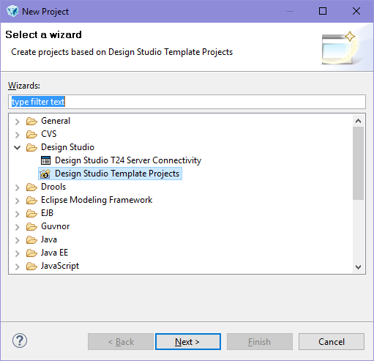

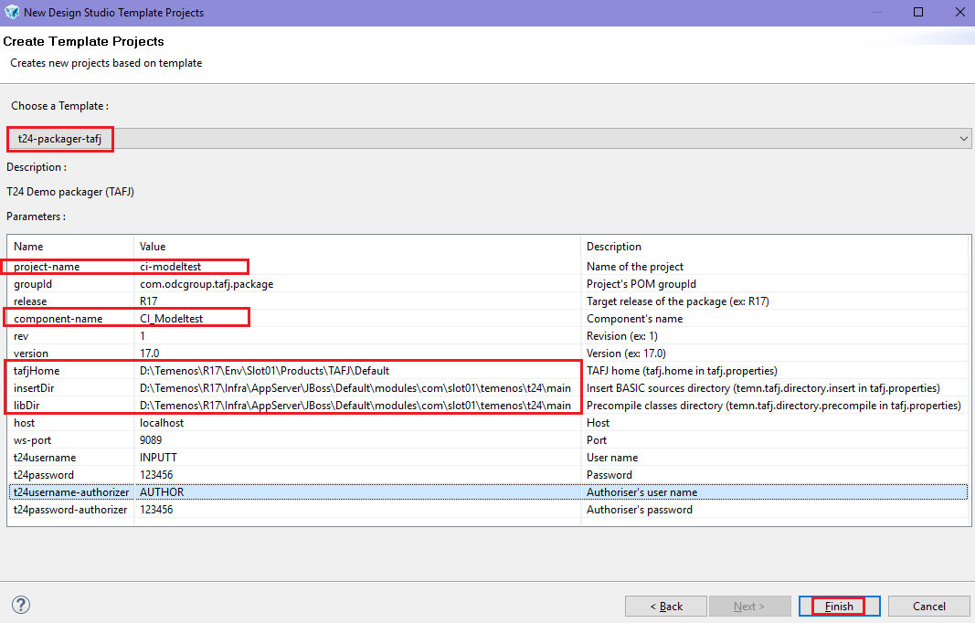

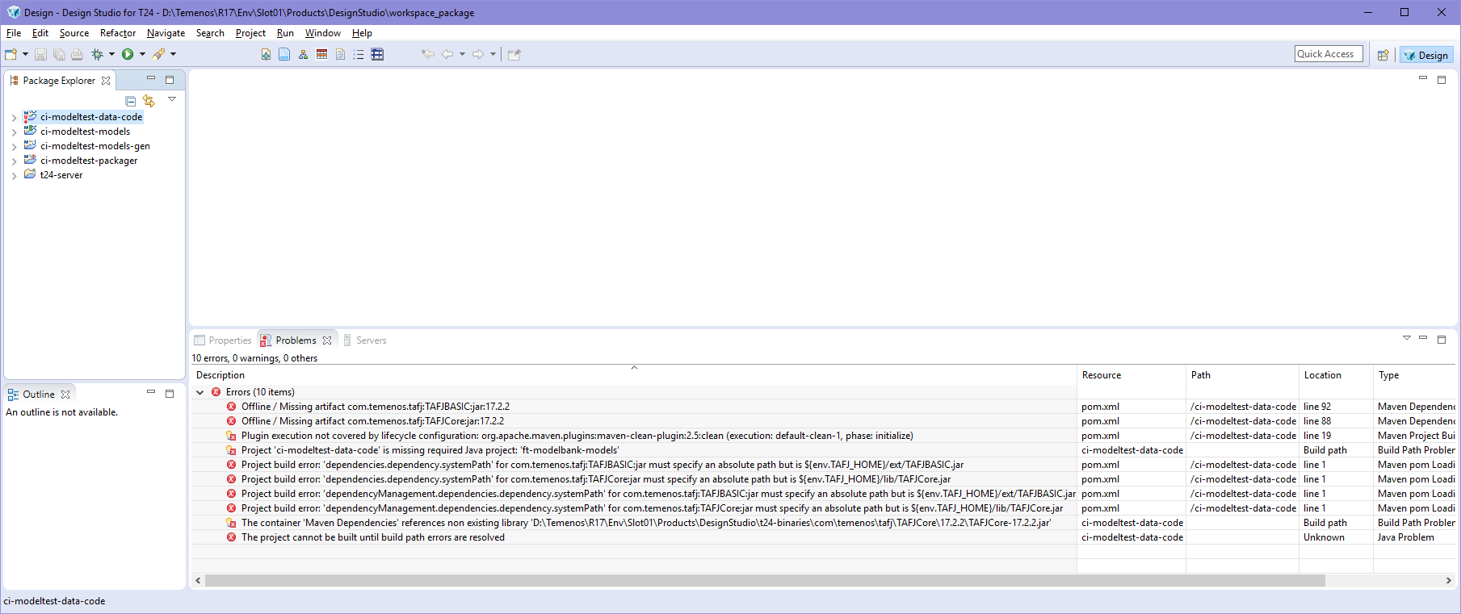

# Update the Maven projects

This is done in order to get rid of the errors:

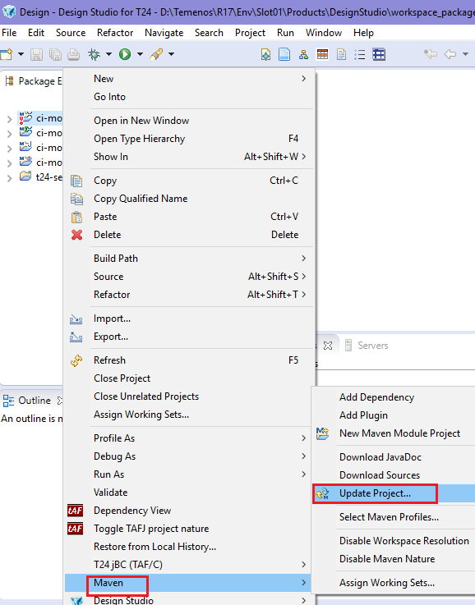 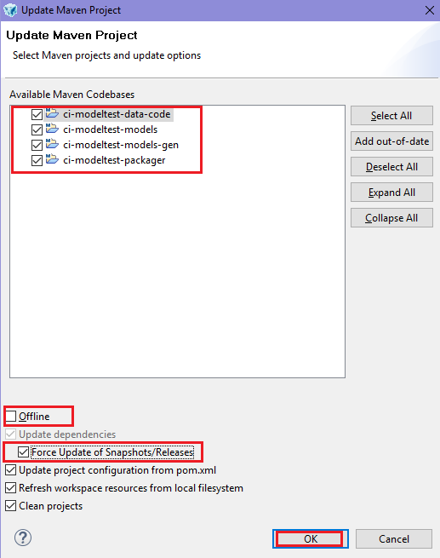

# Error saying “…required java project: ft-modelbank-models”

If an error like this is displayed and your project name is not the one mentioned there it means that name must be changed manually.

* Do a search into entire workspace for “ft-model”:

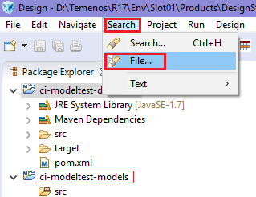

* Correct the content found with the proper name:

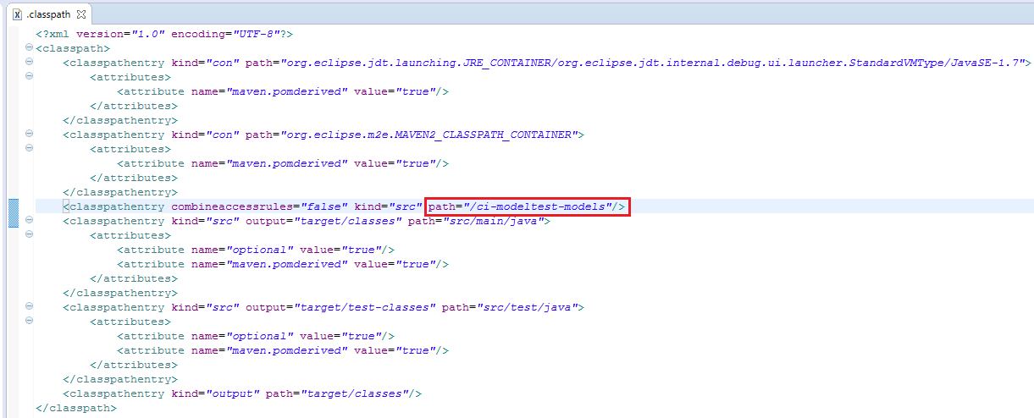

# Errors still persists 1

If you still have the errors then check the ***settings.xml*** file:

* Go to Widow\Preferences

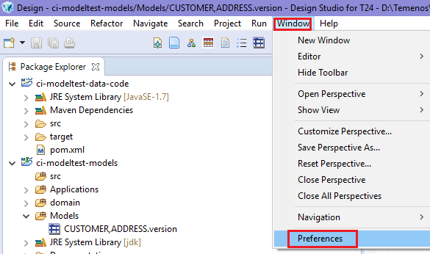

* Go to Maven\UserSettings and click on open file

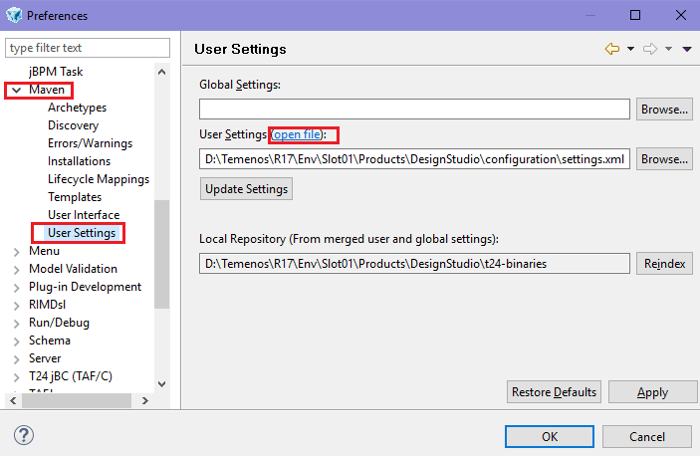

* Check into the ***settings.xml*** file for below lines:

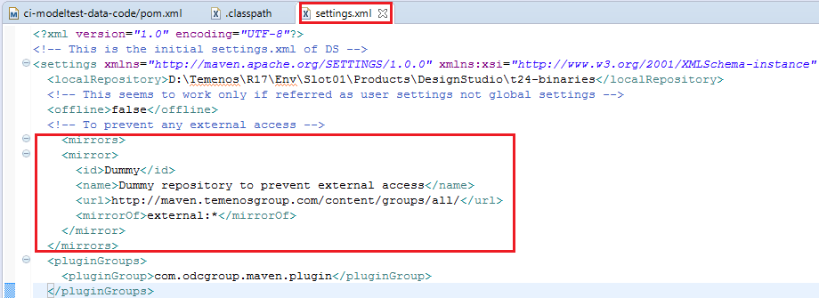

* Update again the maven project
* Build the project in online mode

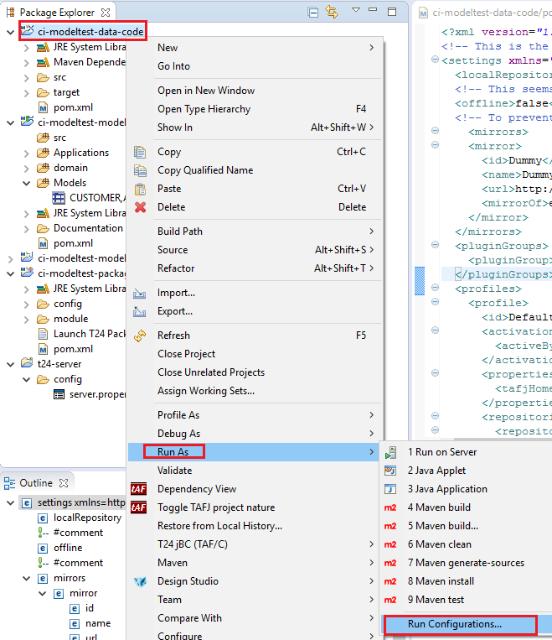 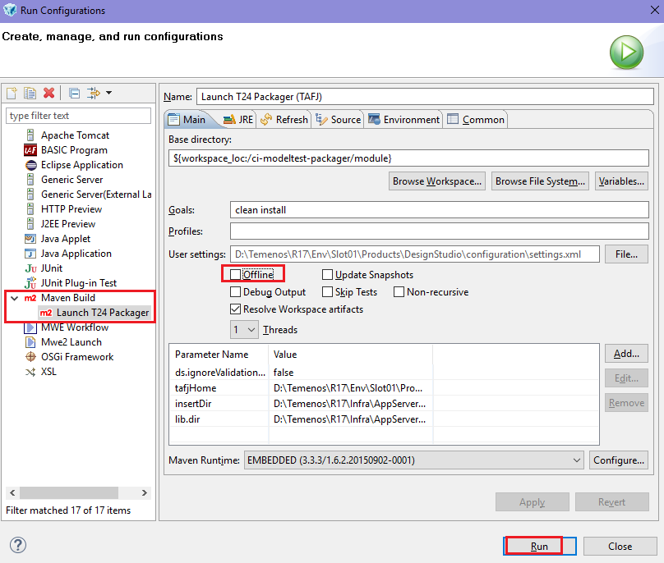

# Errors still persists 2

If you still have the errors then go and set the TAFJ_HOME variable into your system environment.

(Control Panel 🡪 System 🡪Advanced System Setting 🡪 Environment Variables…

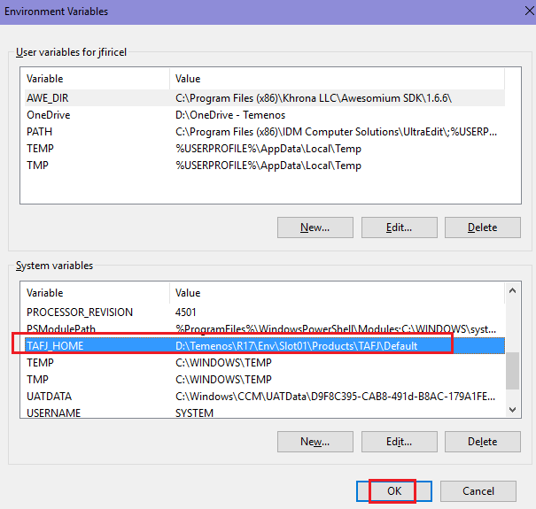

Update again the maven project…No error should be showed anymore into the Problems section.