# 

**DESIGN STUDIO WORKSHOP**

**T24 Graphical Physical and Logical Viewer**

1 Document History 3

2 Pre-requisites 3

3 Initial Setup 3

4 Design Studio Packager 7

4.1 Running the packager in Design Studio 7

4.2 Running the packager installer from CLI 8

4.3 Running the packager in Continuous Integration 8

4.4 Running the package installer from Continuous Integration 8

# Document History

|  |  |  |
| --- | --- | --- |
| Author | Version | Date |
| Yann Andenmatten | 1.0 | 10 OCT. 2016 |
|  |  |  |

Comments:

|  |
| --- |
|  |
|  |
|  |

# Pre-requisites

1. Ensure you have 16GB machine
2. You’ll need the following files
   1. DesignStudioT24-201608.0.0-GDV.zip
   2. DesignStudioT24-Workshop_GDV.docx (this document)

# Initial Setup

1. Create the folder C:\DS\DesignStudioT24-201608.0.0  
   **Note:** changing this folder will require some adaptation of the procedure below.
2. Unzip DesignStudioT24-201608.0.0.zip
3. Start Design Studio (DesignStudioT24.exe)
4. Select the default workspace (C:\DS\DesignStudioT24-201608.0.0\workspace)  
     
   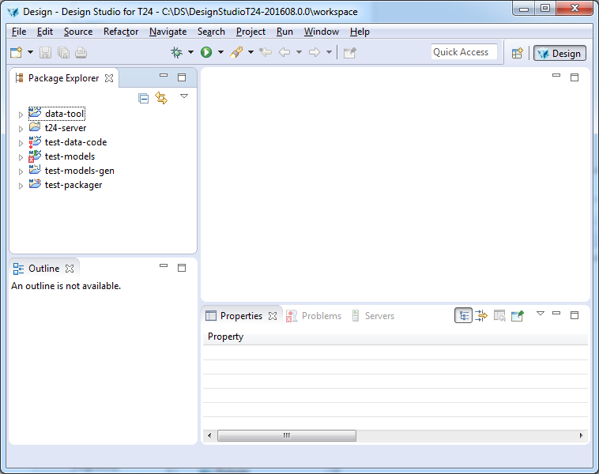

# Open existing schemas

1. Then you will find 3 schema files under test-models/schemas:
   1. AA.ARRANGEMENT.ACTIVITY.schema
   2. PW.PROCESS.DEFINITION.schema
   3. SEC.ACC.MASTER.schema
2. Double click on PW.PROCESS.DEFINITION.schema to open it

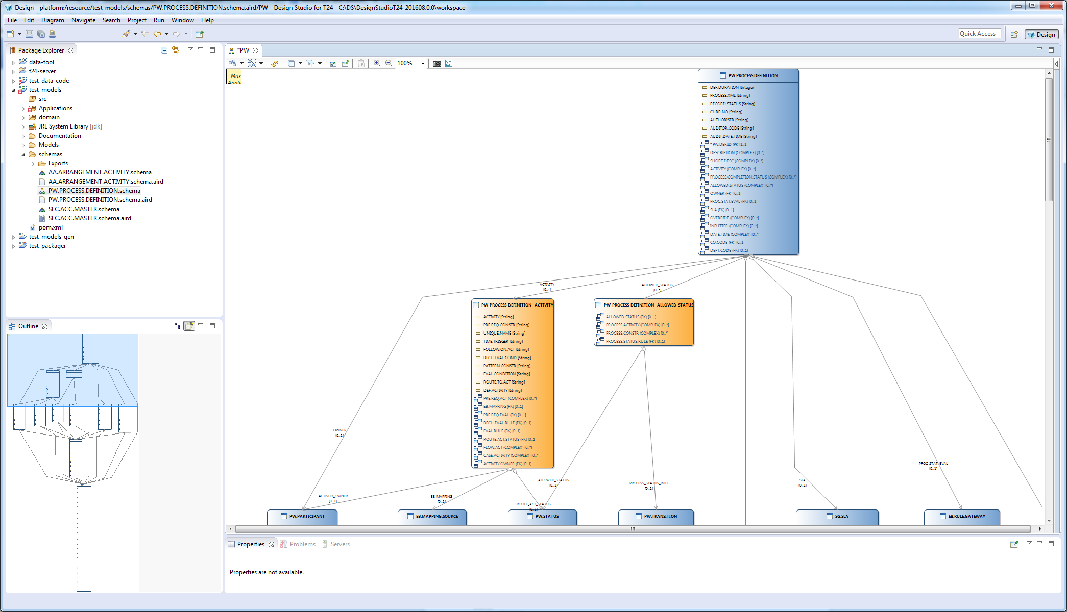

1. Use the Outline view (bottom left) to navigate quickly in big schema
2. First a few explanations. The schema is created from a root entity. Here it is PW.PROCESS.DEFINITION. The orange table represents the multi value / sub value group.
3. Here is a summary of the naming used:  
   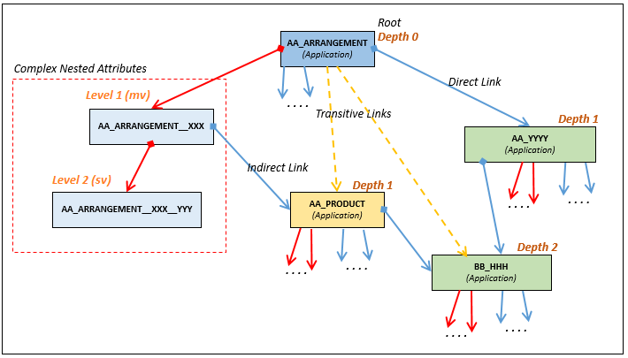
4. Use the filter to change what is hidden:  
     
   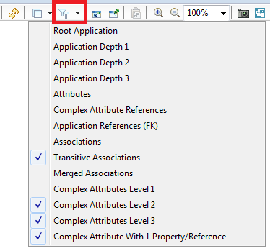

| **Filter** | **Description** |
| --- | --- |
| Hide Root Application | Hide the application used to start the diagram |
| Hide Application Depth 1 | Do not display applications of depth 1 from the root application. |
| Hide Application Depth 2 | Do not display applications of depth 2 from the root application. |
| Hide Application Depth 3 | Do not display applications of depth 3 from the root application. |
| Hide Attributes | Hide (simple) attributes from the application |
| Hide Complex Attribute References | Hide references to complex attribute (multi value/sub value group) |
| Hide Application References | Hide references (field name) to other application |
| Hide Complex Attribute Level 1 | Hide multi values |
| Hide Complex Attribute Level 2 | Hide sub values |
| Hide Complex Attribute Level 3 | Not used |
| Hide Complex Attribute with 1 property | Hide complex attribute with only one property |
| Hide Associations | Hide associations to other applications |
| Hide Transitive Associations | Hide (computed) transitive association (if included at the import) |
| Hide Merged Associations | When several associations exists to between two applications, a merged association can be display instead. This option hides merged association |

1. Use the Arrange All menu from the toolbar to rearrange the schema once the filters have been changed:  
     
   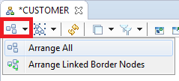
2. The schema can be exported as a DDL equivalent. This feature allows to import generated diagram in another display tool. To do so, right click on the schema > Export Schema > Export as DDL:  
     
   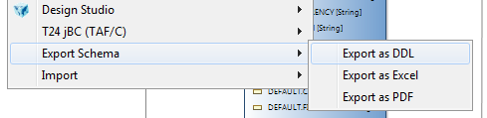  
     
   **Note**: other export functions are not functional yet.

# Create new schemas

1. File > New > New Schema… (experimental)

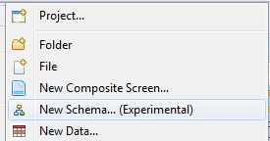

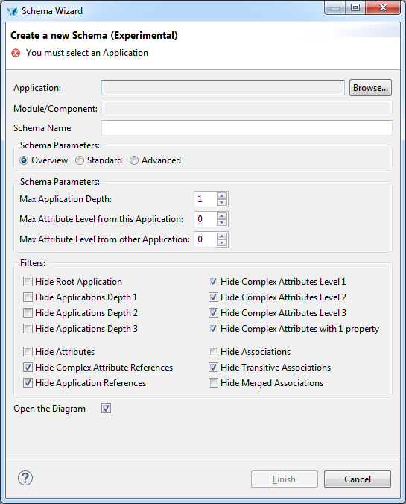

1. Select the Application with the Browse… button
2. Change the Schema Name if you wish
3. Select the Import Option
   1. Overview: Applications without multivalue and subvalue groups
   2. Standard: Applications with multivalue and subvalue groups
   3. Advanced: Display all element, but the transitive associations
   4. Max Application Depth: select how deep should go the schema (>1 can take a long time or reach out of memory)
   5. Max Attribute Level from this application:
      1. 0 means no multi/sub value group (only simple attributes)
      2. 1 means simple attribute and multi value groups
      3. 2 means simple attribute and multi and sub value groups
   6. Max Attribute Level from other Application: same as above but for other application than the root application  
        
      **Note:** the import options above will define the data that is included in the schema. Not included data cannot be included later. Some filtering will be ineffective if you haven’t imported the type of item. For example if you didn’t include multi value and sub value groups, hiding/showing them won’t make a difference.
4. Select the filters applied to the imported schema. These can be changed later.

# Using workspace level options

1. Open the workspace preferences: Window > Preferences
2. Navigate to the Graphical Data viewer preferences in the left pane: Design Studio > Graphical Data Viewer  
   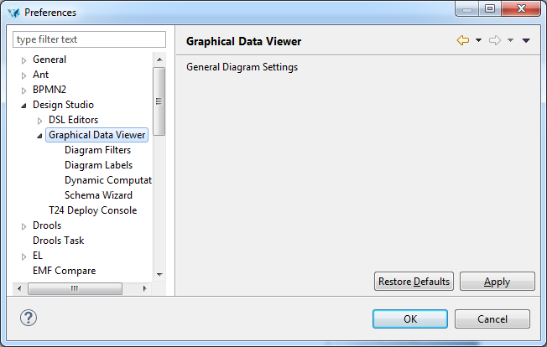
3. There are four configurable items. Diagram Filters and Schema Wizard allow to change the default values of new Schema creation.
4. Diagram Labels offers control over how attribute labels are built and allow to hide unnecessary attributes (like RESERVED attributes).
5. Dynamic Computations controls which dynamic association are computed:
   1. “Compute Merged Associations” allows to replace many associations between two applications by one “global” association. They are displayed in green.
   2. “Auto hide multiple associations between 2 entities” works in conjunction with merged associations to hide the associations displayed as merged association.
   3. Transitive associations are virtual association generated when intermediate table are not part of the schema. For example, if our have A that references B that references C but B is not displayed, then with this option selected, an association between A and C is added to the schema. Transitive associations are displayed in orange.