**Data Preparation:**  
DEAP Dataset:

Raw EEG signals were transformed from the time domain to the frequency domain using FFT. Forty electrodes were used, and the signals were divided into five frequency bands: Theta, Alpha, Low Beta, High Beta, and Delta — resulting in 200 feature rows. Additionally, three self-reported labels — Valence, Arousal, and Dominance — were included as input features to predict user preferences in terms of liking or disliking.

AMIGO Dataset:

Raw EEG signals were transformed from the time domain to the frequency domain using FFT. Seventeen electrodes were used, and the signals were also divided into five frequency bands: Theta, Alpha, Low Beta, High Beta, and Delta — resulting in 85 feature rows. Additionally, three self-reported labels — Valence, Arousal, and Dominance — were also included as input features to predict user preferences in terms of liking or disliking.

**Data Description:**

DEAP Dataset:

In the DEAP dataset, the data has been split into 75% for training and 25% for testing. The training set contains 468,480 samples, each with 204 features, and the labels are divided into two categories: "Liking" (label 1) and "Low Liking" (label 0). Out of the training samples, 313,662 are labeled as "Liking" and 154,818 as "Low Liking". The test set includes 156,160 samples with the same number of features, where 104,554 are "Liking" and 51,606 are "Low Liking".

AMIGO Dataset:

The AMIGO dataset is divided into a training set and a test set with a total of 250,880 samples. The training set contains 188,160 samples (approximately 75%) and the test set contains 62,720 samples (approximately 25%), each with 89 features. In the training data, 119,658 samples are labeled as "Liking" (class 1) and 57,624 as "Low Liking" (class 0). The test set follows a similar pattern, with 39,886 "Liking" and 19,208 "Low Liking" samples.

**Result Analysis: (Represented as lowest performed to highest performed in the table based on F1 Score)**

Model names: Gaussian Naive Bayes, Adaptive Boosting, Logistic Regression, Gradient Boosting Machine, Random Under-Sampling Boosting, Long Short-Term Memory, Gated Recurrent Unit, Light Gradient Boosting Machine, Artificial Neural Network, Convolutional Neural Network, Extreme Gradient Boosting, Decision Tree, Categorical Boosting, Multi-Layer Perceptron, Random Forest, K-Nearest Neighbors

DEAP Dataset:

|  |  |  |  |  |
| --- | --- | --- | --- | --- |
| **Model** | **Precision** | **Specificity** | **Sensitivity** | **F1 Score** |
| GNB | 0.59 | 0.2 | 0.86 | 0.51 |
| AdaBoost | 0.64 | 0.15 | 0.95 | 0.52 |
| LR | 0.64 | 0.18 | 0.93 | 0.54 |
| GBM | 0.71 | 0.22 | 0.96 | 0.58 |
| RUSBoost | 0.59 | 0.65 | 0.57 | 0.58 |
| LSTM | 0.68 | 0.28 | 0.92 | 0.6 |
| GRU | 0.67 | 0.29 | 0.91 | 0.6 |
| LGBM | 0.76 | 0.42 | 0.94 | 0.69 |
| ANN | 0.78 | 0.42 | 0.95 | 0.7 |
| CNN | 0.79 | 0.53 | 0.93 | 0.75 |
| XGB | 0.8 | 0.6 | 0.92 | 0.77 |
| DT | 0.77 | 0.75 | 0.82 | 0.78 |
| CATBoost | 0.82 | 0.57 | 0.94 | 0.78 |
| MLP | 0.83 | 0.78 | 0.88 | 0.83 |
| RF | 0.85 | 0.76 | 0.91 | 0.84 |
| KNN | 0.9 | 0.82 | 0.95 | 0.89 |
| ProposedCNN | 0.96 | 0.95 | 0.98 | 0.96 |

Train Vs Validation Accuracy Curve:

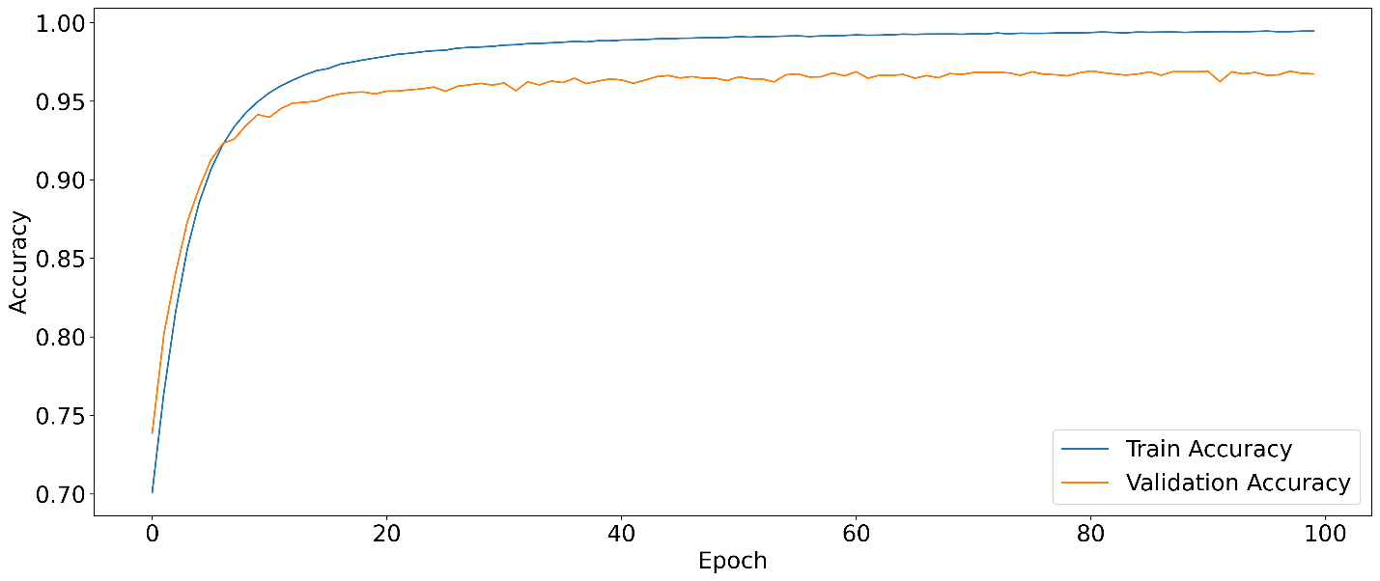

|  |  |  |  |  |
| --- | --- | --- | --- | --- |
| **Data** | **Precision** | **Specificity** | **Sensitivity** | **F1 Score** |
| A | 0.74 | 0.13 | 0.98 | 0.52 |
| V + A | 0.72 | 0.58 | 0.84 | 0.72 |
| V | 0.74 | 0.89 | 0.66 | 0.73 |
| V + A + D | 0.78 | 0.63 | 0.88 | 0.76 |
| Physiological signals | 0.84 | 0.76 | 0.91 | 0.84 |
| Physiological signals + V | 0.93 | 0.89 | 0.96 | 0.93 |
| EEG+ physiological signals + A | 0.93 | 0.94 | 0.95 | 0.94 |
| Physiological signals + A | 0.94 | 0.91 | 0.97 | 0.94 |
| EEG | 0.96 | 0.95 | 0.97 | 0.96 |
| EEG+ physiological signals | 0.96 | 0.95 | 0.98 | 0.96 |
| EEG+ physiological signals + V | 0.98 | 0.96 | 0.99 | 0.98 |
| EEG+V | 0.99 | 0.99 | 1 | 0.99 |
| EEG+A | 0.99 | 0.98 | 0.99 | 0.99 |
| EEG+V+A | 0.99 | 0.99 | 1 | 0.99 |
| EEG+ physiological signals + V + A | 0.99 | 0.99 | 1 | 0.99 |
| Physiological signals + V + A | 0.99 | 0.99 | 0.99 | 0.99 |
| Physiological signals + V + A + D | 0.99 | 1 | 0.99 | 0.99 |
| EEG+V+A+D | 1 | 1 | 1 | 1 |
| EEG+ physiological signals + V + A + D | 1 | 1 | 1 | 1 |

AMIGO Dataset:

|  |  |  |  |  |
| --- | --- | --- | --- | --- |
| **Model** | **Precision** | **Specificity** | **Sensitivity** | **F1 Score** |
| GNB | 0.53 | 0.12 | 0.9 | 0.48 |
| AdaBoost | 0.69 | 0.10 | 0.98 | 0.49 |
| LR | 0.64 | 0.11 | 0.96 | 0.49 |
| RUSBoost | 0.57 | 0.6 | 0.56 | 0.56 |
| GBM | 0.75 | 0.29 | 0.96 | 0.63 |
| GRU | 0.74 | 0.47 | 0.91 | 0.7 |
| LSTM | 0.74 | 0.49 | 0.89 | 0.71 |
| LGBM | 0.84 | 0.6 | 0.95 | 0.79 |
| ANN | 0.83 | 0.73 | 0.91 | 0.83 |
| CNN | 0.87 | 0.73 | 0.94 | 0.85 |
| CATBoost | 0.89 | 0.81 | 0.95 | 0.88 |
| DT | 0.88 | 0.83 | 0.92 | 0.88 |
| XGB | 0.9 | 0.78 | 0.95 | 0.88 |
| KNN | 0.92 | 0.83 | 0.96 | 0.9 |
| MLP | 0.9 | 0.86 | 0.94 | 0.9 |
| RF | 0.93 | 0.86 | 0.97 | 0.92 |
| ProposedCNN | 0.98 | 0.95 | 0.99 | 0.98 |

Train Vs Validation Accuracy Curve:

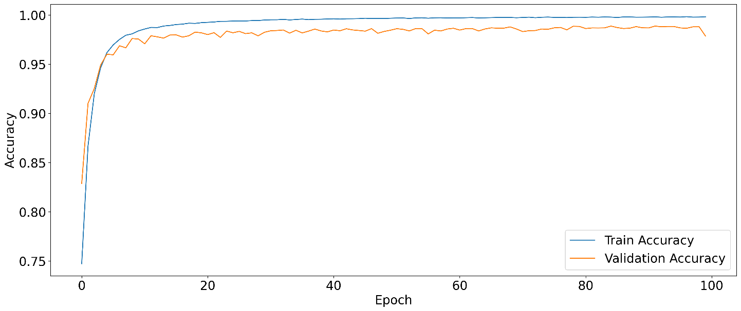

|  |  |  |  |  |
| --- | --- | --- | --- | --- |
| **Data** | **Precision** | **Specificity** | **Sensitivity** | **F1 Score** |
| A | 0.5 | 0.07 | 0.93 | 0.45 |
| V | 0.72 | 0.69 | 0.78 | 0.72 |
| V + A | 0.78 | 0.62 | 0.89 | 0.77 |
| Physiological signals | 0.79 | 0.67 | 0.88 | 0.78 |
| V + A + D | 0.79 | 0.67 | 0.89 | 0.79 |
| Physiological signals + A | 0.94 | 0.91 | 0.96 | 0.94 |
| EEG | 0.96 | 0.95 | 0.98 | 0.96 |
| Physiological signals + V | 0.97 | 0.97 | 0.98 | 0.97 |
| EEG | 0.98 | 0.97 | 0.99 | 0.98 |
| EEG+A | 0.99 | 0.98 | 1 | 0.99 |
| EEG+ physiological signals + A | 0.99 | 0.99 | 1 | 0.99 |
| Physiological signals + V + A | 0.99 | 0.99 | 1 | 0.99 |
| EEG+V | 1 | 1 | 1 | 1 |
| EEG+V+A | 1 | 1 | 1 | 1 |
| EEG+V+A+D | 1 | 1 | 1 | 1 |
| EEG+ physiological signals + V | 1 | 1 | 1 | 1 |
| EEG+ physiological signals + V + A | 1 | 1 | 1 | 1 |
| EEG+ physiological signals + V + A + D | 1 | 1 | 1 | 1 |
| Physiological signals + V + A + D | 1 | 1 | 1 | 1 |

**Proposed Model:**

This model is an improved version of a basic 1D CNNs, designed to better handle complex patterns in sequential data like signals or time-series. It uses special shortcut connections called "residuals" that help the model learn better and go deeper without getting stuck or losing important information. As the model goes deeper, it learns more detailed features step by step, while also using techniques like batch normalization and dropout to keep learning stable and avoid overfitting. Instead of just stacking layers, this design allows the model to be more accurate and reliable, especially on harder task like liking prediction from EEG signals that need deeper understanding of the data.

DEAP Dataset:

The model has a total of 1,232,546 parameters, which roughly equals 4.70 MB of memory usage. Out of these, 1,230,626 parameters are trainable, meaning they will be updated during the training process to learn patterns from the data. The remaining 1,920 parameters are non-trainable, typically coming from components like batch normalization layers, which can maintain running statistics but are not updated through backpropagation.

AMIGO Dataset:

The model contains a total of 1,003,170 parameters, which occupy approximately 3.83 MB of memory. Out of these, 1,001,250 parameters are trainable, meaning they are updated during the training process. The remaining 1,920 parameters are non-trainable, typically associated with layers like batch normalization that maintain internal statistics but are not updated through learning.