# Bayesian Learning Computer Lab 1

* Include all solutions and plots to the stated problems with necessary comments
* Submit report with code attached to the solution of each sub-prblem in ode PDF document
* Submit a separate file containing all code

### 1. Daniel Bernoulli

***Given:*** *s = 13, n = 50, Beta(α0 ,β0) prior for θ where α0 = β0 = 5.*

1. *Draw random numbers from posterior and verify graphically that the posterior mean and standard deviation converges to the true values as the number of draws grows large.*  
     
   The given alpha and beta in the prior distribution can be used to calculate the true mean and standard deviation as well as the alpha and beta for the posterior distribution. We get that the true mean is 0.300 and the true standard deviation is 0.0586. By simulating draws from the posterior distribution using different sample sizes starting with 1000 draws and incrementing this by 1000 until we reach 100000 draws, we can store the sample size, absolute deviance in mean and absolute deviance in standard deviation for each sample size. Figure 1 below shows graphically how the posterior mean and standard deviation converges to the true values as the number of draws grows larger. We would of course need a very large sample size for the deviances to reach zero, but as can be seen in the graph the deviances for the mean and standard deviation are around 0.0001 already at around 100000 draws.

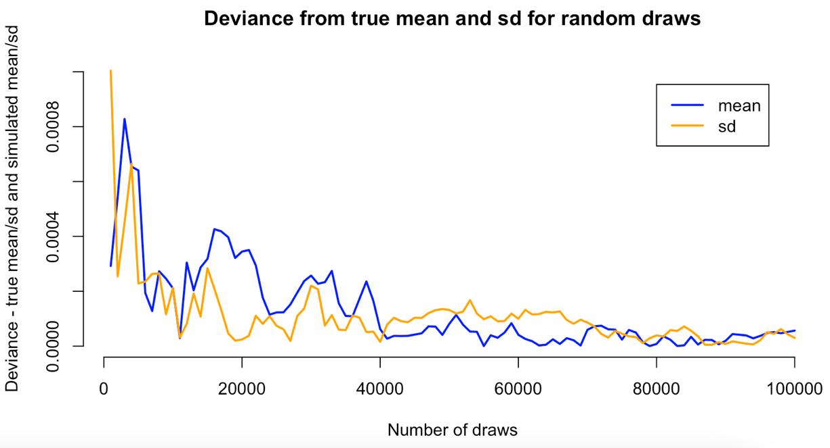

Figure 1 - Calculated mean and standard deviation converge to true mean and standard deviation

1. *Compute the posterior probability Pr(θ < 0.3 | y). Compare with exact value from the Beta posterior.*

Figure 2 below shows the posterior probability for 10000 random draws where the filled area shows Pr(θ < 0.3 | y). This probability is 0.5156, which we can calculate by taking number of samples < 0.3 divided by total number of samples, which gives us 0.5156. This is close to the exact value from the Beta posterior which we calculate using pbeta() (0.5150226).   
  
  
  
  
  
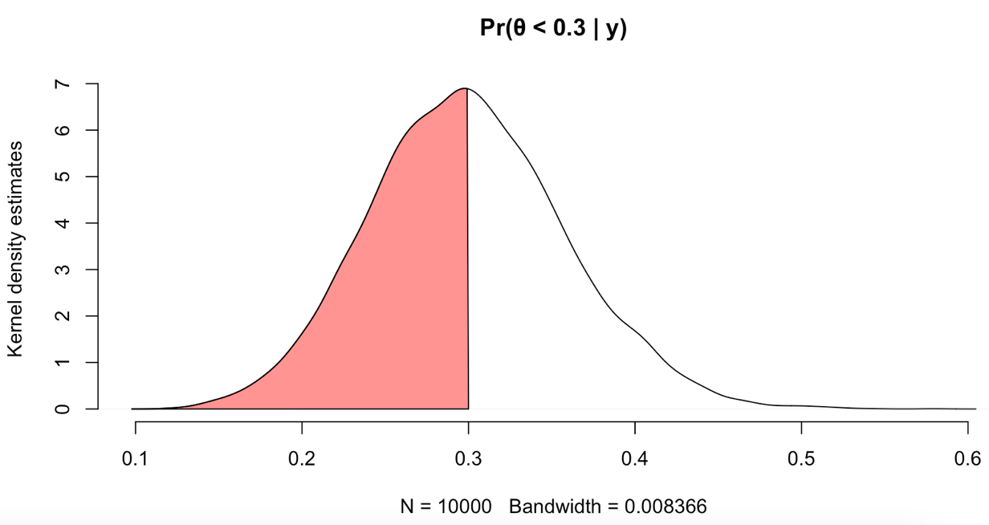

Figure 2 - Filled area shows Pr(θ < 0.3 | y)

1. *Simulate draws from the posterior distribution of the log-odds and plot the posterior distribution of the log-odds.*   
     
   Figure 3 below shows the posterior distribution of log-odds which have been estimated using simulated draws from the Beta posterior. By similating draws from the posterior distribution and transforming these draws to log-odds, i.e. by applying the logit function, we map the probability values from (0,1) to (-inf,inf).   
     
   **Plotta histogram + density plot av original posterior distribution samt posterior distribution av log-odds? Känns oklart vad vi ska komma fram till här**

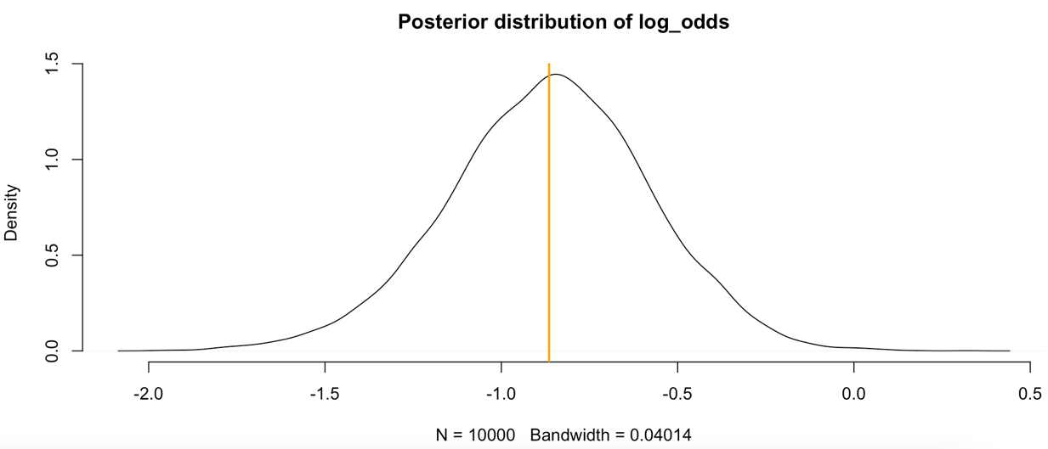

Figure 3 - Posterior distribution of log-odds where orange line shows μ

### 2. Log-normal distribution and the Gini coefficient

***Given:*** *n = 9, y = [33, 24, 48, 32, 55, 74, 23, 76, 17], μ = 3.5, σ2 is unknown.*

1. *Simulate 10,000 draws from the posterior of σ2 and plot the posterior distribution.*

If we assume that the mean is 3.5 we can simulate draws from the posterior distribution of *σ2* by simulating draws from the given Inv -chi^2 distribution. Simulating 10,000 draws and plotting the posterior distribution of *σ2* can be seen in figure 4 below.

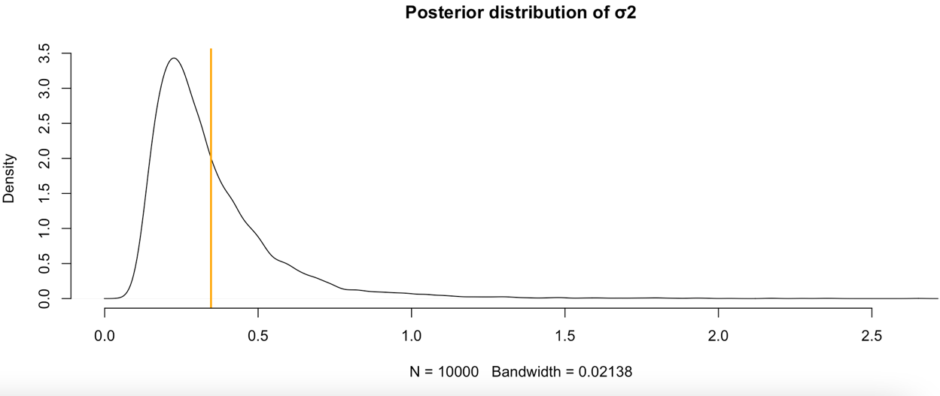

Figure 4 - Posterior distribution of σ2 where orange line shows μ

1. *Use the posterior draws in A. to compute the posterior distribution of the Gini coefficient G for the current data set.*  
     
   Since the posterior draws in A. follow a log N(μ, σ2) distribution, we can use G = 2 Φ (σ /√2) -1 to calculate our Gini coefficient. Figure 5 below shows the posterior distribution for the calculated Gini coefficient and μ in orange.   
     
   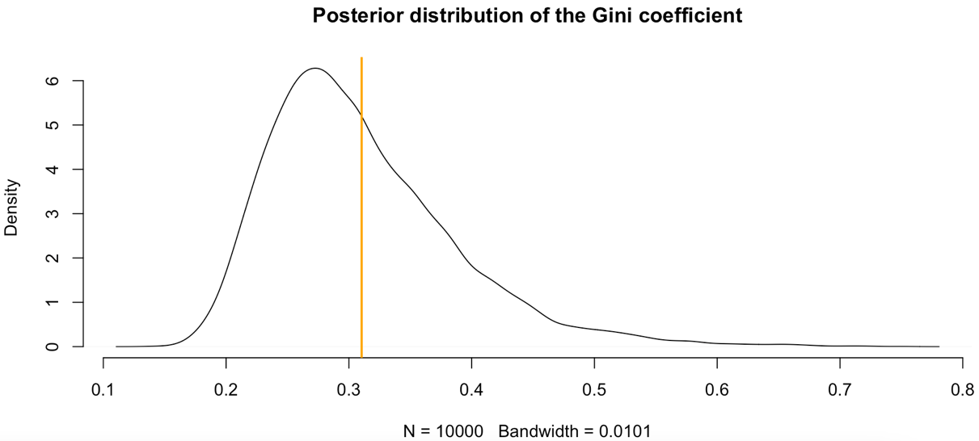

Figure 5 - Posterior distribution of the Gini coefficient where orange line shows μ

1. *Use the posterior draws from B. to compute 95 % equal tail credible interval for G.*  
     
   By calculating mean and standard deviation from our posterior distribution of the Gini coefficient, we can calculate our lower and upper bound for the ETI. K is set to 1.96 as we want our ETI to be 95 %. The interval can also be calculated using the built in qnorm()-function. Figure 6 shows our posterior distribution for the Gini coefficient where the filled area shows our 95 % equal tail credible interval, which is [0.1583, 0.46071].

*k* **Varför olika massa på båda sidorna? Kom vi fram till det`?**

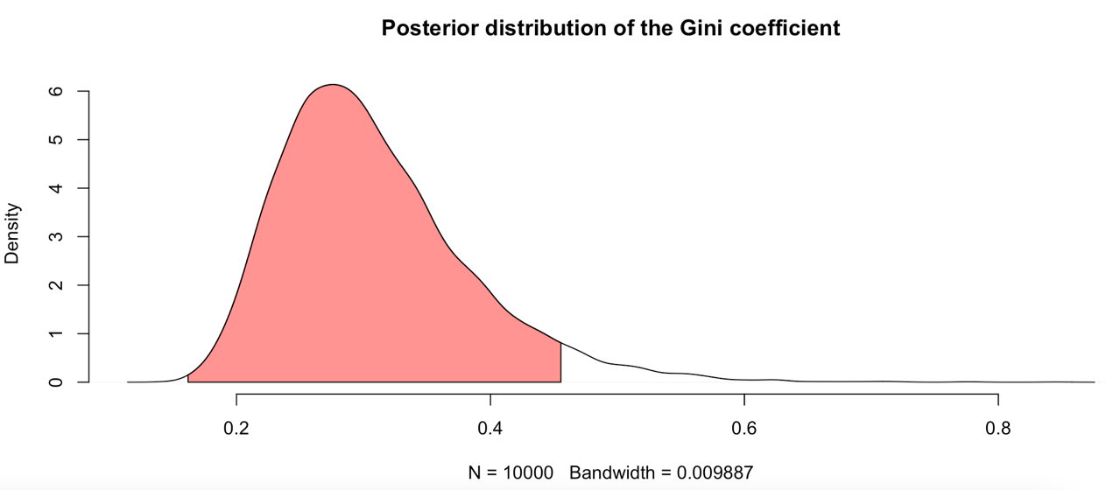

Figure 6 - Posterior distribution for the Gini coefficient where filled are shows 95 % equal tail credible interval

1. *Use the posterior draws from B. to compute a 95 % Highest Posterior Density Interval (HPDI) for G. Compare the two intervals in C. and D.*   
     
   **To compute the 95% HPDI, we begin by extracting x- and y-values from the density estimate from the density()-function and sorting these on decreasing y-value. We can then calculate what value 95% of the accumulated y-values corresponds to, i.e. the accumulated value to stop at when deciding which (x,y)-pairs to look at, and find which indexes corresponds to the 95% HPDI . We can then find the lower and upper bound for the HPDI.**

Figure 7 shows the posterior distribution for the Gini coefficient where the filled area is the 95 % HPDI compared to the orange lines representing 95 % ETI. A comparison of HPDI and ETI shows that the HPDI gives a better summary for the posterior distribution for the Gini coefficient.   
  
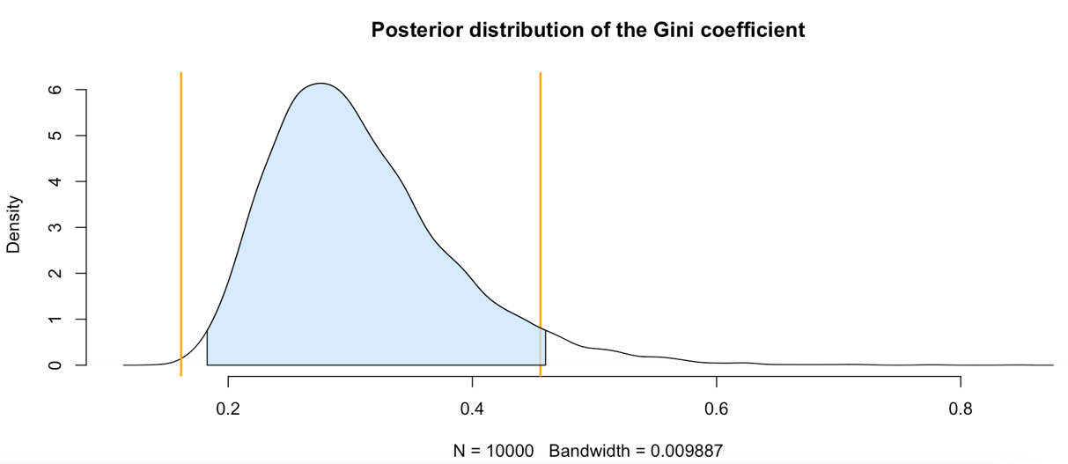

Figure 7 - Posterior distribution for the Gini coefficient where filled area shows 95 % HPDI and orange lines 95 % ETI calculated in C.

### 3. Bayesian inference for the concentration parameter in the von Mises distribution

***Given:*** *n = 10, y = [1.83, 2.02, 2.33, -2.79, 2.07, 2.02, -2.44, 2.14, 2.54, 2.23] in radians, μ = 2.51.*

1. *Derive the expression for what the posterior p(κ | y, μ) is proportional to and plot the posterior distribution of κ for the wind direction data over a fine grid of κ values.*
2. *Find the approximate posterior mode of κ from the information in A.*