**实验3-H3C路由器配置**

**DHCP服务、APR协议**

课程名称：计算机网络 实验教学学时：4学时

年级/班级： 学生人数： 专业：软件工程

**一、实验目的：**

（1）理解DHCP、DHCP中继工作机制，掌握配置H3C路由器作为DHCP服务器、DHCP中继动态分配ip地址的方法。

（2）熟悉ARP协议以及交换机（或网桥）MAC地址学习算法，理解冲突域、广播域的概念及消除方法。

（3）加深对子网划分、路由器组网、静态路由配置的理解

**二、实验原理或预习内容**

（1）教材涉及路由器和交换机原理的相关章节

（2）H3C MSR 系列路由器和交换机 配置指导(V7)

**三、实验环境**

（1）硬件环境需求

2台H3S S3600V2交换机，2台H3C MSR 26-30路由器，多台PC 以及console电缆及转接器，若干条双绞线跳线

（2）软件环境需求

Windows 系统平台

**四、实验内容**

**任务概述**

|  |  |
| --- | --- |
| 主要工作 | 参考资料 |
| 配置路由器为DHCP服务器、中继 | 06-三层技术-IP业务配置指导-整本手册  ARP协议：P13  DHCP服务器：P40  DHCP中继：P64 |
| 更改ip租用时间 | 06-三层技术-IP业务配置指导-整本手册  更改ip租用时间：P45 |
| 配置静态路由 | 07-三层技术-IP路由配置指导-整本手册  静态路由：P17 |

## 任务一：配置H3C-Router路由器为DHCP服务器



* Step1：按照任务一网络拓扑结构进行连接
* Step2：配置H3C-A路由器为DHCP服务器

#开启dhcp服务

[H3C-A]dhcp enable

#设置dhcpip地址池名字为101

[H3C-A]dhcp server ip-pool 101

#设置分配的ip地址网段、子网掩码

[H3C-A-dhcp-pool-101]network 192.168.10.0 mask 255.255.255.128

#设置网关和DNS

[H3C-A-dhcp-pool-101]gateway-list 192.168.10.1

[H3C-A-dhcp-pool-101]dns-list 192.168.10.1

[H3C-A-dhcp-pool-101]quit

#禁止一些ip地的分配，这里不允许网关地址和DNS地址被分配出去

[H3C-A]dhcp server forbidden-ip 192.168.10.1

#设置GE0/0的ip地址

[H3C-A]interface GigabitEthernet 0/0

[H3C-A-GigabitEthernet0/0]undo shutdown

[H3C-A-GigabitEthernet0/0]ip address 192.168.10.1 25

#ip地址设置之后，DHCP服务器分配ip地址给各个设备

[H3C-A-GigabitEthernet0/0]%May 29 19:50:35:187 2015 H3C-A DHCPS/5/ALLOCATE_IP: Server IP = 192.168.10.1, DHCP client IP = 192.168.10.2, DHCP client hardware address = 70f9-6d91-03c9, DHCP client lease = 86400 seconds.

%May 29 19:50:36:190 2015 H3C-A DHCPS/5/ALLOCATE_IP: Server IP = 192.168.10.1, DHCP client IP = 192.168.10.3, DHCP client hardware address = 70f9-6d92-942b, DHCP client lease = 86400 seconds.

%May 29 19:51:28:287 2015 H3C-A DHCPS/5/ALLOCATE_IP: Server IP = 192.168.10.1, DHCP client IP = 192.168.10.4, DHCP client hardware address = 0015-175d-3a98, DHCP client lease = 86400 seconds.

%May 29 19:52:09:287 2015 H3C-A DHCPS/5/ALLOCATE_IP: Server IP = 192.168.10.1, DHCP client IP = 192.168.10.5, DHCP client hardware address = 0015-170b-edfe, DHCP client lease = 86400 seconds.

[H3C-A-GigabitEthernet0/0]quit

#查看当前路由器学习到的MAC地址

[H3C-A]display arp all

Type: S-Static D-Dynamic M-Multiport I-Invalid

IP address MAC address VLAN Interface Aging Type

192.168.10.2 70f9-6d91-03c9 N/A GE0/0 17 D

192.168.10.3 70f9-6d92-942b N/A GE0/0 17 D

192.168.10.4 0015-175d-3a98 N/A GE0/0 20 D

192.168.10.5 0015-170b-edfe N/A GE0/0 20 D

#将新的其他设备进入网络，自动分配地址

[H3C-A]%May 29 19:56:03:987 2015 H3C-A DHCPS/5/ALLOCATE_IP: Server IP = 192.168.10.1, DHCP client IP = 192.168.10.6, DHCP client hardware address = 0015-174b-7bea, DHCP client lease = 86400 seconds.

#路由器更新学习到的MAC地址，对应网络拓扑中有五个设备

[H3C-A]displayarp all

Type: S-Static D-Dynamic M-Multiport I-Invalid

IP address MAC address VLAN Interface Aging Type

192.168.10.2 70f9-6d91-03c9 N/A GE0/0 15 D

192.168.10.3 70f9-6d92-942b N/A GE0/0 15 D

192.168.10.4 0015-175d-3a98 N/A GE0/0 20 D

192.168.10.5 0015-170b-edfe N/A GE0/0 20 D

192.168.10.6 0015-174b-7bea N/A GE0/0 20 D

#使用HP-PC3查看三层交换机L3-Switch学习到的MAC地址

<H3C-Switch>

#Jan 1 00:23:06:062 2010 H3C-Switch SHELL/4/LOGIN:

Trap 1.3.6.1.4.1.25506.2.2.1.1.3.0.1<hh3cLogIn>: login from Console

%Jan 1 00:23:06:212 2010 H3C-Switch SHELL/5/SHELL_LOGIN: Console logged in from aux0.

[H3C-Switch] **display arp all**

Type: S-Static D-Dynamic

IP Address MAC Address VLAN ID Interface Aging Type

192.168.10.1 70f9-6d6e-793b 1 Eth1/0/1 10 D

192.168.10.3 70f9-6d92-942b 1 Eth1/0/24 5 D

* Step3：更改ip租用时间

#查看HP-PC1的ip信息，发现ip租用时间是1天，

#查看PC1的MAC地址对比路由器学习到的MAC地址，并注意查看设置的DHCP服务器的IP，DNS服务器的IP地址。

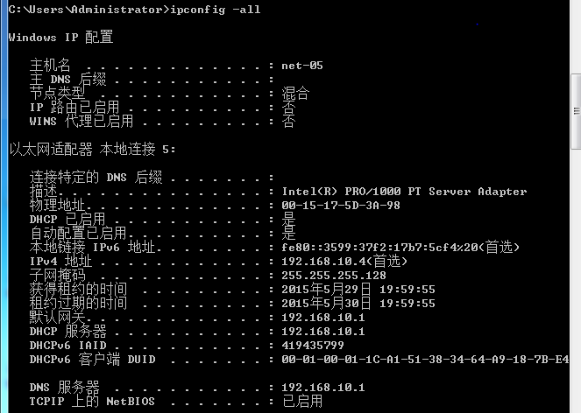

#使用ping命令测试HP-PC1与其他设备的连通性

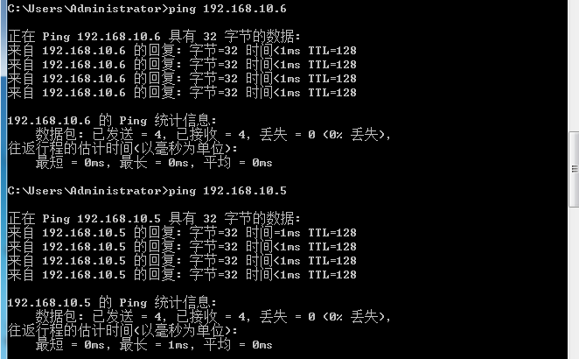

#cmd.exe下，事先可以使用arp –d清空，执行ping之后使用arp–a查看当前PC学习到的MAC地址

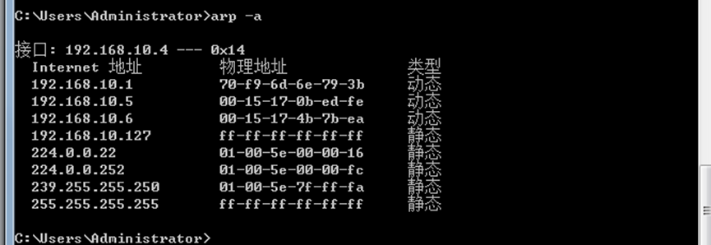

#可以通过设置租用时间来提高ip地址的利用率，及时的收#回客户端已经不使用的ip地址。

[H3C-A]dhcp server ip-pool 101

[H3C-A-dhcp-pool-101]expired day 0 hour 2

#将当前PC分配到的ip地址释放，重新请求

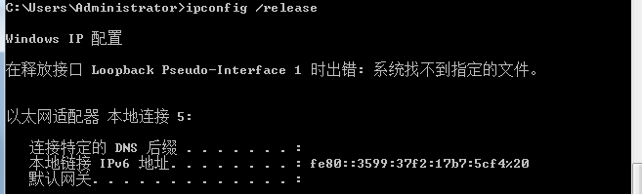

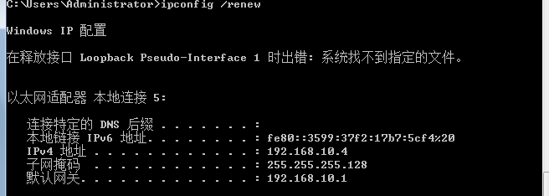

#另外两个PC的命令相同

#ipconfig /release

#ipconfig /renew

#以下是PC与路由器DHCP服务器的数据传输过程，尝试理解其中的意思

[H3C-A-dhcp-pool-101]%May 29 19:59:32:672 2015 H3C-A DHCPS/5/RECLAIM_IP: Server IP = 192.168.10.1, DHCP client IP = 192.168.10.4, DHCP client hardware address = 0015-175d-3a98, DHCP client lease = 86400 seconds.

%May 29 19:59:57:004 2015 H3C-A DHCPS/5/RECLAIM_IP: Server IP = 192.168.10.1, DHCP client IP = 192.168.10.5, DHCP client hardware address = 0015-170b-edfe, DHCP client lease = 86400 seconds.

%May 29 20:00:18:201 2015 H3C-A DHCPS/5/RECLAIM_IP: Server IP = 192.168.10.1, DHCP client IP = 192.168.10.6, DHCP client hardware address = 0015-174b-7bea, DHCP client lease = 86400 seconds.

%May 29 20:00:35:887 2015 H3C-A DHCPS/5/ALLOCATE_IP: Server IP = 192.168.10.1, DHCP client IP = 192.168.10.4, DHCP client hardware address = 0015-175d-3a98, DHCP client lease = 7200 seconds.

%May 29 20:01:10:287 2015 H3C-A DHCPS/5/ALLOCATE_IP: Server IP = 192.168.10.1, DHCP client IP = 192.168.10.5, DHCP client hardware address = 0015-170b-edfe, DHCP client lease = 7200 seconds.

%May 29 20:01:29:387 2015 H3C-A DHCPS/5/ALLOCATE_IP: Server IP = 192.168.10.1, DHCP client IP = 192.168.10.6, DHCP client hardware address = 0015-174b-7bea, DHCP client lease = 7200 seconds.

#重新查看HP-PC1的ip信息，

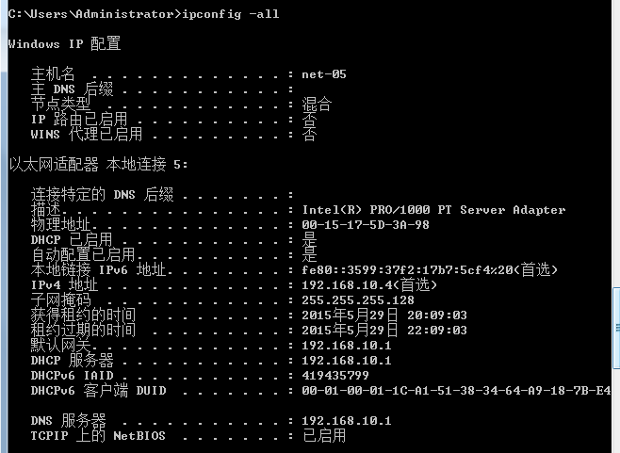

#也可以查看其它PC的ip信息，进行对比验证ip租用时间的变化为两个小时

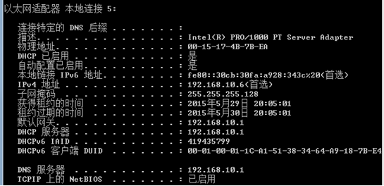

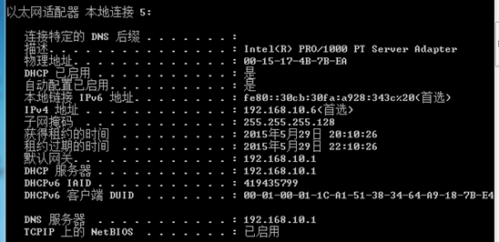

[H3C-A-dhcp-pool-101]quit

[H3C-A]displayarp timer aging

Current ARP aging time is 20 minute(s)(default)

#重新查看学习到的MAC地址，可以发现Aging在不断变化

[H3C-A]displayarp dynamic

Type: S-Static D-Dynamic M-Multiport I-Invalid

IP address MAC address VLAN Interface Aging Type

192.168.10.2 70f9-6d91-03c9 N/A GE0/0 6 D

192.168.10.3 70f9-6d92-942b N/A GE0/0 6 D

192.168.10.4 0015-175d-3a98 N/A GE0/0 20 D

192.168.10.5 0015-170b-edfe N/A GE0/0 20 D

192.168.10.6 0015-174b-7bea N/A GE0/0 20 D

## 任务二：配置H3C-B路由器为DHCP服务器，H3C-A为中继



* Step1：按照任务二网络拓扑结构进行连接
* Step2：配置H3C-B路由器为DHCP服务器

[H3C-B]dhcp enable

[H3C-B]dhcpser

#创建ip地址池 101

[H3C-B]dhcp server ip-pool 101

#设置分配的ip地址网段、子网掩码

[H3C-B-dhcp-pool-101]network192.168.10.0 mask 255.255.255.0

#设置网关和DNS服务器

[H3C-B-dhcp-pool-101]gateway-list 192.168.10.1

[H3C-B-dhcp-pool-101]dns-list 192.168.10.1

[H3C-B-dhcp-pool-101]quit

#创建ip地址池 102

[H3C-B]dhcp server ip-pool 102

#设置分配的ip地址网段、子网掩码

[H3C-B-dhcp-pool-102]network 192.168.30.0 mask 255.255.255.0

#设置网关和DNS服务器

[H3C-B-dhcp-pool-102]gateway-list 192.168.30.1

[H3C-B-dhcp-pool-102]dns-list 192.168.30.1

[H3C-B-dhcp-pool-102]quit

#禁止一些ip地的分配，这里不允许网关地址和DNS地址被分配出去

[H3C-B]dhcp server forbidden-ip 192.168.10.1

[H3C-B]dhcp server forbidden-ip 192.168.30.1

#配置GE0/0，开启、ip地址、接口DHCP工作模式

[H3C-B]interface GigabitEthernet 0/0

[H3C-B-GigabitEthernet0/0]undo shutdown

[H3C-B-GigabitEthernet0/0]ip address 192.168.30.1 24

#设置完成之后，稍等片刻右侧的四个设备均获得了ip地址

[H3C-B-GigabitEthernet0/0]%May 30 11:15:12:568 2015 H3C-B DHCPS/5/ALLOCATE_IP: Server IP = 192.168.30.1, DHCP client IP = 192.168.30.2, DHCP client hardware address = 70f9-6d90-ff91, DHCP client lease = 86400 seconds.

%May 30 11:15:15:674 2015 H3C-B DHCPS/5/ALLOCATE_IP: Server IP = 192.168.30.1, DHCP client IP = 192.168.30.3, DHCP client hardware address = 70f9-6d92-cfcb, DHCP client lease = 86400 seconds.

%May 30 11:17:40:067 2015 H3C-B DHCPS/5/ALLOCATE_IP: Server IP = 192.168.30.1, DHCP client IP = 192.168.30.4, DHCP client hardware address = 0015-170b-edfe, DHCP client lease = 86400 seconds.

%May 30 11:19:55:367 2015 H3C-B DHCPS/5/ALLOCATE_IP: Server IP = 192.168.30.1, DHCP client IP = 192.168.30.5, DHCP client hardware address = 0015-174b-7bea, DHCP client lease = 86400 seconds.

[H3C-B-GigabitEthernet0/0]quit

#进而查看H3C-B路由器学习到的MAC地址

[H3C-B]displayarp all

Type: S-Static D-Dynamic M-Multiport I-Invalid

IP address MAC address VLAN Interface Aging Type

192.168.30.2 70f9-6d90-ff91 N/A GE0/0 15 D

192.168.30.3 70f9-6d92-cfcb N/A GE0/0 15 D

192.168.30.4 0015-170b-edfe N/A GE0/0 20 D

192.168.30.5 0015-174b-7bea N/A GE0/0 20 D

#配置GE0/1，开启、ip地址、接口DHCP工作模式

[H3C-B]interfaceGigabitEthernet 0/1

[H3C-B-GigabitEthernet0/1]undo shutdown

[H3C-B-GigabitEthernet0/1]ip address 192.168.20.2 24

[H3C-B-GigabitEthernet0/1]%May 30 11:22:10:024 2015 H3C-B OSPF/5/OSPF_RTRID_CHG: OSPF 1 New router ID elected, please restart OSPF if you want to make the new Router ID take effect.

#接口工作模式为server（服务器）

[H3C-B-GigabitEthernet0/1]dhcp select server

[H3C-B-GigabitEthernet0/1]quit

#以上均为H3C-B路由器的配置

* Step3：配置H3C-A路由器为DHCP中继

#开启服务

[H3C-A]dhcp enable

#配置GE0/0,开启、ip地址、接口DHCP工作模式、ip地址池dhcp服务器地址

[H3C-A]interfaceGigabitEthernet 0/0

[H3C-A-GigabitEthernet0/0]undo shutdown

[H3C-A-GigabitEthernet0/0]ip address 192.168.10.1 24

#接口工作模式为relay（中继）

[H3C-A-GigabitEthernet0/0]dhcp select relay

#设置ip地址池

[H3C-A-GigabitEthernet0/0]dhcp server apply ip-pool 101

#设置dhcp服务器地址

[H3C-A-GigabitEthernet0/0]dhcp relay server-address 192.168.20.2

[H3C-A-GigabitEthernet0/0]quit

#配置GE0/1,开启、ip地址、

[H3C-A]interfaceGigabitEthernet 0/1

[H3C-A-GigabitEthernet0/1]undo shutdown

[H3C-A-GigabitEthernet0/1]%May 30 11:17:31:216 2015 H3C-A IFNET/3/PHY_UPDOWN: GigabitEthernet0/1 link status is up.

%May 30 11:17:31:217 2015 H3C-A IFNET/5/LINK_UPDOWN: Line protocol on the interface GigabitEthernet0/1 is up.

[H3C-A-GigabitEthernet0/1]ip address 192.168.20.1 24

[H3C-A-GigabitEthernet0/1]%May 30 11:17:44:704 2015 H3C-A OSPF/5/OSPF_RTRID_CHG: OSPF 1 New router ID elected, please restart OSPF if you want to make the new Router ID take effect.

[H3C-A-GigabitEthernet0/1]quit

* Step4：增加静态路由表项

#查看HP-PC1、HP-PC2的ip地址信息ipconfig–all 发现此时无法获得ip地址

尝试分析其中原因：当主机发送DHCP请求报文的时候将数据发送到H3C-A路由器上，H3C-A通过中继向路由器H3C-B单播发送请求。查看路由器H3C-B的路由表发现，H3C-B路由器上没有到网段192.168.10.1/24的网段中的路由。所以数据在H3C-B上不会被发送回来，需要设置到192.168.10.0 的静态路由。

#设置到192.168.10.0 的静态路由**[目的地址子网掩码下一跳]**

**[H3C-B]ip route-static 192.168.10.1 24 192.168.20.1**

#稍等片刻即可看到，192.168.10.0子网中的设备均获得了ip地址

[H3C-B]%May 30 11:28:03:568 2015 H3C-B DHCPS/5/ALLOCATE_IP: Server IP = 192.168.20.2, DHCP client IP = 192.168.10.2, DHCP client hardware address = 70f9-6d91-03c9, DHCP client lease = 86400 seconds.

%May 30 11:28:03:868 2015 H3C-B DHCPS/5/ALLOCATE_IP: Server IP = 192.168.20.2, DHCP client IP = 192.168.10.3, DHCP client hardware address = 0015-175d-3a98, DHCP client lease = 86400 seconds.

%May 30 11:28:07:771 2015 H3C-B DHCPS/5/ALLOCATE_IP: Server IP = 192.168.20.2, DHCP client IP = 192.168.10.4, DHCP client hardware address = 70f9-6d92-942b, DHCP client lease = 86400 seconds.

%May 30 11:28:50:968 2015 H3C-B DHCPS/5/ALLOCATE_IP: Server IP = 192.168.20.2, DHCP client IP = 192.168.10.5, DHCP client hardware address = 0015-17b2-3765, DHCP client lease = 86400 seconds.

#查看H3C-B学习到的MAC地址

[H3C-B]displayarp all

Type: S-Static D-Dynamic M-Multiport I-Invalid

IP address MAC address VLAN Interface Aging Type

192.168.30.2 70f9-6d90-ff91 N/A GE0/0 6 D

192.168.30.3 70f9-6d92-cfcb N/A GE0/0 6 D

192.168.30.4 0015-170b-edfe N/A GE0/0 20 D

192.168.30.5 0015-174b-7bea N/A GE0/0 20 D

192.168.20.1 70f9-6d6e-793c N/A GE0/1 17 D

#查看H3C-B作为服务器所分配出去的ip地址

[H3C-B]displaydhcp server ip-in-use

IP address Client identifier/ Lease expiration Type

Hardware address

192.168.10.2 0170-f96d-9103-c9 May 31 11:28:03 2015 Auto(C)

192.168.10.3 0100-1517-5d3a-98 May 31 11:28:03 2015 Auto(C)

192.168.10.4 0170-f96d-9294-2b May 31 11:28:07 2015 Auto(C)

192.168.10.5 0100-1517-b237-65 May 31 11:28:50 2015 Auto(C)

192.168.30.2 0170-f96d-90ff-91 May 31 11:15:12 2015 Auto(C)

192.168.30.3 0170-f96d-92cf-cb May 31 11:15:15 2015 Auto(C)

192.168.30.4 0100-1517-0bed-fe May 31 11:17:40 2015 Auto(C)

192.168.30.5 0100-1517-4b7b-ea May 31 11:19:55 2015 Auto(C)

* Step5：查看dhcp中继的统计信息

#查看dhcp中继的统计信息，结合DHCP报文格式理解一下统计信息

[H3C-A]displaydhcp relay statistics

DHCP packets dropped: 6

DHCP packets received from clients: 61

DHCPDISCOVER: 53

DHCPREQUEST: 4

DHCPINFORM: 4

DHCPRELEASE: 0

DHCPDECLINE: 0

BOOTPREQUEST: 0

DHCP packets received from servers: 12

DHCPOFFER: 4

DHCPACK: 8

DHCPNAK: 0

BOOTPREPLY: 0

DHCP packets relayed to servers: 47

DHCPDISCOVER: 39

DHCPREQUEST: 4

DHCPINFORM: 4

DHCPRELEASE: 0

DHCPDECLINE: 0

BOOTPREQUEST: 0

DHCP packets relayed to clients: 12

DHCPOFFER: 4

DHCPACK: 8

DHCPNAK: 0

BOOTPREPLY: 0

DHCP packets sent to servers: 0

DHCPDISCOVER: 0

DHCPREQUEST: 0

DHCPINFORM: 0

DHCPRELEASE: 0

DHCPDECLINE: 0

BOOTPREQUEST: 0

DHCP packets sent to clients: 0

DHCPOFFER: 0

DHCPACK: 0

DHCPNAK: 0

BOOTPREPLY: 0

#查看H3C-A路由器学习到的MAC地址

[H3C-A]displayarp all

Type: S-Static D-Dynamic M-Multiport I-Invalid

IP address MAC address VLAN Interface Aging Type

192.168.20.2 70f9-6d70-1f05 N/A GE0/1 4 D

192.168.10.2 70f9-6d91-03c9 N/A GE0/0 6 D

192.168.10.3 0015-175d-3a98 N/A GE0/0 20 D

192.168.10.4 70f9-6d92-942b N/A GE0/0 6 D

192.168.10.5 0015-17b2-3765 N/A GE0/0 20 D

* Step6：测试连通性

#同一子网之间设备自然是联通的，主要是测试左右两个子网设备之间的连通性

#HP-PC1与ip地址为192.168.30.5的设备之间的连通性测试，发现两个子网之间无法通信。查看H3C-A的路由表不难发现，没有到192.168.30.0子网的路由表项。原因与dhcp服务器无法为192.168.10.0子网的设备分配ip地址类似。因此增加路由表项。

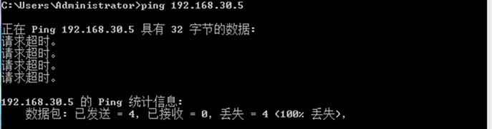

#在中增加到192.168.30.0 子网的路由表项[目的地址子网掩码下一跳]

[H3C-A]ip routing-static 192.168.30.0 24 192.168.20.2

#再次测试HP-PC1与ip地址为192.168.30.5的设备之间的连通性，发现可以通信

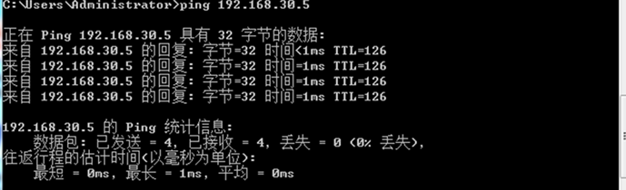

**五、实验结论及思考题**

1. IP地址，网络地址，MAC地址之间的关系与区别？

2. 这个实验使用了NAT机制吗？如果有？哪个设备是NAT设备？哪些IP作为私有IP使用？如果没有，为什么？