Sensor Reference Manual

Author: Simon Hoffmann

Last edited: 11.11.2022

Contents

1. Program Flow-Chart 3

1.1 Program start 3

1.2 Connected with base station 4

1.3 PING 5

1.4 Sensor warning interrupt 6

1.5 Reset button held for 5s 7

1.6 Sensor Specific: Smoke detector – Reset button pressed shortly 8

# Program Flow-Chart

This flowchart is only for a rough overview and does not go into every specific detail.

## 1.1 Program start

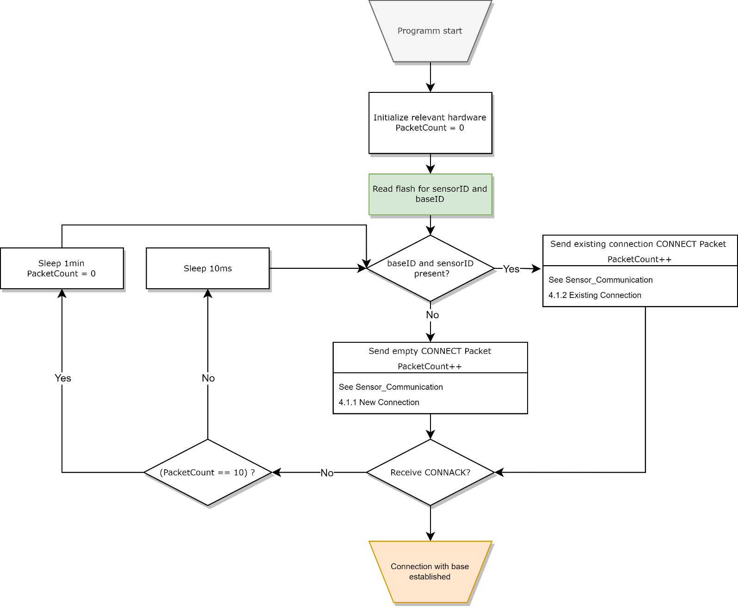The program start initialises all hardware and tries to establish a connection with a base station.

See Connection with base established.

## 1.2 Connected with base station

The Sensor goes into sleep mode to save battery, when awoken it checks if it needs to send data, otherwise it sends a ping to let the base station know it is still active.

This is dependent on the sensor, some send constant information like temperature, others only if an event has occurred.

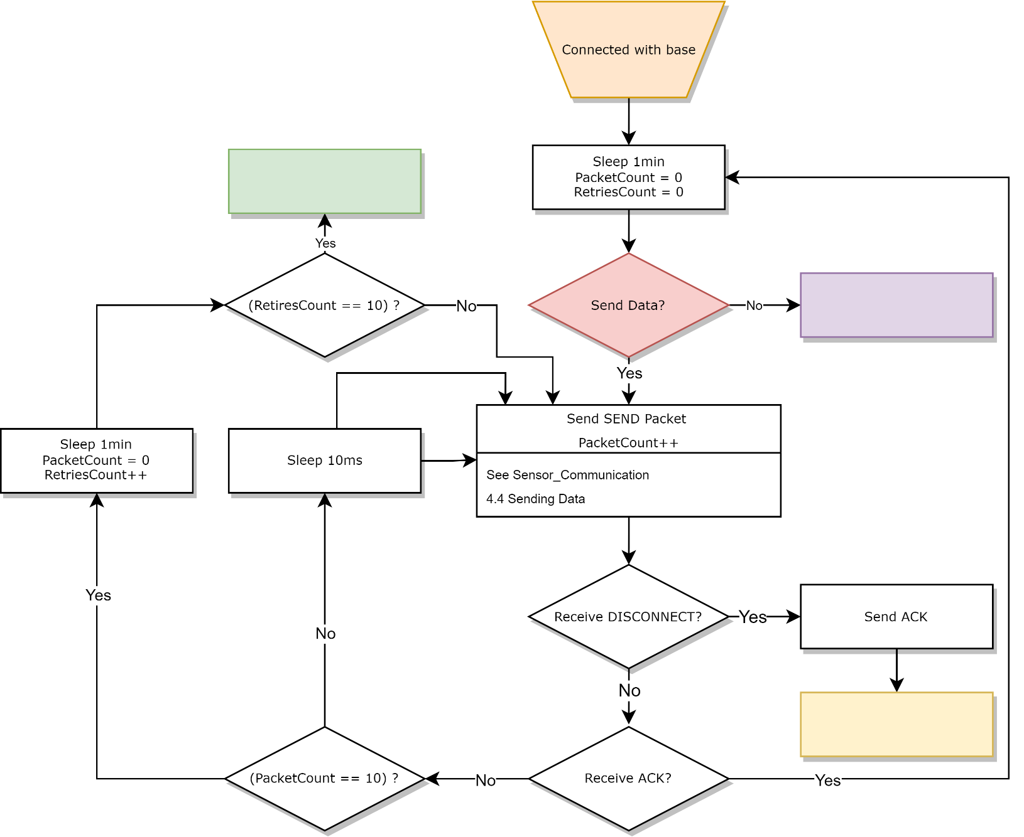If an event has occurred that data precedes any other data trying to be sent.

See (RetriesCount == 10) ,No Data to send.

## 1.3 PING

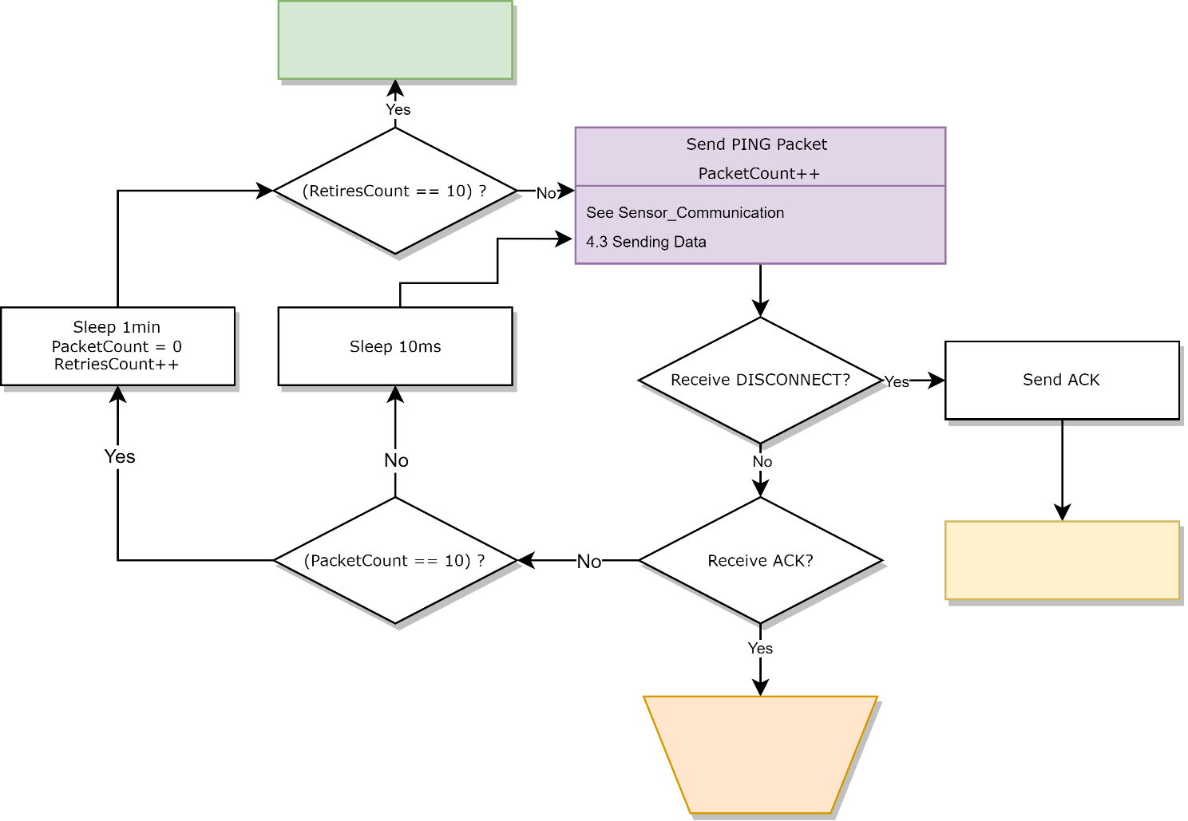

See (RetiresCount == 10), Send ACK, Received ACK.

## 1.4 Sensor warning interrupt

This is executed in an interrupt context, the exact implementation is Sensor dependent.

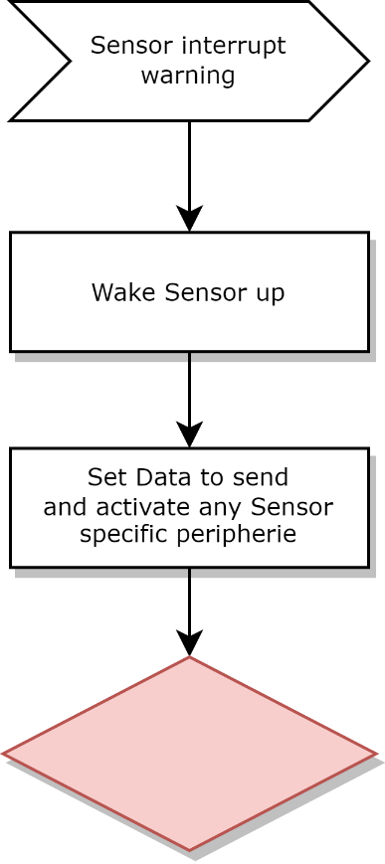

See Send Data.

## 1.5 Reset button held for 5s

This allows a user to manually reset the Sensor to connect it to a different base station.

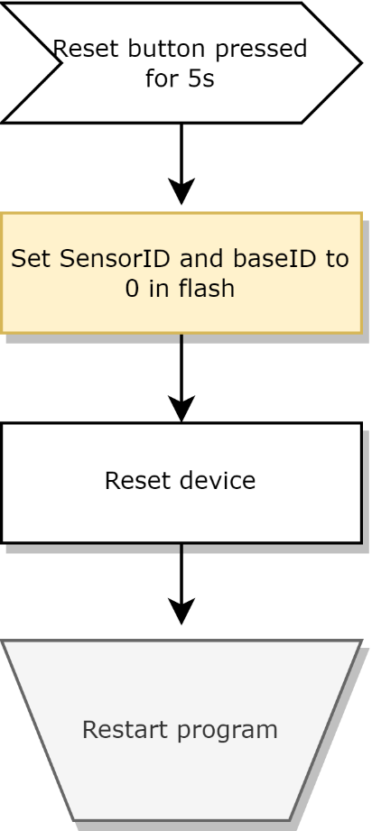

See Start Program.

## 1.6 Sensor Specific: Smoke detector – Reset button pressed shortly

This functionality is only on the Smoke detector sensor

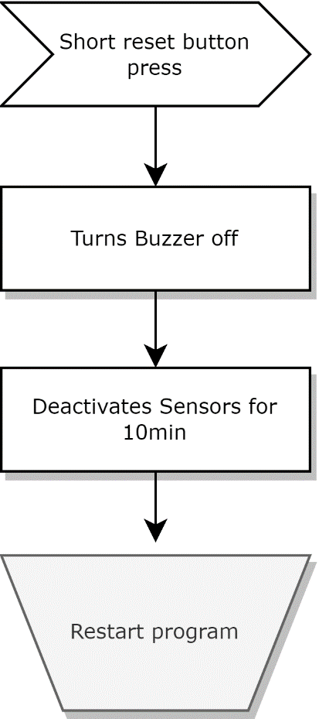

See Program start.