Planning report for thesis at IDA

Author

Ping Liu, pinli313@student.liu.se

Preliminary Title

Performance test and optimize in HTML5-based web game: a case study of Flappy Bird

Problem Description

Nowadays, a lot of Web Games are based on HTML5 canvas, which is the most widely supported standard for 2D immediate mode graphics on the web. However, with the size of application increased, developers inadvertently hit the performance wall.

Actually, there are a lot of articles aim to optimize the performance of Websites, But we find little resource focus on the optimization of web games, especially for HTML5-based web game.

Approach

Basically, I will Chrome as our mainly performance test tools and will focus on the performance test and optimize of Flappy Bird.

I will firstly use some tools test the current implementation of Flappy Bird and then make some optimize by reviewing the principles of writing high quality of HTML5 code.

Literature base

[1] Xu Hui; Wei Lihao; Wang Tian; Luo Xiaoben, Canvas based HTML5 Application Performance Analyzer, Journal of Convergence Information Technology. Dec2012, Vol. 7 Issue 23, p280-289. 10p

[2] <http://flappybird.io/>

[3] <https://developer.chrome.com/devtools/docs/cpu-profiling>

[4] http://www.html5rocks.com/en/tutorials/canvas/performance/

Relevant Courses

TDDB84: Design Patterns

TDDD27: Advanced Web Programming

TDDD97: Web Programming

Time Plan

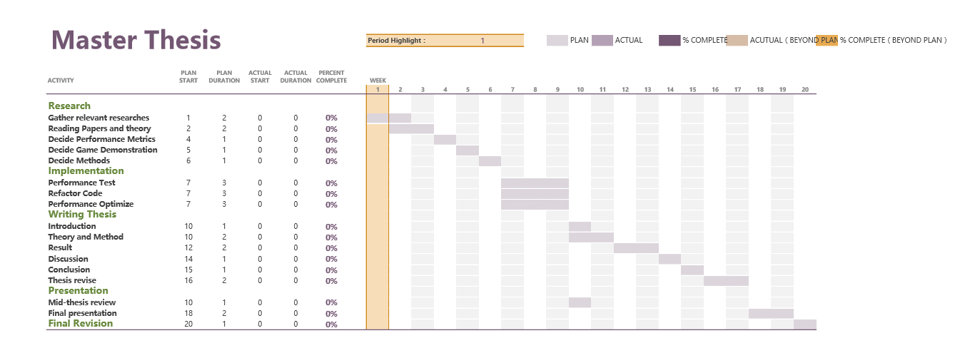

**Description:**

After having some experience and research on the performance Testing and Optimization, now the hardest part of this thesis is to find the correct game as a case study. As mentioned in the Gantt chart, for the research part, 6 weeks will be taken to focus on finding the relevant researches about the theory and methods part about the performance testing and metrics on the website, what’s more, one of the most important target is to find the correct game.

For the implementation part, I think three weeks is enough for performance testing and optimizing since the suitable metrics and games have already been found. Actually for thesis three weeks, every process is mixed, testing, refactoring and optimizing will be performed like a cycle.

Then for the writing part, I think 8 weeks will be appropriate and especially for the theory and methods, it always including some reference. After the first version of this thesis, it will take at least 2 weeks to revise the thesis.

Finally for the presentation, 2 weeks to prepare is enough for me.

Decision Points and risks

For this thesis, there are some decision points and risks need to be identified. Sometimes decision points are also the risks.

**Decision points and risks:**

* Performance metrics take a very important part in this thesis, whether good or bad metrics contribute to the success or fail of this thesis.
* The appropriate game as a case study, the game should be open source and not so complex, what’s more, it should be somehow famous. All of these make it a typical case study.
* Finding some appropriate reference to this thesis, especially some papers.
* The usage of performance testing tools, this part may not be so hard, but try to find some typical testing tools for web performance testing.
* A lot of grammar mistakes, I have already foresee this, and will try my best to solve this.