


Report of Software Architecture
Homework 3: customer information validation system in Adapter Pattern

Basic information
Team name： _______________________________
Class number: ___________________________________________________
Department/school：
Team members with student numbers：

_______________________

Instructor’s comments and score
comments：

score：
signature of the instructor：

Year month date

作业要求：(注意：本作业要用到Java API中的String类的功能，例如charAt(int m)和Character类中的功能，例如Character.isLetter(char c)等)

- Run the AdapterTestGUI class in the the following design in class adapter pattern.
+isValidName( ): boolean
+isValidAddress(): boolean
+isValidZipCode(): boolean +isValidCellPhoneNum(): boolean
+isValidSSNNum(): boolean
<<interface>>
CusInfoValidator
+isValidSSNNum(): boolean
InformationAdapter
Inherits
implements
AdapterTestGUI
InfoValidation
+isValidName( ): boolean
+isValidAddress(): boolean
+isValidZipCode(): boolean +isValidCellPhoneNum(): boolean
You will see a graphical user interface as below.
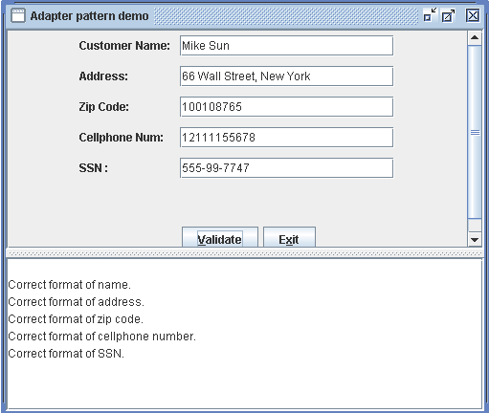
- In the interface CusInfoValidator, add a method “isValidEmailAddr”
- In class InformationAdapter, add and implement the isValidEmailAddr method according to the following requirement:
  - The email address should be formed by English characters from the 26 English alphabets mixed with digits from 0, 1, 2, 3, 4, 5, 6, 7, 8, 9, exactly one “@”, and at least one period mark “.”
  - The leading character should be one of the 26 English letters
  - The length of the whole email address should be at least 5

- Modify user interface AdapterTestGUI to add a row for users to input email address

Report part
- Describe your finished homework, including
    - What method has been added to what class?
    - In order to implement all the methods in the interface CusInfoValidator, why we only need to claim and implement the methods isValidSSNNum() and isValidEmailAddr in class InformationAdapter?
    - You must have noticed that this program is designed and implemented by using class adapter pattern. If the design is changed so that the object adapter pattern is used, then in class InformationAdapter, do we need to claim all the methods that are inside the interface CusInfoValidator and then implement all of them?

- Draw your modified class diagram here

- Summarize the similarity and difference of the Class Adapter Design Pattern and the Object Adapter Design Pattern.

- (Program Testing) List your typical input and output from running your program in validating an email address.

