


Report of Software Architecture
Homework 4: Façade Pattern-user information validation

Basic information
Team name： _______________________________
Class number: ___________________________________________________
Department/school：
Team members with student numbers：

_______________________

Instructor’s comments and score
Comments：

Score：
Signature of the Instructor：

Year Month Date
作业：See the following class diagram, which uses façade pattern to realize an account validation program. Read the source code to understand this design.
Account
+isValid():boolean
+save():boolean
+getFirstName():String
+getLastName():String
-firstName:String
-lastName:String
Address
+isValid(): boolean
+save(): boolean
+getAddress(): String
+getState(): String
-address: String
-city: String
-state: String
CustomerFacade
+setAddress:void
…
+saveCustomerData:boolean
-address:String
-city:String
-state:String
-cardType:String
-cardNumber:String
-cardExpDateString
-fname:String
-lname:String
CreditCard
+isValid():String
+save():String
+getCardType():String
+getCardNumber():String
+getCardExpDate():String
-cardType:String
-cardNumber:String
-cardExpDate:String
UserGUI
main:void

Fig 1. Design of the user information validation system in façade pattern

There are three classes — Account, Address and CreditCard available in the system, each with its own methods for validating and saving the respective user input data to text files. Façade class CustomerFacade is designed to offer a higher level, simplified interface to the subsystem consisting of customer data processing classes (Address, Account and CreditCard).

The CustomerFacade class mainly offers a higher level business service in the
form of the saveCustomerData method. Instead of interacting with each of the subsystem components directly, the client class UserGUI make use of the higher level, more simplified interface offered by the CustomerFacade class to validate and save the input customer data.

The client UserGUI displays the user interface to a user to input the customer data. When the client UserGUI is run, it displays the user interface shown below.

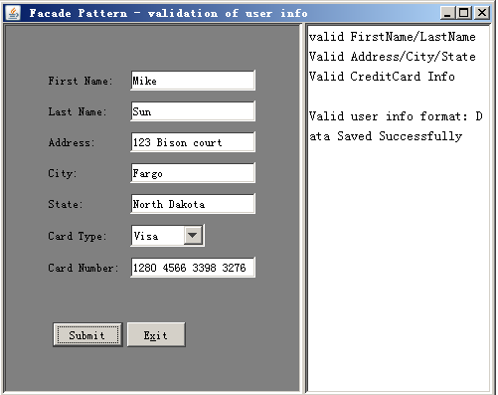

Home work description and requirement: this homework is about adding the zip code validating functionality to the above user information validation system. To accomplish this, you need to do the following.
- Add a new parameter to the constructor of class Address to allow zip code to be input from the user. Pay attention that the method isValidUSZipCode() has been written in the class Address for you to call. Inside the method isValid() in class Address, you need to call the method isValidUSZipCode();
- In the class CustomerFacade, you need to add the zip code validation in the method isValidateUsrInfo();
- Run of UserGUI produces a GUI. In the interface, below the state entry, add another entry called “Zip code”. The Zip code is a 9-digit number like 581025658. No English character is allowed;
- Finally, modify the saveCustomerData() method in class CustomerFacade to save all the valid user information to a single text file named custInfo.txt instead of saving them into 3 files.

Report part
- Describe your finished homework, including
  - In order to add the zip code validating functionality to the above user information validation system, what methods in what classes have you modified in the class hierarchy?

  - What functionalities have you add to the system?

  - What is the advantage of save all the user information to a single file instead of saving them into 3 different files

- Draw your new accurate class diagram here

- What is the advantage of the façade pattern?

- Test the system. List typical input and output from running your finished program.

