ITER Vacuum Vessel — Lateral Rattle Analysis
Revised 2026-05-27 · 5,000-sample Monte Carlo · scipy HiGHS LP · 3-DOF rigid-body model · metric: peak-to-peak range (n=1 wall displacement)
Key result: The vacuum vessel can rattle laterally over a peak-to-peak range of 3.09 mm at the worst (nominal, fully-centred) assembly — a hard theoretical ceiling. This lateral motion is an n=1 rigid displacement of the first wall: during limited start-up on the inner wall it localises the heat load. Monte Carlo over random assemblies: P95 = 3.01 mm, median = 2.24 mm, mode ≈ 2.49 mm. A separate ±187.5 µrad rotation mode is n=0 (it does not perturb the plasma–wall gap).

Assumption (×2 sensitivity): the toroidal slot allowance is taken as ±1.5 mm (3 mm total travel). If it is actually ±3 mm, every number below doubles. Confirm against the as-built gravity-support specification.

1 — Physical mechanism
The VV rests on 9 gravity supports equally spaced toroidally on a ring of radius R ≈ 8 m. Each is a four-bar linkage with free radial motion and a toroidal pin limited to ±1.5 mm. Radial motion is free; toroidal motion is the constrained rattle. The 9×3 constraint matrix has AᵀA = diag(4.5, 4.5, 576) — exactly diagonal, so the three rigid-body DOFs are uncorrelated.
2 — Why it matters: an n=1 first-wall displacement
A rigid horizontal shift of the vessel moves the first wall sideways relative to the plasma axis, so the plasma–wall gap varies as cos(toroidal angle) — a textbook n=1 perturbation. The vessel lands, then moves between shots under thermal and EM loads.
Consequence: When the plasma is limited on the inner wall during start-up, the n=1 gap asymmetry localises the heat load toroidally

Rotation about the vertical axis is n=0 — it leaves the plasma–wall gap unchanged and is treated as a separate local-alignment mode, not part of the n=1 budget.
3 — The number: peak-to-peak rattle range
Each support travels ±1.5 mm, yet the nominal range is 3.093 mm — slightly over the 3 mm slot because the rotation DOF lets the centre exploit the angled supports' slack (a 3-support binding vertex). 5,000-sample Monte Carlo over random assemblies:
Statistic | Range (mm) | Notes
LP ceiling (nominal u=0) | 3.093 | Hard maximum; centred assembly = worst = team's target
P95 | 3.01 | 95th percentile of random assemblies
Mode | 2.49 | Most probable as-built value
Median | 2.24 | Typical random assembly

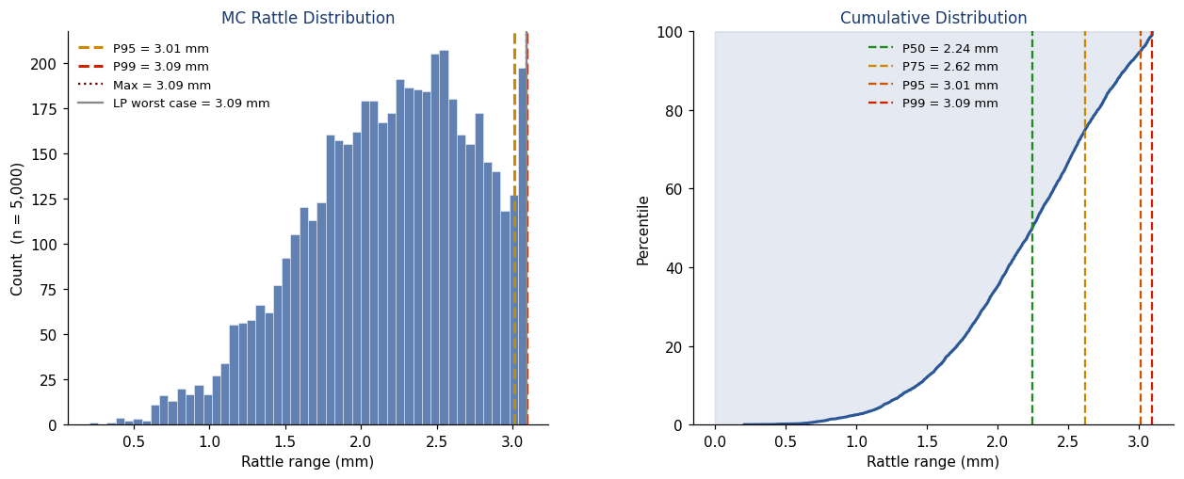
Peak-to-peak range distribution and CDF; nominal ceiling and percentiles marked.
Caution: The range is robust to assembly scatter (P95 = 3.01 mm is barely below the ceiling), and the team aims to centre the brackets — which is the worst case. Use 3.09 mm. The MC P95 is not a relaxation of the design case.

4 — Worst case and typical assembly
The VV rocks along its principal rattle axis. Animations play in the served HTML report; below, each GIF (first frame) is followed by a key-frame strip showing the motion.

Worst case — peak-to-peak range 3.09 mm (the design bound). [animated GIF]
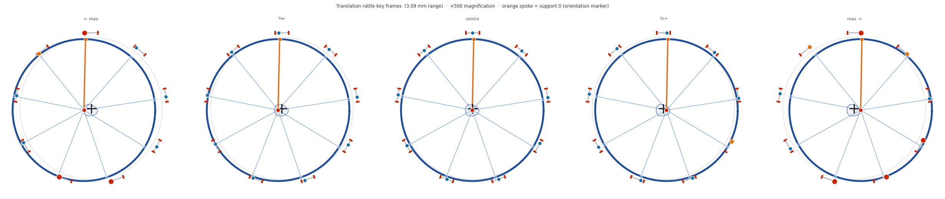
Worst-case key frames (×500 magnification).

Typical as-built assembly, near the distribution mode — range ≈ 2.49 mm (the most likely value). [animated GIF]
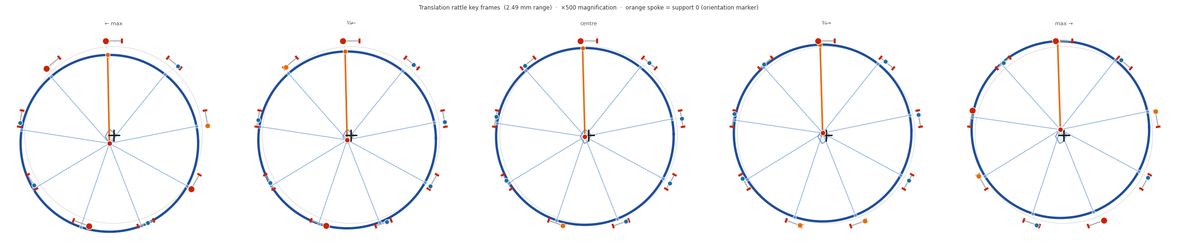
Near-mode (typical assembly) key frames (×500 magnification).
5 — Effect of gap measurements (one sector landed)
Measuring a bracket gap fixes where its 3 mm constraint band sits, not its width — so the bound tightens only when a measured offset happens to be a binding constraint. Because AᵀA is diagonal, adjacent vs spread-out supports are statistically identical (no 'coupled cluster' to target).
Supports measured (k of 9) | Conditional P95 (mm) | Effect
0 (none — today's design state) | 3.01 | baseline
1 (one sector landed) | ≈ 3.0 | no meaningful change
4 | ≈ 2.9 | marginal
6 | ≈ 2.6 | tightening begins
9 (all) | deterministic ≈ 2.5 | one value; 0.2–3.09; never 0

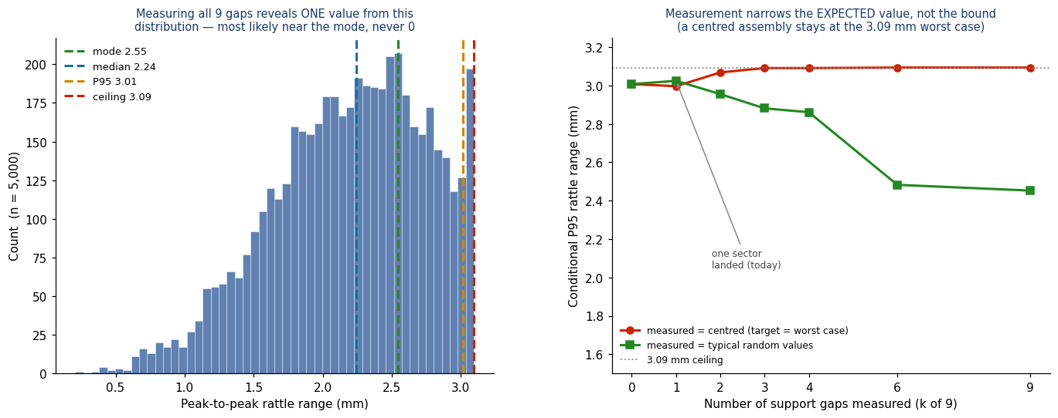
Left: what measuring all gaps reveals (a value from the distribution, never 0). Right: conditional P95 vs gaps measured.
Current state: With one VV sector landed (k=1), the q95 bound is statistically unchanged from the all-unknown baseline. The bound to use today remains 3.09 mm. Measurement reveals the rattle, it does not relieve it; a material reduction needs roughly five or more sectors measured.

6 — Recommendations
# | Recommendation
1 | Use 3.09 mm peak-to-peak as the bounding n=1 lateral wall displacement (nominal/centred = worst case = ceiling).
2 | Do not rely on the MC P95 (3.01 mm) as a relaxation — it is ~3% below the ceiling and the realistic assembly is centred.
3 | Assess start-up heat-load localisation on the inner-wall limiter for an n=1 offset up to ≈ 2.9 mm single-sided, 3.09 mm shot-to-shot.
4 | The bound is set by the 3 mm toroidal slot and is largely irreducible by assembly control — the lever is the tolerance or added toroidal restraint.
5 | Gap metrology gives little benefit until ≥ 5 sectors are measured; confirm whether 'landed' implies a measured gap.
6 | Confirm the ±1.5 mm vs ±3 mm slot interpretation against the as-built GS spec (scales every number ×2).
7 | Treat the ±187.5 µrad rotation (n=0) as a separate local-alignment case for ports/penetrations.

Monte Carlo generated reproducibly by vv_mc_generator.py (scipy HiGHS LP, peak-to-peak range metric, N=5000, fixed seed 20260527 → committed data in data/). Figures and animations by vv_viz.py. Every number regenerates from the repository. Source: Simon-McIntosh/vv.

