ITER Vacuum Vessel — Lateral Displacement Analysis
Simon McIntosh · 2026-05-28
5,000-sample Monte Carlo · scipy HiGHS LP · 3-DOF rigid-body model · metric: max lateral displacement of the VV centre from the gravitational centre (n = 1 first-wall shift)
Summary of findings: The VV rests on 9 inward-inclined gravity supports whose 15° tilt provides a gravitational centring force: the vessel self-centres at rest and departs from the machine axis only under an applied lateral force; pendulum period ≈ 10 s. The n = 1 first-wall metric is the max lateral displacement of the VV centre from the machine axis. Nominal envelope 1.55 mm; across the assembly population P95 = 2.27 mm, max = 2.98 mm; at-rest contribution = 0. Start-up (0→3 MA / 10 s) is favourable: passive vessel currents pull the wall toward the offset toroidal-field magnetic centre and reduce the n ≤ 4 misalignment. Disruption is the bounding VVGS lateral load case (~12 mm/s impact, ~1 MN peak). Gap measurements tighten the bound — each measured sector pulls the polytope toward the centre.

1 — Problem & assumptions
9 VVGS, equally spaced toroidally on a ring R_s ≈ 8 m. Each is a dual-hinge mechanism inclined 15° from vertical (leaning inward). Radial motion is permitted by dowel rotation (thermal expansion); toroidal motion is restrained to a ±1.5 mm slot. The supported mass is M ≈ 8000 t (VV + in-vessel components). The slot allowance ±1.5 mm (3 mm total) is confirmed against the GS design.
Assembly assumption — the source of mobility: The ±1.5 mm slot is an assembly tolerance: the as-built precision with which each VVGS pin lands in its dowel. If the gaps are left unshimmed (the case treated here), it is this tolerance that permits the vessel to be laterally mobile and is what drives this analysis. We model the as-built state by the conservative prior that each u_i is independent and uniformly distributed on [−1.5, +1.5] mm. Shimming a support pins its u_i to a measured value and removes that support's contribution to the mobility (see §6).

The inward 15° inclination puts the support axes' convergence point above the vessel CoG; for the lateral mode the vessel behaves as an inclined-hinge gravitational pendulum — the lateral plane has a parabolic potential well centred on the nominal position.
Quantity | Value
Effective pendulum length L_eff | ≈ 26 m (sensitive to angle; ~2 m / °)
Lateral centring stiffness K = W / L_eff | ≈ 3.0 kN / mm
Natural period T_n | ≈ 10 s (f ≈ 0.1 Hz)
Force to reach a ±1.5 mm stop | ≈ 4.5 kN
Rest position (no lateral force) | q* = 0 (gravitational PE minimum)

2 — Constraint model
Toroidal slide at support i: δ_i = −sin(φ_i)·Δx + cos(φ_i)·Δy + R·Δθ, with |u_i + δ_i| ≤ 1.5 mm. The 9×3 constraint matrix has AᵀA = diag(4.5, 4.5, 576): the three rigid-body DOFs are mutually uncorrelated. The reachable (Δx, Δy) set is the displacement polytope; the metric is the maximum lateral displacement of the VV centre from the gravitational centre.
3 — State diagrams
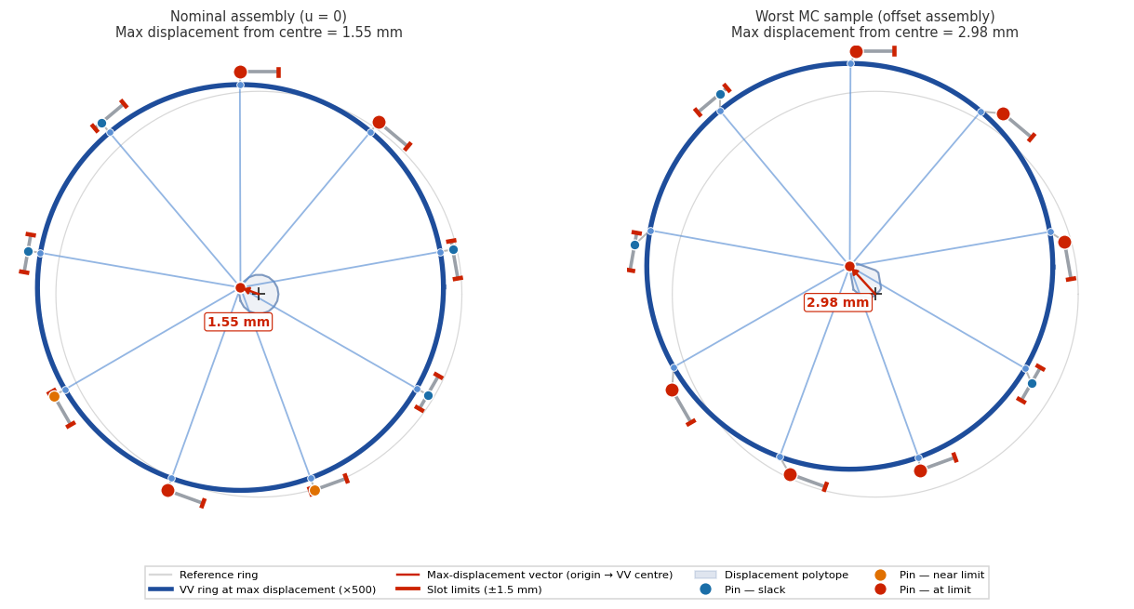
The VV sits at the gravitational centre in both panels (rest position). The shaded polygon around the centre is the displacement polytope — the kinematic envelope of possible lateral displacements under applied force. Left: nominal assembly (envelope half-width 1.55 mm). Right: worst observed MC sample — the offsets shift the polytope so the far corner lies up to 2.98 mm from the centre. ×500 magnification.
4 — Forced-excursion envelope
The animations sweep the VV centre through the polytope along its principal axis — the kinematic envelope of lateral motion about the centred rest position. With no applied force the vessel sits at the centre; sufficient applied force drives it through the envelope. ×500 magnification.

Worst observed MC sample — max forced departure ≈ 2.98 mm. [GIF first frame]
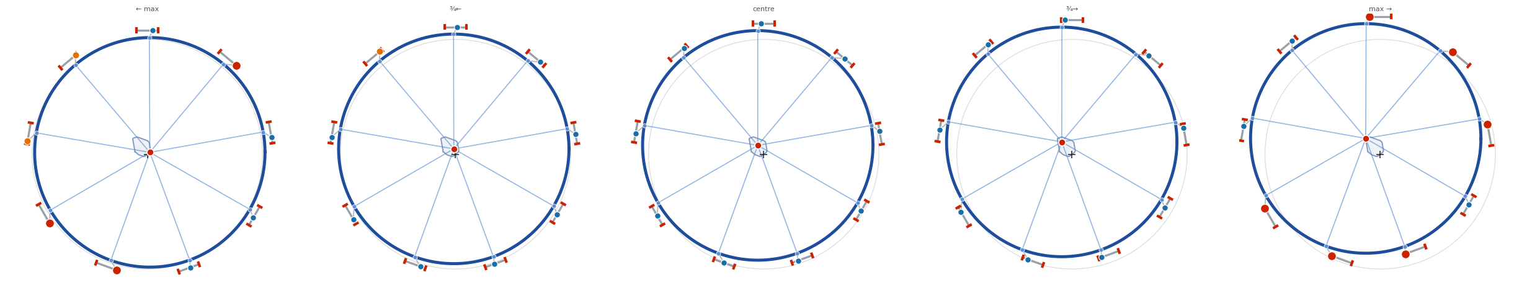
Worst-case key frames.

Typical as-built assembly (near the distribution mode) — max forced departure ≈ 1.49 mm. [GIF first frame]
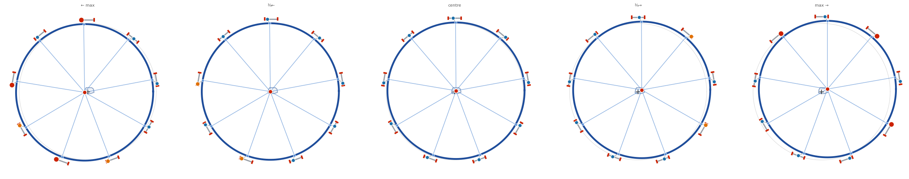
Near-mode (typical) key frames.
5 — Monte Carlo distribution
Statistic | Max lateral displacement (mm)
Nominal (u = 0) — symmetric envelope half-width | 1.55
Mode | 1.49
Median (P50) | 1.53
P95 | 2.27
P99 | 2.53
Max observed (n = 5000) | 2.98

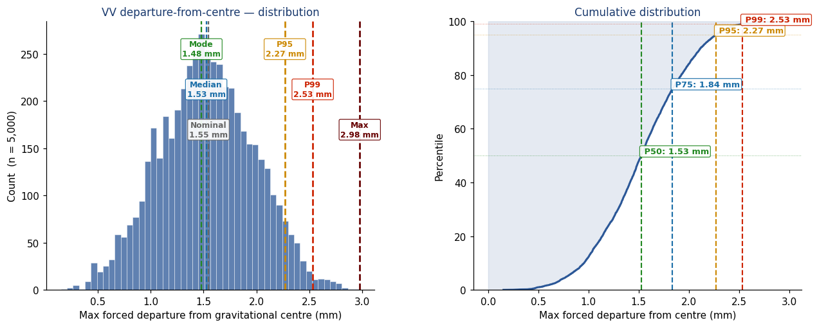
Distribution (left) and CDF (right) of the maximum lateral displacement of the VV centre from the gravitational centre, over 5000 independent Uniform(±1.5 mm) assemblies. Nominal (centred-assembly) gives the symmetric envelope; offset assemblies reach further from the centre.
6 — Effect of gap measurements
Each measured gap fixes one u_i and pulls the polytope toward the gravitational centre: under this metric measurement directly tightens the conditional displacement bound. AᵀA is exactly diagonal so adjacency is irrelevant; only the number of measured sectors matters. With all 9 measured and found near-centred, the conditional bound collapses to the 1.55 mm nominal envelope.
Measured sectors (k of 9) | P95 — centred (mm) | P95 — typical (mm)
0 (baseline) | 2.27 | 2.27
1 | ≈ 2.26 | ≈ 2.26
3 | ≈ 2.19 | ≈ 2.22
5 | ≈ 2.05 | ≈ 2.00
9 (all) | → 1.55 (nominal env.) | deterministic

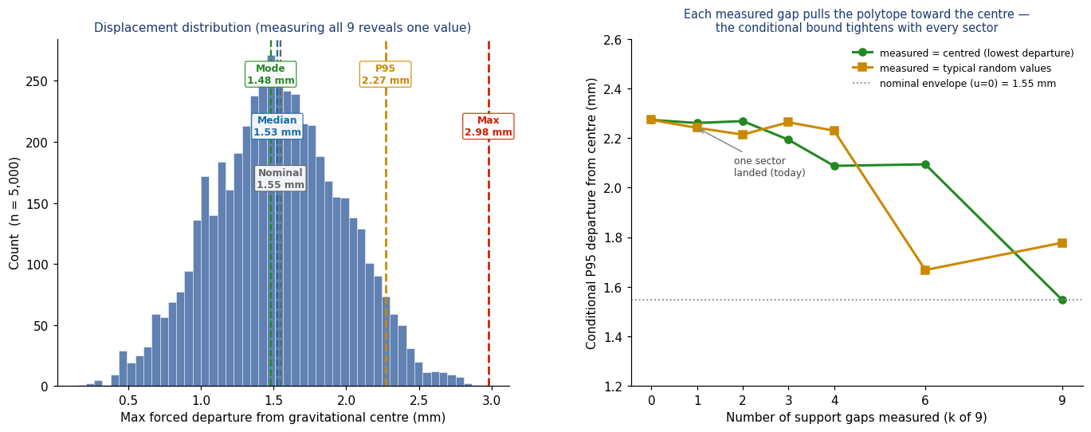
Left: the displacement distribution. Right: conditional P95 vs number of sectors measured, for two scenarios of the measured values (centred / typical random).
7 — Start-up lateral loads: passive self-alignment
During the 0 → ~3 MA, ~10 s plasma current ramp, the dI_p/dt induces image currents in the vessel. These currents interact with the n ≤ 4 toroidal-field asymmetry produced by TF vault closure tolerances to produce a lateral n = 1 force on the vessel.
Start-up displacement direction: The direction is favourable: the lateral force on the induced vessel current pulls the vessel TOWARD the n = 1 magnetic axis of the (offset) toroidal field — passive vessel currents act to self-align the wall with the field. Any vessel motion during the ramp therefore CLOSES the peak-to-peak misalignment between the n ≤ 4 filtered first-wall and toroidal-field profiles, rather than opening it. The start-up ramp is not a budget-eroding event — it is the opposite.

Order-of-magnitude force: with vessel image current of O(10⁵ A) during the ramp, B_T ≈ 5 T, fractional n = 1 field error ε ~ 10⁻⁴–10⁻³, and a toroidal length scale ~ 2πR, the lateral force F_ramp ~ ε · I_vv · B_T · L is of order 1–10 kN — comparable to the F_stop ≈ 4.5 kN centring threshold. The ramp duration (10 s) is comparable to T_n (~10 s), so the single-ramp dynamic response factor is ~1.3–1.5; F/K = 0.3–3 mm quasi-static becomes a peak excursion of order 1–4 mm — below the 1.5 mm gap when combined with the favourable direction. A defensible value needs the EM transient.
8 — Disruption loads &amp; VVGS impact case
A current quench delivers an MN-scale lateral impulse over ~10 ms — far faster than T_n ≈ 10 s and far larger than the kN-scale centring. On this timescale the vessel responds as a free mass:
Quantity | Estimate
Impulse J = ∫F dt | (10 MN)·(10 ms) ≈ 10⁵ N·s
Velocity v = J / M | 10⁵ / 8×10⁶ kg ≈ 12 mm/s
Free-pendulum amplitude v·T_n / 2π | ≈ 20 mm (≫ 1.5 mm gap)

VVGS impulsive lateral load: The vessel impacts the dowel stops at ~12 mm/s with ~0.5 kJ of kinetic energy. For a rigid stop, peak lateral force on the VVGS is of order ~1 MN — much larger than the steady gravity-related lateral demand. This is an impulsive lateral load case for VVGS design, distinct from steady operation, and is potentially the bounding load case for VVGS lateral capacity. The soft kN-scale centring provides essentially no deceleration before impact.

9 — The 6 mm n ≤ 4 first-wall budget
The start-up heat-load criterion limits the peak-to-peak difference between the n ≤ 4 filtered first-wall and toroidal-field profiles to ≤ 6 mm. The VV n = 1 contribution to the first-wall side is the lateral displacement quantified above.
Operating condition | VV n = 1 contribution
Quiescent / between shots (no lateral load) | ≈ 0 mm (self-centred)
Start-up ramp (passive currents → wall follows TF) | net REDUCES mismatch
Steady asymmetric thermal/EM loads | F/K — sub-mm
Disruption transient (forced) | up to gap (1.5 mm) + overshoot
Kinematic ceiling (worst random assembly) | ≈ 2.98 mm

Budget allocation: Under nominal start-up conditions the VV n = 1 contribution is small AND favourable (it closes the misalignment). The remaining 3–6 mm of the budget is available for the toroidal-field side (mainly TF vault closure n ≤ 4) and any other first-wall n ≤ 4 contributors.

Author: Simon McIntosh. Monte Carlo data generated reproducibly by vv_mc_generator.py (scipy HiGHS LP, max-lateral-displacement-from-centre metric, N = 5000, fixed seed 20260527 → committed data/). Figures and animations by vv_viz.py; displacements magnified ×500. Centring parameters M ≈ 8000 t, 15° inclined dual hinge → L_eff ≈ 26 m → K ≈ 3 kN/mm, T_n ≈ 10 s, F_stop ≈ 4.5 kN. Every number regenerates from the repository. Source: Simon-McIntosh/vv.

