|  |  |  |
| --- | --- | --- |
| **Problem Chosen** B | **2020 MCM/ICM Summary Sheet** | **Team Control Number** 2015730 |

**The Longest Lasting Sandcastle Foundation**

**Summary**

Building sand castles by the sea is a very interesting activity. Many people want their sandcastle to be able to resist the impact of the waves. Here we will analyze the structure of sandcastle foundation which can withstand the waves the most and determine the best sand-to-water mixture proportion. Besides it will also stand longer on rainy days.

For the first problem, we analogized the surface of the sandcastle foundation to a slope, and analyze the force on the sand grains with the starting conditions of wet sand. Therefore, we mainly consider the force distribution and current velocity. We think that the more homogeneous and dispersed the force distribution is, the more the sandcastle foundation can withstand the impact of waves, and the longer it can last. And the more homogeneous and slower the current velocity around the sandcastle foundation, the sand can stay close to the sandcastle foundation for longer and support the sandcastle foundation for longer.

In order to analyze these two factors, we consider this problem as a fluid-structure coupling problem, so we first establish the finite element equation of the coupling system, then the ANSYS FLUENT is used to simulate and analyze several basic shapes and some common sand castle shapes. In this way, we get the force distribution of each shape and the flow velocity distribution around them. By comparing the force distribution and the velocity distribution of those shapes to each other, the advantages and disadvantages of each shape are found. Based on these advantages and disadvantages, we can get the shape of sandcastle foundation.

For the second question, we think that water has both lubrication and adhesion to sand, and the change of water content will change the size of the angle of repose. According to the function of the repose angle varying with the sand-to-water mixture proportion, the sand-to-water mixture proportion of the sand corresponding to the maximum repose angle is found. And the optimal sand-to-water mixture proportion is obtained by data visualization.

For the third problem, we synthetically consider the influence of the wave from the same horizontal direction and the influence of the rain in the vertical direction, using ANSYS FLUENT to simplify the wave and the rain reasonably. we analogized them to the flow with different velocity in different direction. Then we simulated the model from the first problem. After that we considered that the influence of the precipitation deposition on the sandcastle foundation.

After giving the final model, we carried on the simulation verification to the model. The final result indicated its rationality, finally, we analyzed the merit and shortcoming of the model and obtained the conclusion.

**Keywords**: Fluid–structure interaction, CFD，ANSYS FLUENT, Finite element equation, Wet sand starting condition

**Contents**

**1. Introduction**....................................................................................................................................................3

1.1Backwound………………………………………….………………………………………………………3

1.2Problem of restatement and analysis……………………………………………………………….3

**2. Assumptions and Justifications**  .........................................................................................................3

**3.Notations**…………….........................................................................................................................................4

**4.Models…………**............................................................................................................................................4

4.1Structure model…………………………………...………………..………………4

4.1.1Wave shot stage…………………………………...……………………..………………….……4

4.1.2Water flow climbing stage…………………………………………………..……………….5

4.1.3Wave falling stage…………………………………………………………..5

4.1.4 the Foundation of Model……………………………………………………7

4.1.5 Solution and Result………………………………………………………….10

4.1.6 Analysis of the result………………………………………………………..11

4.2 Water-To-Sand Mixture Proportion Model…………………………………………..12

4.2.1 the Foundation of model…………………………………………………….12

4.2.2 Solution and Result…………………………………………………………..12

4.3 Rainproof model…………………………………………………………………….14

4.3.1 Analysis of the problem………………………………………………………14

4.3.2 Solution and Analysis…………………………………………………………15

**5.Better strategy**............................................................................................................................................17

**6. Advantages and disadvandages**......................................................................................................17

6.1Advantages……………………………………………………………………….17

6.2Disadcantages…………………………………………………………………….17

**7. Conclusion**......................................................................................................................................................18

**8.Article**………………………………………………………………………………..18

**9.References**…………………………………………………………………………….21

**1.Introduction：**

**1.1 Background**

Making sandcastles is almost an entertainment activity which people, both adults and children, have to do on the beach. People will pile up various shapes and add a beautiful scenery to the beach. However, these beautiful shapes are not necessarily resistant to the erosion of the waves, so we hope to obtain an optimal 3-dimensional geometric shape of the sandcastle foundation to make it last on the beach for the longest period of time.

**1.2 Problem Restatement and Analysis**

In order to make the sandcastle foundation last on the beach for the longest time, we need to comprehensively consider various factors to build a three-dimensional geometric shape of the sandcastle foundation, and integrate other factors for optimization.

Then what do we use to measure the age of a sandcastle? To answer this question, we define the following models:

* The less sand taken away by each wave shock, the better it will be
* The more the surface forces are dispersed for the waves shock, the better it will be
* The slower the velocity of the water flow formed around the structure, the better it will be

**2.Assumptions and Justifications**

* **The slope of the beach is small, and the impact to the sandcastle foundation is negligible**

*Because we mainly consider the sandcastle structure model, the small slope of the beach will not have a large impact on its structure and location*

* **Tides and waves have the same effects on sandcastle foundation**

*Considering that the mechanical characteristics of waves and tides have been very similar after they reached the beach, we assume that waves and tides have the same effect on sandcastles*

* **Ignore the speed loss of the waves on the beach, and the flow velocity is constant**
* **The height of the waves does not change, and the direction of its shock is parallel to the beach and directly opposite the sand castle**

*Since the sandcastle foundation is at roughly the same distance from the water, and generally as far away from the sea as possible, so we assume that when the waves reach the sandcastle foundation, the direction is horizontal and the height is constant*

* **The sand loss rate is positively related to water flow velocity**
* **The diameter of the sand used in the sandcastle foundation is same, and are all 0.25mm**

**3.Notations**

 the diameter of sand granules

 the gravity of sand granule

 the density of water

 the wave height

 the velocity of water flow

 the inclination of the bevel

 the drag force produced by the water flow

 the pressure of water on the foundation

 the solution vectors defined at the fluid

 the solution vectors defined at the structure nodes

 the finite element equations in fluid-structure interaction systems

 the interaction fluid equation

 the interaction structural equation

 the repose angle of sand granules

 the moisture content of sandcastle foundation

**4 Models**

**4.1 Structure model**

For the basic structure of the sandcastle foundation, as its durability is considered firstly, in order to simplify the model and combine the knowledge of structural mechanics, we can compare it with the dam, that is, approximating the force of the granules on the bevel (although the final result may not be a regular bevel but can still be equivalent to many section with different tilt angles) and then analyze its force characteristics to obtain the following processes:

**4.1.1 Wave shot stage**

Firstly, the front of the sandcastle foundation is hit by waves. At the wavelet, the granules are under horizontal impact pressure and forces  and parallel to the beach. The buoyancy of the sand, and the gravity of the sand are also considered. Since the effects of, on the particles in the shoreline direction cancel each other out, ,can be ignored, and the forces in the direction of the slope are mainly considered to obtain the jet action force diagram

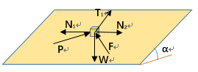 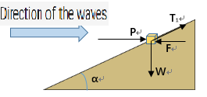  
  (1)

Figure1 wave shot stage force diagram

**4.1.2 Water flow climbing stage**

After the wave hits the sandcastle foundation, it breaks up and forms a climbing water on the surface of the sandcastle. At this time, the granules are mainly subjected to the drag force  and the lifting force  generated by the climbing water, and the granules' self-gravity and the their interaction force , The climbing water flows upward along the bevel, and the drag force  is the same as the direction of the water flow. Due to the relatively small velocity of the climbing water flow, the interaction force  between the granules and its own gravity  have a hindrance effect, and the climbing water lasts a short time, so the climbing water generally does not cause sand granules a greater movement.

**4.1.3 Wave falling stage**

When the waves fall, the sand granules are mainly affected by the drag forceparallel to the bevel generated by slope flow , the upward force  perpendicular to the bevel, and the head pressure caused by the water head difference of the drop in the water level on the bevel surface.as shown:

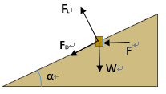

Figure2 wave falling stage force diagram

(2)

Where 、­—resistance coefficient、upward force coefficient are all functions of the Reynolds number（）of sand granules，—the density of water；—the diameter of sand granules； —Velocity of water flow acting on granules on the bevel **[1]**

For the dynamic water pressure , can be calculated as follows

 (3)

Where —Wave climbing

Combined external force to the sand granules：

（4）

When the water flows back down, a slope flow is formed along the slope. The erosion of particles by the slope flow is the main form of wave damage to the bevel. When the water flow falls, the sand granules at this time are in a critical starting state or sway in place due to the effect of the jet stream and the creeping water flow on the bevel, which fails to stabilize, and the drag force of the return flow on the sand granules and gravity are in the same direction along the slope, and the water inside the sand pores generates an external negative pressure . From the analysis of the force, the sand is in the most unstable state at this time. It is easily washed away under action.

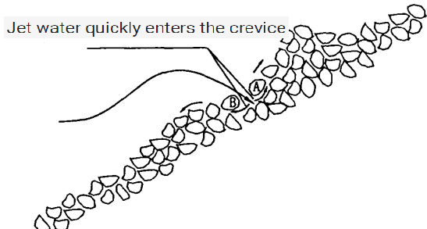 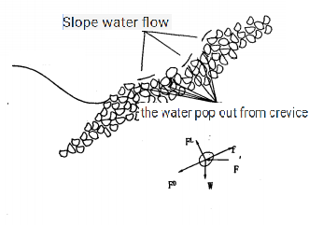

Figure3 water jet stream and slope water action diagram

Applying this minimum element force model to sandcastle foundation, we believe that when the waves hit, the front of the sandcastle foundation bears the brunt, that is, the shot stage, and then forms a climbing water flow on the front, followed by erosion on the side (there is no impact) In the falling stage, the back side bears the brunt and forms a climbing water flow (the water flow velocity when falling is small can be considered to have a small impact on the sand castle), the same side is washed away, and the slope flow is formed on the front side. The sand granules taken away in this process are the most.

Comprehensive analysis of the force characteristics above-mentioned and introduce intergranular discrete forces，resulting in sand starting conditions：

 （5）

Where  is the repose angle of sand granules, which are directly affected by water-sand ratio to reflect its structural stability .

According to Roe’s research, the intergranular discrete force can be calculated by the following formula **[2]**

 （6）

Where  is the distance between granules, it can be seen from the above formula that the force of the sand particles is related to the distance between them, so the water to sand ratio of the sand castle will have a greater impact on its stability.

According to the starting conditions and combined with the above-mentioned force analysis, the sand castle structure needs to disperse the force as much as possible when the waves hit the incident stage, and the sand castle force has a large relationship with the inclination of the slope. Therefore, the surface shape must be reasonably designed to reduce Jets and climbing waters cause instability of the surface sand grains that are affected first, thereby minimizing the sand grains taken away by the sloped stream formed by the fall.

The waves form a water flow around the sandcastle foundation. The larger of the flow rate , the more sand particles are taken away. Therefore, the structure of the sandcastle foundation should also make the flow velocity as homogeneous as possible to prevent the speed of destruction of the sandcastle from being caused by the local flow velocity being too fast. Considering the sand castle structure as a whole, the classic fluid-structure interaction model is used for analysis:

Establishing the finite element equation of the coupled system, and the solution vector of the coupled system is written ,  are the solution vectors defined at the fluid and structure nodes, therefore ，. The finite element equations in fluid-structure interaction systems can be expressed as **[3]**

 （7）

Where , are  , corresponding finite element equation. The analysis shows that the interaction fluid and structural equations can be expressed as  and 。

Finally, we use ANSYS software to simulate and solve the fluid-structure coupling model, and obtain the force distribution of the structure and the flow velocity distribution of the structure in the system and analyze and discuss the best 3-dimensional structure model.

**4.1.4 The foundation of model**

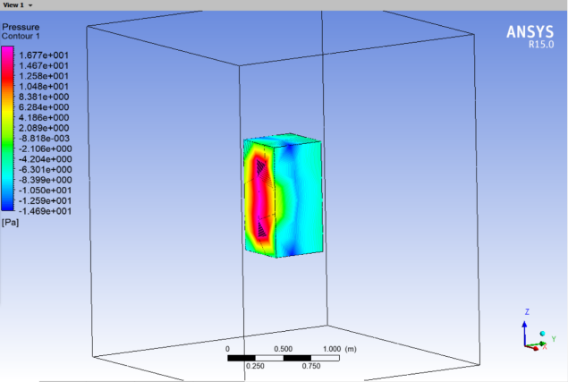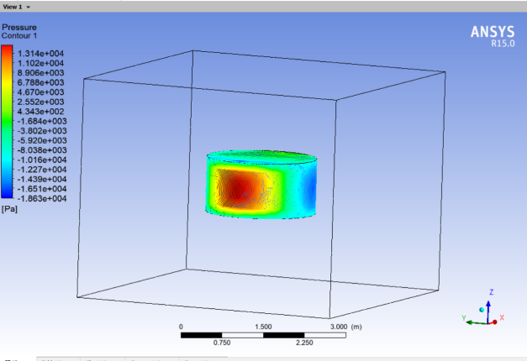

Figure4 pressure distribution Figure5 pressure distribution

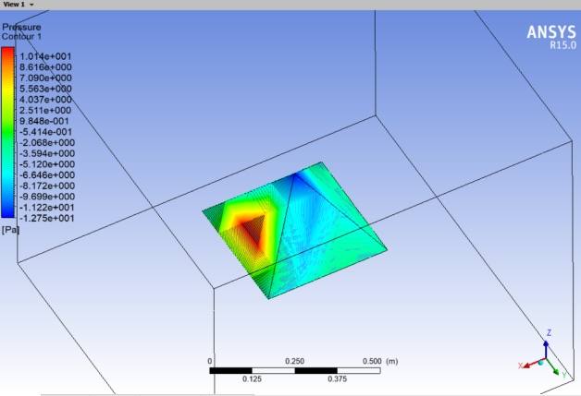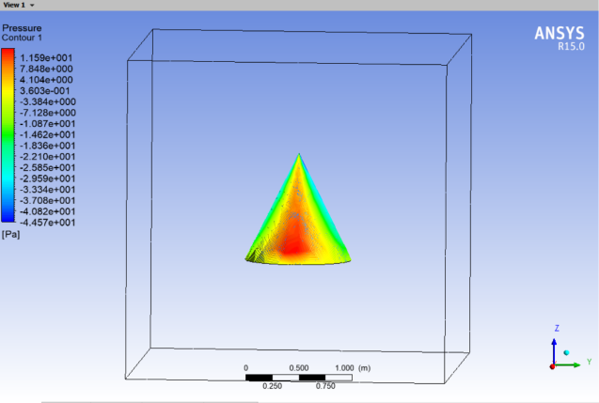

Figure6 pressure distribution Figure7 pressure distribution

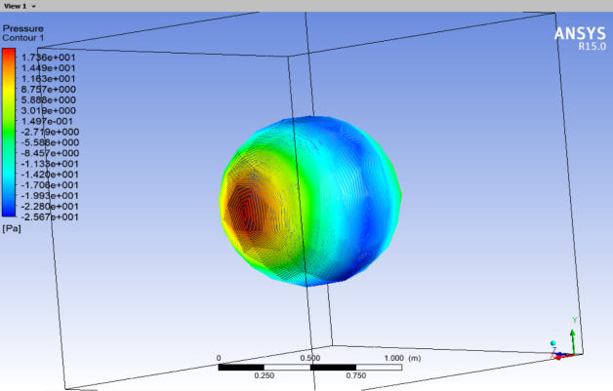

Figure8 pressure distribution

Next we used ANSYS FLUENT software simulation:

First of all, we only consider the force exerted on an object when the wave comes in from the front. We selected some possible shapes and some basic graphic elements for force simulation. In this way we control:

1. The flow rate is the same 5m/s.
2. The construction material is the same.
3. The shape of the object size is roughly in line with the reality of the sandcastle foundation size.

After getting the force distribution of each figure above, then carry on the analysis to get the best sandcastle foundation shape:

1. By comparing the force acting on Figure 4 and Figure 5, we find that the force acting on the front of the plane is greater than that acting on the curved surface, and the force acting on the plane is more concentrated. Therefore, for the sandcastle foundation to be built, try to use a curved surface facing the direction of the wave. As this disperses the force, reduces local pressure and makes the sandcastle foundation more resistant to impact.
2. Compared with Figure4 and Figure6, combined with Figure5 and Figure7, we found that the impact force will be greatly reduced if the force plane is changed from vertical to inclined plane. Furthermore, we find that the force distribution is the most homogeneous for this kind of curved surface with slope in Figure7.
3. In addition, we also consider the force acting on the sphere. But we find that the pressure will converge to a point in the direction facing the wave for the sphere. And the force distribution is not homogeneous. In this way, this shape is not used because the pressure near the point is even greater than the maximum pressure acting on the plane.

Next, we continue to use ANSYS FLUENT to simulate the flow velocity near the object:

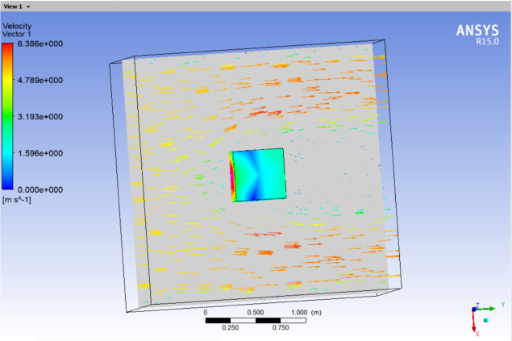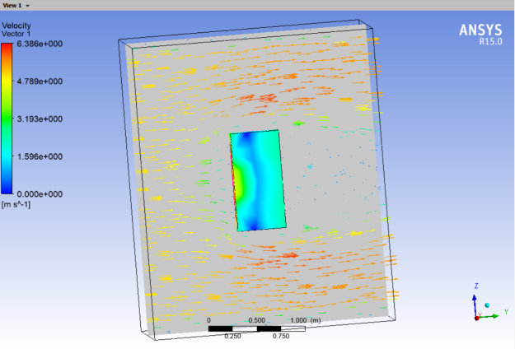

Figure9 velocity distribution Figure10 velocity distribution

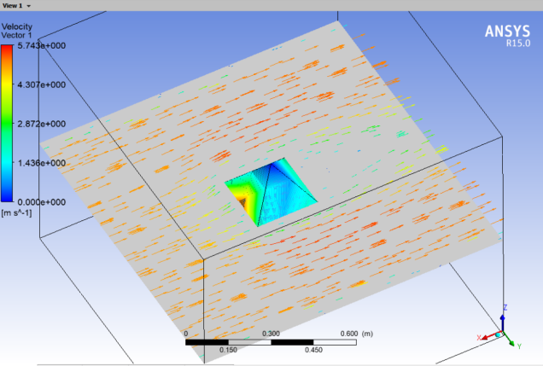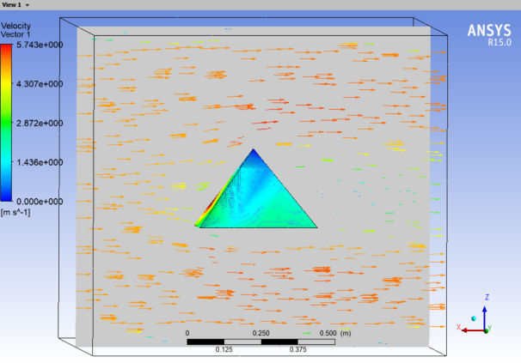

Figure11 velocity distribution Figure12 velocity distribution

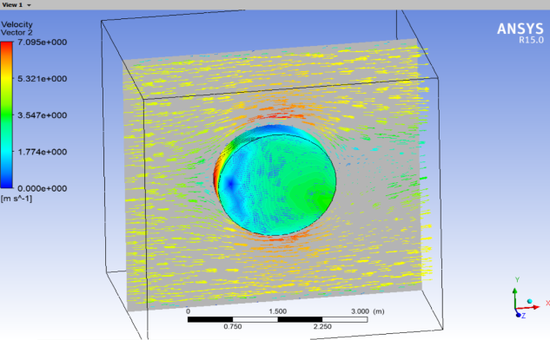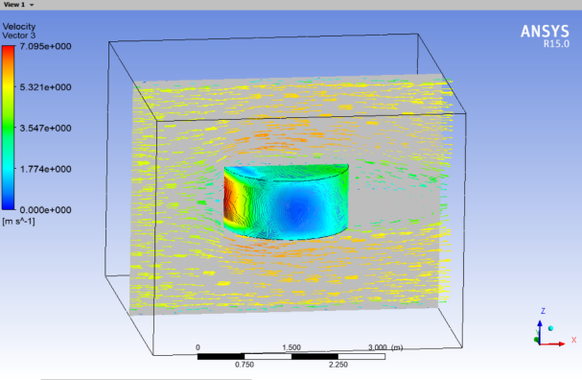

Figure13 velocity distribution Figure14 velocity distribution

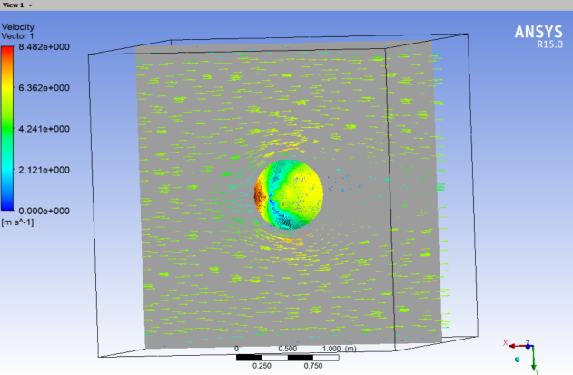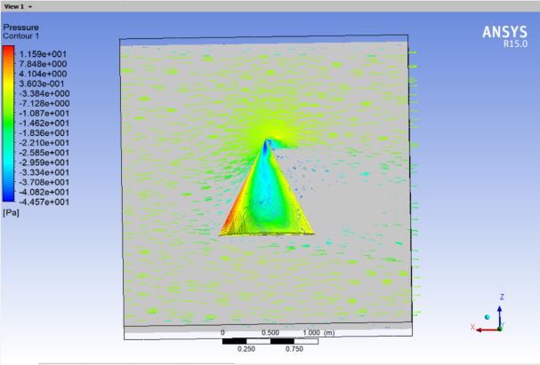

Figure15 velocity distribution Figure16 velocity distribution

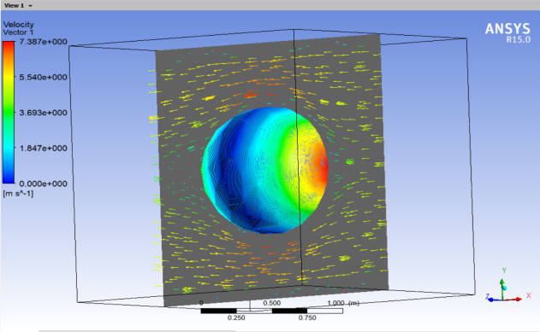

Figure17 velocity distribution

In the above simulation processes, we still control:

1. The wave current velocity remains unchanged at 5ms.
2. The material is the same.
3. The size is close to the size of the real sandcastle foundation

Then we start the analysis:

1. Through the observation of Figure9, Figure10, Figure11, Figure12, we found that the flow rate around the edge of object is faster, from our previous analysis, the faster the flow rate, the more sand would be taken away, so we have to choose a more homogeneous distribution of flow velocity structure. Therefore, we should minimize the appearance of edges in the structure of sandcastle foundation. And the connection between the faces should be as smooth as possible.
2. By looking at Figure13, Figure14, Figure15, Figure16, and Figure17, we found that when the edges were removed, the flow velocity in most of the area around the sandcastle foundation became more homogeneous, but the flow velocity on both sides increased. In addition, Figure16 shows that when the water completely flooded the sandcastle foundation, the sharp angle at the top of a Sandcastle can also cause a sudden change in the flow rate, which would have a bad influence on the sandcastle foundation.

**4.1.5 Solution and Result**

Through the simulation and analysis of the force distribution and the velocity distribution, we get the conditions of the ideal sandcastle foundation shape:

1. Because the front of the sandcastle foundation is facing the direction of the wave, and according to the simulation results, the front water velocity is very low. So we should take account for the impact force of the water firstly. So the front of the sandcastle foundation should be as wide as possible slope, but also it needs to be slightly bent, such a structure is the most conducive to dispersion of impact force structure, which can make the sandcastle foundation more resistant to the impact of waves.
2. Since the tide is a dynamic process of up and down, the tide rushes from the front of the sand castle to the sand castle at each high tide, and from the back of the sand castle at low tide. So the structure of the back of the sandcastle foundation should be as broad as possible, and be with slightly bent, as the structure of the front.
3. On both sides of the sandcastle foundation, the current does not cause a direct impact, but the nearby water flow velocity is faster, if the current velocity is too fast, the sand on both sides of the sandcastle foundation would be quickly carried away, this is not conducive to the long-lasting sandcastle foundation. We should therefore consider the effect of current velocity rather than the impact of current on both sides of the sandcastle foundation. According to the analysis results, the side should be parallel to the current direction as far as possible, and the sand heap trend should be more natural, as little as possible bending and twisting.

Finally, combined with the conclusion of the analysis, we have constructed the ideal sand castle structure and carried on the stress distribution simulation and the nearby flow velocity simulation, the results are as follows:

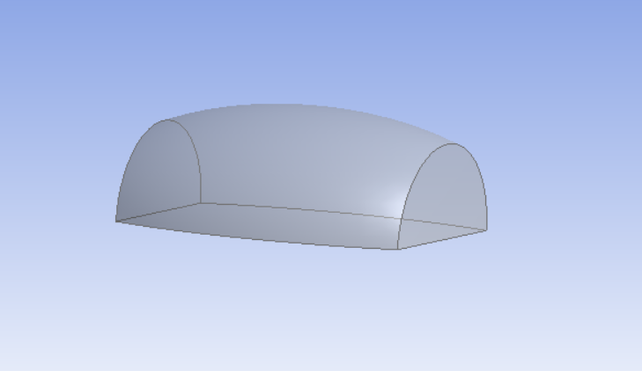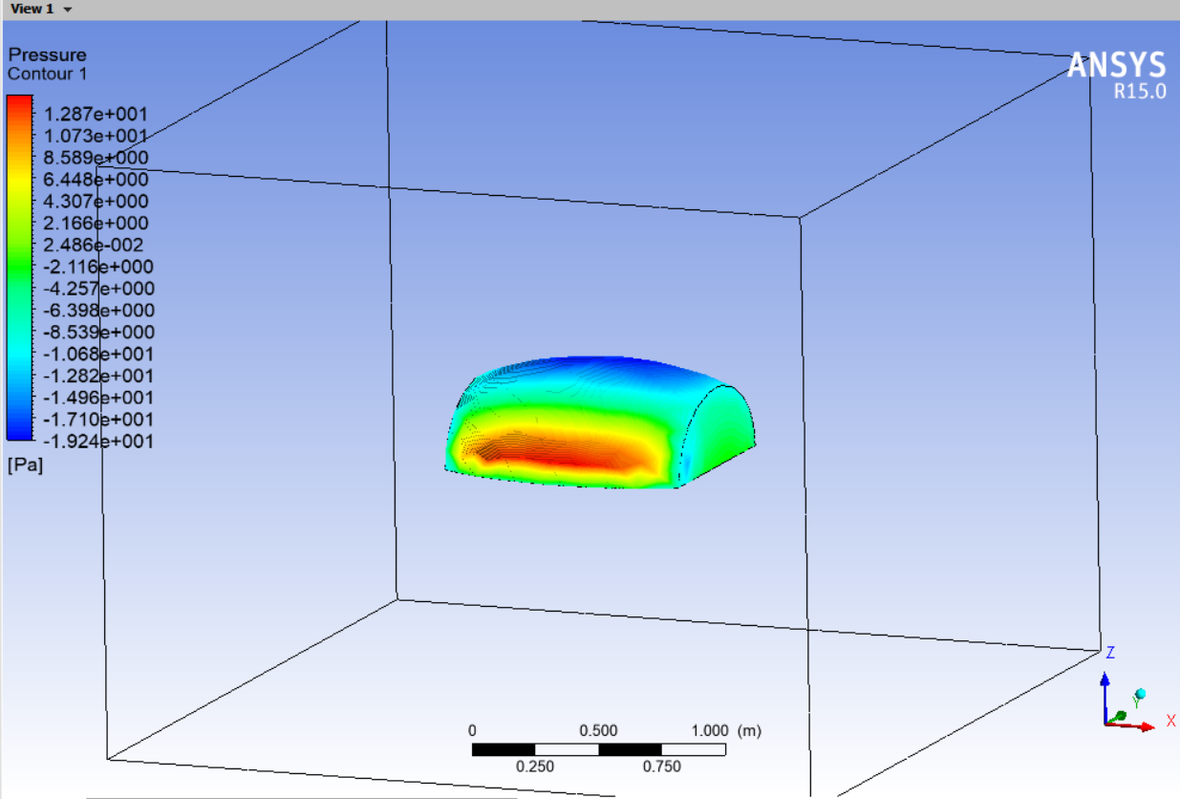

Figure18 our model Figure19 force distribution

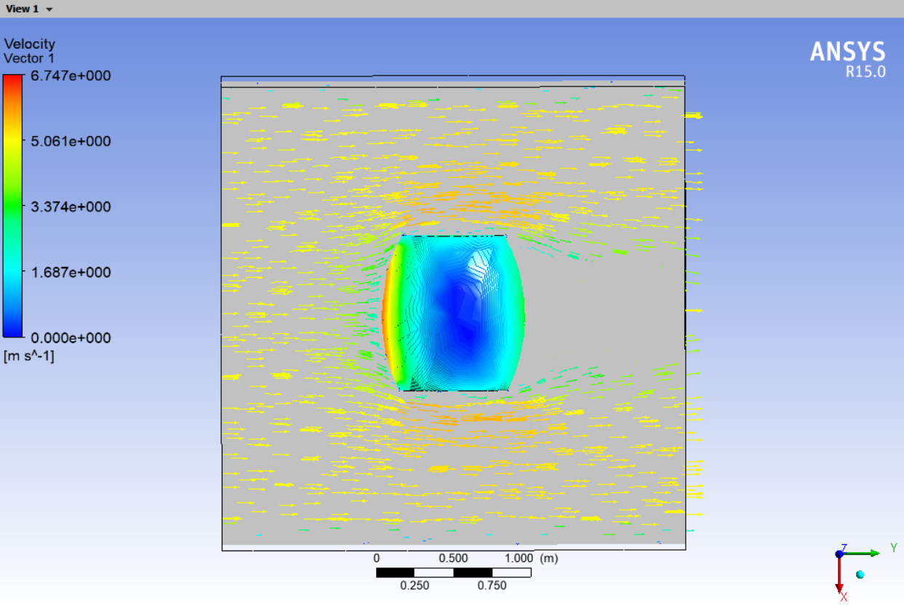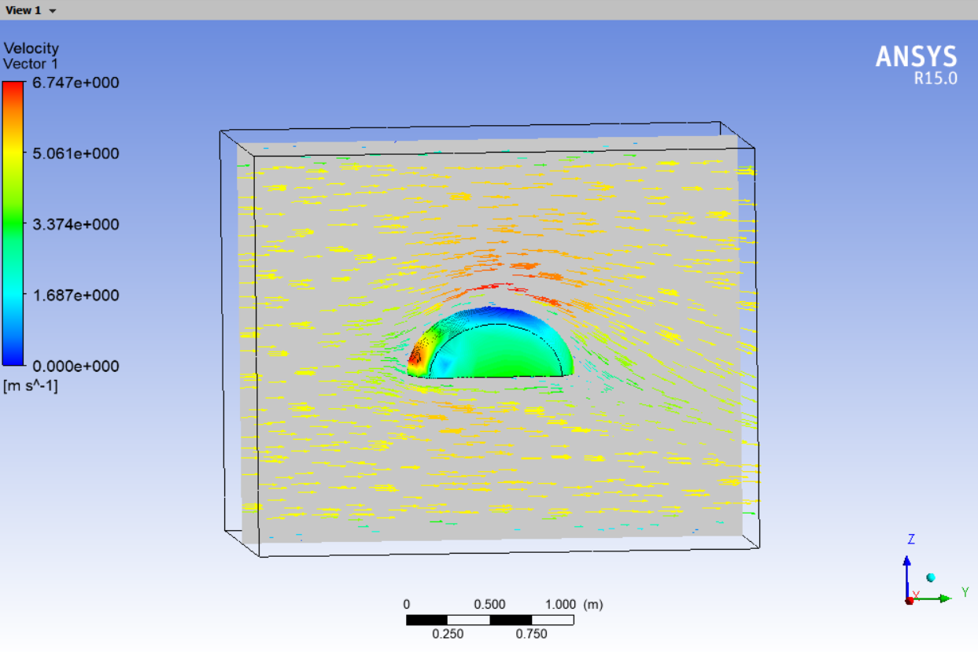

Figure20 velocity distribution Figure21 velocity distribution

**4.1.6 Analysis of the result**

By observing the simulation results, we find that the impact force distribution and velocity distribution of this kind of sandcastle foundation are the most homogeneous among all the models analyzed so far. And because the geometry is symmetrical, so when the tide falls behind the sandcastle foundation, it can ensure that the force distribution and velocity distribution is homogeneous too. It makes full use of the conclusions we have drawn before, and the simulation results are consistent with our theoretical analysis, so we consider it as the optimal solution under the conditions given by the first problem.

**4.2 Water-to-Sand Mixture Proportion Model**

**4.2.1 The foundation of model**

Wet sand and dry sand have different physical characteristics, wet sand is generally more suitable for building sandcastles than dry sand. Because the water added to the sand greatly increases the repose angel (the steepest stable slope that matter can form), allow the development of long-range correlations, or clumps. In addition, in the stress analysis of the first model, it is found that the angle of repose also affects the starting conditions of sand grains. Therefore, we establish and analyze the repose angel model of sand to obtain the best sand-to-water mixture proportion. **[4]**

For sand, under the influence of dry and wet changes, a water film can be formed on the surface of the particles, and the thickness of the water film will also augment with the increase of water content. When the sand contains pore water, a liquid bridge can be formed in the particle contact area of the loose sand to generate a liquid bridge force meniscus force, so that the particles are bonded with each other.

In the process of changing from drying to saturated water-bearing state, the repose angle  will go through the process of slowly increasing first, then rapidly increasing, reaching the maximum value, keeping stable, and finally decreasing to the minimum value. During the change of the repose angle, mainly the water film between particles plays a double role of lubrication and liquid bridge adsorption.

**4.2.2 solution and result**

Equation of Internal Friction Coefficient Considering Lubrication of Water Film and Adsorption Force of Liquid Bridge in Bulk Sand [5]：



——Average water film thickness ——Sand Friction Coefficient in Unsaturated State

——Friction Coefficient of Sand Particles in Saturated State

According to the change rule of the repose angle with water content, combined with the mechanism analysis of water content affecting the repose angle, the functional   
equation of the repose angle is constructed considering water film lubrication effect and liquid bridge adsorption force.



——the repose angle reduced from dry state due to water film lubrication；

——the repose angle increased by meniscus force；

——water content ——calculation parameters

 related to the particle characteristics of sand grains. By looking up relevant research, we can obtain [5]:

；

At this present stage, it is not clear how the water film lubrication decreases with the increase of water content. First, we assume that when the water content is small, the influence of lubrication on the internal friction coefficient is relatively weak compared with that of liquid bridge adsorption. Therefore, we assume that only considering lubrication, the repose angle decreases linearly with the increase of water content.

When the water content is 0%，the repose angle  is 33°；When the water content increases to  , sand is saturated, the repose angle  is 31°.





Combine : 

Draw a curve according to this equation:

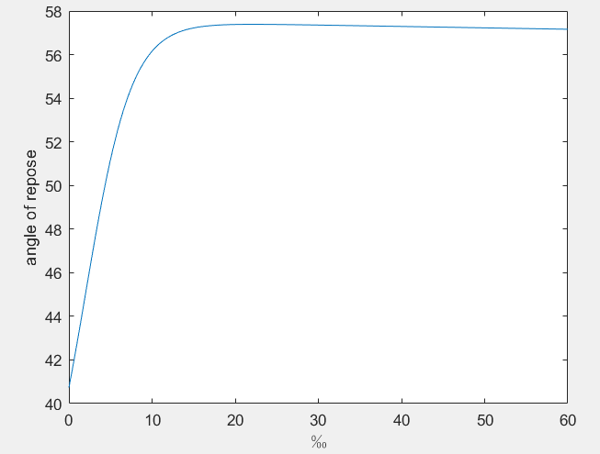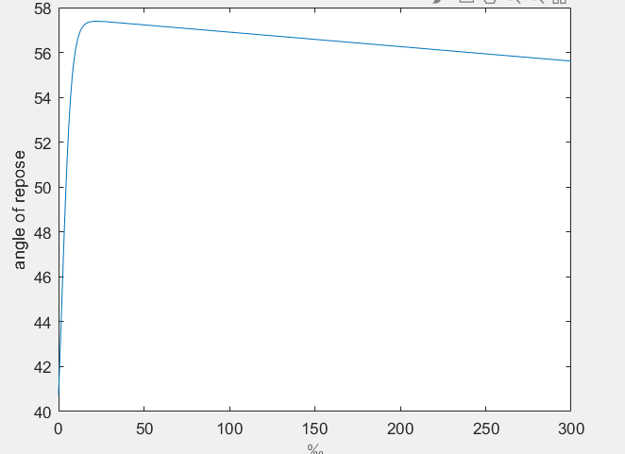

Figure22 graph of with  Figure23 graph of with 

According to the curve, we can conclude that when the water content is 2% (i.e. the sand-water ratio is 1:50), the repose angle of the sand pile reaches the maximum, and then when the water content continues to rise, lubrication plays a dominant role and the repose angle decreases obviously.

However, considering that when the water content increases, the lubrication effect will increase sharply, and the whole will mainly show the liquid flow property, which will increase sharply, we use the modified form of adding exponential function to simulate the effect.



Draw the curve after adding correction and analyze it:

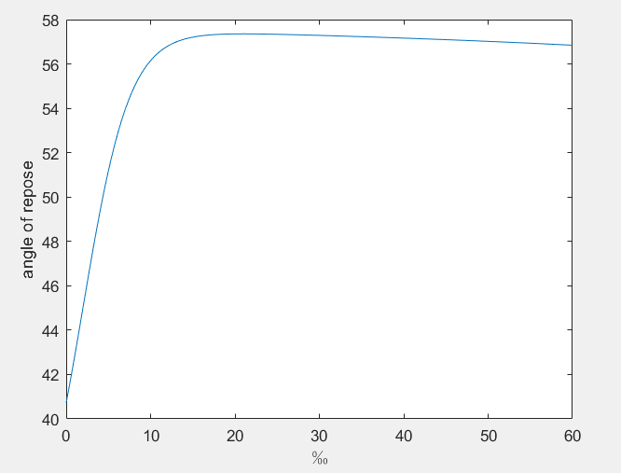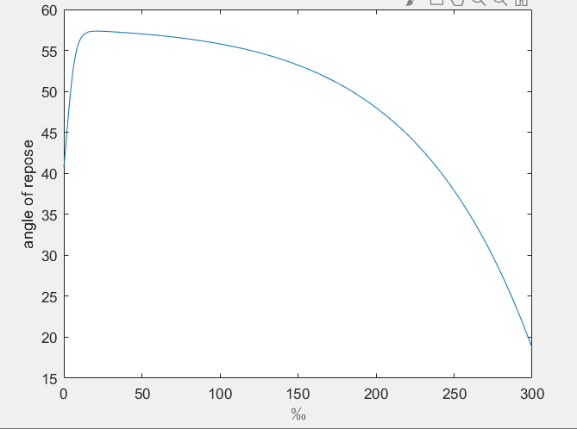

Figure24 graph of with  Figure25 graph of with 

In this model, we weaken the influence of lubrication when the water content is low and greatly strengthen the influence when the water content is high. The obtained results are more obvious. The repose angle is affected by the sand-to-water mixture proportion and has the highest point, which is 20‰, and then the lubrication is strengthened and decreases more rapidly. Therefore , the optimal sand-to-water mixture proportion is about 2:100.

**4.3 Rainproof model**

**4.3.1 Analysis of the problem**

In order to simulate the rain conditions, we changed the direction of the current to flow down from directly above the sand castle. Compared with the impact of waves on sand castles, rainwater has less impact on sand castles, and we will appropriately slow down the flow velocity to 1m/s. Because compared with the impact of waves on sand castles, rainwater has less impact on sand castles.

After the above improvement, we simulated the rain on the model derived from question 1, and the results are as follows:

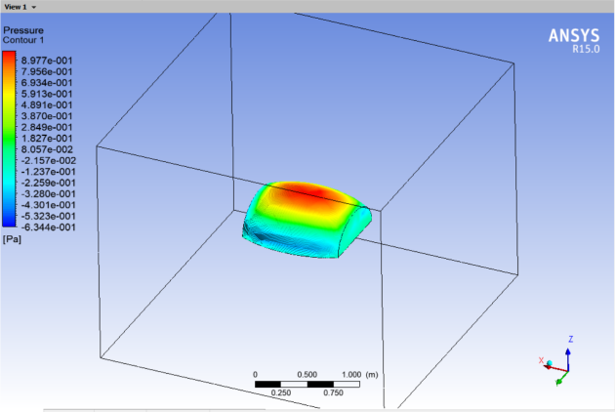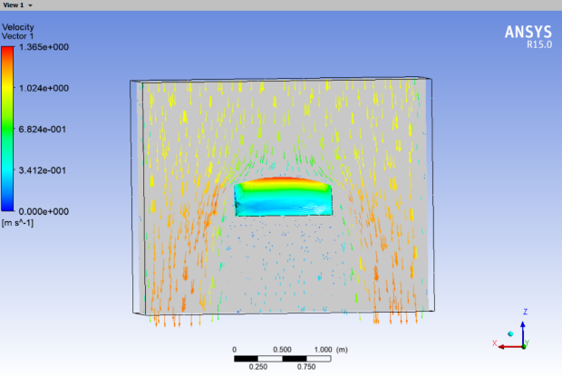

Figure26 Pressure Distribution of Figure27 Velocity Distribution of

the sandcastle foundation in rain the sandcastle foundation in rain

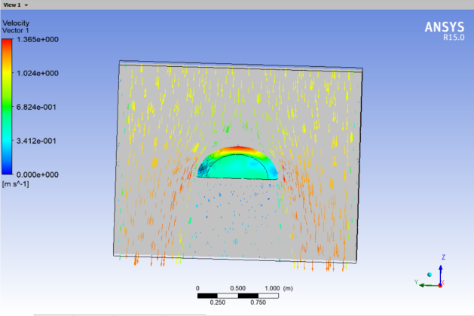

Figure28 Velocity Distribution of

The sandcastle foundation in Rain

From the analysis of the above figure, we can know that we do not consider the impact of water from above on the sandcastle foundation in the first model, the top of our sandcastle foundation is relatively flat, but the stress distribution of this top can be relatively uniform when facing the impact of water from above. Although the flow rate of rainwater near the ground of the sandcastle foundation will accelerate, we think that a slight increase in the flow rate in this area will have little impact on the sandcastle foundation because the impact of rainwater is too small compared with waves.

However, this geometry has a fatal disadvantage that it is easy to deposit rainwater at the top. In this way, more rainwater will seep into the sand castle, and with the passage of time, the rainwater at the top cannot be removed in time, which will cause a substantial increase in the sand-to-water mixture proportion. According to our analysis in question 2, it can be known that excessive sand-to-water mixture proportion is very unfavorable to the sandcastle foundation, which may make the sandcastle foundation become fluid similar to mud, resulting in failure to maintain the shape of the sandcastle foundation and even collapse of the sandcastle foundation.

In order to solve the problem of rainwater deposition at the top, we choose to appropriately increase the radian at the top of the sandcastle foundation, so that the rainwater at the top can be left along the side as soon as possible, so that the rainwater is not easily deposited at the top, and naturally the sand-to-water mixture proportion will not be greatly increased.

**4.3.2 Solution and Analysis**

We simulated the force distribution, velocity distribution, rain force distribution and velocity distribution of the improved model respectively. It is shown in the following figure:

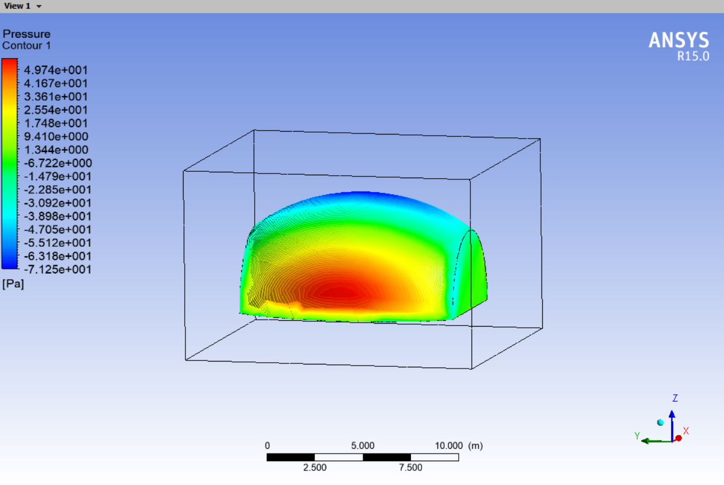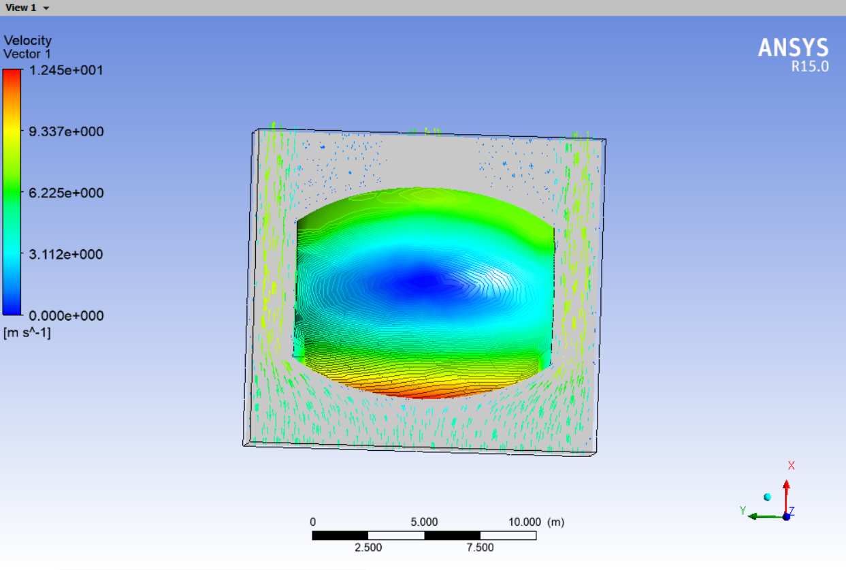

Figure29 force distribution of the Figure30 velocity distribution

improved model affected by waves of the improved model affected by waves

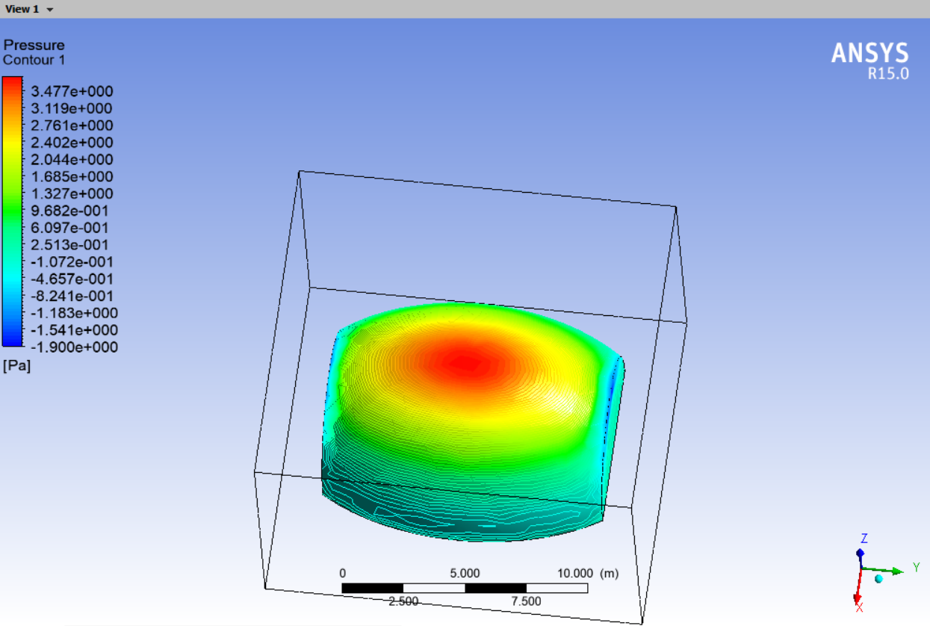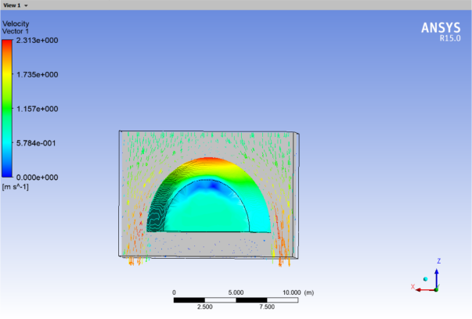

Figure31 force distribution of the improved Figure32 velocity distribution of the

model affected by rainwater improved model affected by rainwater

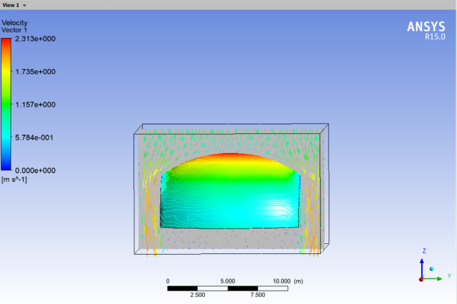

Figure33 Velocity Distribution Affected by

Rainwater in Improved Model

By observing Figure29 and Figure30, we found that after increasing the radian of the top, the stress distribution and velocity distribution of the sandcastle foundation are not much different from those before the improvement, so we concluded that the improved sandcastle foundation can still well withstand the influence of waves.

By observing Figure31, we found that after improvement, the stress distribution of the sandcastle foundation became more concentrated and larger in value when facing the impact of rain. However, we think that this slight change can be ignored because we assume that the impact force caused by rain is relatively small.

By observing Figure32 and Figure33, we found that after the improvement, the rainwater flow rate around the sandcastle foundation increased significantly. This means that rainwater can be drained away faster, and at the same time, as the amount of sand carried away by the water flow is proportional to the flow rate, it also means that more sand is easily carried away by rainwater. As we think that the impact of rainwater scouring is small and negligible, and the sedimentation of rainwater at the top of the sandcastle foundation will bring more impact than the increase of sand-to-water mixture proportion, we give priority to draining rainwater at the top of the sand castle. From this point of view, we think that the increase of flow velocity around the sandcastle foundation is more conducive to draining the rainwater at the top and preventing the rainwater from silting up, so on the whole we think that this phenomenon brings more benefits.

To sum up, we think that the model obtained after adjusting the top radian can meet the rainy day conditions.

**5 Better strategy**

Through the above modeling analysis, it is found that the durability of the sandcastle foundation is mainly affected by its structure and materials such as sand-water ratio, so we consider better strategies from the aspects of the sandcastle foundation material itself and structure.

1. First of all, considering from the material itself, some dicalcium silicate can be doped into the sand, because this substance will react with water to generate colloid with condensation effect, which can make the sandcastle more stable.
2. Secondly, considering from the structural aspect, small stones can be laid on the bottom layer of the sand castle to make the foundation of the sand castle firmer. At the same time, wooden sticks can be used to help fix the corners or joints of the sand castle. Some shells can be used to protect the sand castle where the sand castle is directly impacted by the waves.
3. In addition, we can use more sand grains of different sizes when stacking sand castles, because this will increase the locking force between grains and help stabilize the sand castle.
4. After the sand castle is completed, a small umbrella can be inserted at the top of the sand castle, which can reduce the evaporation of water when the sun is fierce and prevent the sand castle from being too loose and difficult to bear due to the small water-sediment ratio. When it rains, the infiltration of rainwater can be reduced as much as possible and the collapse of sand castle caused by rainwater can be slowed down.
5. Some through holes can be drilled in the sand castle. When the sea wave rushes to the sand castle, part of the wave will pass through these through holes without causing greater impact to the sand castle. This measure effectively reduces the impact of the wave and saves materials.

**6 Advantages and Disadvantages**

**6.1 Advantages**

1. The influence of water impact and erosion are comprehensively considered, and their distribution is visualized and vivid.
2. We grasp the key elements and take the repose angle as the standard to measure the sand-to-water mixture proportion, which is simple and intuitive.
3. We simplify reasonably and boldly, not considering the internal changes of waves and rain, but equivalent them to water flows with different velocities but keeping constant, which is convenient for analysis. We also simplify the sand castle surface as an inclined plane, and analyze the stress on the sand grains on it, and obtain the three main stages of wave impact.

**6.2 Disadvantages**

1. We do not consider the impact of sand loss on water flow and sand castle during the whole process.
2. We only consider the influence of waves from the same horizontal plane, but we fail to consider that waves can ripple and slap from the vertical direction.

**7 Conclusion**

The front of the sandcastle foundation is as wide as possible with a slope of a large radian, which is conducive to the structure of dispersing the impact force and makes the sandcastle foundation more resistant to the impact force of waves. The structure of the back is the same as that of the front to disperse the pressure from the back. The water flow on both sides of the sandcastle foundation is fast. So the side need to be parallel to the water flow direction, and the sand pile moves naturally without bending and twisting.

As follows:



Figure34 the model of the question 1

In question 2, we determined the best sand-to-water mixture proportion ratio to be 2:100 through the highest point of the repose angle.

In response to the impact of rain, we improved our model and raised the top radian of the model in question 1 to make it a more exaggerated curved surface. The model can effectively resist the impact of rain water, make it evenly distributed, and drain away the top rain water at the same time to prevent the impact caused by rainwater deposition.

As follows:

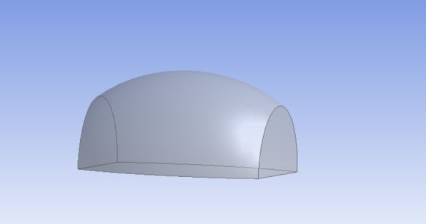

Figure35 the model of the question 3

**8.ARTICLE**

**What Makes Your Dream Come True**

When you think of a trip to the seaside, what comes to mind first? Was it the intense surfing, scuba diving? Or would you rather lying on the beach, looking out over the horizon and sunbathe? Or building a bonfire on the beach, holding hands with friends and relatives and forgetting about work and life, dancing and enjoying the moment? Of course, all of these activities are fun, but do you remember when you were a kid on the beach, trying to build the strongest, most Beautiful beach castle in the world? Here, Fun In The Sun magazine helps you achieve your childhood dream of building the most durable beach castle. Firstly, let’s build the longest lasting sandcastle foundation.

So the question is, what should be done?

First, let's look at the structure. If we want to build a durable sandcastle foundation, then it must face two difficulties: first, the tidal fluctuations will make the waves continuously impact on our sandcastle foundation. Second, the waves that don't hit our sandcastle foundation head-on will steal the sand around them when you're not looking. And over time the sandcastle foundation will become unstable or even collapse.

From the practical experience of life, generally vertical buildings are easy to collapse due to the impact of water or strong wind, while facilities with a certain degree of tilt, such as dams, are more resistant to impact and erosion, because the structure disperses the impact to a greater extent and thus maintains its stability. The faster the flow rate on the sandcastle foundation surface, the faster it erodes, all other things being equal, the structure of the sandcastle foundation therefore slows down the flow of water as much as possible so that each wave shock carries less sediment with it.

In order to solve these two problems, we carry out simulation experiments on the force distribution diagram and velocity distribution diagram of various possible models respectively, and finally get the most ideal sandcastle foundation structure model, which is the most resistant to the impact of waves. The sandcastle foundation model that will make your dream come true!

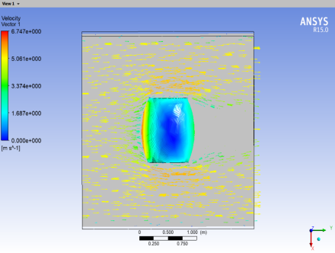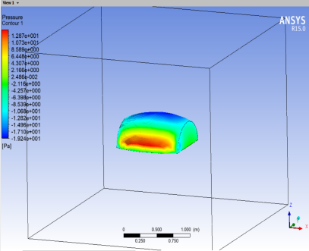

Figure36 the shape of foundation Figure37 velocity distribution Figure38 pressure distribution

Now you can see that the Figure 36 is the shape that can make your dreams come true, and of course we'll explain why. In Figure 37 and Figure 38, the higher the pressure or flow rate, the closer the color is to red, and the lower the pressure or flow rate, the closer the color is to blue.

In our model, the color gradient is more natural and there are no very deep colored spots of local red. This means that the force and velocity distribution is more homogeneous, there is no place where the velocity is too large or the force is too concentrated. Yeah, you guessed it. We have overcome the difficulties of pressure and the flow rate.

Simulation results show us that this sandcastle foundation model can withstand the pressure of waves and water erosion to the maximum, and it is quite possible to achieve your childhood dream of building the most durable sandcastle foundation!

At this point you might ask, what if it rains? Could it shape still stand? And, of course, we thought about that. If you're worried that the rain is going to collapse your sandcastle foundation, one small thing you can do while building it is to slightly raise the curvature of the top of the sandcastle foundation.

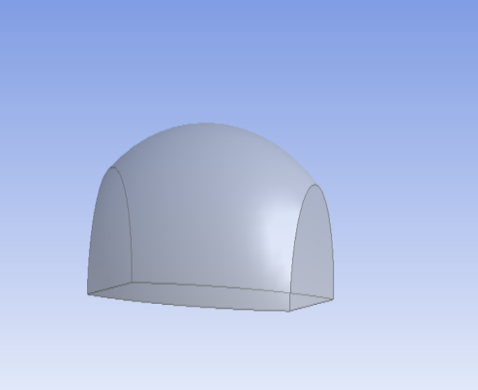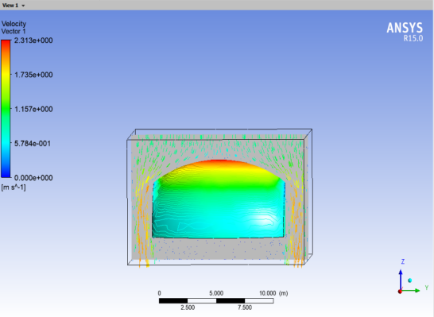

Figure39 Structure For rain Figure40 velocity distribution&pressure distribution

The figure 39 is the result. As you can see from figure 40, the color of lines on either side of the sandcastle foundation are deeper, which means the water is moving faster. In this way, we can reduce the amount of rain that accumulates on top of the sandcastle foundation by letting it flow down as quickly as possible, thus minimizing its impact on the sandcastle foundation.

After solving the structural problem, we can start with considering the materials of the sandcastle foundation. Almost everyone knows that wet sand is easier than dry sand to build a strong and reliable castle. Why is that? Because water acts as an adhesive between the sands in wet sand, increasing the angle of repose (a measure of the forces acting on each other) , wet sand is stronger than dry sand and less likely to be washed away.

So the question is, why add more water to the sand castle is not strong, but there is the risk of collapse and landslide? In fact, water is also a lubricant, too much water will reducing the maximum angle of repose sand pile, thus increase the lubrication between the sand, making the sand easier to flow. So the angle of repose of wet sand Increases first and then decreases, which means that there is an optimal sand-to-water mixture proportion, making your sand castle the strongest. When the ratio of sand to water is about 2:100, the angle of repose of sand is the largest. So, in order to build a stronger sandcastle foundation, we can ensure the most suitable structure and choose the most appropriate sand-to-water mixture proportion, building the longest-lived sandcastle foundation.

**Reference**

[1] C. Xiao-yu, L. Tianqing, T. Boming, and H. Lie, “Mechanism of wave scouring and failure on loose bank slope” *Journal of Chongqing Jiaotong University*, 2006

[2] L. Xiaoping, D. Zhibao, “Experimental Study on Wind Erosion Starting Wind Speed of Wet Sand” Bulletin of Soil and Water Conservation, 2002

[3] P. Ji, Y. Shouqi, and Y. Jianping “Numerical calculation of the effect of fluid-structure interaction on the internal flow field of a centrifugal pump” *Transactions of the Chinese Society for Agricultural Machinery*,1997

[4] D. J. Hornbaker, R. Albert, I. Albert A.-L. Barabási, P. Schiffer, “What keeps sandcastles standing?” scientific correspondence,1997

[5] C. Shan, “A preliminary study on the angle of repose of loose sand in a changing water environment”, 2014