### PART 1 - NETWORK SPECIFICATIONS AND DIAGRAM

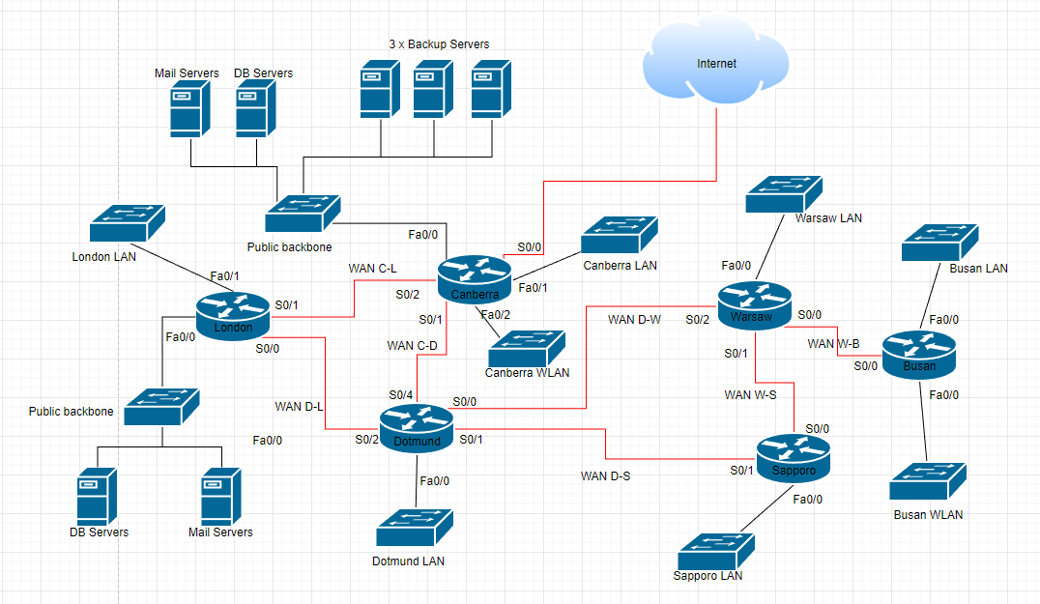

**PART 2 - Subnet the network using VLSM, and assign IP addresses to the appropriate devices.**

Table1

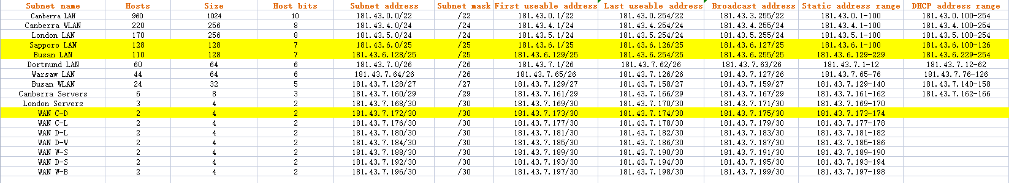

Table2

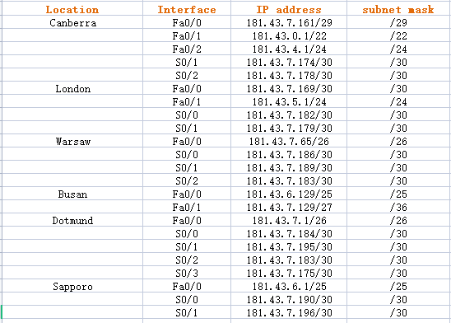

Table3

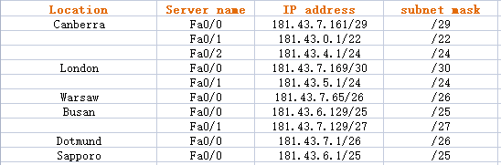

### **PART 3**

