CP1402 Assignment - Networking Case Study

# Introduction

This case study has been divided into three (3) components.

You are to design a network, research and source appropriate devices justifying choices (feasibility, efficiency, etc.), subnet the network, assign IP addresses to the appropriate devices, and design ACLs to satisfy security requirements.

**Note**: This is ***not*** a group project. Each student must individually complete all parts of their submission.

Students ***must*** start with a ***new document*** and they must not have another person’s file in their possession at any time. Students may discuss the task with each other, but each student must write their assignment independently and not show their work to other students.

# Deliverables

1. A single **Word document** (.docx) – containing all parts

# Assignment breakdown

## Scenario

myNetwork Services Inc., an Australian data analytics company, has asked you to assess and redesign their network. They are opening a new branch in Adelaide, which will require new equipment. They have existing contracts and hardware to maintain fibre-optic leased line WAN links between sites.

PART 1 - Network diagram

PART 2 - Subnet the network and assign IP addresses to the appropriate devices

PART 3 - Research and source appropriate devices justifying choices (feasibility, efficiency, etc.) with a Weighted Scoring Model (WSM)

# PART 1 - Network specifications and diagram

## Network Specifications

You have been given a rough sketch of the network topology below. You are to draw the network using Visio, subnet the network (see **part 2**), and assign port numbers and IP addresses to ports.

## Network Structure

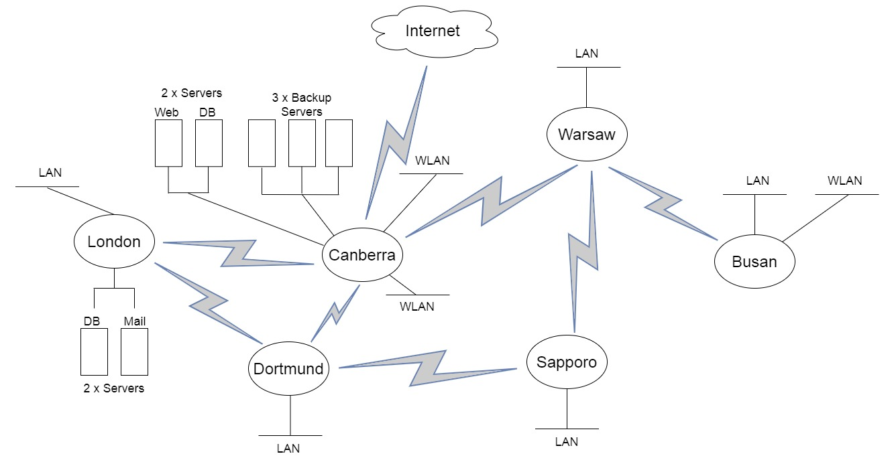

## Hardware

* Only include one switch in you diagram for each LAN or WLAN (even if more are required)
* Servers should be on their own LAN
* The Canberra router is connected to the Internet and provides access to the ***public backbone containing a web server and a database server.*** It also provides access tothe ***backup servers.***

# PART 2 - Subnet the network using VLSM, and assign IP addresses to the appropriate devices.

## Each location has the following number of hosts

Sapporo, London, Warsaw, and Dortmund each include a wireless LAN for clients to use.

|  |  |  |
| --- | --- | --- |
| **Location** | **Workstations** | **WLAN addresses** |
| Canberra | 480 | 110 |
| Busan | 55 | 12 |
| Sapporo | 64 |  |
| London | 85 |  |
| Warsaw | 22 |  |
| Dortmund | 30 |  |

## Subnetting

Use VLSM to subnet the network topology using a public class B network. You are to use the table format below to provide the subnet details.

**Table 1**. Subnets (including WAN subnets)

*Spreadsheet Columns*: Subnet name, subnet address, subnet mask (in slash format), first useable address, last useable address, broadcast address, static address range and DHCP address range (all addresses to be in dotted decimal notation)

**Table 2**. Router Interfaces

*Spreadsheet Columns*: Location, interface, IP address, subnet mask (in slash format)

**Table 3**. Servers

*Spreadsheet Columns*: Location, server name, IP address, subnet mask (in slash format)

**Additional requirements:**

* Choose one public B class network address for the entire network and subnet this block of addresses to optimise spare addresses for future expansion.
* Place the WAN subnets in the blocks directly following the LAN/WLAN address space.
* Add 100% to each subnet to allow for growth in the number of hosts specified for each LAN (i.e. workstations × 2). Do not allow for any growth in the number of servers or size of WLANs
* DHCP will to be used for IP address allocation for hosts in each subnet and these ranges are to be allocated for each LAN.
* Static IP addresses are to be allocated where appropriate: router interfaces and servers.
* The ISP has given us an IP address of 100.200.16.26/30 for our Internet connection at Perth **Note: this address is part of the ISP’s network, and is not involved in subnetting for the corporate network.**

# PART 3 - Research and source appropriate devices justifying choices (feasibility, efficiency, etc.)

You are to research and submit a project procurement plan for the Adelaide network. The devices you must include are routers, switches, and wireless access points. Make sure the devices you select can handle the number of workstations required and provide a good quality of service to wired and wireless users. Devices should be **enterprise-grade**, not home or gaming equipment.

Your project plan and final recommendations should be based on a Weighted Decision Matrix (like the WDM you did in the Procurement Practical). You are to compare four (4) devices from each category and to base the decision on reasonable and well-justified attributes.

The budget for procurement is $4,000. You may exceed this if you can justify it well.

Your project plan is to contain the following components:

**Weighted Decision Matrix - hardware resource requirements analysis**

* Include a written justification for priorities and attributes given in the matrix
* Create your WDMs in Excel and copy and paste them into your Word doc

**Budget**

* Create a well-presented table of the prices of all devices and the total cost
* Include hardware only, not labour

# 

**CP1402 Marking Scheme**

Ensure that you follow the processes and guidelines taught in class to produce high quality work. This assessment rubric provides you with the characteristics of exemplary, good, satisfactory, and unacceptable work in relation to task criteria.

|  |  |  |  |  |  |  |  |  |  |  |
| --- | --- | --- | --- | --- | --- | --- | --- | --- | --- | --- |
| **Criteria** | | **Exemplary (90-100)%** | | **Good (70-80)%** | | **Satisfactory (50-60)%** | | **Limited (20-40)%** | | **Very Limited (0-10)%** |
| **Part 1 Topology Design**  **Diagram appearance**  **/10** | | 1. Created in MS Visio (or draw.io for external students) using Cisco icon set, and the diagram is: 2. Neat and professional 3. All lines at set angles (multiples of 30, 45, 90 degrees) 4. Lines do not end short 5. Lines do not appear over the top of devices 6. Lines align if on same level | | Most of the criteria are satisfactory (See criteria under "exemplary") but some minor issues. | | Over half of the criteria are satisfactory (See criteria under "exemplary") but some minor issues. | | Under half of the criteria are satisfactory (See criteria under "exemplary") or significant issues in some areas. | | Many problems (e.g. not done in Visio, inconsistent formatting, diagram does not align to subnetting scheme, etc). |
| **Diagram Labels and Devices**  **/10** | | Topology is accurate and the diagram   1. Includes device names 2. Interface names 3. Interface IP addresses 4. Masks in slash format 5. Text neatly placed and sized | | Most of the criteria are satisfactory (See criteria under "exemplary") but some minor issues. | | Over half of the criteria are satisfactory (See criteria under "exemplary") but some minor issues. | | Under half of the criteria are satisfactory (See criteria under "exemplary") or significant issues in some areas. | | Many problems (e.g. topology is inaccurate; devices are not named, etc). |
| **Part 2 Subnetting**  **Scheme**  **/20** | | 1. LANs and WLANs are the correct size. 2. All required LANs and WLANs are documented. 3. WANs are the correct size. 4. All required WANs are documented. | | Most of the criteria are satisfactory (See criteria under "exemplary") but one or two minor issues, such as a missing LAN, or incorrect address block choice. | | Most of the criteria are satisfactory (See criteria under "exemplary") but several minor issues (e.g multiple missing LANs or WANs) or a significant issue such as incorrect size. | | Some LANs and WANs are documented.  Sizes are correct, or at least not outlandishly incorrect. | | Few LANs and WANs are correctly identified.  Nonsensical subnet size chosen. |
| **Subnet Tables**  **/15** | | Based on the chosen subnetting scheme, the following specifications are available and correct for LANs and WLANs table, and WANs table:   1. Subnet address 2. Subnet mask 3. Broadcast address 4. First usable address 5. Static address range (LANs and WLANs only) 6. DHCP address range (LANs and WLANs only) | | Most of the criteria are satisfactory (See criteria under "exemplary") but some minor lapses. | | Most of the criteria are satisfactory (See criteria under "exemplary") but several minor issues, or a significant issue such as missing a column. | | Tables are presented and contain most of the correct columns, and some correct entries. | | Tables contain major issues such as impossible subnet bounds, or negligible attempt, or not done. |
| **Router and Servers Tables**  **/10** | Based on the chosen subnetting scheme, the following specifications are available and correct in the router interface and servers tables:   1. Location 2. Interface 3. IP address Subnet mask | | Most of the criteria are satisfactory (See criteria under "exemplary") but a few minor issues or missing interfaces. | | Over half of the criteria are satisfactory (See criteria under "exemplary") but some minor issues. | | Table is presented, but contains several significant errors such as mismatched IP addresses or missing columns. | | Table is generally incomplete or incorrect. | |
| **Part 3 - Procurement WDMs – Attributes & justification**  **/10** | Clear, concise, and reasonable justifications for priorities and attributes given in the matrices. All hardware types covered. | | As per “exemplary”, but some minor lapses. | | Reasonable justifications for some priorities and attributes given in the matrices. | | Poor justifications for priorities and attributes given in the matrices, or only one hardware type covered. | | Nonsensical or missing justifications for priorities and attributes. | |
| **WDMs – Hardware choices**  **/10** | Compares four (4) models of each hardware type.  All models are appropriate for an enterprise environment. | | As per “exemplary”, but some minor lapses. | | Compares at least three (3) models of each hardware type. Some choices are appropriate for an enterprise environment. | | Few models compared, or missing some hardware types. | | Negligible attempt or not done. | |
| **WDMs – Tables and Budget**  **/15** | All required WDMs available, structured as per the practical example.  Budget is professional, detailed, accurate, and visually appealing. | | As per “exemplary”, but some minor lapses. | | WDMs per “exemplary”, but several minor lapses, or significant issues in structure or content.  Budget is generally accurate and visually appealing. | | Some WDMs available, but several significant issues in structure or content. | | Negligible attempt or not done. | |