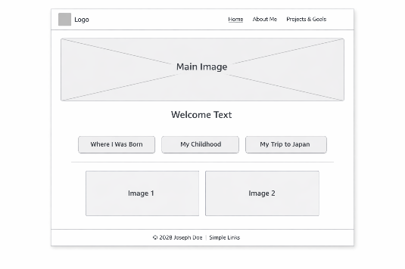
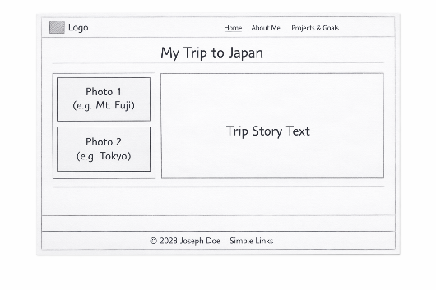
#31241F Cocoa Brown
#e9b8c9 Shilo
#0A2A92 Torea Bay
#5992c6 Danube
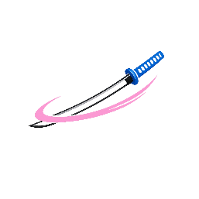<style> @import url('https://fonts.googleapis.com/css2?family=Rock+Salt&family=Shadows+Into+Light&display=swap'); </style>

