Forecasting the lifecycle of social issue in China

By
Liang Yulu, BComp

A dissertation submitted to the
School of Computing and Information System
In partial fulfilment of the requirements for the degree of

Bachelor of Computing with Honours


University of Tasmania
June, 2013

Abstract
Social issues, the event discussed by people in their daily life, can relate to personal life and can have an impact with companies’ strategy. There are so many social issues occurring every day, but we can’t record and analyze all of them. However, while social issues happen, people may discuss it with friends via Social Networking Services (SNS) and may find out more information through Search Engine. Therefore, large SNS and search engine companies, such as Twitter, Weibo, Google, and Baidu, provide Social Issue Analytic Service (SIAS) for user to discuss or understand what is happening in their society.

Dealing with the social data from SIAS, we discover the relevance between individual and social issues and forecasting social issues. This research will focus on forecasting the lifecycle of social issues. Lifecycle are the trends, which may go up, down or be stable. What this research presents is applying a forecasting model with appropriate parameters to gain a predicting output in the near future.

Firstly, the Researchers will collect the social data, namely keywords, 50 rankings, and related news, which focus on each keyword, from Chinese SIAS, Baidu Top Trends, hourly. Since the social data is diffusive information, it cannot be utilized directly. Before inputting it into a forecasting model, the social data has to be trained into instances with unified length. Subsequently, the Researchers will apply a high forecasting accuracy model from the server’s suggested forecasting models to achieve predicting outcome. During the evaluation, the Researchers will compare these forecasting. In addition, the length and number of instance will be evaluated. The third experiment is to evaluate the range of predicting output by using an appropriate forecasting model with suitable parameters.

Acknowledgement
First of all, I am very thankful to my supervisor, Prof. Byeong Ho Kang for this whole year. He always showed me the way to finish this thesis and give a lot of help in writing and presentation.

Secondly, I would be indebted to another supervisor, Soyeon Han. She spent most of her time to help me change the mistake in this thesis and lead me a good direction on the way to PhD. In this year, her advises did help me a lot on figure out the problem and finishing experiments.

Next, I am very grateful to people, Xue Wanli, David, Leo and Chen zhao, who give a lot of suggestion on final presentation practicing.

Of cause, I can’t forget my friends, Chang Wei and Xia Lianyu, who help me to correct my grammar mistake in this paper.

The most important thankful is to my family, my parents and wife. Father and Mather forgive me that I cannot go back to China with you during Chinese new year. Also, I am very thankful to you, Chen NingMei, for taking care of me and this family in these years.
Table of Content
Abstract 2
Acknowledgement 3
List of Figures 6
1. Introduction 7
2. Literature Review 11
2.1. Introduction 11
2.2. Social Issues Analytic Service 11
2.2.1. Google Trends 12
2.2.2. Twitter Trending Topics 13
2.2.3. Baidu Top Trends 14
2.2.4. Weibo Data Trends 16
2.3. Forecasting Techniques 17
2.3.1. Qualitative Forecasting 18
2.3.2. Quantitative Forecasting 20
2.4. Summary 28
3. Methodology 29
3.1. Introduction 29
3.2. Method description 29
3.2.1. Data Collection 30
3.2.2. Data Pre-processing 32
3.2.3. Forecasting Methodology 36
3.3. Summary 45
4. Evaluation 46
4.1. Introduction 46
4.1.1. Test method 47
4.2. Compared 3 Artificial Intelligent Models with two missing value 48
4.2.1. Missing value 48
4.3. Different length and number of instances comparison 50
4.3.1. Different lengths of instances comparison 50
4.3.2. Comparing 3 different number of instances 51
4.4. Range of predicting value comparison 53
4.5. Time spent on FFNN with different length and number of instances 54
4.6. Summary 56
5. Conclusion 57
6. Further Works 59
7. References 61
Appendix A – CD ROM 65

List of Figures
Figure 1-1: The relationship between user, SIAS and this research. 8
Figure 3-1: The data flow for Methodology 30
Figure 3-2: the graph shows the average distance value for each hour. 34
Figure 3-3: the flow present the counting of available hours 35
Figure 3-4: FFNN with one hidden layer 38
Figure 3-5: the idea of K-nearest neighbor 42
Figure 3-6: the topology of logistic regression 43
Figure 4-1: The result of 3 forecasting tables with different missing values. 49
Figure 4-2: The result of length for each instance 51
Figure 4-3: The relationship between the number of instance and the number days in training dataset 52
Figure 4-4: The result of reducing the days from training dataset 52
Figure 4-5: The result of predicting value based on different acceptable differences. 53
Figure 4-6: The running time of 3 lengths for each instance 54
Figure 4-7: The running time in different training dataset 55

Introduction
Diffusion, as a special type of communication, is to create and share information with individuals for the purpose of retrieving further information under certain channels . On the Internet, there is lots of diffusion information through. However, only a few belong to arguable events, and enable users or companies to pay attention to them. These are called Social issue.

On the other hand, much discussed topics concerning social issues take place in their daily life since they represent not only the situation of objective existence but also the product of subjective awareness. For example, the occurrence of an interesting social issue may lead to the discussion via Social Network Service (SNS) and people may search it with help of search engine. As a result, unprecedented amount of social data was collected by Search engines, Social networking Services and news stories.
In recent years, these services have been used in analysing social data and providing social data analytic service for users. Social issue analytic services (SIAS), for example, Google Trends, Twitter Topic Trends, Google News Top Stories, Baidu Top Trends, and Weibo data trends update the list of the most searched or discussed social issue keywords regularly. We focus on these SIAS and will explain suitable forecasting methodologies used for analysing social issue keywords. The relationship between user, Search Engine and SNS, SIAS and my research is presented as Figure 1. The flow of Figure 1 is following:
- Social issues occurs in location or global.
- Local people will discuss them via SNS and other people will search them via search engine.
- If these social issues will be discuss or search a lots, the SNS or search engine companies will update them as top ten (10) or fifty (50) keywords in SIAS for other user to join discussion easily.
- This research uses top ten (10) or fifty (50) keywords in SIAS as input data to forecasting the lifecycle of keywords in near future. It will provide top ten (10) or fifty (50) future keywords for use to decide whether the social issue is worthy to discuss or not.
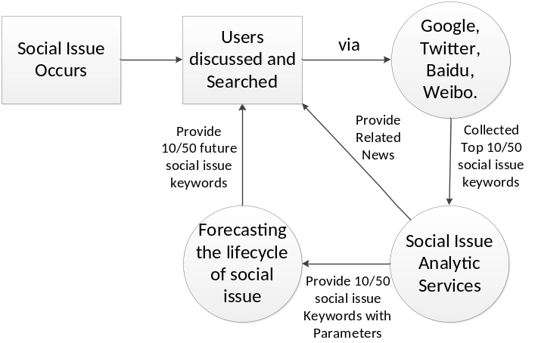
Figure 1-1: The relationship between user, SIAS and this research.

Google Trends, one of the most popular SIAS in the world, provided world-wide social issue data based on searching the frequency of typed keywords of users since 2006. Financial experts can make use of Google Trends to analyse the lifecycle of a social issue keyword, which is related to their topics or requirements, or to compare it with the lifecycle of similar keywords in a particular time or location for their business strategies. However, Google trends only provides social issue keywords without any actual value, such as, search volume, ranking or other parameters that may impact the lifecycle of social issues.

Baidu Index is another popular Chinese SIAS service for presenting the lifecycle of each social issue keywords, similar to Google Trends. Baidu Top Trends, one web page of Baidu Index, lists the top 50 social issue keywords with ranking number, search volume, and related news, which one part of my research will find out appropriate parameters for higher accuracy of forecasting lifecycle of social issue keyword. There are three reasons why I used Baidu Top Trends as a research objective: a), Baidu update top 50 social issue keywords hourly and some potential discussable hot social issue keywords will be increasing quickly based on the large search frequency. In China, the number of Internet user is booming. In 2011, Yu, Asur and Huberman, stated that there were more than a million Bulletin Board System (BBS) and some 220 million bloggers in China. According to a sample survey, people post over 3 million messages via BBS, news commentary sites, blogs, and etc., and over two thirds of Chinese netizens frequently place postings to discuss various topics, and to fully express their opinions and represent their interests each day. Therefore, when a hot event occurs, more users in Baidu and Weibo, which are compared to other search engines and SNSs, would like to search and discuss the social issues. As Baidu and Weibo have a great amount of social data, Baidu and Weibo offer the social issue keywords analysis service with some parameters for real time event and encourage users to jump in these topics easily; b), in Chinese search engine market, Baidu have 3 times more people share than Google because the search algorithm in Baidu is more suitable for Chinese than Google and is based on the Chinese government policy. Google quit from mainland China in 2010 and stayed in Hong Kong. As a result, even though Google have already collected social issue from the whole world, the base number of search volume of social issue in China is still less than Baidu; c), Research on Baidu will be used to compare the difference, relationship and trends with Google for more details on same social issue keywords. Some of the research on Google Trends is hard to be reused in Baidu Top Trends because of different users interesting in the two Search Engines. Users in Google pay more attention to real time events, but in Baidu, Entertainment can have more search frequency. Also, social issue keywords in Google Trends is opened to expert users for further research, but in Baidu Top Trends, everybody can use those social issue keywords to find out related news and their interesting information.

Research on Baidu and Weibo has become popular recently, and some of research is similar with Google Trends or Twitter detection techniques.
In this thesis, my main focus is on Forecasting the lifecycle of social issues. I would like to research on social issues analytic service in Chinese like SNS and search engine, which provide more social issues hourly with more parameters than Google and Twitter. If I can forecast the lifecycle of social issue and get a high accuracy output, the result will be used for preparing for further benefits and threads for business strategies and media attention. In this research, lifecycle can be forecasted by including peak, lifetime and tendency as they are the key point required to analysis short turn usage. For instance, while a company detects a social issue, which is related and may impact to its benefits, it can use my methodology to check how long this issue will last and if it will become high attention by Media, and then the forecasting output can be evidence for benefit or thread evaluations and company can prepare for further strategies. This paper is to find appropriate parameters and forecasting technologies, which may impact the output, for forecasting the lifecycle of social issues.

In section 2, I will review some previous research on social issues analytic service and
traditional forecasting techniques. In section 3, I do some experiment on building forecasting data models after data collection, training data and applied forecasting models. In section 4, I will evaluate for comparing forecasting techniques, parameters in input data, predicting value and time spending.

Literature Review

Introduction
This research is about forecasting the lifecycle of social issue in China. In first section of Literature Review, I mainly focus on the previous research about SIAS for finding what value I can use in this research. There are 4 popular services I could choose for my research, such as Google Trends, Twitter Trending Topic, Baidu Top Trends and Weibo Top Trends. However, since forecasting the lifecycle of social issue keywords is new top, there is not much research on this area. As a result, I review some research by using social data to forecast or detect specific social issue. In second section of Literature Review, I focus on forecasting techniques with input data and then separate them as two groups: Qualitative and Quantitative forecasting models based on different structure of input data.

Social Issues Analytic Service
As the number of users in China increase exponentially, more and more people would use Baidu to search social issues and Weibo to discuss these with friends. As a result, the social data collected by these two sites has boomed these two companies eventually opened Baidu Index Trends and Weibo Topic Trends services for users to find real time social issue keywords easily.

At present, researches conducted on Baidu and Weibo seemed to be scarce and mostly patterned after researches on Google or Twitter, which has more developed SIAS. The literatures reviewed in this section, therefore, would be of those researches made on Google or Twitter Trending Topics with the goal of finding out if the social issue keywords used in these sites can be used as forecasting input data and to identify related works done on the same subject. Furthermore, related researches were gathered to find out parameters used, the reason for such selection, and the process by which the parameters were used.

Google Trends
Google Trends service, which was opened in May 2006, offered the specific region, timespan, search volume, news volume, and etc. for further researching. There are two interfaces—Google Trends and Google Insights for Search (I4S)—opened for users. In I4S, Google has around 30 categories at first level and over 250 categories at lower level in English classification engine.

In Google Trends and Google Insights for Search, numerous parameters were used as input data which are further related to social issues and other previous researches that had already been published using Google Trends. Rech, suggested utilizing social data in Google Trends for the following business strategies: support acquisition decisions, support business decisions, shape research activities, investigate technology maturity, investigate potential markets, investigate market penetration, focus marketing efforts, focus advertisement efforts and etc. He further presents that Google’s database of searches and news articles can work on media attention, search interests, and cause-effect from single to multiple topics.

Furthermore, in relation to business, Choi and Varian used specific social issue keywords in Google trends as research object to predict the short term of various economic indicators while using examples on Motor vehicles, unemployment benefits and Travel in HK areas. The input data was the average query index in the beginning of a month and was used to predict 4 to 6 weeks trends. To do this, a simple seasonal autoregressive (AR-1) model was used to estimate and forecast Google Trends with relative social issue keywords or categories; after which t the predicting trends were identified and compared with original trends and official reports, which include vehicle reports from the U.S. Census Bureau in Motor, unemployment report from the US Department of Labour and travel report from the Hong Kong Tourism Board. With regards to the unemployment experiment, it was found that Google trends data was able to deal with recognizing more than two turning points, which is difficult to predict in economic trends.

Rather than economic areas, a huge number of social data from Google trends can be used for tracking influenza-related symptoms. Ginsberg and etc. , built a system to detect current weekly influenza-like illness search social issue keywords, such as “indications of flu” or “flu indications”, and then reported it for the next day.

Twitter Trending Topics
Twitter, which is a Social Network Service (SNS) and was created in March 2006, was researched for the topological characteristics and information sharing as a new medium by Kwak, Lee, Park, & Moon. Social data were collected and ranked according to the number of followers, PageRank, and the ranking of re-tweets for identifying the influence of users and analysing the tweets on the top ten topics.

Compared with that of Google, most of the Twitter topics are real world events, celebrities, and movies, and because of the kind of interaction between users in Twitter, only 72% of the daily topics are fresh. As a result, trends in Twitter are different from Google. In addition to this, the top ten trends are selected based on Tweets users follow and the current location of users. These are labeled hottest at the moment instead of being popular for a few days.
Due to Twitter’s geographical characteristics, Sakaki and etc. , present the idea of using social data as tweet in Twitter to send warning messages to users after natural disasters like earthquakes or typhoons. Support Vector Machine for high accuracy detection when identifying and classifying if tweets could be positive or negative. After which, a system called Toretter is developed for short term prediction of earthquake which elicited over 10 tweets within 10 minutes with emails sent to users within 1 minute.

Additionally, Twitter has a huge number of users and over 50 million social data as tweets per day, so detected content in Twitter now becomes popular. Mathioudakis and Koudas discussed the benefit of detecting social data in Twitter Trending Topics. It was found that Twitter Trending Topics manifests fast-evolving news stories which can capture the public’s attention. As a result, a system was built to detect real-time social issue keyword via Twitter stream based on user’s requirement and to analyse accurate description of each topic.

However, social issue keywords in Twitter Trending Topics may be misused by spammers and bring virus in short links. These problems are called Trend-stuffing. Irani and etc. , classified and identified social data with short URL into closed-related and unrelated group to study Trend-Stuffing. Statistical Methods, such as naïve Bayes, C4.5 decision trees and Decision stumps, were used to analyse and compare data. Results later show that naïve Bayes classification method can reach a better result because it requires easy training process.

Baidu Top Trends
Baidu is the most popular Chinese Search engine. Compared to Google, the searching algorithm in Baidu is more suitable to Chinese as Baidu focuses on valuable content of web pages unlike Google which pays attention to links.

Because of higher relevance to users’ keyword inputs, Baidu could be considered as one part of evaluations. Canhui Wang and etc. , displayed an automatic online news topic ranking algorithm for measuring inconsistency of media focus and user attention, which is two primary factors of topic ranking. After developing the algorithm, news search service provided by Baidu was used to collect news titles based on two factors: single media focus, and combined media focus and user attention. The algorithm was further tested for collecting news related to users’ requirement the results of which was compared on the basis of the two factors reflecting users’ interests.

Additionally, Haofen Wang and etc. , developed a prototype, AdSearch, to return various numbers of relevant ads using query expansion, which can match users’ queries with bid phrases related to a block-based index. The evaluation started with the collection of social data about title and the content in result page after searched query logs in Baidu as Chinese social dataset were compared with English dataset for supporting ad searching. After this, four (4) respondents were asked to classify the returned ads from AdSearch and Baidu into relevant and irrelevant level to find out if query expansion with ranking scheme can find relevant ads.

Like Google, Baidu also offers search trends service based on search volume of users, which are called Baidu Index. There are several sections in trends service, such as: real-time hotness topic, one week hotness topic, one day hotness topic, events, entertainment and so on. Baidu records all data from users and ranks these into sections depending on search volume. There were some researches which used Baidu as a social dataset container. To solve the increasing rate of datasets and query size, Ao and etc., advised that using Linear Regression and Has Segmentation techniques in Graphics Processing Unit (GPU) platforms would be effective in binary search algorithm. Baidu is considered the popular search engine in China offering the most frequently accessed inverted indexes in main memory. Thus, Baidu can be used as dataset provider to store accessed inverted indexes in GPU to support their research.

Weibo Data Trends
Sina Weibo is a Chinese Microblog service opened on the 14th of August, 2009 by Sina. One year later, the number of users grew up to more than 50 million and each day, before the end of 2013 over 25 million tweets are transmitted. It became the most popular SNS in China.

Social issue keywords in Twitter concentrate upon current global events and news stories, but in Sina Weibo, social issue topics re-tweeted mostly contained jokes, images, and videos. As a result, while rumours occur as specific social data, users in Twitter can easily find official resources to justify if these are true or false information based on previous researches in the area. However, Sina Weibo offers a rumour busting service to bust wide spread of false rumours. Fan Yang and etc. ,utilized this service to collect false rumours in microblogs for an automatic rumour detecting study. Around 19 features were collected for each microblog through this service. The features were classified into two groups using SVM-classifier: rumours and non-rumours. With appropriate features, their experiment result in Propagation-based, Account-based, and Content-based detection reached to around 78%.

Moreover, there is one more research about rumour transmission in Sina Weibo. Statistics presents that at least one rumour is re-tweeted on Weibo widely. Qinying Liao and Lei Shi , proposed a case study of different user-roles and evolution of content pattern about rumour discussion via qualitative and statistical analysis of a popular scandal in Weibo. Social data were collected from June 21, 2011 to July 31, 2011 about related microblogs using Guo Meimei as social issue keyword after these events occurred. Without any spams in microblogs, 49725 tweets were gathered for experiment. These tweets were analysed as Overall Trends to present how rumour transmitted during 41 days results.

Similar to Sakaki and etc. in Twitter, Yan Qu and etc. , researched how Chinese netizens responded to the 2010 Yushu Earthquake over Sina Weibo. Various types of social data transmission were discussed while the spread of data and study of emergency response were compared with other culture or countries. Two social issue keywords were utilized: Yushu earthquake and Qinghai earthquake, to search and collect related social data as microblogs in a period of 48 days after the disaster happened. These microblogs were classified into four (4) major groups: information messages, action related, opinion related and emotion relation. These social data were used to analyse the trends of attention and activity shift about emergency response in different phases.

Furthermore, there is one more research for location based social networks. Haorao Yu and etc. , used Weibo in reflecting users’ regular sleeping time and living behaviour in different time zone. There were 844 random Weibo users’ microblogs detected and 1579623 posts with location data to detect living behaviour by finding the longest inactive time among dense data and statistics methods in sparse data. After which two users were compared according to sleep time.

Forecasting Techniques
Forecasting the lifecycle of social issue is beneficial in preparing for threads on business strategies or media attentions. Therefore, it is necessary to use appropriate input data within suitable forecasting techniques. However, forecasting techniques in social issue is fresh and there are not many researches done in these areas. As a result, popular forecasting techniques such as qualitative forecasting, quantitative forecasting, time series forecasting and artificial intelligence forecasting were reviewed for the purpose of this research while traditional techniques in economy and science were also covered.

Qualitative Forecasting
Qualitative forecasting techniques use current data or knowledge to forecast output, which is justified by experts. When past data is not available, qualitative forecasting techniques are considered, and it is based on the opinion and judgment of experts.

The Delphi technique is a popularly used instrument for helping qualitative forecasting and decision making using qualitative data as refined opinion. It collects responses of various degree from worst to best based on the expert’s experience with the average weights of which are calculated. On 2006, Chang and Wang, combined Fuzzy, Delphi and Artificial Neural Network in Printed Circuit Board (PCB) industry for monthly sales prediction, improving the forecasting accuracy and helping managers to do decision making. Monthly sales data from Taiwan electronic company were collected from Market demand domain, Macroeconomics domain and Industrial production domain. After which, Fuzzy and Delphi method as FDM were combined to deal with the questionnaires for better convergence. All possible factors were collected for first round questionnaire from domain experts. In second round questionnaire, experts were asked fuzzy number from 1 to 10 for each factor. After which, the second answers was fuzzified and counted for minimum index, maximum index and average index and then formulas were used to confirm the consentaneous important number of each factor. In an experiment on feature selections, FDM without the linear tendency was compared to Stepwise Regression Analysis and it turns out that FDM have higher accuracy than SRA.
Chang and Wang, meanwhile, thought that qualitative forecasting techniques as Delphi can be used only when limited data is provided. Similar to their research, Choong-Ki Lee and etc. , focused on forecasting the number of tourists who will come to a Korean International Tourism Expo in 2012 using qualitative forecasting model and quantitative forecasting model with limited data. On 2008, these data were presented using qualitative techniques as Delphi model utilized for predicting the requirement from tourism when unprecedented nature occurred in near future. Some 29 experts were chosen as panel from tourism academicians, Korean National Tourism Organization, tourism research institute, and event managers with Delphi method to forecast the requirement of local or foreign visitors. On the first round, Delphi questionnaire about forecasting tourism demand for the Expo and reasons were answered by the panel via email on July 2006. On the second round, these experts revised after summarizing the result from the first round in August. Finally, result displays that it will have a lower bound of 6.4 million and upper bound of 7.1 million visitors at 95% confidence.
Additionally, as the forecasting distribution in Bayesian method can help to present the probability of motion up or down, Bayesian in qualitative forecasting techniques are well suitable for predicting the direction of motion in economic time series. Dorfman displayed the logit-based technique to present composite qualitative predictions for the direction of motion in seasonal farm hog price. USDA measured the price of Hogs as the seasonal farm hog price, and following series data were collected: the number of sows farrowing in ten states, U.S. commercial cattle slaughter, total broiler-type eggs hatched, disposable income and pork cold storage from 1961 to 1992. The composite weights, which relied on composite predictions, were constructed from the probability generating function, which computed the probability of a correct forecasting result and used by logit model. This new method of forming composite qualitative forecasts related the composite weights to the ability of interest in qualitative forecasting accuracy. During the evaluation, it was found that the highest accuracy rates for forecasting ups, forecasting downs, and total in the set of composite predictions.
Naik and Leuthold , considered that qualitative and quantitative measures could impact decision-making in guiding economic agent. Furthermore, qualitative forecast evaluation turned into point method was of primary concern. As a result, a limitation about the turning point method in qualitative estimation as 2X2 contingency table was presented because the direction of the turning or no turning point could not be counted.

Quantitative Forecasting
In this age of information explosion, the data recorded from various areas is hard to analysis one by one using mere human brain. So, statistic models, mathematical formulas or new machines are used in computing o as to deal with huge numbers of meta data. Quantitative forecasting models are used to evaluate future requirement as a function of history data. At the begin of quantitative forecasting techniques, huge number of data should be collected and experience from older data should be considered to predict the more precise result.
As described above, qualitative forecasting techniques can impact decision making, but it has limitation about turning point. As a result, Lin and etc. , combined quantitative and qualitative feature in financial reports which proved to be more appropriate to forecasting short-terms stock price movements simultaneously. Financial reports and financial ratios were collected from the EDGAR database and all available quarterly and annual reports and daily open and close stock quotes released from January 1, 1995 to December 31, 2008. Then financial reports were analysed utilizing a weighting scheme to combine both quantitative and qualitative feature of financial reports. After which, a method was developed, which has the advantages of K-means and Hierarchical Agglomerative Clustering (HAC) method, called Hierarchical agglomerative and Recursive K-means clustering (HRK) to forecast the short-term stock price movements. HRK can be robust to noise and avoids the over fitting problem, localize the clusters and improve choosing the quality of prototypes. Finally, experiments were designed for comparing HRK with SVM, naive Bayes, and PFHC to get the accuracy of the prediction and the average profit per trade simulated the buying and selling trading based in the forecasting short-term stock price movements.
Statistical methods are superior to judgmental approaches in a various number of forecasting although qualitative forecasting can bring benefit on prediction preparation and be the only feasible option without history data. Thus, a manager will agree on face value a figure produced by quantitative forecasting model when the predictions disaccord with subjective evaluation in market. Mathews , present that prediction accuracy can be intervened by an empirical investigation of the effects of human. The related performance of a sales prediction before and after manipulation was investigated to manage adjustment of sales prediction output in superior or inferior forecasting. Data as 281 repeat purchase products from UK healthcare industry were collected with the following information: quarterly sale forecasting produced by the forecasting model, quarterly sales forecasting but after modification by management and actual sales volume for the forecasting period. Then, multiple measures of forecast accuracy were used and the effects of subjective revision are discussed in terms of size, directionality and distribution of errors to investigate 281 items. After numerous experiments, it was found that manipulation leads to an improvement in predicting performance and that individual expertise in the form of situation specific knowledge may be the key element underlying forecasting improvement, which included knowledge of time period, knowledge of nature of data, and other factors affecting the time series.
Furthermore, in weather forecasting areas, quantitative forecasting techniques are famous models based on different requirements. Statistical and mathematical methods could be considered into quantitative models. Glahn and Lowry researched an objective weather forecasting technique, called Model Output Statistics(MOS), which determines relationship between prediction and variables by numerical model statistically. Also, Holtslag and Bruijn presented an Air Mass Transformation (AMT) model for forecasting short range weather of temperature and humidity in lower atmosphere or other specific positions.
There are currently numerous quantitative techniques, however, in this research some traditional forecasting models were classified into two popular models which can be used to improve forecasting accuracy; these are Time series models and Artificial Intelligence models.

Time Series forecasting
Time series is a sequence of data points, measured at successive times, spaced at time intervals and combined a pattern and some random errors. Furthermore, time series forecasting techniques are based on history data, using a time series model to predict near future outcome as event or data point via separating the pattern from different error by pattern’s trend, its long-term increase or decrease, and its seasonality or the change caused by factors. There are 3 famous time series models, namely: Autoregressive (AR) models, Integrated (I) models, and Moving Average (MA) models, depended on linear history data points.

There are a number of researches about AR-1 model in relation to Time Series Forecasting techniques as mentioned in section 1.1.1. However, here are further examples for the AR-1 model. Wu and Brynjolfsson also demonstrated that social data from Google trends with specific social issue keywords can be used to predict housing trends in housing market utilizing the seasonal AR-1 model same as with Choi and Varian. The input from Google Trends were collected by searching a specific social issue keywords, “Housing price” or “real Estate Agencies” and to further evaluate, Housing sales from National Association of Realtors and House price index from the Office of Federal Housing Enterprise Oversight were collected and using housing market indicators the outputs were compared. Furthermore, it was found that Apple Laptops, HD DVD and Blue-Ray market can be analysed in similar ways.
In the traditional time series forecasting model, the Auto-Regression Integrated Moving Average (ARIMA) model is combined AR, MA and I models together and is the best choice to deal with linear dataset. Zhixian Yan , utilized spatial extensions of ARIMA model, Trajectory Flow Time series model, to analyse and forecast vehicle speed using network-constrained trajectory data. Trajectory data was detected and collected from mobile or sensor devices, such as GPS, to record the sequence of spatiotemporal points including space and time value of moving object. The normal ARIMA model considered only applies to and forecasts trajectory speed based on quantitative data without any knowledge of spatial neighbourhood in the network, but combining two spatial time series model, Vector ARMA and Space-Time ARIMA, as Trajectory Flow, can fix these problems for traffic flow status in the road segments. During evaluation, trajectory flow with real world data in a Brazilian city was used for trajectory speed and forecasting as well as spatial-time series model with simulated data set in Brinkhoff generated for analysing vehicle movement data. Finally, predicted results from Traj-ARIMA were seen to be reasonable globally and were able to discover changed behaviour of the moving object trajectories.
As Zhixian Yan mentioned, ARIMA models can be the top-choice of linear time series methods. However, ARIMA models can’t guarantee accuracy of nonlinear methods. Amin and etc. , present a forecasting method which can integrate linear and nonlinear time series models without any human intervention, selects and construct the forecasting model via estimation of the real world Quality of Service (QoS) datasets of 800 web services behaviours. ARIMA as a linear method and Self Exciting Threshold ARMA (SETARMA) as a nonlinear method were combined into a forecasting method and this method has two components: constructing the time series model and forecasting future QoS value and estimating the accuracy of this forecasting. Then, the automated method was evaluated with data collected from 800 web services, which including response time and time between violations, for the accuracy and performance of forecasting. During evaluation, it was assumed that time series models were of serial dependency, normality, immobility and invariability. As a result, the forecasting accuracy of ARIMA models can be improved by an average 35.4%.

Artificial Intelligence Forecasting
Despite of the time series models being a suitable linear model to deal with nonlinear data point, Artificial Intelligence (AI) models can be a better choice. AI Forecasting is a computer-based analytical process for near future prediction that presents behaviour and actions that are considered “intelligent” by human observers. One goal of AI Forecasting is to help organize and supply history data for predicting decision-making process in such a way as to improve overall efficiency and performance. In traditional economy, there are 3 most popular AI forecasting methods: Neural Networks, K-nearest neighbors and Logistic curve.

Neural Networks
Artificial Neural Networks (ANN) offers prospective result for forecasting, especially for time series dataset. In statistical methods, ANN has an advantage on universal function approximates making it an excellent choice for detecting nonlinear ties. As a result, Emam , proposed using a neural network model to forecast foreign exchange rates market in short-terms specially FOREX. Emam downloaded a history data including high, low, close, open and volume for the daily, weekly, monthly data and used Mean Square Error as error measurement. In the result, it was found that ANN, with a good data preparation, input selections, variable selection, training algorithms and a predefined model for validation, is a good data driven model. Additionally, it was suggested that feed forward neural network with back propagation learning algorithm could be used in financial time series for good result.
Plus, there are more advances in using NN as forecasting techniques. Halliday, researched the Self Organizing Maps(SOM) to limit Neural network inputs and training data requirements and then used the Neural Network based on predicting the trends of trading period to develop primary simulation for equity markets. It was believed that NN as a statistical tool could help users to learn from training data and then make use of data that is present in the input data set intrinsically. Like any statistical tool, neural networks are limited by the intrinsic information in input data. So, with a neural network approach, users can at best hope the system derives information otherwise obscured in the training set. Thawornwong and Enke in 2004, forecasted the directions of future excess stock return containing Feed-Forward Neural Networks and probabilistic. It was thought that NN is good at modelling non-linear processes without priori assuming the input and output variables during the generating process and this method was selecting the variable when the useful unknown data occurred, especially when non-linearity existed in the financial market. NN are data-driven method, which is in process without any pre-specification as it can learn by adjusting the weights to forecast the output target of a given set of input samples independently.
As a result, NN is one of the most popular forecasting techniques in traditional forecasting areas, for examples, Stock Market forecasting, Sale Prediction, Emerging Market and other trading or financial Market.
In obtaining success in predicting stock market, methods should use minimum input data from huge number of data set to find out the accuracy result effectively. Cowles , who is one of the first people who started forecasting stock market, used statistical methods to predict stock trading on 1933. However, more and more data in stock market is coming out every data, so in recent years, more research turn out to use new forecasting techniques to analyse data. In 2009, Atsalakis researched over 100 published articles about predicting stock markets, which pay attention to different Neural Networks techniques, and also present the behaviour of forecasting stock market. Motiwalla and Wahab present using Artificial Neural Network (ANN) and regression to exam predictable variation in US stock returns and compared trading results get from between ANN models and regression. In these papers, the popular NN in stock market is Feed Forward Neural network (FFNN), which most authors believe that FFNN can get a high accuracy for stock market or sale prediction. Baba , used hybrid algorithm, which used for training the parameters in the FFNN, to make a good forecast of stock prices in the Japanese market. 8 years later, Baba and Suto , combined FFNN and the Temporal Difference Learning (TD-Learning) Method to develop an intelligent decision support system for predicting stocks.

Rather than stock market, NN can work on other economic areas. In a supermarket, after considered prices, advertising campaigns and holidays, a forecasting Neural Network system was introduced to manage the process of determining the expected sale figures by Thiesing. In other economic areas, Harvey researched on using Neural Networks to predict emerging market returns instead of linear prediction models as emerging markets provide the viability of nonlinear forecasting techniques. Cao present Neural Networks for predicting stock price returns in China emerging markets after comparing linear models from financial area with univariate and multivariate Neural Network models.

Also, NN not only support the non-linear model, but also can have a good result from linear model. Rech, compared linear modelling with other 3 Neural Network modeling, Information Criterion Pruning(ICP), Cross-Validation pruning(CVP) and Bayesian Regularization Pruning(BRP), for forecasting exercise on a 30 time series from economy to ecology. On 2005, Vanstone estimated the ANN model within a trading strategy, and then tested it if it was able to produce economically important results after accounting for costs.

K-Nearest Neighbors
Identifying which data is for forecasting and training, and which is history data, can be learned through ANN efficiently, but it is important to have learning procedure or pre-processing before building the forecasting model and it may cost a longer time for this step than other AI forecasting model, such as K nearest neighbors (K-NN). K-NN algorithms are pattern recognition techniques and a typical lazy learner method for pattern recognition based on the similarity of individual sample points, which coexist surrounded by similar properties . As a result, K-NN can classify an unclassified input data into the classification of the nearest of a set of training data without any learning procedure.

Lora and etc. , present an idea about forecasting the hourly load for economic and secure operation of electrical power systems by using K-NN to compute the optimal on/off status and generate the units schedules. They believed that K-NN have been successfully worked on the traditional pattern recognition such as medical diagnosis tools, game theory expert systems or time series forecasting and K-NN can be applied for electricity market price forecasting too.

Typical K-NNs by weighting distance of neighbors can increase the accuracy of properties selection effectively. However, the disadvantage of K-NN, the typical weighting method, is that it did not consider the distribution of neighbors in classification while scatter of sample points near class boundaries is high. To deal with this problem, Kaveh-Yazdy and etc. , proposed a novel weighting method to find the neighbors accurately for predicting physiological status of human subjects.

Logistic Curve
Logistic Curve is another pattern recognition model, which was applied on forecasting many social and technological patterns. While the condition or error on the patterns did not change, Logistic can recognize physical limitation for increasing trends in the future. Mohamed and Bodger, consider the logistic model as a mathematical equation using consumption data of economic factors in forecasting electricity. They present that Logistic model using varying amount of past data further used as research tool for observing the forecasting effects. Therefore, it was proposed that this is a means to predict electricity consumption in New Zealand with growth curve.
Using Logistic curve to predict human population is suggested by Nigel Meade. He present an idea about re-estimating modified Logistic model to model and forecast the increase of human population locally or globally. Also, Logistic curve was applied to sale prediction. Harvey , proposed that combining Logistic model with time series forecasting techniques will predict the net sales of a product. It was considered that logistic curve, fitting a non-linear trend of stock data, could put relatively more weight on observations of net sales at the start.

Summary
After reviewing previous works, it was found that the social data from these four (4) SIAS could be one part of this research, but these need to be pre-processed before use. Also, since Qualitative forecasting techniques involves for less historical data, this research considers Quantitative forecasting techniques where social data can be collected as historical data. During the data collection, for two month, it was found that some social data disappeared from the trends and then reappear again after a few hours. As a result, the social data gathered is non-linear in structure. Therefore, three (3) Artificial Intelligence forecasting techniques, such as FFNN, K-NN and Logistic curve, will be applied as forecasting model in this research’s methodology.

Methodology
The goal of this research is to forecast the lifecycle of social issues by using appropriate parameter and forecasting model. In the first section of the Literature Review, which was about SIAS, there were four (4) popular services could be considered. After reviewing forecasting model, three (3) AI were identified as applicable to this methodology.

Introduction
This section, introduces the methodology of this research that would allow forecasting the lifecycle of social issues in China. In process, there are several sub-issues to be addressed so as to achieve the research goal. These would be as follows:
- Which social issue analytic service could be selected for data collection;
- What kinds of parameter may impact prediction accuracy;
- What length of each instance will be fitted to the forecasting models; and
- Which forecasting models can give a better result

Method description
To achieve the research goal and solve the sub-issues, the methodology was further divided into 3 steps as shown in Figure 3-1. The process begins with, data collection; after which the data were process; Finally, the results were forecasted to predict output. To be more specific, in the first step, social issue keywords with several parameters along with related news were collected from Baidu Top Trends hourly. In this stage, we found that various numbers of keywords in the top 50 list before were disappeared from ranking for a few hours and then reappeared back to the list again. It is hard to determine if same keyword has the same meaning after break and this situation was noising to gain the accuracy for each keyword. Therefore, to train these keywords with parameters for a better and clear predicting output, main questions, which calculated average lifetime, with two (2) sub-questions including disappeared time, average lifetime and missing value, should be solved in second step. In the Forecasting model step, there are three (3) popular forecasting models from quantitative forecasting techniques were applied to gain and compare the accuracy of predicting output. These are FFNN, Logistic curve and K-NN.

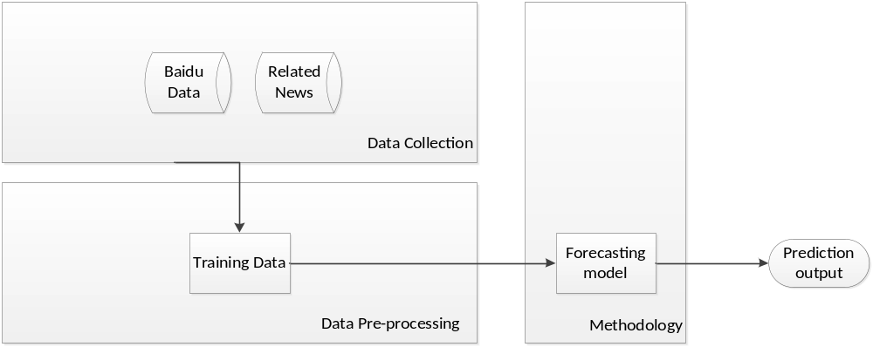
Figure 3-2: The data flow for Methodology

Data Collection
First of all, history data should be applied and collected from one of four (4) suggested SIAS. After reviewing, Baidu Top Trends was selected over other Social Issue Analytic Service (SIAS) to be used as dataset of social issue keywords. This decision was done under the following considerations:
- There are different group of search engine and SNS users. In Weibo or Twitter, users pay more attention on entertainment events or celebrities. However, in Baidu, people would be more interested on social issues. In other words, the social issue topics in Baidu Top Trends included covers more categories than SIAS provided by SNS;
- The behavior of users is totally different between Baidu and other SIAS. Users of Weibo will share topics which they are interested in and discuss these with other people. Normally, these topics are presented by other famous people and are discussed by their followers. On the other hand, users of Baidu understand what they are looking for exactly and then they would use an appropriate keyword to search what they want. As a result, it is convenient for users to search for related news in Baidu and the related news provide by top 50 keywords are more accurate.
- Baidu, a famous Chinese search engine, has various numbers of active users and large searching query base. Therefore, it can offer lots of social data analysis for Baidu Top Trends.
- Social issue keywords in Baidu Top Trends are updated hourly;
- Baidu Top Trends offers more parameters than Google Trends or Twitter Trending Topic as well as four (4) or five (5) related news for each keyword, which could solve disappeared time problem for this research. Meanwhile, Baidu Top Trends updated around 50 keywords every hour. Weibo Data Trends, on the other hand, offers 20 keywords hourly, but it does not have related news for each keyword as Baidu top Trends. Moreover, since a keyword disappears and comes back later, it would be difficult to identify if the same keyword has the same meaning as before.

Thus, social issue data from Baidu Top Trends appear to be a better choice for this research compared with other 3 SIAS.

Baidu Top Trends
After we determined that Baidu Top Trends is better for collection, we will decide what kinds of parameters were provided and could be collected in this service. Like Google Trends, Baidu Top Trends also offered the search trends service based on the search volume of users. There are several sections on trends service, such as real-time hotness topic, one week hotness topic, one day hotness topic, events, entertainment and so on. Baidu Top Trends records all data from users and rank these according to the above mentioned sections depending on search volume.

However, only real-time hotness topic section is updated hourly, which again is useful for this research by following reasons:
- All real time keywords were present in ranking, search volume and related news.
- Real-time hotness topic focuses on the rate of change of new keywords. The rate of change of the new keyword is equal to the searching volume in the last 24 hours divided by the searching volume in second for the last 24 hours. While users enter this section, it will return top 50 trends from highest rate of change.
- This section is updated hourly.

As a result, since 02 November, Real-time hotness topics in Baidu Top Trends with search volume, ranking number, keyword, date time and their 4 or 5 related news hourly were collected. At the same time, these were added as a group and labelled using GroupID, meaning the 1st hour collection becomes 1st group in the Database. In the social data set, ranking number, which is ranking of each keyword and up to 50 in each group, could be our parameter in this research.

Data Pre-processing
During the 6-month data collection period, some questions were raised and needed to be addressed during the training input dataset. Since different keywords have different lifetimes, the length of ranking number of each keyword is totally different. This problem will impact in building a forecasting data model by using training data, which does not fit a uniform length of instances. As a result, in this step, our main aim is to unite the length of ranking number of each keyword, which is called Average Lifetime, for better comparison and slicing the ranking number of each keyword into same length of instances for forecasting models.

Disappeared time
Before dealing with average lifetime problem, the disappeared time problem should be solved. During six (6) months of data collection, the main finding of lifecycle of each social issue keywords is not linear regression because some keywords will disappear for a few hours and come back to top fifty (50) keywords again. The disappeared period of a keyword is a disappeared time of this keyword and this disappeared time problem will impact to determine if same keyword will not mean the same after reappear. Let's assume that the keyword "Apple", a computer company, appeared in the list of top fifty (50) but after one hour, it disappeared; Twenty hours later, “Apple”, a fruit, displayed in the rank again. In this case, second “Apple” should be a new keyword in training data since it means completely different with first “Apple”. As a result, before using these disappeared keywords as training data, data pre-processing to solve the disappeared time is necessary and it is important to figure out if the disappear keywords are meaning the same.

While there are many keywords with disappeared time from data collection and it was quite difficult to determining all these keywords. However, it is quite clear that this disappeared time problem will impact the accuracy of each keyword. As a result, before using these disappeared keywords as training data, its pre-processing is necessary and it is important to figure out if the disappearing keywords mean the same. Otherwise, two different keywords must be used training data.

It was hard to solve this disappeared time problem for each keyword, so, for the purpose of this research, the average difference between two gaps we computed by using related news. In this stage, nouns were extracted from the related news of each keyword in each hour. After that, these were compared to the end of the previous lifecycle of a keyword and the start of the next lifecycle of a keyword, such as 2046 in figure 1 and 2355 in figure 2 Jaccard distance method is then used to count the difference between these nouns. Jaccard Distance is the derivative of Jaccard index, which is a statistic for comparing similarity of two sample sets. In this case, nouns sets from two same keywords are two sample sets and the formula for Jaccard Distance is as follows:
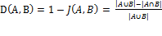 1
In (1), if the result is closed to 1, it means that meanings of same keyword in two periods are totally different; If the result is approaching 0, it means the keyword has quite similar meanings after reappear.
After Jaccard distance was computed, results were recorder hourly and average for each hour is calculated. The result of which can be seen in Figure 3-2.

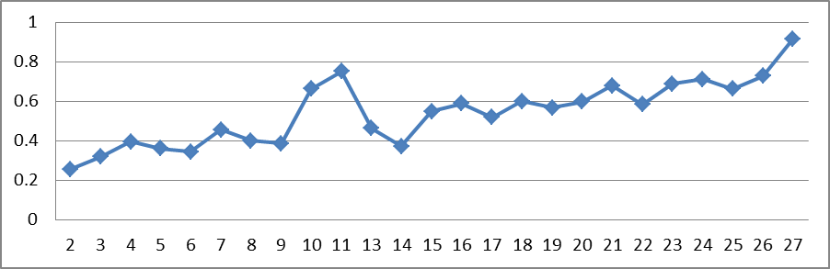
Figure 3-3: the graph shows the average distance value for each hour.

After 9th hour, Figure 3-2 shows that the Jaccard Distance value is closer to 1, thus, 9 hours was used as available average disappearing time because value of 9th hour is lower than 0.4, which is quite similar. Even through, the value in 14th hour is low too, that is an exception because of data deficiencies. If a keyword disappears beyond 9 hours, then it shall be set them as different keyword. However, if the disappearance time is less than 9 hours, it will set as same keyword.

Average Lifetime
After solving the disappeared time problem, the lifetime of keyword and disappeared time were combined to count the available average hour for initial length of training data set. The flow is as shown in Figure 3-3:
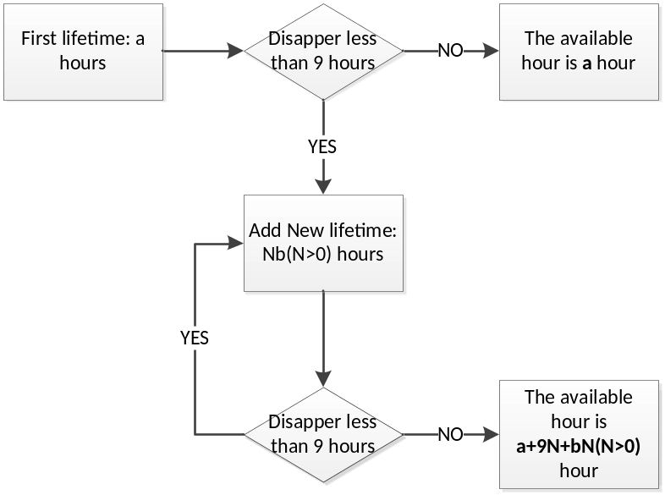
Figure 3-4: the flow present the counting of available hours

After average the lifetime of keywords in total 65 days’ training dataset, the available hour is 13 hours. So, in the end of pre-processing data, I cut each keyword into one period of 13 hours as initial training data, which is one instance. The 13 hours length of each instance is default length in here and I will test the accuracy of different lengths in Evaluation section.

Missing value
After decided the average lifetime of ranking number for each keyword, the next question about how to deal with disappeared time will be considered in each instance. Since this disappeared time will impact the accuracy of the initial result, there are two (2) replaced values which could be used to define value of disappeared time for instances:
- Question Mark: as the disappeared value is a missing value from the ranking number of Baidu Top Trends, question mark could be used to define this disappeared value.
- Number 51: since the disappeared value is always large than 50, number 51 could be one of options for disappeared time.

In the experiment, these two special values will be used in training data to reduce the influence of disappeared time for comparing the result.

Forecasting Methodology
In third step of data flow, three (3) popular forecasting models, which are FFNN, KNN and Logistic, shall be applied for predicting output as we mentioned in Literature Review and the accuracy of which are compared to results in later experiments.

After data pre-processing, qualitative forecasting techniques are used to forecast the lifecycle of social issues because: 1). Baidu Top Trends provided social issue keywords analysis service which can be used as historical data for quantitative forecasting techniques. 2), ranking number will disappear and come back a few hours later, so data will be non-linear and AI model will be considered. As a result, it would be assumed that FFNN, one of the popular AI models, can have high accuracy and also other two AI models, such as K-NN and Logistic, were introduced for comparison with FFNN in Evaluation section.

FFNN
First AI forecasting model is FFNN, which is the most popular predicting machine learning model in stock market forecasting. There are many researches using FFNN to forecast for better accuracy in Literature Review by following reasons:
- FFNN as a statistical tool could learn from training data and then make use of data that is present in the input data set intrinsically.
- FFNN are data-driven method can learn by adjusting the weights to forecast the output target of a given set of input samples independently. (Thawornwang and Enke, 2004)
- FFNN is good at model non-linear processes without priori assuming the input and output variables during the generating process.(Halliday,2004)
Before applying FFNN, the number of hidden layers should be determined. To deal with the number of hidden layers, Jeff Heaton, presented that there are not many researches using more than one hidden layers and two hidden layers will be enough for any kind of trends. He believed that the reasons to determine the number of hidden layers are as follows:

- 0: only be used in linear data structure or decision making. As the data structure in this research was non-linear, zero (0) hidden layer could not be a better choice.
- 1: can be used in mapping from one finite space to another. If there is not any specific requirement, one hidden layers can work on many cases using FFNN.
- 2: can build any smooth mapping to any accuracy and 2 hidden layers can work for any kind of trends currently with a specific requirement.

In this forecasting methodology, the use of single hidden layer was decided upon since there are finite input data currently and single hidden layer can save more time on building the forecasting data models than two or more hidden layers. Here is the topology of FFNN with one input layer, , one output layer, , and single hidden layer as shown in Figure 3-4 and each instance in training data is a node .
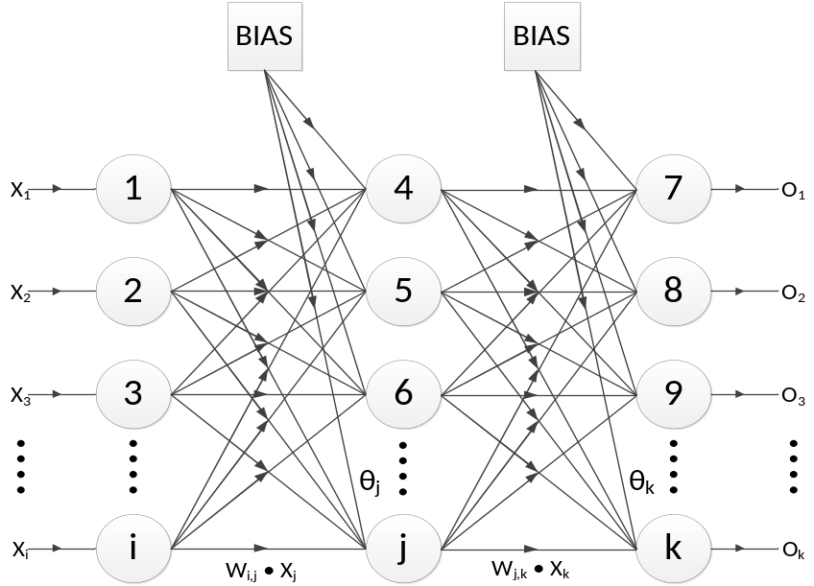
Figure 3-5: FFNN with one hidden layer

There are two (2) steps in FFNN, such as Feed Forward Step and Back Propagation Step. First step is to achieve the forecasting output, and second step is to learn based on the error from training data independently.
Feed Forward Step
This step is to input training dataset into input layer and en propagates in each layer to achieve the output. After the training dataset is put into the input layer, the weighted sum of the input to the node in the hidden layer is given by:
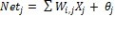 2
The term is the weighted value multiplied by a BIAS node which is equal to 1 to avoid zero values in Neural Network as (3) ：
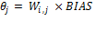 3
Since the training data is non-linear structure, so the sigmoid equation was required as follows:
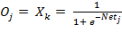 4
Equations (2) to (4) can be used to determine the output value for node k in the output layer as normal Neural Networks. This process will be finished after each node in the different layers has received an error signal repeat, which describes its relationship with the overall error.

Back Propagation Step
After the last step, these errors are updated for each connection weights until all the training patterns are encoded. This step is to minimize value of the error function in weight space and then learning process will use the weights containing the minimum value for building forecasting model. In the different layers, learning algorithms will be difference.
In output layer, the difference between the actual output and the predicting output is as follows:
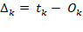 5
: the predicting output node;
: the actual output node.
Next, the error signal in output layer can be display as:
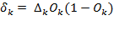 6
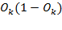: is the derivative from equation (4).
As the proportional in Δ rule, equation (7) to (8) are the formulas to edit the weight, , is:
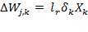 7
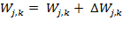 8
: is the changed weight from the node to the node.
is the learning rate, which is a relatively small constant that presents the relative change in weights and default value is 0.3. If the learning rate is small, the network will learn slowly. However, if the learning rate is large, the network may oscillate around minimum point and adjust the lowest point but never reaching it.
is same as and is the input value to the node.
During the updating process of the weights, an improving modification from equation (8) is as follows:
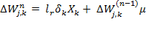 9
: the momentum term, is used to accelerate the learning process and supported the weight changing in the same direction Sequentially. The default value is 0.2.
In hidden layer, the Error Signal for the node can be calculated as:
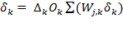 10
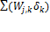: the term adds all nodes with the weighted error signal in the output layer.
As same as Equation (8) and (9), the formula to update the weight,, from the node and the node is:
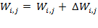 11
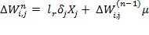 12
Finally, Back Propagation is derived by minimizing the error on the output nodes over all the patterns in the network and Error Function, E, as following:
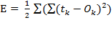 13
After training the forecasting model by FFNN, the forecasting model will be used for predicting ranking of input dataset. During this process, forecasting model will learn from input dataset automatically.

IBK (K-NN)
Second advised AI forecasting model is K nearest neighbors (K-NN). K-NN is a simple pattern recognition forecasting model that stores all training dataset and classifies new input dataset based on a similarity measure or distance functions as present in Figure 3-5 .
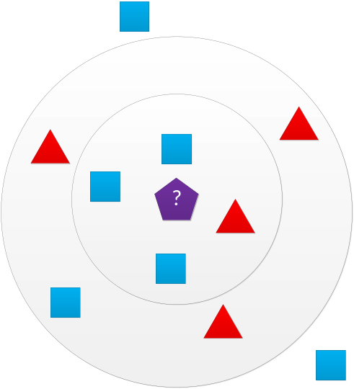
Figure 3-6: the idea of K-nearest neighbor

In this graph, squares and triangles in circle are training dataset and pentagon is the input dataset. After pattern recognition, pentagon will become a square based on the distance functions of K-NN, which is present as following equation:
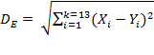 14
Distance functions will include Euclidean as Equation (14), Manhattan, Minkowski and the value of K, which is how many neighbors are considered for one instance, can be determine that using 3 to 10 can get a better result than 1-NN normally. However, because of time limitation, this methodology uses only the Euclidean as default distance measure and 1-NN or NN will be applied.

Logistic Curve
Final AI forecasting model is Logistic model. Logistic model is a linear regression which can forecast the probability of each ranking number from 0 to 1, which serves as a logistic curve as seen in Figure 3-6, and then the highest probability one will be the future ranking . The prediction in logistic regression is based on one or more predictors, such as numerical and categorical.
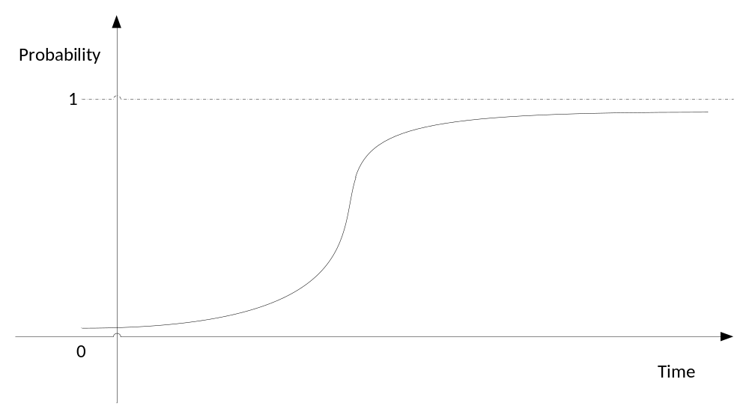
Figure 3-7: the topology of logistic regression

The logistic regression equation can be written in terms of an odds ratio, .
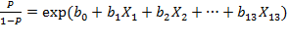 15
：is the probability of one instance.
: is the constant of curve.
: is the slope of curve and the coefficient, which is the value that changed with X.
: is the first hour ranking in training data.
After transformation, Probability equations for logistic regression in training data set are as:
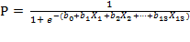 16
By using this equation (16), we will get each probability of total fifty (50) possible ranks for each keyword and the highest probability ranking will be expected ranking as predicting output.

Summary
Social data were collected from Baidu Top Trends and ranking of keywords was used as parameters from Jan 17 2013 to March 23 2013 as training dataset, which included 65 days of data. Then, to unite the instance for forecasting models, the average disappeared time and average lifetime of training dataset, which is set default as 13 were computed. After training data, this training dataset was inputted into three (3) forecasting models. The predicted output from forecasting models becomes predicted ranking, which is the forecasting result. These parameters and forecasting models are evaluated in another section of this paper.

Evaluation
The main topic of this research is to forecast the lifecycle of social issues in China. In this section, there are four sets of evaluation, such as forecasting model experiment, length and number of instances in training data testing, predicting value evaluation, and time spent experiment were introduced.

Introduction
In the methodology section, each keyword with ranking number, articles and date of collecting time had already been described and pre-processed and 3 main forecasting technique models in qualitative forecasting areas were applied. The Researcher designed four sets of experiments based on different purposes, such as testing forecasting model, evaluating length of instance and number of training dataset, evaluating the predicting value and time spent experiment in different length and number of instances.
The first experiment is to evaluate three forecasting models, which are Feed Forward Neural Network, K-Nearest Neighbor and Logistic curve, with two different missing values replacement, number 51 and question mark. This experiment aims to compare and gain the better forecasting models with an appropriate missing value for later experiments. After determining an appropriate forecasting model with missing value replacement, second experiment is to evaluate the length of each instance and number of instances in training dataset. This experiment aims to gain a better accuracy from different length and numbers of social data set. When the Researcher has a better suggestion for forecasting model, suitable length of each instance and number of instances, the Researcher will proceed to the third experiment, which is testing the forecasting value. In this experiment, The Researcher will conduct an experiment to get the accuracy of suggested forecasting model and appropriate length and number of instances from the last two experiments. The final experiment is time spent experiment in different length and number of instances. It discusses how to balance running time of forecasting model for a predicting output and time spent on it.

Test method
Before starting the experiment, the Researcher has to determine the input data and the training data for building forecasting data models from the training dataset. The Researcher has three advised forecasting models with ranking number as parameters and a training dataset to which models can be fit. As the training dataset is not large enough, after taking a sample of the validation data from training data, our model would not fit the validation data but it will fit the training data. Having only 65 days of training dataset from data collection, there was a scarcity of instances to separate it into training data and input data, so for this circumstance, testing methods will be applied in to evaluate parameter of training. The testing approach used is the k-Folds Cross Validation, k is equals to 10. The main reason for applying k-Folds Cross Validation is to deal with data scarcity and k value as 10 is generally use in Cross Validation.

Cross validation is a -validation technique model for evaluating how the results of a statistical analysis will generalize to an independent data set and where the original sample is randomly partitioned into K equal size subsamples. Usually, the K value in K-Folds cross validation as 10 is commonly used. During the cross validation, training dataset was randomly cut into ten groups, and setting the first group as input data and others as training data to build forecasting model. In the next procedure, the second group will be the input data and other groups will be training data and this will be repeated for a total of 10 rounds.

Compared 3 Artificial Intelligent Models with two missing value
After determining the testing method, the Researcher will introduce the first experiment, which is comparing three AI models with two advised missing value. Since other experiments are based on forecasting models with an appropriate missing value, it is necessary to decide which forecasting model could be the best for the initial test. There are three Artificial Intelligent forecasting models introduced in the Literature Review and illustrated in Methodology:
- Feed Forward Neural Network (FFNN): a machine learning technique.
- K-Nearest Neighbor (KNN): a pattern recognition technique and given that the Researcher determines the K as 1, 1-NN or NN will be applied in this experiment.
- Logistic Curve: a pattern recognition technique.

Before training dataset input into these 3 forecasting models, missing value problem have to be determined as blank as missing value in instances cannot be recognized in forecasting models, which will ignore the disappear time and impact to final predict the result.

Missing value
To solve the missing value problem, there were two missing value replacement introduced in Methodology section, which are question mark and number 51. Two different missing values will change the structure of training dataset. For instance, if question mark is selected as the missing value, the structure of training dataset is non-linear model; but if number 51 is selected as the missing value, the structure becomes linear model. Since the data structure is changed, the accuracy from different forecasting models may change too.

As a result, The Researcher will compare the different forecasting models in question mark first, and change the missing value into number 51 by using the following processes:
- Collecting the social data from Baidu Top Trends between January 17th 2013 and March 23rd 2013
- Training the social data into 13- hour length of instances and replace missing value with number 51 and question mark
- Before inputting training dataset into forecasting models, the Researcher used 10-fold Cross Validation to separate training dataset into 90% training data and 10% validation data as input data
- Run training data in 3 forecasting models to build a forecasting data models
- Input validation data into forecasting data models to predict the outcome
- After the prediction ranking output materializes, compare the predicting result with the actual ranking number afterwards count the percentage of accuracy.
The result of 3 forecasting models with two missing value is presented as Figure 4-1.
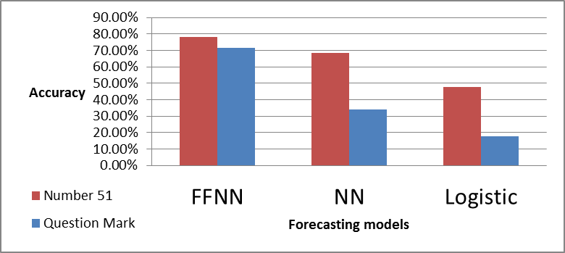
Figure 4-8: The result of 3 forecasting tables with different missing values.

As seen in the bar chart, X-axis indicates the three forecasting models and Y-axis indicates the accuracy. Red bar represents the missing value replaced with number 51 and blue bar represents the question mark replacement. It is noticeable that the result of number 51 presented as the red bar in the table above is consistently better than the question mark in three different forecasting models, remarkably in NN and logistic. The accuracy of number 51 is twice higher than question mark. Also, the result gathered in using FFNN shows best result regardless of which missing value is applied the missing value replaced by number 51 accumulated the best result based on six experiments. As a result, The Researcher will use FFNN as a forecasting model and with number 51 as the missing value for the following experiments.

Different length and number of instances comparison
After determining the forecasting model with a better missing value replacement, the Researcher will apply the forecasting model, FFNN, into the second group of experiments, which are testing the accuracy of different length of each instance and the number of instances in training dataset.

Different lengths of instances comparison
Initially, this evaluation is for assessing the accuracy with different length of instances. Stated in the second procedure, the Researcher came to a decision to use 13 as the default length of instances in forecasting models to come up with an output predicting ranking number. Since the different length of instances will have an impact in building the different size of forecasting data models, which will have different accuracy and running time. In FFNN, the Researcher will test the length for accuracy for this section. The collecting of and pre-processing step are similar with the previous step but in this circumstance, the Researcher reduced the length of instances into 10 and 7 hours for each instance and will apply it only in FFNN.
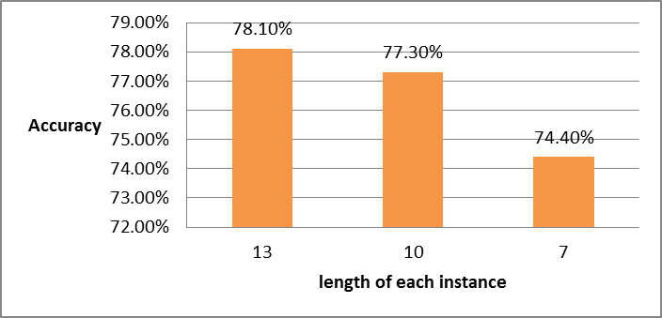
Figure 4-9: The result of length for each instance

In Figure 4-2, the X-axis indicates the different length of instances in training dataset and the Y-axis indicates the accuracy from FFNN. In this graph, as the lengths shorten, the accuracy decreases. Comparing 13 and 10, the accuracy decreased 0.8 %. In the case where the length is reduced to 7, the accuracy decrease abruptly. For the rest of the experiments, the Researcher will apply 13 as the default value to be used in each length for each instance. Moreover, the length, which is over 13, such as 16, can be affiliated in further experiments. The Researcher is certain that the longer length each instance is cut- the more length cut in each instance will render faster accuracy forecasting model to predict.

Comparing 3 different number of instances
The first experiment tests the length of each instance, while the second experiment compares the accuracy of the different number of instances. In this experiment, the Researcher will test whether the number of instance in training dataset has an impact in accuracy. The relationship between the number of instance and the number of days in training dataset is presented in Figure 4-3. While the Researcher reduces the days from training dataset, the number of instances decreases. To present a clear comparison result, the Researcher cuts down some days from training data instead of reducing the number of instance. In the training dataset, the Researcher used a total 65 days and for this experiment. After which the Researcher will reduce the days to 55 from January 17th 2013 to March 17th 2013. Finally, reduce it to 50 days from January 17th 2013 to March 12th 2013 will be used for training dataset.
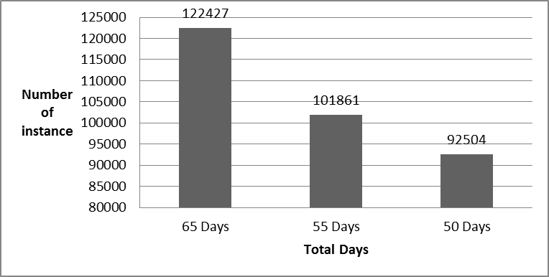
Figure 4-10: The relationship between the number of instance and the number days in training dataset

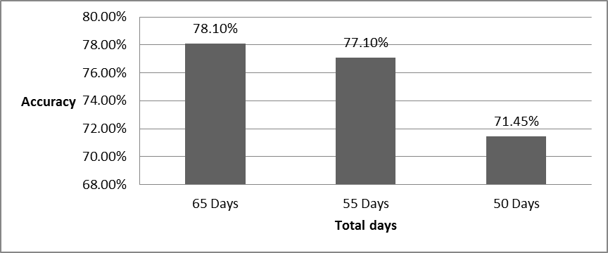
Figure 4-11: The result of reducing the days from training dataset

As presented in Figure 4-4, X-axis represents the total days in training dataset and Y-axis represents the accuracy. In this graph, as the total days reduce, the accuracy drops. Between 65 days and 55 days, the dropping is insignificant and it only reduced 1% of accuracy. After 55 days was lessen, the trend suddenly decreases and drops to 71.45%. In this experiment, the number of instances in training dataset had an impact to the accuracy of predicting ranking number and the Researcher considered that the greater number of instance in training dataset, FFNN can reach a greater accuracy. However, after the number of instances increased, the Researcher found that the running time in FFNN also increased. Therefore, the Researcher will examine them in later experiments.

Range of predicting value comparison
After testing the forecasting models, the missing values, the length of each instance and the number of days in dataset, the Researcher came up into a conclusion that FFNN with number 51 as missing value replacement, which was cut down as 13 hours length for each instance in total 65 days training dataset, can reach a better accuracy. Therefore, this experiment aims to examine how FFNN achieve accuracy. In this experiment, the Researcher will compare the forecasting output in FFNN with the actual value from input data based on an acceptable difference. Acceptable difference is the absolute value between forecasting output and actual value. During the experiment, the process is same as with the first experiment but in this case, the Researcher needs to add one step to gain the predicting output from FFNN. After comparing the predicting ranking with the actual ranking, we will record the number of instance in acceptable distance and then the result, which is the number of correct result, will be divided by the total instances number for the accuracy. The result is presented as Figure 4-5.
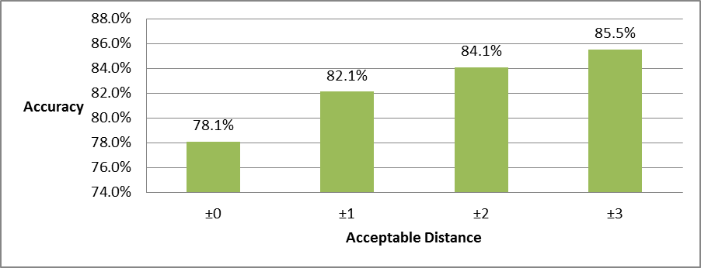
Figure 4-12: The result of predicting value based on different acceptable differences.

As displayed in Figure 4-5, the X-axis represents the acceptable difference and the Y-axis represents the accuracy. In this graph, while the acceptable difference increases, the accuracy also increases. However, after acceptable difference is increased into 2, the accuracy growth is stable. Between ±2 and ±3 difference, the accuracy only increased 1.4% and the Researcher is certain that the acceptable difference which more than ±3 will increased stably. As a result, if acceptable difference is equal to 2, the accuracy of FFNN using length of 13 will be 84.1% which means that the accuracy of FFNN is above average if we ignore the error, which is less than ±3.

Time spent on FFNN with different length and number of instances
After 3 groups of experiments in accuracy testing, the Researcher will evaluate the performance of different length of each instance and different number of instances to discuss how to balance running time and accuracy in FFNN. In this group of experiment, the Researcher will test the running time on different length of each instance. This running time includes building forecasting data models and predicting output from input data. The processing is similar with the previous experiment and this experiment was done 10 times the average time spent. The result is presented in Figure 4-2.
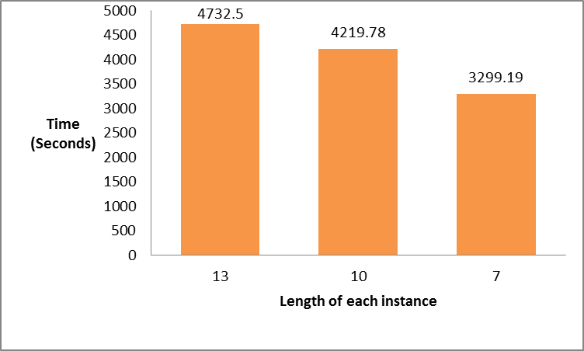
Figure 4-13: The running time of 3 lengths for each instance
In Figure 4-6, X-axis represents 3 lengths of each instance and Y-axis represents the time spent on building the forecasting data models, which unit is seconds. The difference of length between 13 and 10 is only around 500 seconds but compared to length between 10 and 7, the difference is over 900 seconds. As a result, the Researcher is certain that the increasing length of each instance will enhance the performance time of FFNN but will increase slowly after more length of each instance is used.

The next experiment is done to test the time spent on different number of instances in training dataset. The Researcher will test three training dataset involving different days’ data within 10 times for average running time. The result is presented as Figure 4-7.
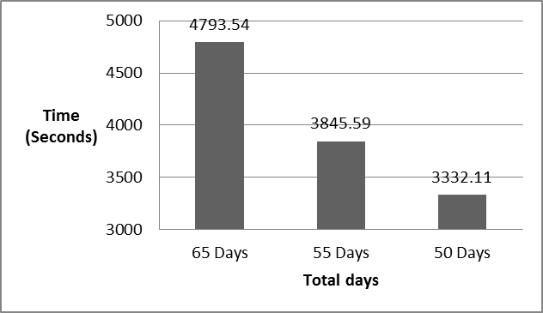
Figure 4-14: The running time in different training dataset

In Figure 4-7, X-axis represents the number of days included in training dataset, which illustrates that more days involve more instances, and Y-axis represents the running time, which the unit of time used is seconds. The number of instances in 5 days gap is around 10,000 and the time spent on 5 days gap is around 500 seconds. As a result, the increasing running time in this experiment is based on the increasing number of instance and the change rate is quite similar between them.

Summary
Concluding the four groups of experiments, the Researcher believes that if we want to have more accuracy result, the usage of longer length of each instance and more number of instances in FFNN with number 51 as missing value, will cost relative time.

Conclusion
As mentioned in this paper, the main objective of this research is to forecast the lifecycle of social issues in China.

There were two minor sub-questions in this topic:
- What parameters can be applied?
- Which techniques can attain our target and get higher accuracy?
Primarily, 4 Social Issue Analytic Services (SIAS) can be considered. Among 4 SIAS, Baidu Top Trends, a popular Chinese search engine, provides more parameters, such as keywords, ranking number, and related news, which helps deal with potential problems. Ranking number is the main parameter used in forecasting the lifecycle of social data. Methodology and evaluation of this paper is based on this SIAS.

In solving the second question, we assessed the forecasting techniques as classified into two large groups. Between those two groups, we are certain that Artificial Intelligent forecasting model, which is a noun-linear structure, fits social data better. Then again, as a non-linear structure of social data, it is necessary to train them before fitting forecasting models. Afterwards, the Researchers applied and compared 3 AI forecasting models and evaluated the length and number of instances.

After evaluation, the Researcher suggested that FFNN could have a better result in forecasting model in predicting the lifecycle of social issue. Since replacing the missing value with number 51, it can reach a high accuracy, 51 could be a choice to deal with the disappearance of time, which is a stated problem in Methodology. In terms of the experiments for length and the number of instance, it is stated that the more data is in training dataset, the more accuracy we can get. However, since more instances in training dataset for FFNN will spend a relative longer time to gain the forecasting output to balance running time and accuracy will depend on the significance of social data. After the number of instances increase, the Researcher will consider other machine learning forecasting models, such as K-NN, or a better data pre-processing step to train a qualitative history data.

Further Works
Stated are some ideas for further research on forecasting social issues. Although, FFNN can reach a high accuracy compared with the other two machine learning techniques, it spends longer time in predicting the outcome. There are some suggestions to help further research enhance the accuracy and reduce running time effectively.
- Other machine learning forecasting techniques
In this research, the Researchers have already introduced 3 AI forecasting models, which include one machine learning technique, FFNN, and two pattern recognition techniques, K-NN and Logistic Curve. After evaluating, we found out that machine learning techniques can reach a higher accuracy than other two pattern recognition techniques. Since we only applied one machine learning model in this project, the Researcher considers that other machine learning forecasting models can also reach a high accuracy.
- Further FFNN study
When the Researcher applied FFNN as a forecasting model in the Methodology section, the Researcher mentioned that learning rate of the back propagation step in FFNN is 0.3 and the momentum term is default value 0.2, which is common used in FFNN. Since this learning rate reduces, it can enhance the accuracy of predicting outcome but increase the learning time in the whole process of building the forecasting data model. Different from the learning rate, momentum term can speed up the learning process by changing weight in the same direction. How to select the value of the learning rate and momentum term can be a further research.
- Increasing length of each instance
In the evaluation of length of each instance, the Researcher reduced the length in training dataset and then came out with the result, which is longer length can have higher accuracy. However, the Researcher did not choose the length, which is longer than 13, in this experiment. The Researcher considered that it may increase the accuracy but it will enhance the running time.
- Balance between running time and accuracy study
As mentioned in the Conclusion section, to gain a higher accuracy, the running time also increase in FFNN. How to create balance between running time and accuracy can be a further study. This balance depends on how important the social data means to users. In addition, there is a limitation to this study, it is stated that running time cannot be beyond the expected forecasting time. For instance, if users expect a forecasting value after 10 hours but the running time is after 10 hours, there is no use of waiting for the said forecasting result.

References

Appendix A – CD ROM

- Data Collection (including source code in PHP)
- Data Pre-processing (including source code in PHP)
- The result and data in Evaluation 1 for section 4.2
- The result and data in Evaluation 2 for section 4.3
- The result and data in Evaluation 3 for section 4.4
- The result and data in Evaluation 4 for section 4.5

