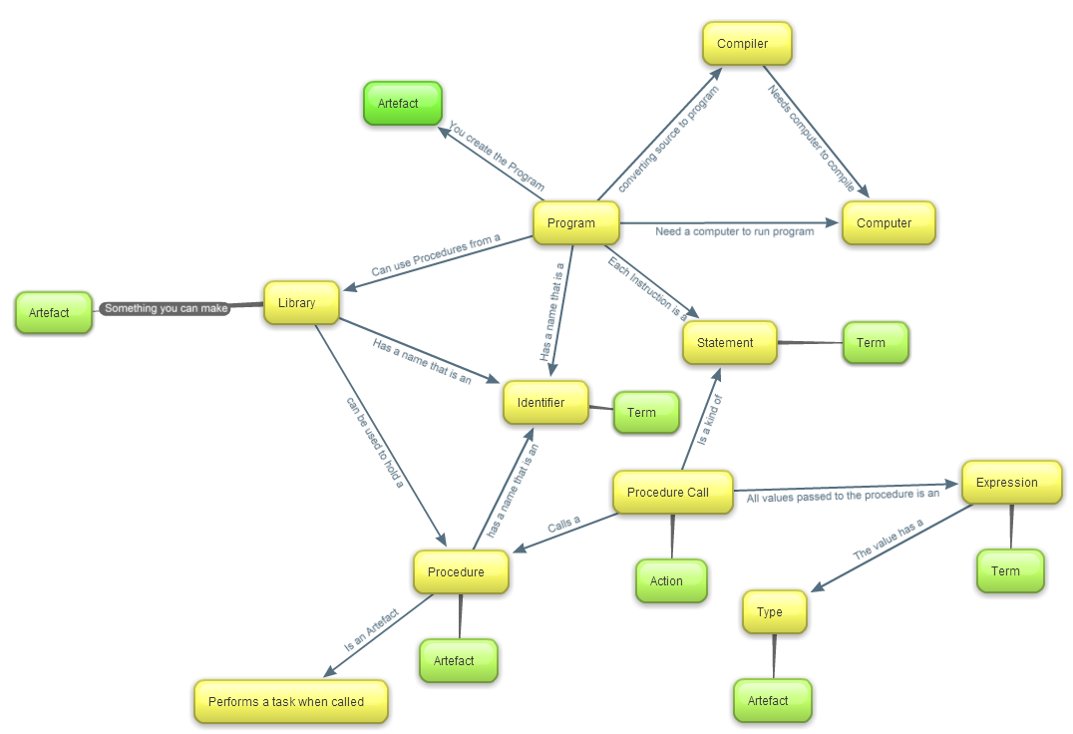

The Program is built by compiling the source code into something the computer can understand, by the computer. The computer runs the programs.

A program is built up from statements controlling the computer to perform certain actions.

The program is built up from Identifiers which name variables you create. The program is built up of libraries that list of code which can be reused. The library stores the Identifiers.

The statement is ordered by the Procedure Call to order the Procedure.

Procedure Call uses the Identifiers to select the correct Procedures to run.

Each variable passed through the Procedure call is an expression.

Every Procedure can be called through the Identifier which is stored in the library