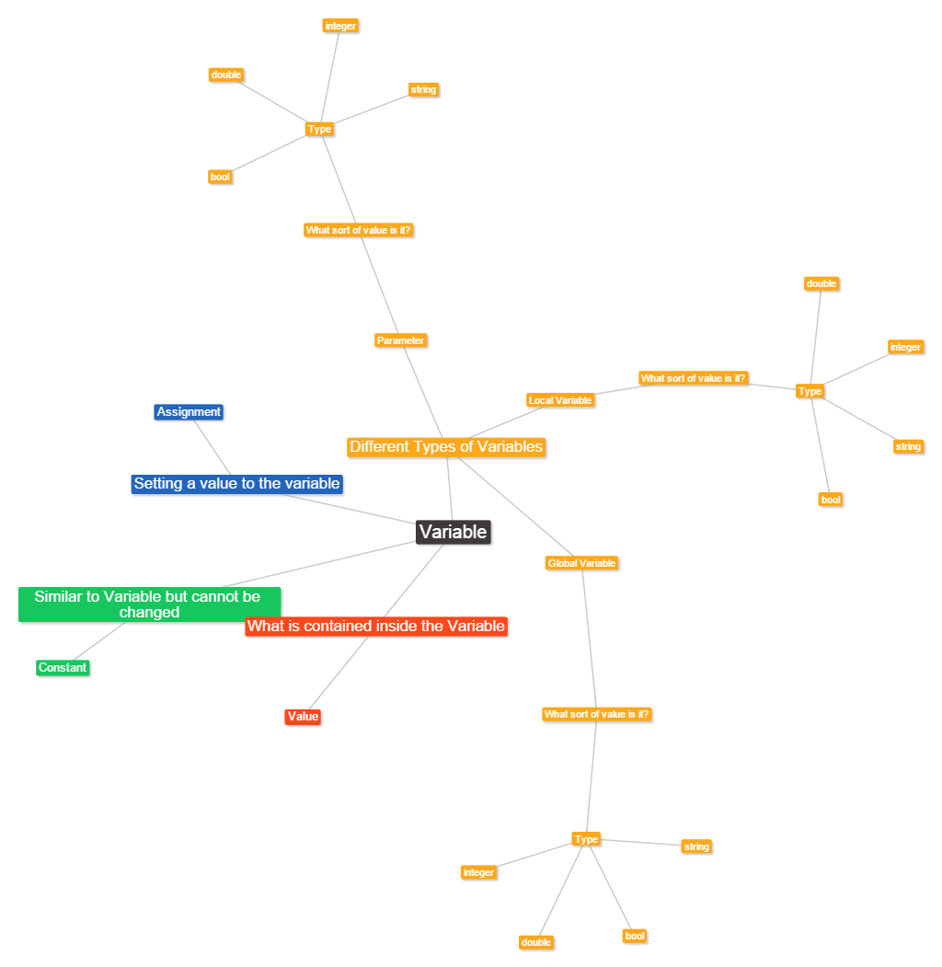Variables have different types and forms. You can have the local Variable which values will only be understood in the procedure or function where as you can have Global variables which can be used anywhere in the program. Also you can have parameters which assign the variable to the procedure/function so that it can be passed to the procedure to define actions. The Variable contains the Value which can be made up of different types such as integer aka numbers, string aka text and double aka number with decimals. A constant is a Variable that cannot be changed. Assignment is the way we set a variables value.