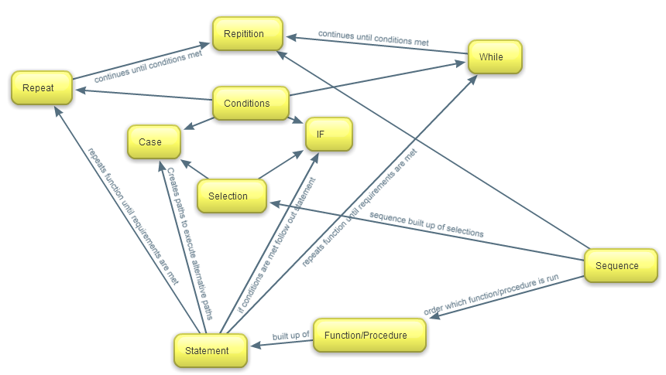

All the types of statements can contain conditions which can set conditions or meet or branch paths. Repetition aka loops (while and repeat) require the condition to be met to continue or the statements inside the function/procedure will repeat endlessly until they are met. Selection is the branching of paths to get different results depending on the answer.

Selection includes case and if statements.

Sequences are the order in which the selection or repetition is read in the function/procedure.