Task 1

|  |
| --- |
| C:\Users\Simonor\AppData\Local\Microsoft\Windows\INetCache\Content.Word\ss (2016-08-10 at 01.59.10).jpg |

Task 2

Mobiles have less powerful hardware so they require more efficient code to run applications with low process/load times compared to PC programs which can run less efficiently and not affect performance by that much due to the high processing power of modern computers. Mobiles require using less power, memory and processing power to perform the same tasks a PC would perform due to the portability reducing performance, memory and battery capacity.

Mobile Operating systems are required to operate with a touch screen having a lack of physical hardware to control the device such as keyboards and mice that a PC have exclusively. Having different methods of using the device leads to different ways people will use the device so it requires a more practical User interface that works better with a touchscreen and the smaller screens.

Android devices have a higher layer Operating system as well as the Linux kernel underlying the system. The Linux kernel controls the functions of the hardware. The Android Operating system sends requests to the kernel to use the mobiles hardware. If you want to use the camera, the OS will ask the kernel to use it as well as to display the view on the screen. Due to this Android has to cater for interruptions from other activities such as the phone ringing. Due to this Android and the applications can be unfocused from the user’s attention and then regain focus when the phone call is done without losing progress in what you were doing requiring the apps to save state before they lose focus. Another difference between Android and windows is that the Linux kernel supports a large amount of different architectures and is open source so that developers can modify it how they want.

Task 3

MDPI

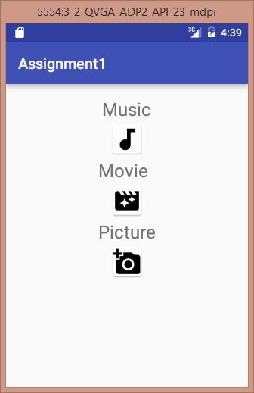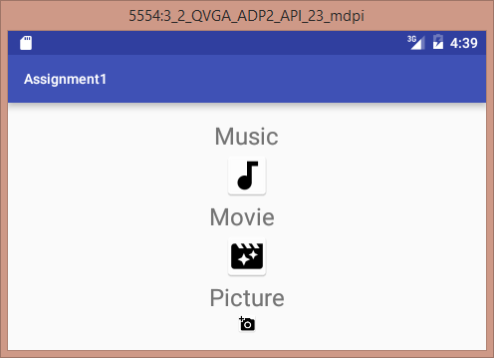

HDPI

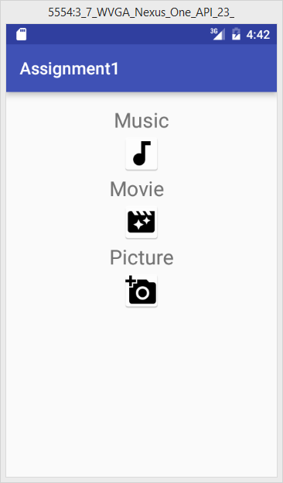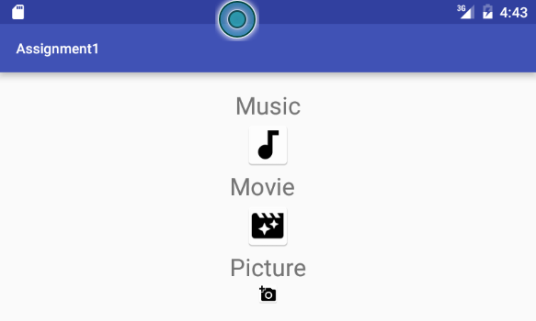

XHDPI

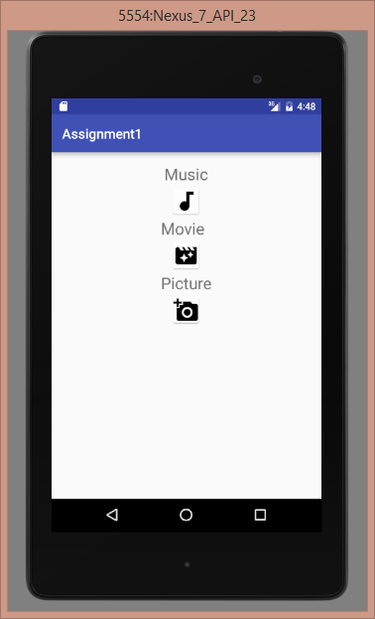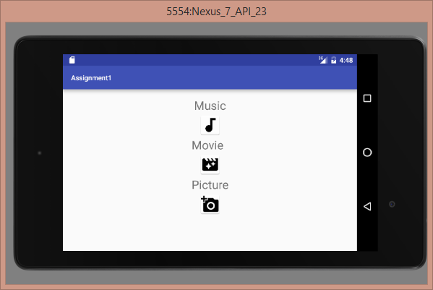

Low Density Images on XHDPI Screen

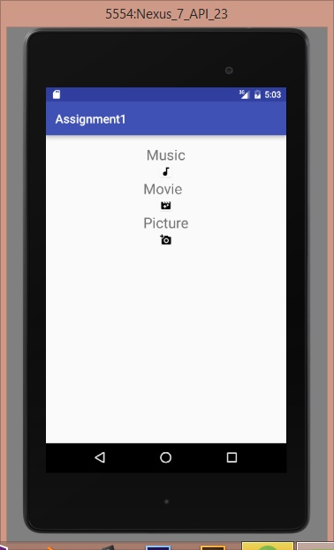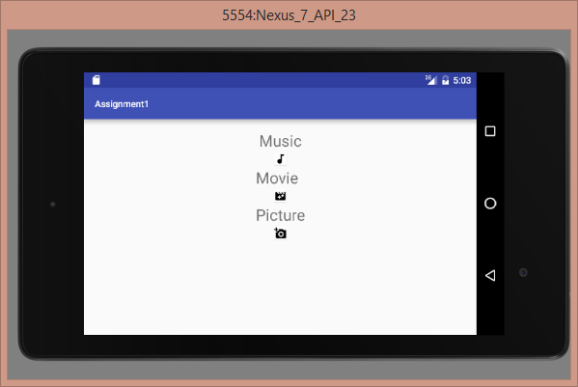

If you force a high density screen to show low density images will become very small as the screen’s resolution is larger than the low density screens. If the developer tries to scale the small image the image will become stretched making it look very pixelated. If the developer forces high DPI it can also cause pixilation if the Image is set to scale depending on the screen size with stretches the pictures.

Task 4

Separation of concern is a design principle which involves breaking a program down into specific concerns. Concerns are different aspects of software functionality. This design principle involves keeping code for different concerns separate. A classic example of Separation of concerns is HTML and CSS, since CSS is styling which is one concern and HTML is layout as another concern.

Separation of concern is important when designing UI as you require different UI’s for different phones with differing screen sizes, resolutions and operating systems.

An example of Separation of Concerns in the Android Studio IDE would be the visual aspect and layout of what you see on the mobile screen EG

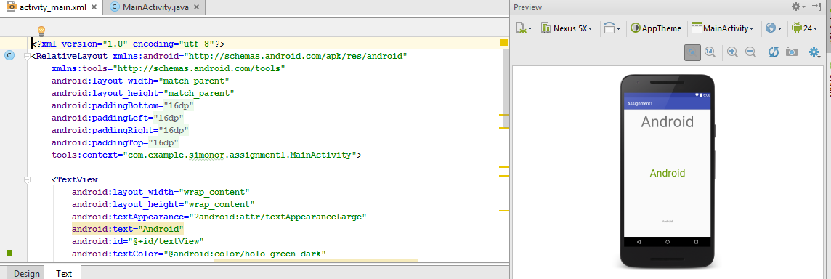

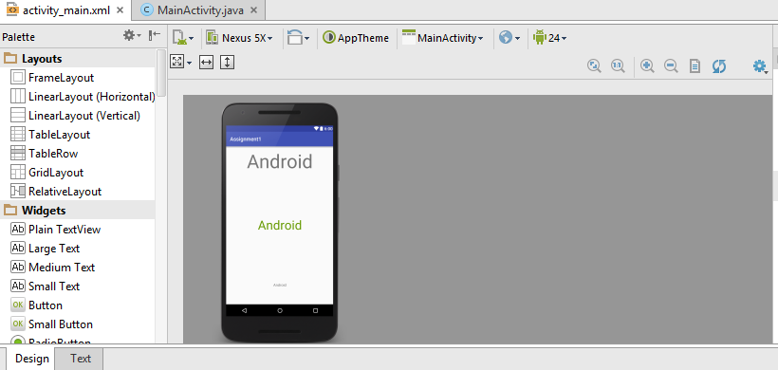

VS the behind the scenes code which performs tasks for the application as shown below

