Task 1

1. Explain why the time information updates when the orientation changes. You must include two images of the app (one portrait, the other landscape). You should also include the Activity life-cycle diagram to support your argument -- clearly highlight the states that trigger the observed time change.

|  |  |
| --- | --- |
|  |  |

When the screen is moved from portrait to landscape orientation the current activity is destroyed and the activity is recreated and initialized again. This results in private instance variables being lost and reset to default values. The only time this static clock is setting the time is when it initializes and that happens when the screen is changing orientation. So as the diagram shows as below when the app changes orientation the activity is restarted back to the onCreate() function which initializes the variables.

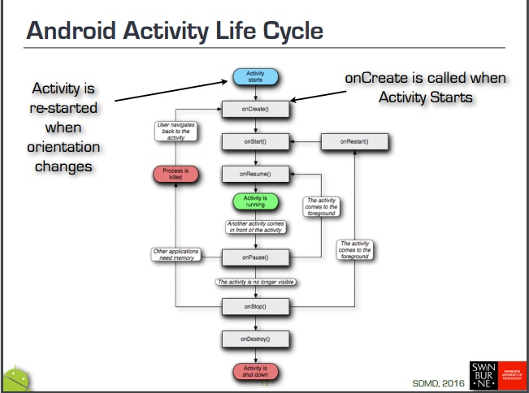

Reference: <https://ilearn.swin.edu.au/bbcswebdav/pid-6055506-dt-content-rid-32441878_2/courses/2016-HS2-COS30017-218827/L03-Complex-Interactions.pdf>

1. Briefly describe the difference between Resume, Pause and Stop states.

The visible lifetime of an activity is between the start and stop states. During this time the user can see the activity on screen however it may not be the main focus of the user in the foreground. The foreground lifetime is between resume and pause where the user’s main focus and interactivity is on screen.

The Resume state is active when the activity is interacting and the main focus of the user. This is when the activity is at the top of the stack.

Pause state is when another activity is about to resume into the foreground and take the focus. This state is usually used to commit unsaved changes to data.

Stop state is when the activity is no longer visible as another activity has taken over or this activity is being destroyed.

Task 2

Briefly explain how you triggered the restart event -- include the screenshot as evidence.

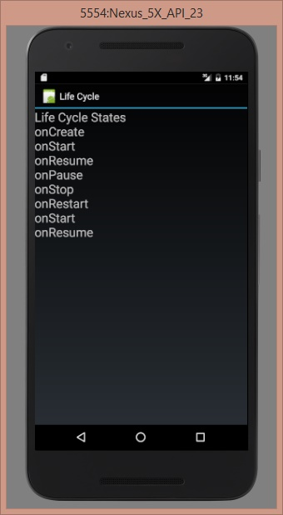

I triggered the restart event by pressing the overview button which caused the activity to lose direct focus and view all activities that are stopped and can be restarted which happens when the activity is redisplayed on the screen after losing focus.

Task 3

Write a short explanation (under 1 page including images and Log messages) describing why some life cycle states are shown only in the Log, but not on screen.

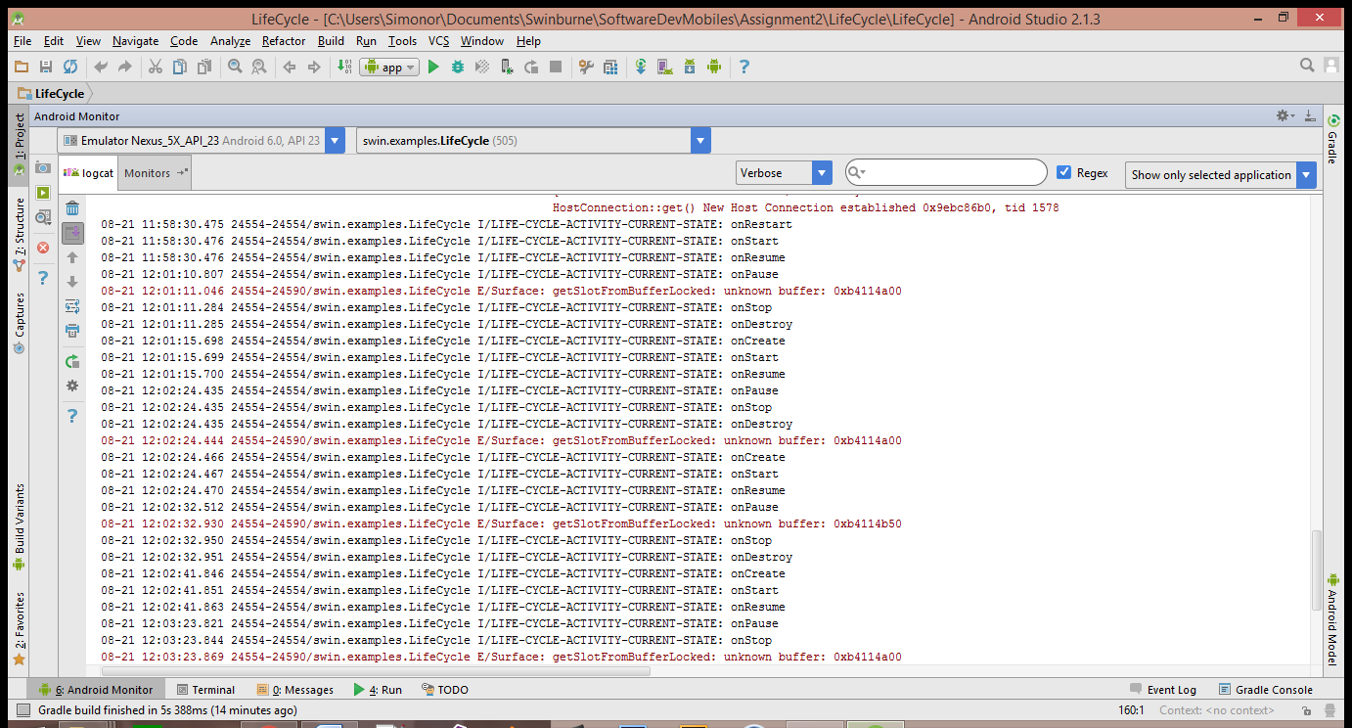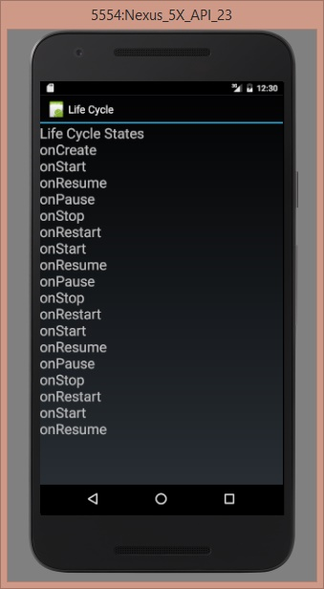

The states displayed on the screen are all part of the lifetime of an activity which happens between onCreate and onStop, however onDestroy is not displayed.

When changing the orientation of the screen only create, start and resume are shown as displayed below. However pause, stop and destroy are not shown. This is because another activity comes into focus on the display before the activity reaches pause, stop and destroy states. The pause saves the information in the lifecycles app with onSaveInstanceState() so if a user presses the home button it will save states changes after it has visibly left the screen when you open it back up after .

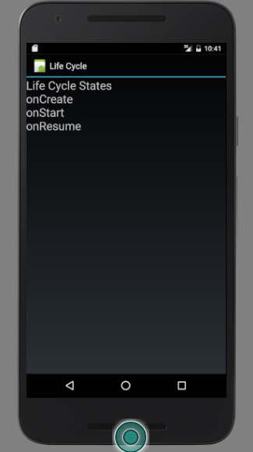

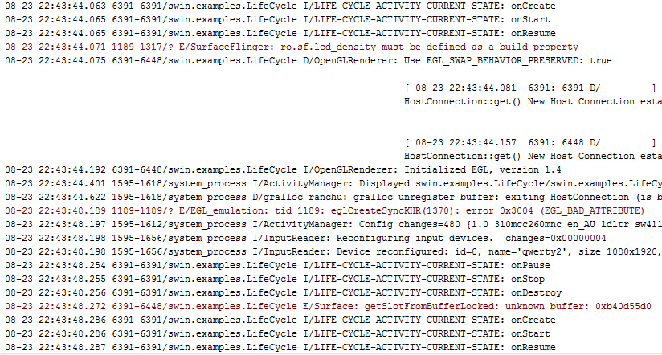

However when pressing the home, back or overview buttons pause and stop are displayed when re-entering the app but destroy still not.

OnDestroy is not displayed as the activity is finishing or being destroyed by the system.

There is no way to return back into the activities lifecycle from the onDestroy method as there is no way it could be displayed inside the app while it is running. As shown below once the activity gets to the onDestroy method, it can only progress to the activity being shut down.

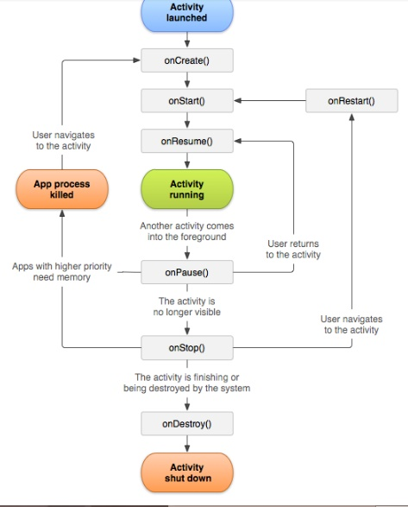

Reference: <https://developer.android.com/images/activity_lifecycle.png>

Task 4

Describe the concept of String externalisation and how it assists localisation (in under 1 page, including images). Illustrate using examples from the Android platform. You must create an app. that will say “Welcome to my app” in English and one other language (e.g. French, Hindi, Chinese). You must take screen shots of the same app.

String externalisation is an easy way to bring multilingual support to your app without having to rewrite all text inside the application. The concept involves making a group of external text files named after the locale with the languages in each. All words/sentences will be linked to variable names so that every instance of their use in the application will come up in whatever locale the android device is running. As shown below you have string values for different languages and the system will pick the correct one from the locale the device is running.

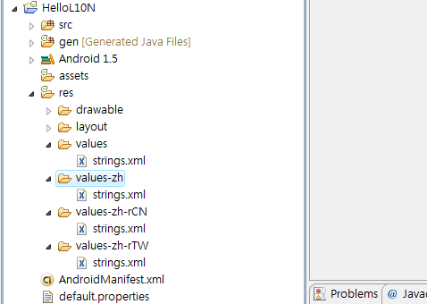

Reference: <https://ykyuen.files.wordpress.com/2009/12/android_localization.png>

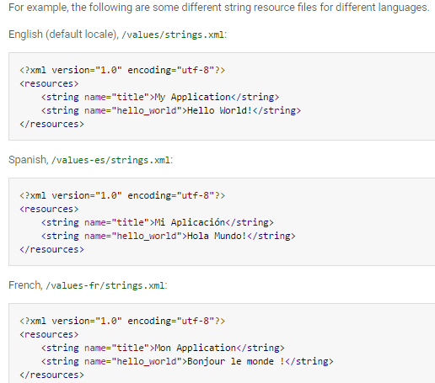

Reference: <http://www.tutorialspoint.com/android/android_localization.htm>

Above shows the text files that contain the different language code so it can be interchanged easily instead of making a bunch of different versions of the whole app for different regions.

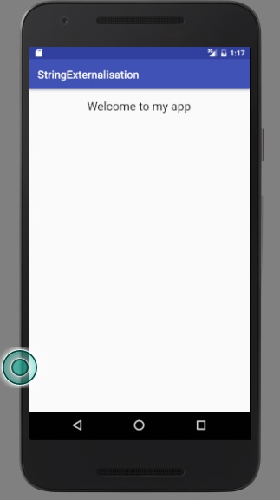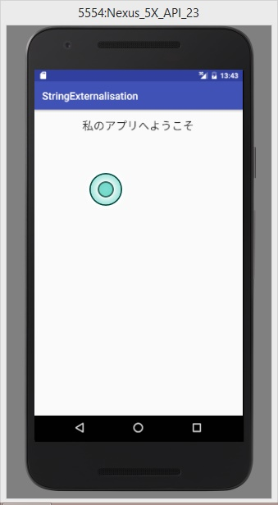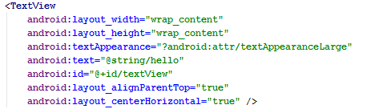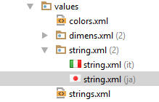

Task 5

