Task 1

- App has a total of three different activities.

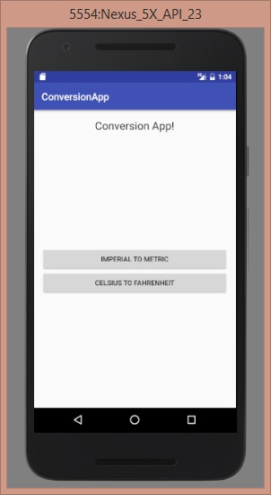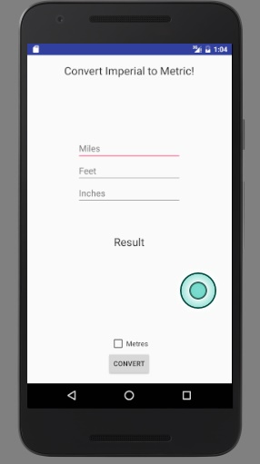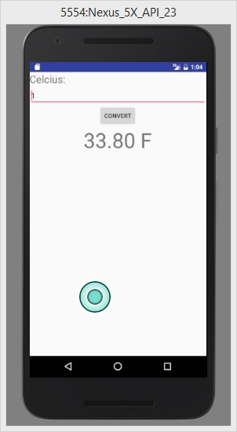

- Properly support orientation changes. Specifically, it should not lose values/state information.

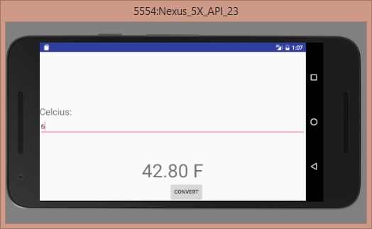

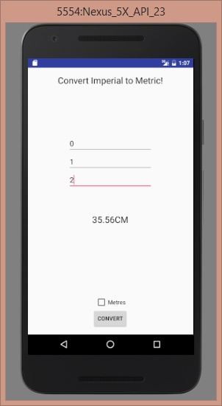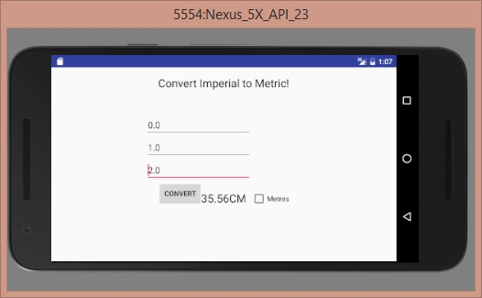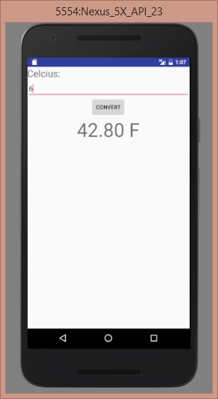

- Provide code snippets showing how different activities are connected.

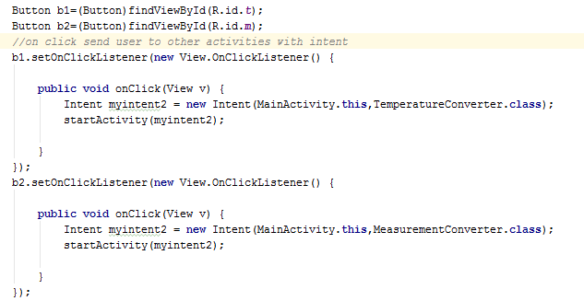

- Provide code snippets showing how orientation change is managed.

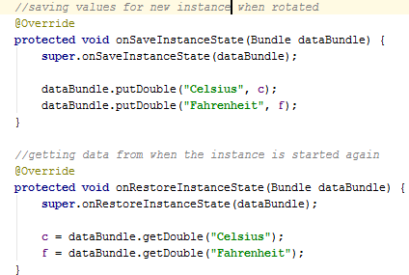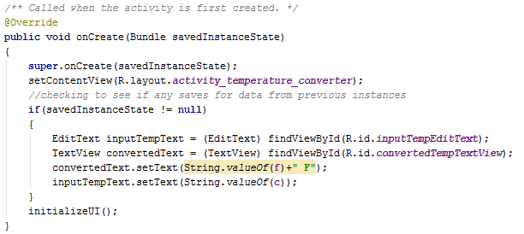

- Provide code snippet showing the XML layouts of the activities.

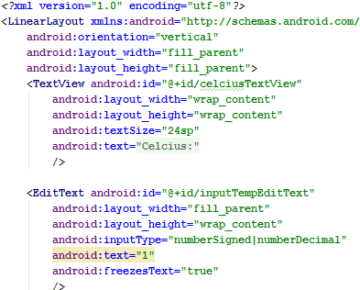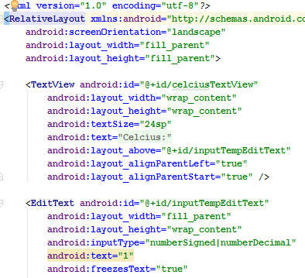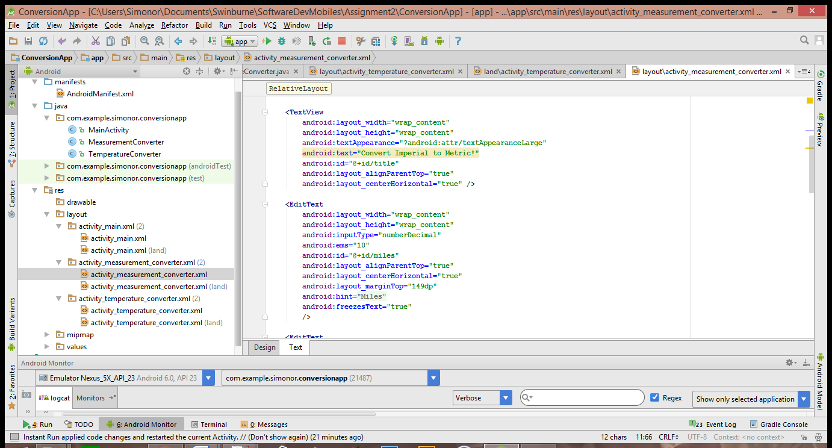

- Code snippets are commented appropriately

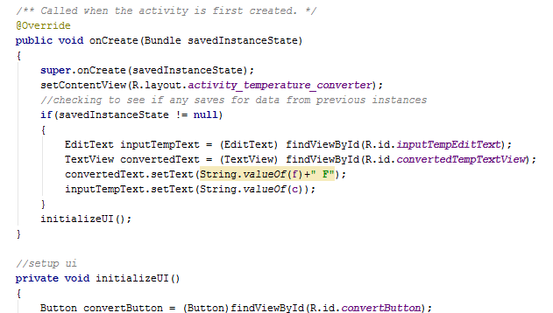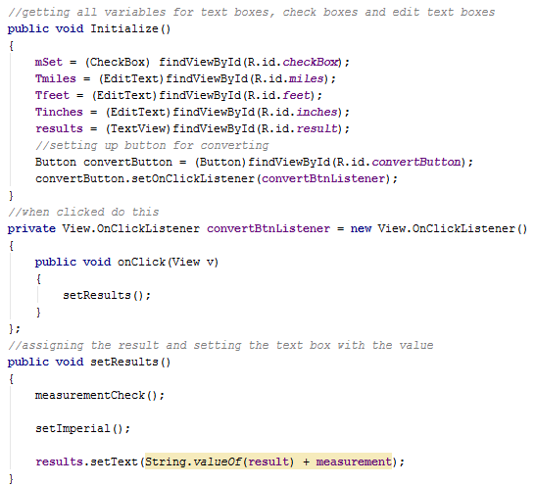

Task 2

- Code snippets show how the two activities are connected.

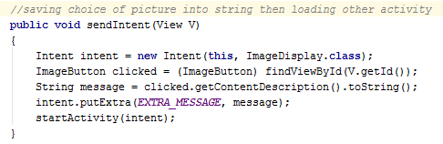

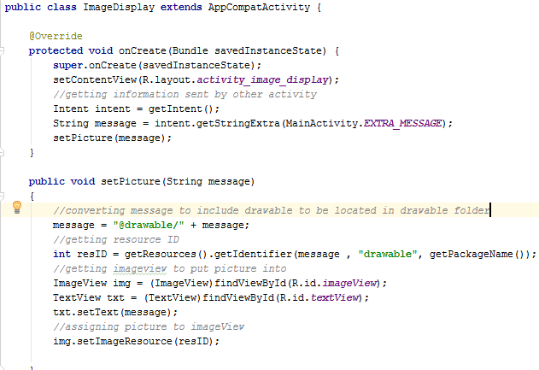

- Code snippet shows the XML layouts of the activities.

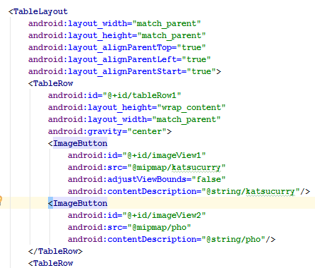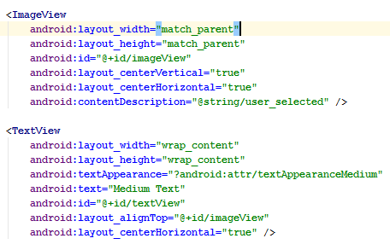

- Code snippets are commented appropriately.

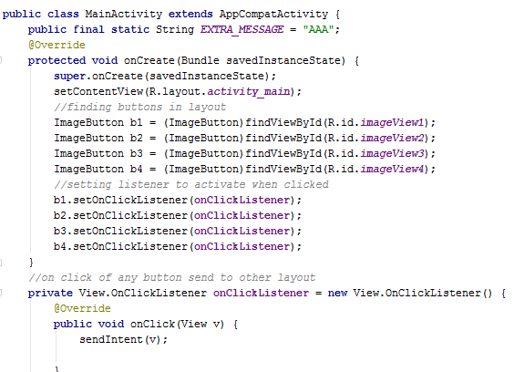

- Code snippet shows how the image and text are loaded/set



- String values are in external XML values (not within layout)

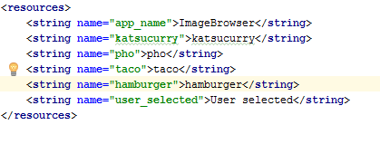

- Screen shots show how the app works

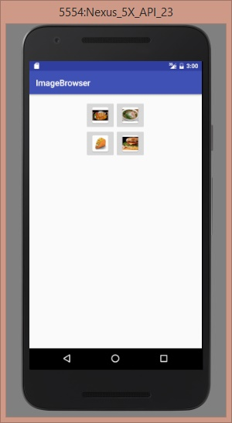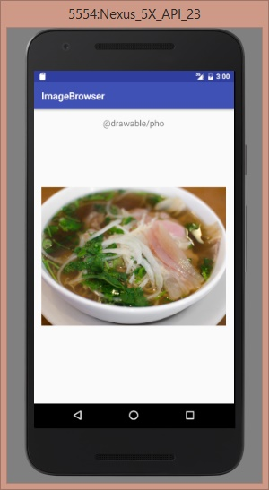

Task 3

(a) Why is the intent messaging facility considered as a late run-time binding between

components?

Late runtime binding means that the compiler does not check intent code so that if there are errors the app will fail. Intents are just information packets so there is no reason why the compiler should check a message between components during runtime. It does not have a compile time binding between components

(b) What are the contents of the passive data structure (of an intent)?

The content of an intent is holding an abstract description of an action to be performed and holding some data in a bundle.

(c) Why is the word “passive” used for the intent data structure? (Hint: What is the responsibility

of an Intent object? Do they have any inherent intelligence built into them?)

The intent system is completely asynchronous. The receiver will get the message only if they request to see intents. Intents do not perform the action themselves, instead they redirect the description for another activity perform it.

(d) Use an example to better explain the sentence “abstract description of an operation to

be performed”.

Intent email = new Intent(Intent.ACTION_SEND, Uri.parse(“mailto:));

startActivity(Intent.createChooser(email, “Choose an email client from…”));

This Intent is an abstract description, in which the description is ordering any activity that can respond for example, writing an email. The intent is redirecting the operation to be performed to an email program with the <mailto:> command. On a device certain activities will respond to this call of intent and use the description to then perform an action such as writing an email.