Introduction

(What does this report contain? Describe the task briefly, why you undertook it and key findings)

This usability test was designed to test the FluidUI prototype of the sun times app and see how easy it was for the users to undertake tasks set by the scenarios and receive feedback on design and usability of the prototype. My key findings returned that the location table which displays saved locations and has a button to view a table was unnecessarily complex compared to the demands set by the key features and what the scenarios required.

Usability Test Method

(Describe the method -- rephrase above method and adjust if you changed it slightly)

To perform the tests I created a Google Forms which linked the supplementary information that was required for the testers to read before trying out the prototype. Below is 2 pictures with some the setup I had to receive feedback after I explained the required information and told them how to fill it out. The first picture included the layout of the activities for the users to look at.

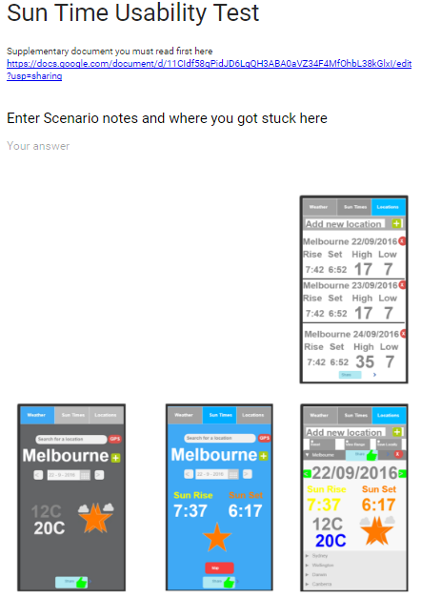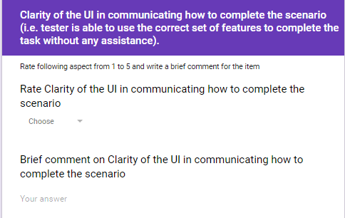

Findings

a. General comments from the users (while performing scenarios)

The users had no problems with scenario 1 clearly understanding how to perform the task given to them with ease. They mentioned how it was clear and concise what to do to complete the task. They all clearly understood how to search for locations and had no problem understanding how the date system worked and how to change it.

The second scenario however was a challenge for the users, with a majority of users got stuck when moving to the locations tab. They understood how to add locations with the plus button and search bar but could not access the table of the locations saved. The other tester had issues with the scenario itself complaining that it was not specific enough mentioning that the countries listed were too general and could not enter longitude/latitude/town names for the specific places that will be stayed in. However after getting over the issues with the locations tabs they thought it was quite easy to understand how to email the table over with the clear share button at the bottom of the page which would send intent to the messenger or email app.

They also all found scenarios 3 and 4 very easy with no problems in understanding how to get the current GPS location with the button. Also they had no problem understanding the method to check the next day with the directional arrows next to the calendar. There was also no problem in users understanding how to use the SMS feature by pressing the share button at the bottom of the screen.

b. Survey results (conducted at the end of the test)

The users thought the buttons were intuitive and was easy to navigate the app except the locations tab which was a bit cluttered with too many buttons on screen and an extra activity that is not needed. One user believed the UI was functional however thought it could look more aesthetically pleasing. All users believed the locations tab was not as clear as the other screens with too much information and small buttons. One user commented about the yellow text on the white background, thought to remove the stars to signify weather/daylight and thought it doesn’t add enough information.

User was unclear on the function of the star on each page and thought that the colour scheme on the location screen was not strong. They commented that apart from the locations tab the general difficulty to use the application was straightforward and easy to use.

In relations to the prototype communicating the intent of the application a majority of the users had no problem understanding that it was a sun rise/set app however one user commented that because it had the weather component which was not used in the scenarios it was not obvious that it was designed to be used as a sun rise/set app as it had a layout that could be like just a weather app.

Discussion on Usability test

(What was surprising/interesting/unexpected? What areas need attention? What did you learn by doing the usability test? What would you change in your design?)

I was not surprised the Locations tab was confusing for the users as just after creating it; I felt conflicted with its design but decided to keep it to receive feedback on the current design. I learnt that without a doubt I will need to redesign the locations tab with less buttons, putting them into the user bar and removing the extra activity that is not required for the pre-set user expectations.

I was slightly surprised that one of the users commented that the visual style was below average as I tried to make it very simple and easy to understand without flashy graphics and animations. One thing I noticed was the mistake I made with the yellow text on the white background in the Locations tab which definitely needs to be changed. From this feedback I might redesign the aesthetics to make it look more pleasing to the eye. After redesigning the UI I would perform another User Test with the working prototype to see if any more changes are required to better the final product.

Summary

(Key findings from usability test, A short summary of your reflection)

The most important feedback I received was to redesign the activities from the Locations tab and merge them into one, replacing the buttons onto an action bar. Also I might want to increase the visuals on the tabs to be more unique and appeasing.

To get more accurate results I believe it would be beneficial to actually make a usable prototype and having the testers use the app on a real mobile. Some of the testers were confused by how the test worked which required me to explain details about functionality when you click certain buttons what actions were performed. This lead to some slanted feedback since I had to explain and assist what would happen after a button press instead of the users experiencing it from themselves. Having the testers just mess around with an app prototype can give more feedback than just showing them the FluidUI design of it.

References

<https://www.fluidui.com/>

Appendix

The survey:

<https://docs.google.com/forms/d/e/1FAIpQLSfCwiIABHh0OyRlkzTqBfAjAIhrAydmq3VmjXMu5vg-IEOIlQ/viewform>

The Supplementary Document:

<https://docs.google.com/document/d/11CIdf58qPidJD6LqQH3ABA0aVZ34F4MfOhbL38kGlxI/edit?usp=sharing>

The Results:

<https://docs.google.com/spreadsheets/d/1ghfaFgog-Ipm0ohPyX4FXugsUZHROHwlwIiLiPY88II/edit?usp=sharing>