**Verb-noun analysis:**

Simulation assume existence of multiple object - tribes. Starting amount of tribes and their population is defined by simulation user, it can change over time.

Their village bases and units (archers, spearmans and warriors) are located on procedurally generated board and have certain statistics. Board size is defined by user. There are also monsters on board. They are hostile towards to villagers (Hard to kill, but worth it). Tribes can expand using food, certain amount can allow to make new unit. User defines starting number of food and spawn rate.

When two hostile units meet there is chance to start war. It lasts till one of village is defeated. Morale system depends on lost units and collected food, values over 100 points increases amount of units, while lower 0 decreases.

**CRC Cards:**

|  |
| --- |
| Class: Ui_Simulation |
| Responsibilities:  Runs the simulation itself |
| Collaborators:  villagerBase  board |

|  |
| --- |
| Class:  board |
| Responsibilities:  Generating and holding map  Generating monsters on empty spots  Generating food on empty spots  Generating village bases on empty spots  Generating units (Warrior, Spearman or Archer) on empty spots  Checking if villageBase is far enough from other bases to not stack them next to each other |
| Collaborators:  calc  Ui_Simulation  unit |

|  |
| --- |
| Class:  calc |
| Responsibilities:  Calculating all math problems needed to be solved |
| Collaborators:  Board  villagerBase  resource |

|  |
| --- |
| Class:  villageBase |
| Responsibilities:  Holds statistics of village bases  Holds list of bases  Removes bases if tribe gets destroyed  Updates morale level |
| Collaborators:  Ui_Simulation  unitStatic |

|  |
| --- |
| Class:  monster |
| Responsibilities:  Holds positions of monsters  Holds statistics of monsters  Holds list of monsters |
| Collaborators:  unitDynamic |

|  |
| --- |
| Class:  resource |
| Responsibilities:  Holds position of resources  Holds list of resources |
| Collaborators:  unitStatic |

|  |
| --- |
| Class:  archer |
| Responsibilities:  Holds statistics of archers  Holds positions of archers |
| Collaborators:  unitDynamic |

|  |
| --- |
| Class:  spearman |
| Responsibilities:  Holds statistics of spearmans  Holds positions of spearmans |
| Collaborators:  unitDynamic |

|  |
| --- |
| Class:  warrior |
| Responsibilities:  Holds statistics of warriors  Holds position of warriors |
| Collaborators:  unitDynamic |

|  |
| --- |
| Class:  unit |
| Responsibilities:  Inheritance class for unitStatic and unitDynamic |
| Collaborators:  unitStatic  unitDynamic  board |

|  |
| --- |
| Class:  unitStatic |
| Responsibilities:  Inheritance class for resource and villageBase |
| Collaborators:  unit  resource  villageBase |

|  |
| --- |
| Class:  unitDynamic |
| Responsibilities:  Inheritance class for archer, spearman, warrior and monster |
| Collaborators:  unit  archer  spearman  warrior  monster |

Class diagram

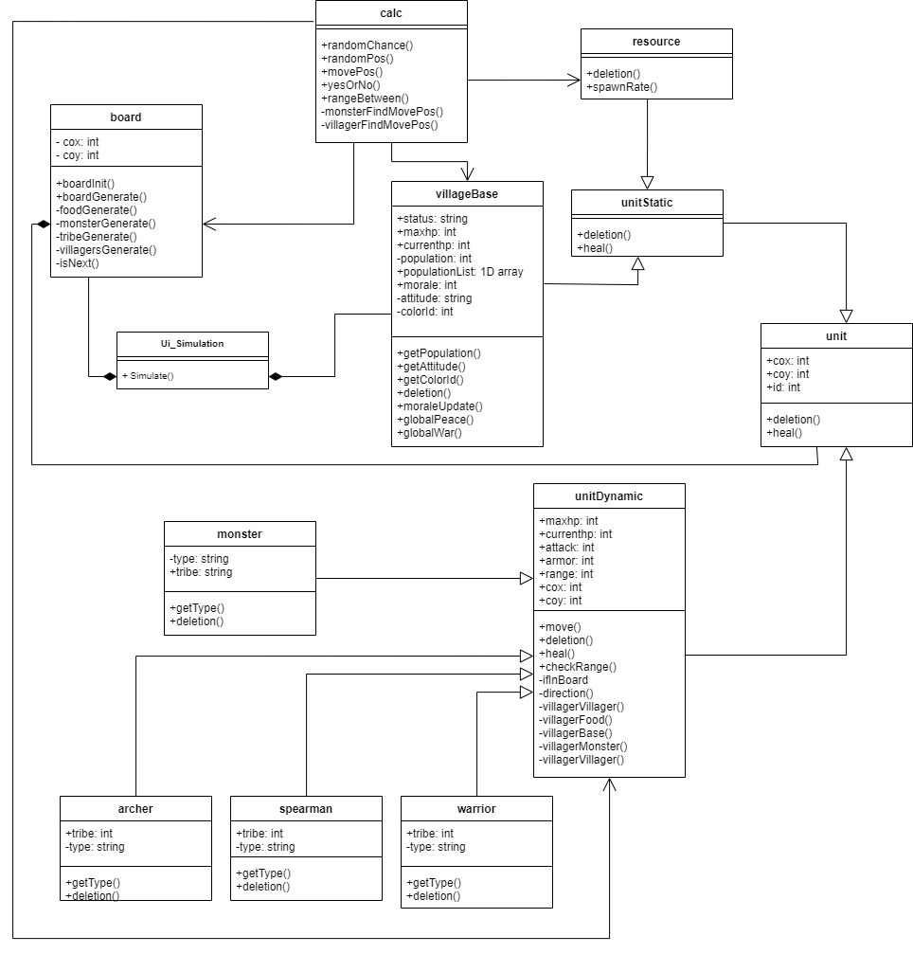

Use case diagram

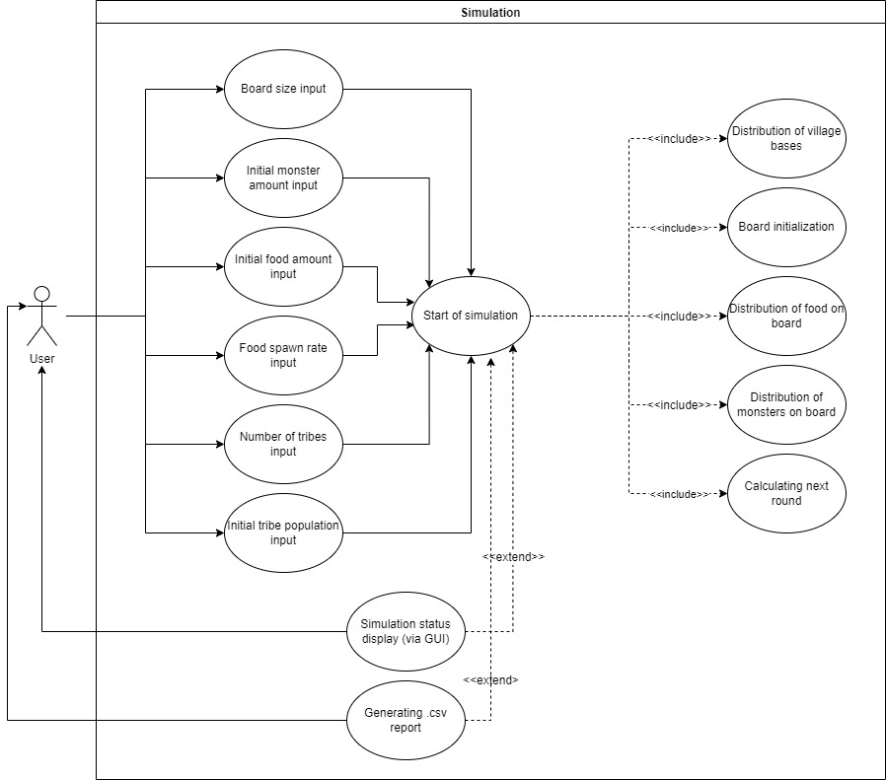

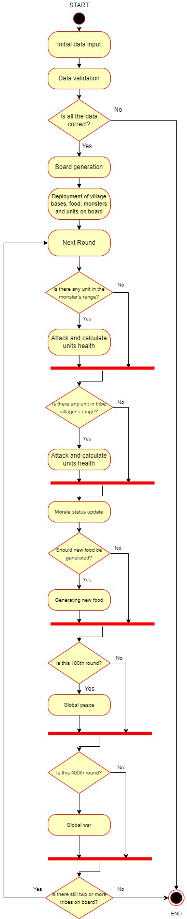Flow diagram

Sequence diagram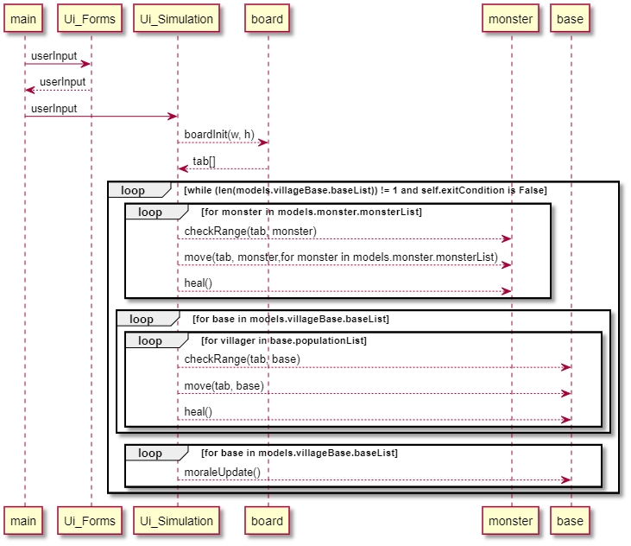

State machine diagram

