Game Design Document

Fill up the following document

1. Write the title of your project.

Dragons and dungeons.

1. What is the goal of the game?

To defeat the main boss who can be summoned by collecting artifacts from other dungeons.

1. Write a brief story of your game.

First the main character (you) will have to level up to get stronger, and the main character has to find dungeons which can be found by killing nearby mobs. Once the main character kills all the bosses found in the dungeons and collects all the artifacts required for summoning the main boss, then the main character can summon the great dungeon which is where the last boss appears, but before he/she can fight the final boss there are some requirements which are: the player has to have atleast reached the 40th level, then he has to kill the other bosses in the great dungeon . With this the player can summon the final boss and fight him. If he wins he has the option to leave the game or continue to play the game, but if something unfortunate has happened in other words the player has died after death the player can respawn with all of his items he has collected so far, but the penality will be that he will lose some levels. This game will also be a multiplayer game.

1. Which are the playing characters of this game?

* Playing characters are the ones who respond to the user based on the input from the user.
* Cars, monkeys, dinos, wizards, etc., are the playing characters in the game.

|  |  |  |
| --- | --- | --- |
| Number | Character Name | What can this character do? |
| 1 | Sorcerer | He can use magical abilities and move around.(He can only use magical items such as a wand, staff, etc.) |
| 2 | Gunner | He can use a gun with special gun related abilities.(He can only use certain gun related items such as: a pistol, rifle, sniper rifle,etc) |

1. Which are the Non-Playing Characters of this game?

* Non-Playing characters are the ones that don't have an action or behavior when the user interacts with the game.
* Hurdles, stones, bananas, coins, etc., are non-playing characters in the game.

|  |  |  |
| --- | --- | --- |
| Number | Character Name | What can this character do? |
| 1 | Merchant | He sells items to the player |
| 2 | Dungeon bosses(dragons) | He tries to kill the player. He also drops an artifact which is used to summon the final boss’s dungeon |
| 3 | Mini dragons | Smaller and wekaer version of the normal dragon and also tries to kill the player, it has a small chance to make a dungeon appear when killed. |
| 4 | Final boss(The Ancient Dragon) | Tries to kill the player and when killed the game is over(but the player can still continue to play the game) |
| 5 | Guardians of the great dungeon | They guard the great dungeon and attemps to kill anyone who tresspasses, when all of the guardians are killed the ancient dragon can be summoned |

Draw your imagination of this game. What does this game look like?

* Draw the game either on your computer or on paper.
* Add images of the game scenes to show each of the playing and non-playing characters at least once.

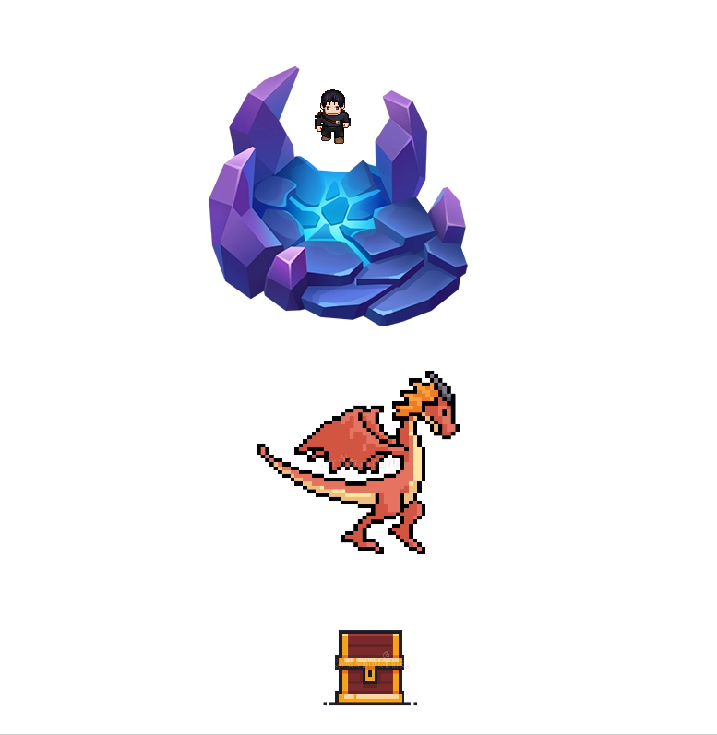

How do you plan to make your game engaging?

I will make the game to have a leveling system, there will also be a leaderboard for people to compete, then there will be more than four dungeons to unlock the final boss and the difficulty of the dungeons increase as the player progresses and sets on to his journey.