

Technical Safety Concept Lane Assistance

**Document Version: [Version]**

**Template Version 1.0, Released on 2017-06-21**



# Document history

**[Instructions: Fill in the date, version and description fields. You can fill out the Editor field with your name if you want to do so. Keep track of your editing as if this were a real world project.**

**For example, if this were your first draft or first submission, you might say version 1.0. If this is a second submission attempt, then you'd add a second line with a new date and version 2.0]**

|  |  |  |  |
| --- | --- | --- | --- |
| Date | Version | Editor | Description |
| 2019-01-03 | 1.0 | Simon Beyer | Initial draft |
|  |  |  |  |
|  |  |  |  |
|  |  |  |  |
|  |  |  |  |

# 

# Table of Contents

**[Instructions: We have provided a table of contents. If the table of contents is not showing up correctly in your word processor of choice, please update it. The table of contents should show each section of the document and page numbers or links. Most word processors can do this for you. In** [**Google Docs**](https://support.google.com/docs/answer/116338?co=GENIE.Platform%3DDesktop&hl=en)**, you can use headings for each section and then go to Insert > Table of Contents.** [**Microsoft Word**](https://support.microsoft.com/en-us/help/285059/how-to-create-a-table-of-contents-by-marking-text-in-word) **has similar capabilities]**

Document history

Table of Contents

Purpose of the Technical Safety Concept

Inputs to the Technical Safety Concept

Functional Safety Requirements

Refined System Architecture from Functional Safety Concept

Functional overview of architecture elements

Technical Safety Concept

Technical Safety Requirements

Refinement of the System Architecture

Allocation of Technical Safety Requirements to Architecture Elements

Warning and Degradation Concept

# Purpose of the Technical Safety Concept

**[Instructions: Answer what is the purpose of a technical safety concept?]**

The Technical Safety Concept defines how the subsystems interact at the massage level and describes how the ECUs communicate with each other.

# Inputs to the Technical Safety Concept

## Functional Safety Requirements

**[Instructions: Provide the functional safety requirements derived in the functional safety concept ]**

|  |  |  |  |  |
| --- | --- | --- | --- | --- |
| **ID** | **Functional Safety Requirement** | **ASIL** | **Fault Tolerant Time Interval** | **Safe State** |
| Functional  Safety  Requirement  01-01 | The Electronic Power Steeriing ECU shall ensure that the oscillating torque amplitude requested by the LDW function is below Max_Torque_Amplitude. | C | 50 ms | LDW will set the oscillating torque to 0. |
| Functional  Safety  Requirement  01-02 | The Electronic Power Steeriing ECU shall ensure that the oscillating torque frequency requested by the LDW function is below Max_Torque_Frequency. | C | 50 ms | LDW will set the oscillating torque to 0. |
| Functional  Safety  Requirement  02-01 | The electronic power steering ECU shall ensure that the lane keeping assistance torque is applied for only Max_Duration. | B | 500 ms | LDW will set the oscillating torque to 0. |

## Refined System Architecture from Functional Safety Concept

**[Instructions: Provide the refined system architecture from the functional safety concept]**

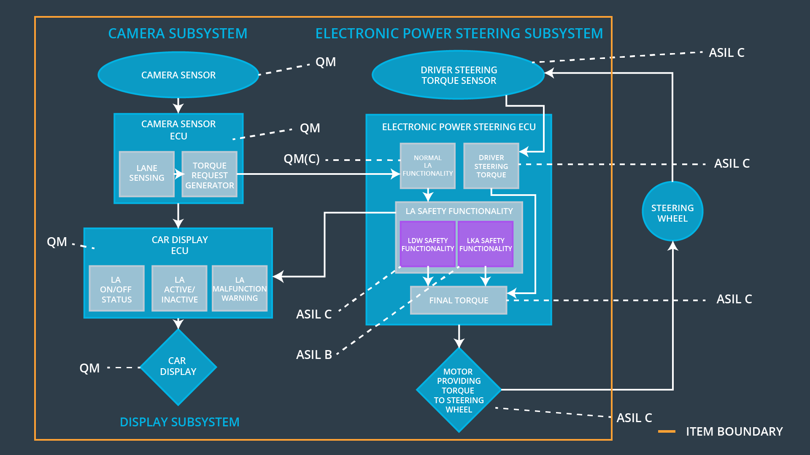

### 

### Functional overview of architecture elements

**[Instructions: Provide a description for each functional safety element; what is each element's purpose in the lane assistance item? ]**

|  |  |
| --- | --- |
| **Element** | **Description** |
| Camera Sensor | The camera sensor reads in images from the road. |
| Camera Sensor ECU - Lane Sensing | The Lane Sensing element reads in an image from the Camera Sensor and extracts lane markings from that image. |
| Camera Sensor ECU - Torque request generator | The Torque request generator derives a steering torque based on the sensed lane markings and the current vehicle position and sends it to the Electronic Power Steering ECU. |
| Car Display | The Car Display shows a warning light to the driver, when the vehicle leaves the lane. |
| Car Display ECU - Lane Assistance On/Off Status | The Lane Assistance On/Off Status indicates whether the Lane Assistance System is turned on or off by the driver. |
| Car Display ECU - Lane Assistant Active/Inactive | The Lane Assistant Active/Inactive indicates whether the Lane Assitant System is fully operational (e.g. has found lane markings an is able to apply a steering torque). |
| Car Display ECU - Lane Assistance malfunction warning | The Lane Assistance malfunction warning indicates that the system is deviated and it is shut down (or degraded). |
| Driver Steering Torque Sensor | The Driver Steering Torque Sensor provides the torque that the driver puts on the steering wheel to the Electronic Power Steering ECU. |
| Electronic Power Steering (EPS) ECU - Driver Steering Torque | The Driver Steering Element reads in the signal from the Driver Steering Torque Sensor which indicates how much (torque) the driver is steering. |
| EPS ECU - Normal Lane Assistance Functionality | The Normal Lane Assistance Functionality |
| EPS ECU - Lane Departure Warning Safety Functionality | This Element receives the torque demand from the Torque request generator in the Camera Sensor ECU and limits the vibration torque to the amplitude and frequency limit. |
| EPS ECU - Lane Keeping Assistant Safety Functionality | The Safety Functionality Element takes care of the functional safety requirements (e.g. it ensures the limits on the vibration torque and the maximum time on the Lane Keeping functionality. |
| EPS ECU - Final Torque | The Final Torque outputs a final torque based on the torque demand from the Normal Lane Assistance Functionality and the driver steering torque. |
| Motor | The Motor applies the demanded torque that is demanded by the Electronic Power Steering ECU onto the steering wheel. |

# Technical Safety Concept

## Technical Safety Requirements

**[Instructions: Fill in the technical safety requirements for the lane departure warning first functional safety requirement. We have provided the associated functional safety requirement in the first table below. Hint: The technical safety requirements were discussed in the lesson videos. The architecture allocation column should contain element names such as LDW Safety block, Data Transmission Integrity Check, etc. Allocating the technical safety requirements to the "EPS ECU" does not provide enough detail for a technical safety concept.]**

**Lane Departure Warning (LDW) Requirements:**

Functional Safety Requirement 01-01 with its associated system elements

(derived in the functional safety concept)

|  |  |  |  |  |
| --- | --- | --- | --- | --- |
| **ID** | **Functional Safety Requirement** | **Electronic Power Steering ECU** | **Camera ECU** | **Car Display ECU** |
| Functional  Safety  Requirement  01-01 | The lane keeping item shall ensure that the lane departure oscillating torque amplitude is below Max_Torque_Amplitude | X |  |  |

Technical Safety Requirements related to Functional Safety Requirement 01-01 are:

|  |  |  |  |  |  |
| --- | --- | --- | --- | --- | --- |
| **ID** | **Technical Safety Requirement** | **ASIL** | **Fault Tolerant Time Interval** | **Architecture Allocation** | **Safe State** |
| Technical  Safety  Requirement  01 | The LDW safety component shall ensure that the amplitude of the ‘LDW_Torque_Request’ sent to the ‘Final electronic power steering Torque’ component is below ‘Max_Torque_Amplitude’. | C | 50 ms | LDW Safety block | LDW shall set the oscillating torque to 0. |
| Technical  Safety  Requirement  02 | As soon as the LDW function deactivates the LDW feature, the ‘LDW Safety’ software block shall send a signal to the car display ECU to turn on a warning light. | C | 50 ms | LDW Safety block | LDW shall set the oscillating torque to 0. |
| Technical  Safety  Requirement  03 | As soon as a failure is detected by the LDW function, it shall deactivate the LDW feature and the ‘LDW_Torque_Request’ shall be set to zero. | C | 50 ms | LDW Safety block | LDW shall set the oscillating torque to 0. |
| Technical  Safety  Requirement  04 | The validity and integrity of the data transmission for ‘LDW_Torque_Request’ signal shall be ensured. | C | 50 ms | Data Transmission Integrity Check | LDW shall set the oscillating torque to 0. |
| Technical  Safety  Requirement  05 | Memory test shall be conducted at start up of the EPS ECU to check for any faults in memory. | A | Ignition Cycle | Safety Startup Memory Test | LDW shall set the oscillating torque to 0. |

**[Instructions: Fill in the technical safety requirements for the lane departure warning second functional safety requirement. We have provided the associated functional safety requirement in the table below. Hint:. Most of the technical safety requirements will be the same. At least one technical safety requirement will have to be slightly modified because we are talking about frequency instead of amplitude. These requirements were not given in the lessons]**

Functional Safety Requirement 01-2 with its associated system elements

(derived in the functional safety concept)

|  |  |  |  |  |
| --- | --- | --- | --- | --- |
| **ID** | **Functional Safety Requirement** | **Electronic Power Steering ECU** | **Camera ECU** | **Car Display ECU** |
| Functional  Safety  Requirement  01-02 | The lane keeping item shall ensure that the lane departure oscillating torque frequency is below Max_Torque_Frequency | X |  |  |

Technical Safety Requirements related to Functional Safety Requirement 01-02 are:

|  |  |  |  |  |  |
| --- | --- | --- | --- | --- | --- |
| **ID** | **Technical Safety Requirement** | **ASIL** | **Fault Tolerant Time Interval** | **Architecture Allocation** | **Safe State** |
| Technical  Safety  Requirement  01 | The LDW safety component shall ensure that the frequency of the ‘LDW_Torque_Request’ sent to the ‘Final electronic power steering Torque’ component is below ‘Max_Torque_Frequency’. | C | 50 ms | LDW Safety block | LDW torque request amplitude shall be set to zero. |
| Technical  Safety  Requirement  02 | As soon as the LDW function deactivates the LDW feature, the ‘LDW Safety’ software block shall send a signal to the car display ECU to turn on a warning light. | C | 50 ms | LDW Safety block | LDW torque request amplitude shall be set to zero. |
| Technical  Safety  Requirement  03 | As soon as a failure is detected by the LDW function, it shall deactivate the LDW feature and the ‘LDW_Torque_Request’ shall be set to zero. | C | 50 ms | LDW Safety block | LDW torque request amplitude shall be set to zero. |
| Technical  Safety  Requirement  04 | The validity and integrity of the data transmission for ‘LDW_Torque_Request’ signal shall be ensured. | C | 50 ms | Data Transmission Integrity Check | LDW torque request amplitude shall be set to zero. |
| Technical  Safety  Requirement  05 | Memory test shall be conducted at start up of the EPS ECU to check for any faults in memory. | A | Ignition cycle | Safety Startup Memory Test | LDW torque request amplitude shall be set to zero. |

**Lane Departure Warning (LDW) Verification and Validation Acceptance Criteria:**

**[OPTIONAL: For each technical safety requirement, identify both the verification and validation acceptance criteria. “Validation” asks whether or not you chose the appropriate parameters. “Verification” involves testing to make sure the vehicle behaves as expected when the parameter value is crossed. There is not necessarily one right answer. Look at your verification and validation acceptance criteria from the functional safety concept for inspiration.]**

|  |  |  |
| --- | --- | --- |
| **ID** | **Validation Acceptance**  **Criteria and Method** | **Verification Acceptance**  **Criteria and Method** |
| Technical  Safety  Requirement  01 | Make a study to test how drivers react to different torque amplitudes/frequencies to prove that we chose an appropriate value for ‘Max_Torque_Amplitude’/’Max_Torque_Frequency’. | Do a software test by inserting a fault into the system. When the demanded torque amplitude/frequency crosses the limit ‘Max_Torque_Amplitude’/’Max_Torque_Frequency’, the lane assistance output must be set to zeros within 50 ms. |
| Technical  Safety  Requirement  02 | Make a study to test how drivers react on the warning light when the LDW function deactivates the LDW feature. | Do a software test with Electronic Power Steering ECU, Car Display ECU and its communication. When setting primary ‘LDW_Torque_Request’ outside the limits ‘Max_Torque_Amplitude’/’Max_Torque_Frequency’ the Car Display must show the warning light. |
| Technical  Safety  Requirement  03 | Make a study to test how drivers react on the total loss of steering vibration torque when the LDW function deactivates the LDW feature. | Do a software test with the Electronic Power Steering ECU. When setting the primary ‘LDW_Torque_Request’ outside the limits ‘Max_Torque_Amplitude’/’Max_Torque_Frequency’, the signal ‘LDW_Torque_Request’ from the Safety Lane Assistance Functionality Block must be 0. |
| Technical  Safety  Requirement  04 | - no validation possible - | Do a software test with the Electronic Power Steering ECU, Car Display ECU and its communication. The data that is transmitted from EPS ECU to Car Display ECU shall not be deviated. Artificial communication errors shall be detected. |
| Technical  Safety  Requirement  05 | - no validation possible - | Do a software test with the EPS ECU by artificially altering the memory. The memory check shall find all memory deviations. |

**Lane Keeping Assistance (LKA) Requirements:**

**[Instructions: Fill in the technical safety requirements for the lane keeping assistance functional safety requirement 02-01. We have provided the associated functional safety requirement in the table below. Hint:. You can reuse the technical safety requirements from functional safety requirement 01-01. But you need to change the language because we are now looking at a different system. The ASIL and Fault Tolerant Time Interval are different as well.]**

Functional Safety Requirement 02-1 with its associated system elements

(derived in the functional safety concept)

|  |  |  |  |  |
| --- | --- | --- | --- | --- |
| **ID** | **Functional Safety Requirement** | **Electronic Power Steering ECU** | **Camera ECU** | **Car Display ECU** |
| Functional  Safety  Requirement  02-01 | The lane keeping item shall ensure that the lane keeping assistance torque is applied for only ‘Max_Duration’ | X |  |  |

Technical Safety Requirements related to Functional Safety Requirement 02-01 are:

|  |  |  |  |  |  |
| --- | --- | --- | --- | --- | --- |
| **ID** | **Technical Safety Requirement** | **ASIL** | **Fault Tolerant Time Interval** | **Allocation to Architecture** | **Safe State** |
| Technical  Safety  Requirement  01 | The LKA safety component shall ensure that the signal ‘LKA_Torque_Request’ sent to the ‘Final electronic power steering Torque’ component is only active for ‘Max_Duration’. | B | 500 ms | LKA Safety block | LKA torque request amplitude shall be set to zero. |
| Technical  Safety  Requirement  02 | As soon as the LKA function deactivates the LKA feature, the ‘LKA Safety’ software block shall send a signal to the car display ECU to turn on a warning ligth. | B | 500 ms | LKA Safety block | LKA torque request amplitude shall be set to zero. |
| Technical  Safety  Requirement  03 | As soon as a failure is detected by the LKA function, it shall deactivate the LKA feature and the ‘LKA_Torque_Request’ shall be set to zero. | B | 500 ms | LKA Safety block | LKA torque request amplitude shall be set to zero. |
| Technical  Safety  Requirement  04 | The validity and integrity of the data transmission for ‘LKA_Torque_Request’ signal shall be ensured. | B | 500 ms | Data Transmission Inegrity Check | LKA torque request amplitude shall be set to zero. |
| Technical  Safety  Requirement  05 | Memory test shall be conducted at start up of the EPS ECU to check for any faults in memory. | A | Ignition Cycle | Safety Startup Memory Test | LKA torque request amplitude shall be set to zero. |

**Lane Keeping Assistance (LKA) Verification and Validation Acceptance Criteria:**

**[OPTIONAL: For each technical safety requirement, identify both the verification and validation acceptance criteria. “Validation” asks whether or not you chose the appropriate parameters. “Verification” involves testing to make sure the vehicle behaves as expected when the parameter value is crossed. There is not necessarily one right answer. Look at your verification and validation acceptance criteria from the functional safety concept for inspiration.]**

|  |  |  |
| --- | --- | --- |
| **ID** | **Validation Acceptance**  **Criteria and Method** | **Verification Acceptance**  **Criteria and Method** |
| Technical  Safety  Requirement  01 | Make a study to test that the time ‘Max_Duration’ chosen really dissuades drivers from taking their hands off the wheel.Make car or software tests that the system really does turn off if the lane keeping assistance ever exceeded max_duration. | Make car or software tests that the system really does turn off if the lane keeping assistance ever exceeded max_duration. |
| Technical  Safety  Requirement  02 | Make a study to test how drivers react on the warning light when the LKA function deactivates the LKA feature. | Do a software test with Electronic Power Steering ECU, Car Display ECU and its communication. When the time ‘Max_Duration’ passes without a torque from the driver, the Car Display must show the warning light. |
| Technical  Safety  Requirement  03 | Make a study to test how drivers react on the total loss of steering support torque when the LKA function deactivates the LKA feature. | Do a software test with the Electronic Power Steering ECU. When the time ‘Max_Duration’ passes without a torque from the driver, the signal ‘LKA_Torque_Request’ from the Safety Lane Assistance Functionality Block must be 0. |
| Technical  Safety  Requirement  04 | - no validation possible - | Do a software test with the Electronic Power Steering ECU, Car Display ECU and its communication. The data that is transmitted from EPS ECU to Car Display ECU shall not be deviated. Artificial communication errors shall be detected. |
| Technical  Safety  Requirement  05 | - no validation possible - | Do a software test with the EPS ECU by artificially altering the memory. The memory check shall find all memory deviations. |

## Refinement of the System Architecture

**[Instructions: Include the refined system architecture. Hint: The refined system architecture should include the system architecture from the end of the technical safety lesson, including all of the ASIL labels.]**

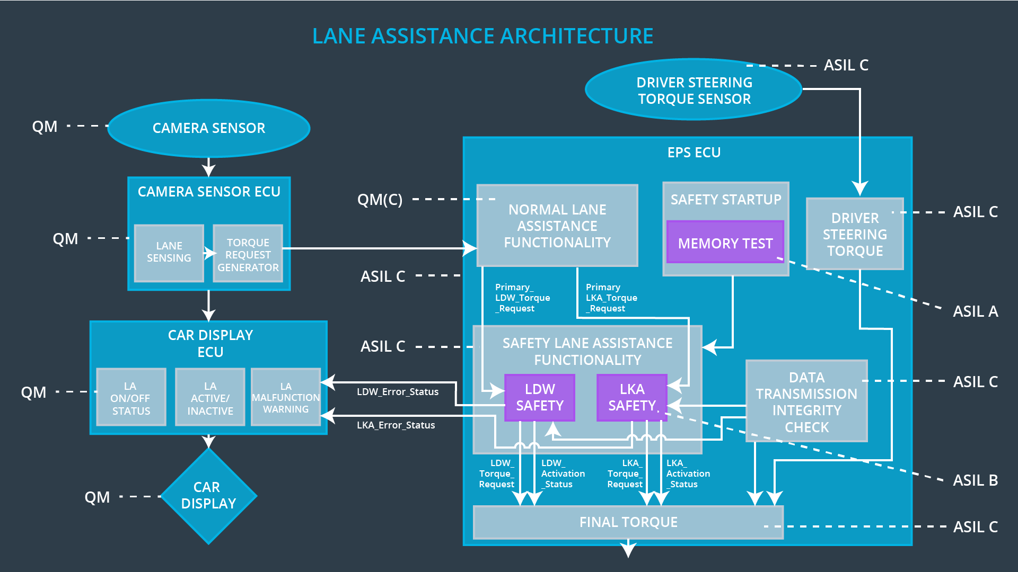

## Allocation of Technical Safety Requirements to Architecture Elements

**[Instructions: We already included the allocation as part of the technical requirement tables. Here you can state that for this particular item, all technical safety requirements are allocated to the Electronic Power Steering ECU]**

All technical safety requirements are allocated to the Electronic Power Steering ECU.

## Warning and Degradation Concept

**[Instructions: We've already identified that for any system malfunction, the lane assistance functions will be turned off and the driver will receive a warning light indication. The technical safety requirements have not changed how functionality will be degraded or what the warning will be.**

**So in this case, the warning and degradation concept is the same for the technical safety requirements as for the functional safety requirements. You can copy the functional safety warning and degradation concept here.**

**Oftentimes, a technical safety analysis will lead to a more detailed warning and degradation concept. ]**

|  |  |  |  |  |
| --- | --- | --- | --- | --- |
| **ID** | **Degradation Mode** | **Trigger for Degradation Mode** | **Safe State invoked?** | **Driver Warning** |
| WDC-01 | Turn off the funcionality – Set torque request to 0 | The lane departure warning function applies an oscillating torque with very high torque amplitude or torque frequency (above limit). | Yes | A message on the car display shows the driver, that the lane departure warning function is not available. |
| WDC-02 | Turn off the funcionality – Set torque request to 0 | The lane keeping assistance function is not limited in time duration which leads to misuse as an autonomous driving function. | Yes | A message on the car display shows the driver, that the lane keeping assistance function is not available. |