

Software Safety Requirements and Architecture

Lane Assistance

**Document Version: [Version]**

**Template Version 1.0, Released on 2017-06-21**



# Document history

**[Instructions: Fill in the date, version and description fields. You can fill out the Editor field with your name if you want to do so. Keep track of your editing as if this were a real world project.**

**For example, if this were your first draft or first submission, you might say version 1.0. If this is a second submission attempt, then you'd add a second line with a new date and version 2.0]**

|  |  |  |  |
| --- | --- | --- | --- |
| Date | Version | Editor | Description |
| 2019-01-03 | 1.0 | Simon Beyer | Initial draft |
|  |  |  |  |
|  |  |  |  |
|  |  |  |  |
|  |  |  |  |

# 

# Table of Contents

**[Instructions: We have provided a table of contents. If the table of contents is not showing up correctly in your word processor of choice, please update it. The table of contents should show each section of the document and page numbers or links. Most word processors can do this for you. In** [**Google Docs**](https://support.google.com/docs/answer/116338?co=GENIE.Platform%3DDesktop&hl=en)**, you can use headings for each section and then go to Insert > Table of Contents.** [**Microsoft Word**](https://support.microsoft.com/en-us/help/285059/how-to-create-a-table-of-contents-by-marking-text-in-word) **has similar capabilities]**

Document history

Table of Contents

Purpose

Inputs to the Software Requirements and Architecture Document

Technical safety requirements

Refined Architecture Diagram from the Technical Safety Concept

Software Requirements

Refined Architecture Diagram

# Purpose

**[Instructions: Answer what is the purpose of this document?]**

The purpose of the Software Requriements and Architecture Document is to develop requirements and metrics against which the item can be verified, that will ensure its functional safety.

# Inputs to the Software Requirements and Architecture Document

**[Instructions:**

**REQUIRED:**

**You are only required to develop this document for the LDW (lane departure warning) amplitude malfunction. So here, provide the technical safety requirements for the LDW amplitude malfunction as well as the refined system architecture diagram from the technical safety concept.**

**OPTIONAL:**

**Expand this document to include software safety requirements for the LDW frequency malfunction as well. Go even further and document software safety requirements for the Lane Keeping Assistance (LKA) function as well.**

**]**

## Technical safety requirements

Technical Safety Requirements related to Functional Safety Requirement 01-01 are:

|  |  |  |  |  |  |
| --- | --- | --- | --- | --- | --- |
| **ID** | **Technical Safety Requirement** | **ASIL** | **Fault Tolerant Time Interval** | **Architecture Allocation** | **Safe State** |
| Technical  Safety  Requirement  01 | The LDW safety component shall ensure that the amplitude of the ‘LDW_Torque_Request’ sent to the ‘Final electronic power steering Torque’ component is below ‘Max_Torque_Amplitude’ | C | 50 ms | LDW Safety | LDW shall set the oscillating torque to 0. |
| Technical  Safety  Requirement  02 |  |  |  |  |  |
| Technical  Safety  Requirement  03 |  |  |  |  |  |
| Technical  Safety  Requirement  04 |  |  |  |  |  |
| Technical  Safety  Requirement  05 |  |  |  |  |  |

## Refined Architecture Diagram from the Technical Safety Concept

**[Instructions:**

**REQUIRED: Provide the refined system architecture diagram from the technical safety concept**

**]**

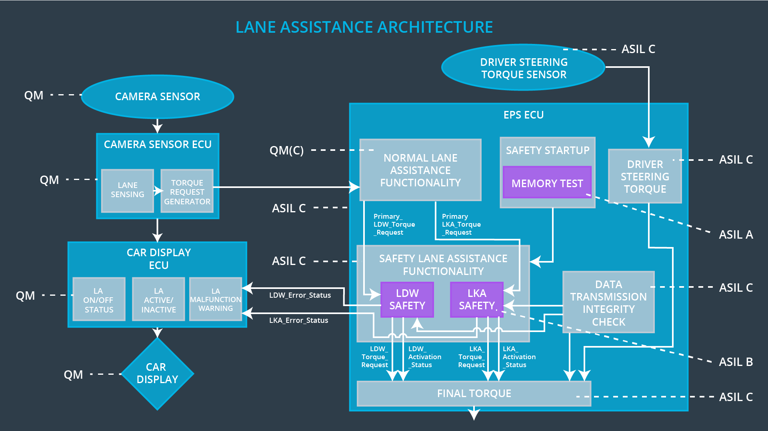

# Software Requirements

**Lane Departure Warning (LDW) Amplitude Malfunction Software Requirements:**

**[Instructions: Fill in the software safety requirements for the LDW amplitude malfunction technical safety requirements. We have provided the associated technical safety requirements. Hint: The software safety requirements were discussed in the text from the software and hardware lesson.**

**OPTIONAL:**

**CHALLENGE ONE**

**Develop software safety requirements for the Lane Departure Warning (LDW) frequency function and modify the system architecture as needed.**

**CHALLENGE TWO**

**Develop software safety requirements for the Lane Keeping Assistance (LKA) function and modify the system architecture as needed.**

**]**

|  |  |  |  |  |  |
| --- | --- | --- | --- | --- | --- |
| **ID** | **Technical Safety Requirement** | **ASIL** | **Fault Tolerant Time Interval** | **Allocation to Architecture** | **Safe State** |
| Technical  Safety  Requirement  01 | The LDW safety component shall ensure that the amplitude of the LDW_Torque_Request sent to the Final Electronic Power Steering Torque component is below Max_Torque_Amplitude |  |  |  |  |

|  |  |  |  |  |
| --- | --- | --- | --- | --- |
| ID | Software Safety Requirement | ASIL | Allocation Software Elements | Safe State |
| Software  Safety  Requirement  01-01 |  |  |  |  |
| Software Safety Requirement 01-02 |  |  |  |  |
| Software Safety Requirement 01-03 |  |  |  |  |

|  |  |  |  |  |  |
| --- | --- | --- | --- | --- | --- |
| **ID** | **Technical Safety Requirement** | **ASIL** | **Fault Tolerant Time Interval** | **Allocation to Architecture** | **Safe State** |
| Technical  Safety  Requirement  02 | The validity and integrity of the data transmission for LDW_Torque_Request signal shall be ensured |  |  |  |  |

|  |  |  |  |  |
| --- | --- | --- | --- | --- |
| **ID** | **Software Safety Requirement** | **ASIL** | **Allocation Software Elements** | **Safe State** |
| Software Safety Requirement 02-01 |  |  |  |  |
| Software Safety Requirement 02-02 |  |  |  |  |

|  |  |  |  |  |  |
| --- | --- | --- | --- | --- | --- |
| **ID** | **Technical Safety Requirement** | **ASIL** | **Fault Tolerant Time Interval** | **Allocation to Architecture** | **Safe State** |
| Technical  Safety  Requirement  03 | As soon as a failure is detected by the LDW function, it shall deactivate the LDW feature and the LDW_Torque_Request shall be set to zero |  |  |  |  |

|  |  |  |  |  |
| --- | --- | --- | --- | --- |
| **ID** | **Software Safety Requirement** | **ASIL** | **Allocation Software Elements** | **Safe State** |
| Software Safety Requirement03-01 |  |  |  |  |
| Software Safety Requirement03-02 |  |  |  |  |
| Software Safety Requirement03-03 |  |  |  |  |
| Software Safety Requirement03-04 |  |  |  |  |
| Software Safety Requirement03-05 |  |  |  |  |

|  |  |  |  |  |  |
| --- | --- | --- | --- | --- | --- |
| **ID** | **Technical Safety Requirement** | **ASIL** | **Fault Tolerant Time Interval** | **Allocation to Architecture** | **Safe State** |
| Technical  Safety  Requirement  04 | As soon as the LDW function deactivates the LDW feature, the LDW Safety software block shall send a signal to the car display ECU to turn on a warning light |  |  |  |  |

|  |  |  |  |  |
| --- | --- | --- | --- | --- |
| **ID** | **Software Safety Requirement** | **ASIL** | **Allocation Software Elements** | **Safe State** |
| Software Safety Requirement 04-01 |  |  |  |  |

|  |  |  |  |  |  |
| --- | --- | --- | --- | --- | --- |
| **ID** | **Technical Safety Requirement** | **ASIL** | **Fault Tolerant Time Interval** | **Allocation to Architecture** | **Safe State** |
| Technical  Safety  Requirement  05 | Memory test shall be conducted at start up of the EPS ECU to check for any faults in memory |  |  |  |  |

|  |  |  |  |  |
| --- | --- | --- | --- | --- |
| **ID** | **Software Safety Requirement** | **ASIL** | **Allocation Software Elements** | **Safe State** |
| Software Safety Requirement 05-01 |  |  |  |  |
| Software Safety Requirement 05-02 |  |  |  |  |
| Software Safety Requirement 05-03 |  |  |  |  |
| Software Safety Requirement 05-04 |  |  |  |  |

# 

# Refined Architecture Diagram

**[Instructions: Include the refined system architecture. Hint: The refined system architecture should include the system architecture from the end of the software and hardware lesson, including all of the ASIL labels.]**