**Evaluation**

A screenshot of the confusion matrix can be seen below:

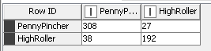

As seen in the screenshot above, the overall accuracy of the model is 88.496%.

The confusion matrix shows that there are:

308 True Positives

192 True Negatives +

500 Correctly predicted values

38 False Positives

27 False Negatives +

65 Wrongly predicted values

This means that the model predicted 308 of the 346 PennyPinchers correctly, this is an accuracy of 89%. The model also predicted 192 of the 219 HighRollers correctly, which is an accuracy of 88%.