**Analysis Conclusions**

The final KNIME workflow is shown below:

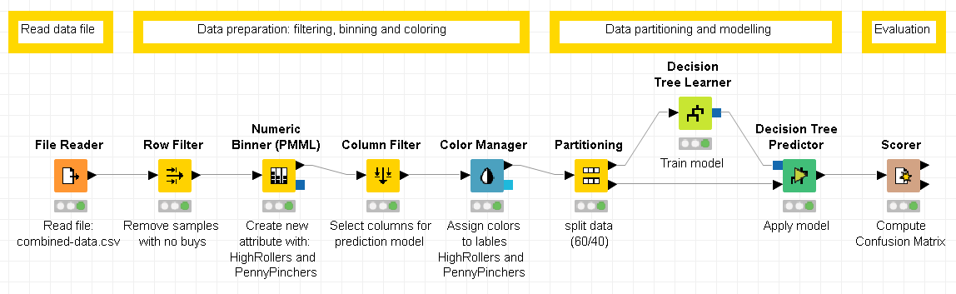

What makes a HighRoller vs. a PennyPincher?

Apparently the platform type is the best estimator for predicting if someone is a HighRoller or a PennyPincher. Most people with an i-phone are HighRollers while almost all Linux users are PennyPinchers. From the Windows and Android users also most are PennyPinchers, while Mac users have a relative high amount of HighRollers.

|  |
| --- |
| **Specific Recommendations to Increase Revenue** |
| 1. Target i-phone and Mac users mainly with ads for expensive items (> $5). |
| 2. Target Android, Linux and Windows users mainly with ads for cheaper items (≤ $5). |