**Training Data Set Creation**

The training data set used for this analysis is shown below (first 5 lines):

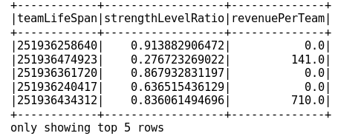

The dimensions of the final data set are:

169 rows x 3 columns

The elbow-method is applied to determine the number of cluster (see graph below). From this graph I selected k = 5 as the number of clusters.

