GROUP PROJECT 1

BY

YIMING CHEN

YU-HSIN CHAO

ARTEM CHAYKIN

Contents

Introduction 3

Assumptions 3

Limitations 4

Process Description 4

Tasks 5

Identify each End User (External User) segment 5

Final ERD (conceptual model) 16

Components of ERM table 17

Sample Data 18

ALUMNI 18

CLUB 18

CLUB MEMBERSHIP 18

EVENT 18

EVENT REGISTRATION 19

HOST 19

INVITATION 19

SPECIAL INVITATION 20

DONATION 20

Reports 20

Summary 22

# **Introduction**

This paper has been prepared by our group in order to present our vision on the design of a system for managing data regarding an university alumni association. This system supposed to help managing data about all the activities within the association and provide tools for the better management plans as well as to give the insight into some statistics. It is our first big team effort that has been accomplished in a mere two weeks by the team of three people. We glad to present our vision to your judgement and hope it meets your expectations.

# **Assumptions**

After careful investigation of the problem and discussion of all the facts, we can assume the following:

1. In order to be a member of the alumni association a member should has at least once paid his/her membership to GAC;
2. Clubs should have at least one member because if there are no people in club what’s the point of it;
3. Each club has a director and any member can be a director;
4. Membership registration and event registration are only possible if the appropriate fees have been received;
5. All fees/memberships and events/ are mandatory. If there’s no payment has been received, no further actions can be performed;
6. Event attendance is not mandatory;
7. If a member receives separate invitations for the same event he/she has only be registered once and pay event fee once;
8. Donations are not mandatory but encouraged;
9. All donations are treated as one off (no re-occurring donations).

# **Limitations**

1. Overlapped memberships, e.g. GAC membership has expired but another club is still active.
2. Events expenses – details about event hosting – rentals, catering, performers could be included in the database to help keep tracking them and for future planning.
3. Clubs’ inventory – details on what clubs need to run successfully could also be presented if team would have been asked.
4. Membership and event fee payment information wasn’t included in the paper as well.

# **Process Description**

During the last two weeks, we were working closely to accomplish the task to our best understandings.

Our group first have met after the midterm exam. During this meeting, we presented and discussed our initial thoughts and draft diagrams. Basic understanding of business rules, assumptions, limitations, and core entities have been established during that time.

The next meeting happened on the night of the dropped class. We worked further on the problem, digging deeper, unveiling new facts, and getting closer to the possible solution. We normalized entities up to 3NF and decided which one of them we were going to depict in our paper. Also, we worked on the possible questions to the instructor and on who will create what part of the paper for the final presentation.

In the interim, we were working on our own and communicate with each other using ‘Discussions’ section of D2L website.

After we received the answers from the instructor, we continued working on the project. We had our final meeting on Monday where we have worked on the final touches and come up to the final agreement on how we wanted to finalize and present the latest and greatest version of our paper to your verdict.

# **Tasks**

## Identify each End User (External User) segment

Business rules:

1. Alumnus can be a member of one or more clubs. Club can have one or more members.
2. A member can be a director to zero or one club and every club has only one director.
3. Event can be hosted by one or more clubs and a club can be a host/co-host for only one event.
4. Invitations to the event can be sent to one or more members and a member can receive a one event invitation for the co-hosted event or many invitations from different clubs that host separate single club events.
5. Host can send one or more invitations and each invitation can be sent by only one host;
6. Each member can make zero or many donations and every donation can be made by only one member.
7. Each donation can be split between one or many clubs and many clubs can receive funds from the single donation;
8. Each club can receive zero to many donations and every donation can be given to one or many clubs.

End User (External User) segments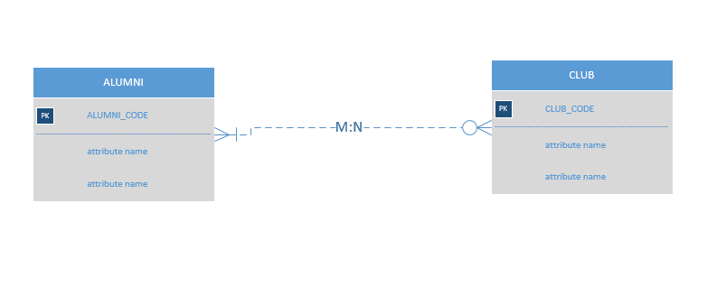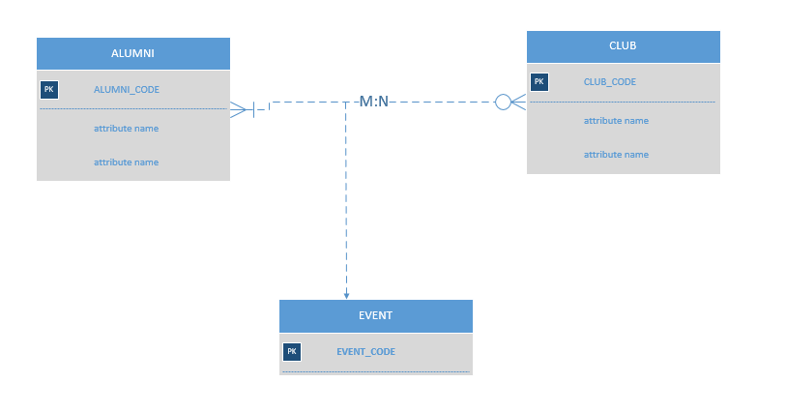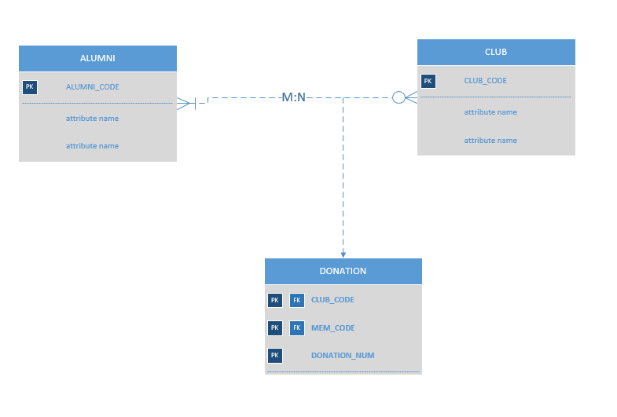

● Bridging M:N relationships, redrawing the extended ERD and restating the expanded business rules

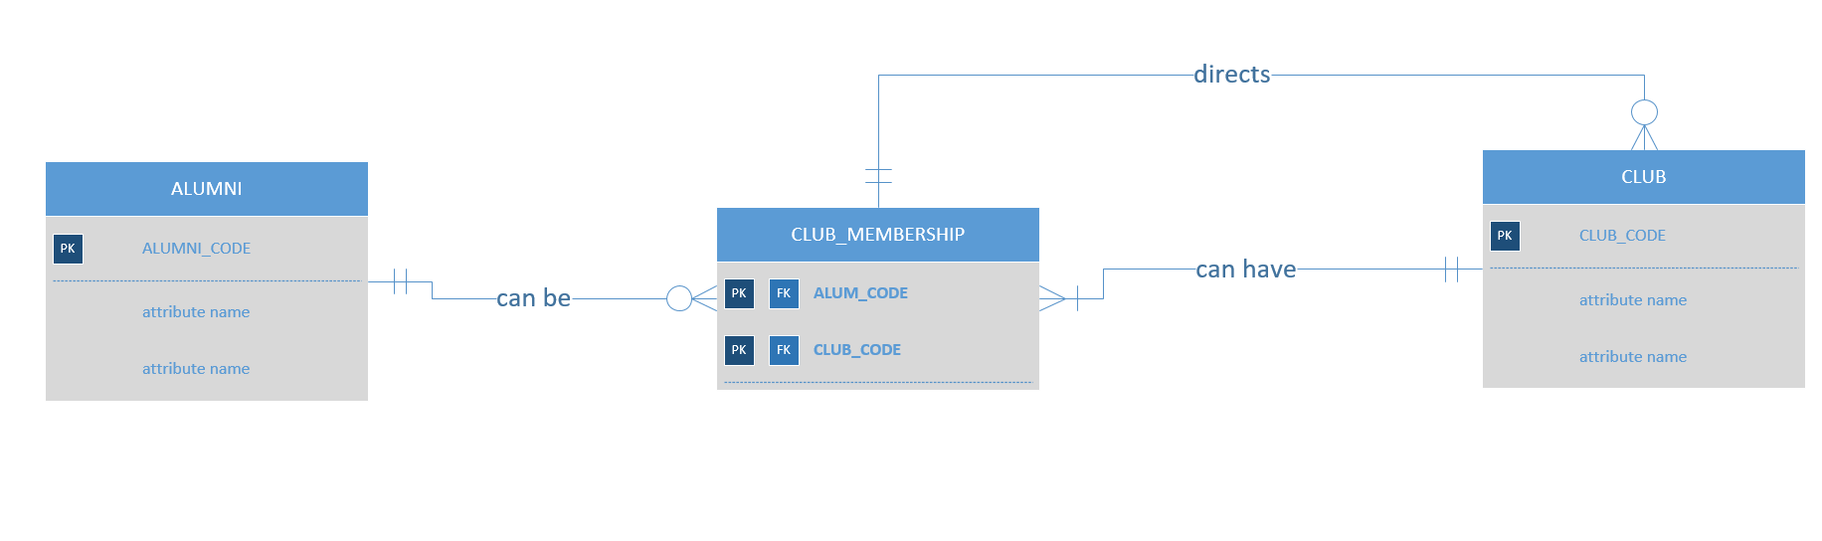

Business rules:

Each alumni can be in zero or more club membership; each club membership can only have one alumni.

Each club can have one or more club membership; each club membership can only have one club.

Each club member can direct zero or more club, each club can only be directed by one club member.

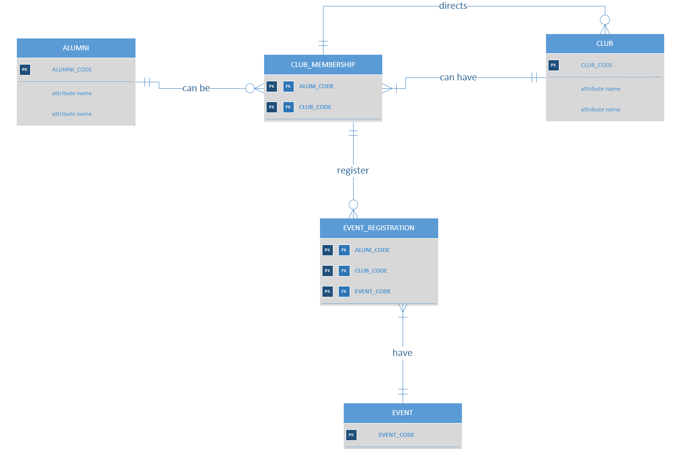

Business rules:

Each club member can be in zero or more event registration; each event registration must have one and only one club member.

Each event must have one or more event registration; each event registration can only have one event.

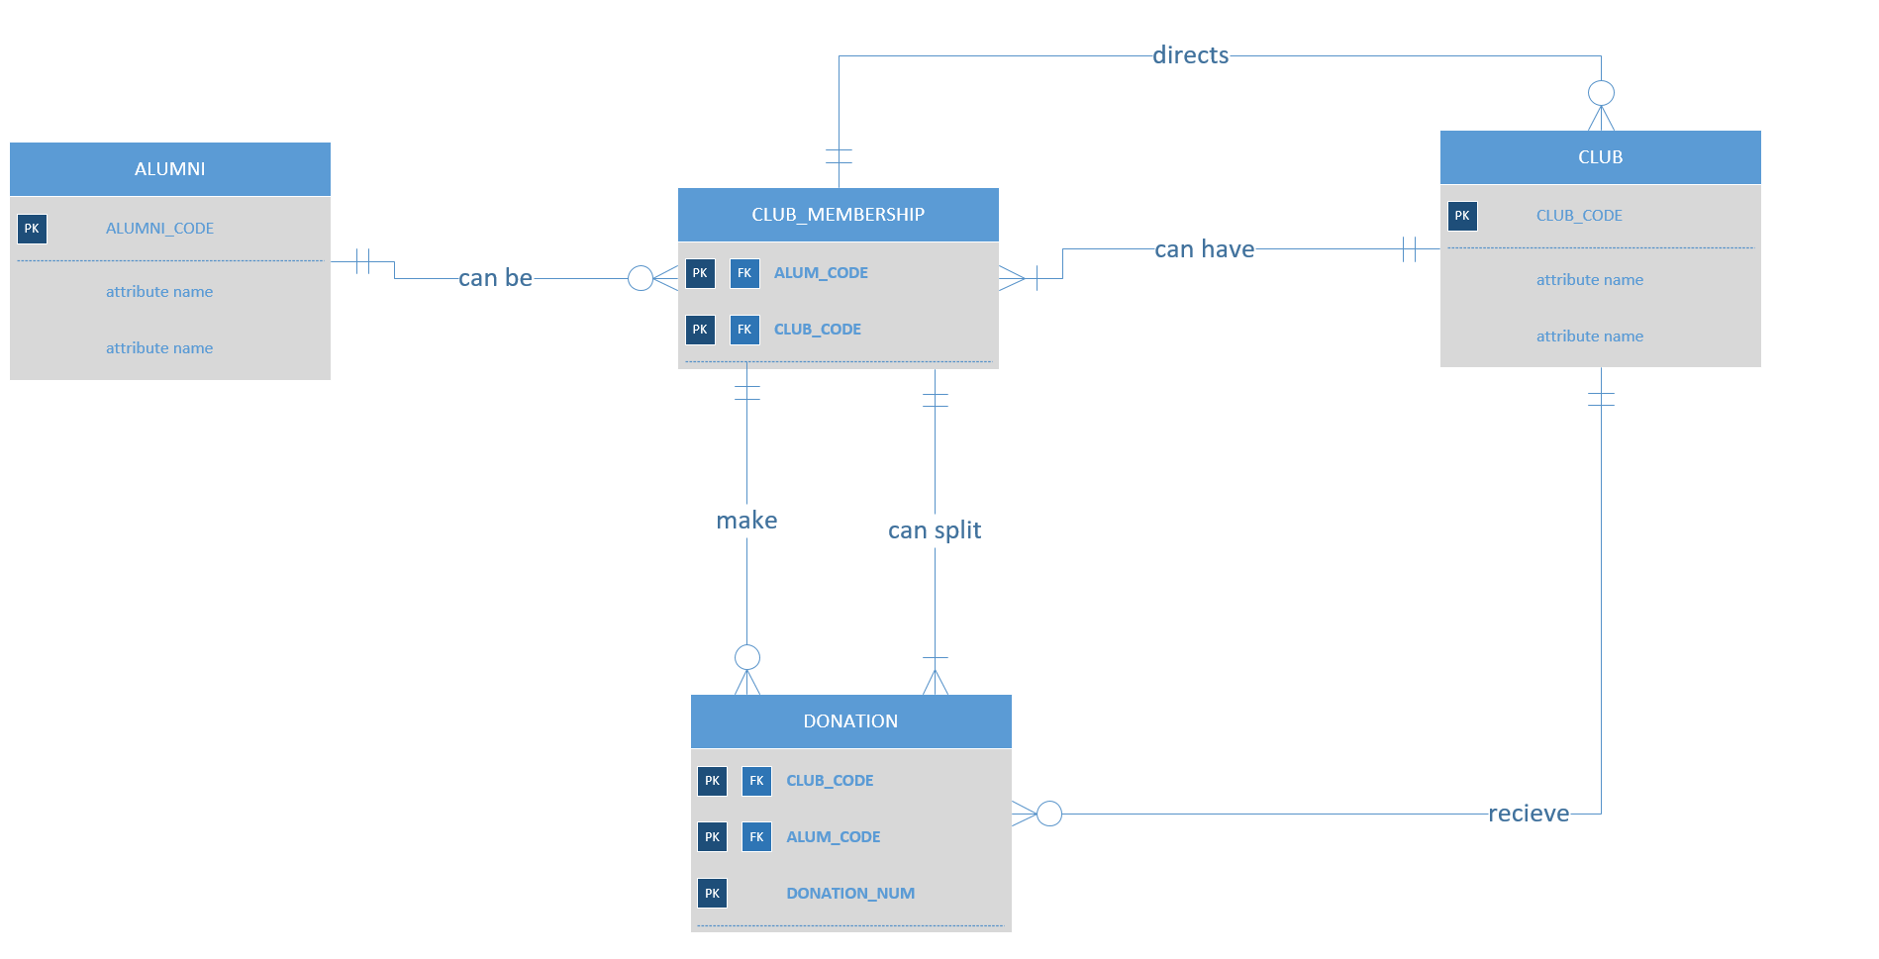

Business rules:

Each club member can make zero or more donation; each donation can be made from only one club member.

Each club member can split donation to different clubs; each donation can be made from only one club member.

Each club can receive zero or more donation; each donation is only sent to one club.

● Show all attributes, including PKs, FKs and all other non-key attributes (indicate required attributes)

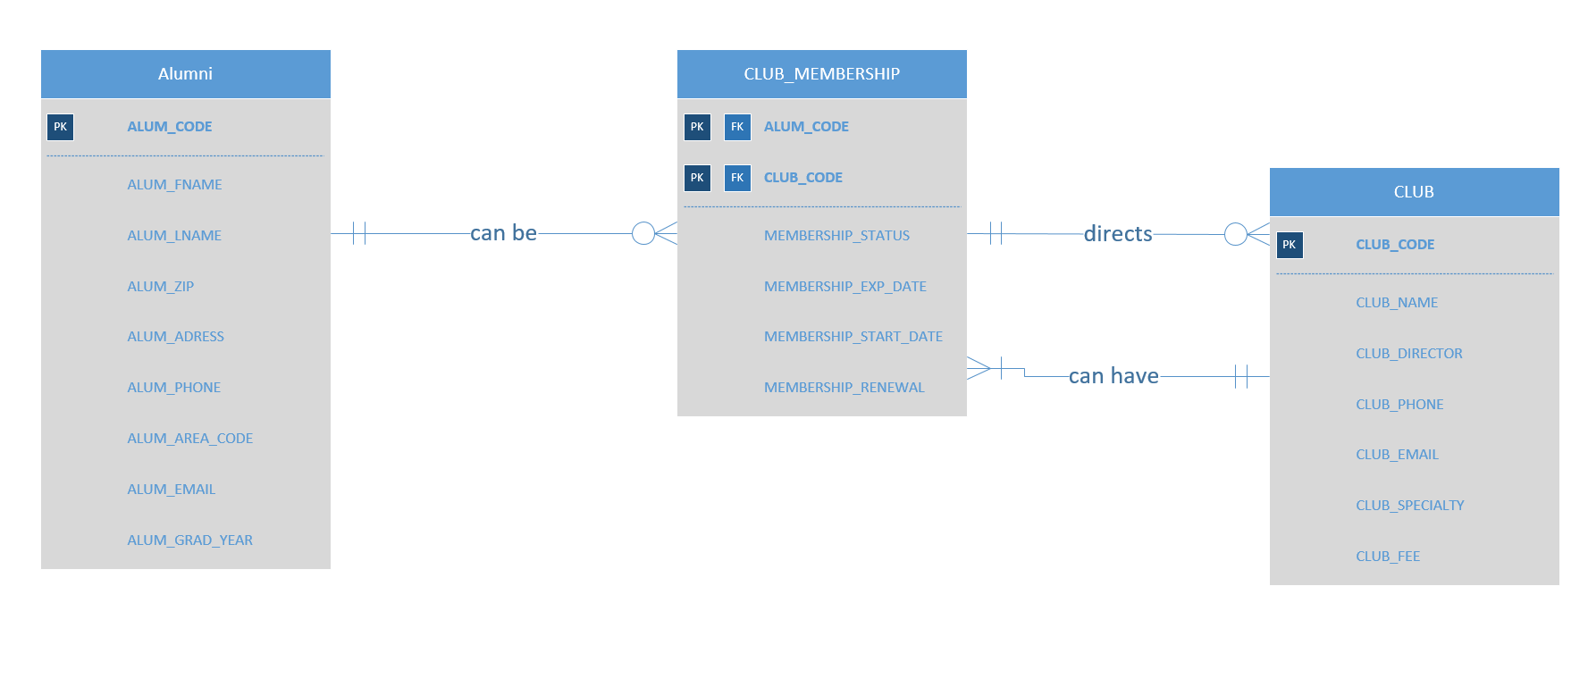

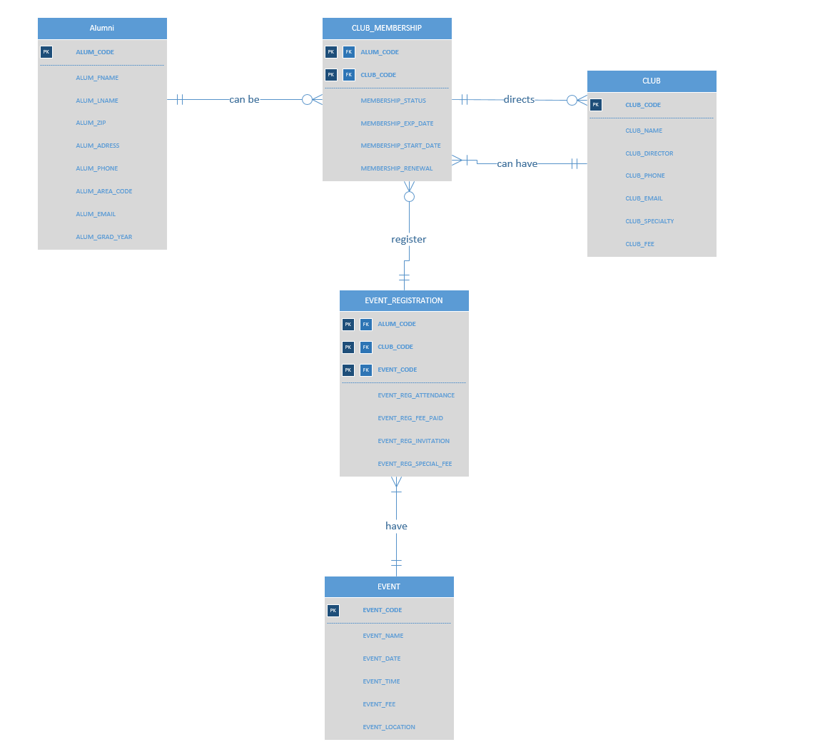

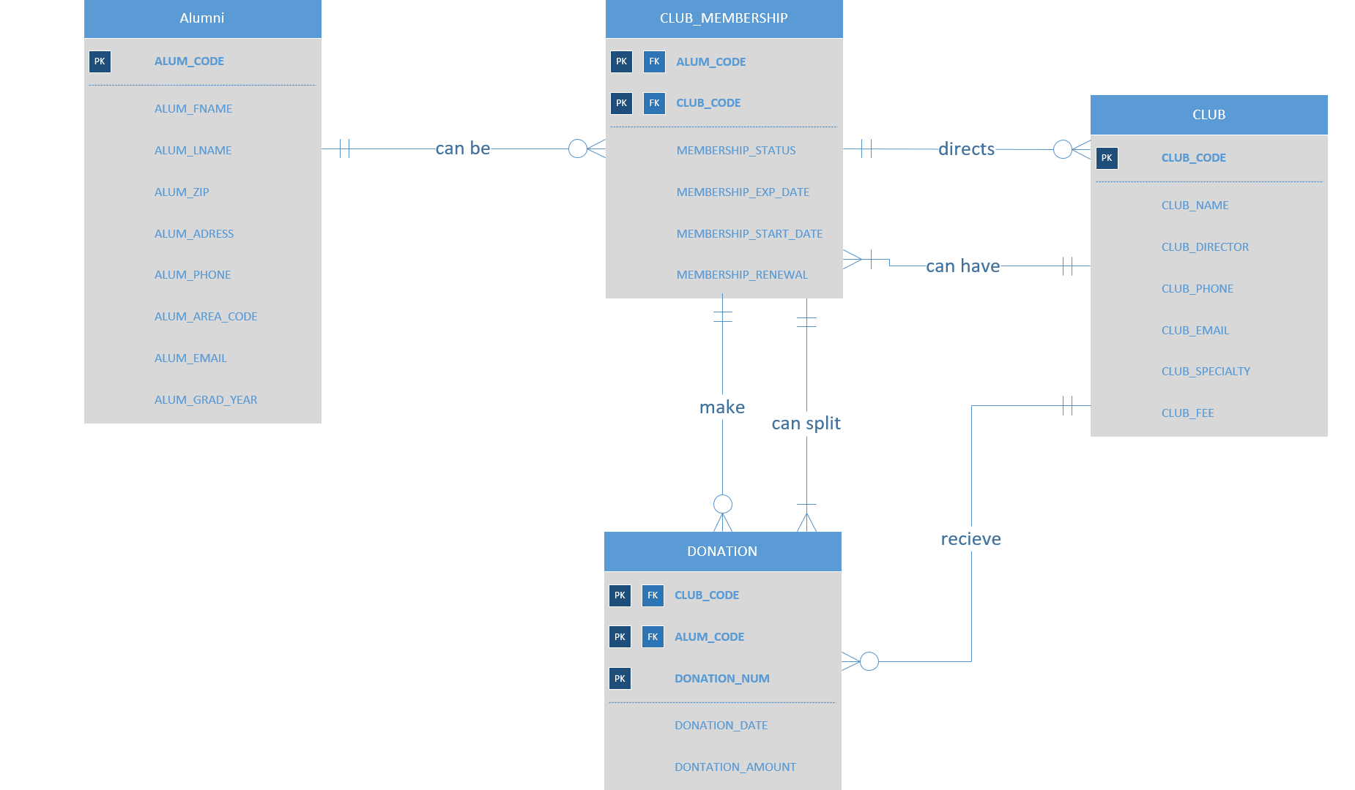

● Here is a sample of the normalization process we used to build our final ERD.

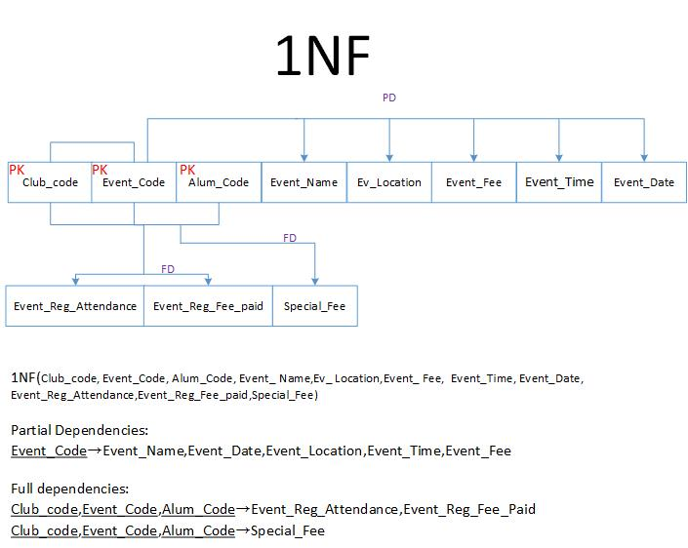

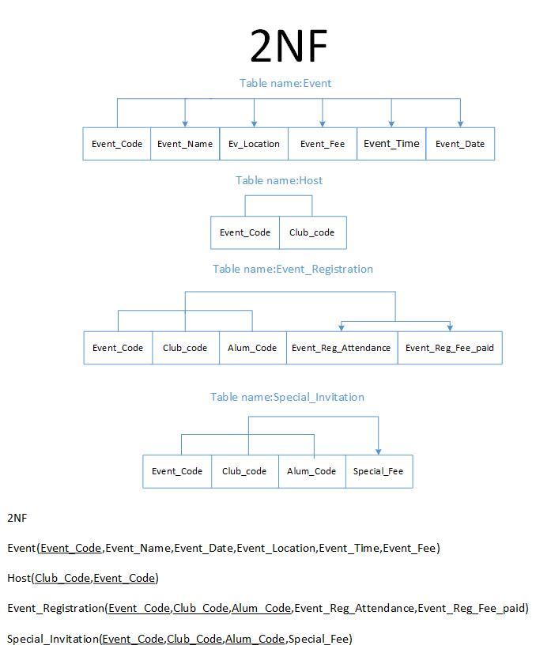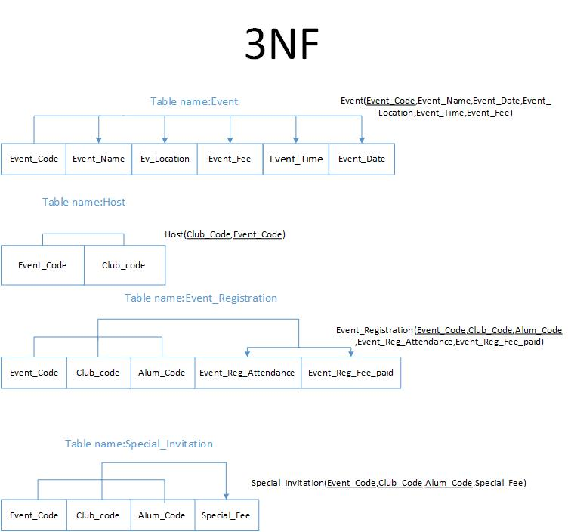

Relational schemas for entities:

* 1. *ALUMNI/strong entity/* – (ALUM_CODE), **ALUM_FNAME, ALUM_LNAME,** ALUM_ADDRESS, ALUM_ZIP, **ALUM_EMAIL,** ALUM_AREA,ALUM_PHONE, **GRAD_YEAR.**
  2. *CLUB/strong entity/* – (CLUB_CODE), **CLUB_NAME, CLUB_DIRECTOR, CLUB_SPECIALTY, CLUB_PHONE, CLUB_EMAIL, CLUB_FEE.**
  3. *CLUB_MEMBERSHIP/weak entity/* – (ALUM_CODE[FK], CLUB_CODE[FK]), **MEMBERSHIP_STARTDATE,** MEMBERSHIP_EXP_DATE, **MEMBERSHIP_STATUS, MEMBERSHIP_RENEWAL**/number/**.**
  4. *EVENT/strong entity/* – (EVENT_CODE), **EVENT_NAME, EVENT_DATE, EVENT_LOCATION, EVENT_TIME, EVENT_FEE.**
  5. *EVENT REGISTRATION/weak entity/*  *–* (EVENT_CODE[FK], ALUM_CODE[FK], CLUB_CODE[FK] ), EVENT_REG_ATTENDANCE/bool/, **EVENT_REG_FEE_PAID**/bool/
  6. *HOST/weak entity/* – (EVENT_CODE[FK], CLUB_CODE[FK])
  7. *INVITATION/weak entity/* – (CLUB_CODE[FK], EVENT_CODE[FK], ALUM_CODE[FK]), **INVITATION_SENT**/bool/
  8. *SPECIAL_INVITATION/weak entity/* – (CLUB_CODE[FK], VENT_CODE[FK],ALUM_CODE[FK]), **SPECIAL_FEE**/bool/
  9. *DONATION/weak entity/* – (CLUB_CODE[FK], ALUM_CODE[FK], DONATION_NUM), **DONATION_DATE, DONATION_AMOUNT**.

List of attributes for each entity:

1. *ALUMNI*
   * ALUM_CODE – surrogate attribute generated each time a new member registered;
   * ALUM_FNAME – person’s first name;
   * ALUM_LNAME – person’s last name;
   * ALUM_ADDRESS – street number and name
   * ALUM_ZIP – postal code
   * ALUM_EMAIL – personal email address for contact purposes;
   * ALUM_AREA – area code for phone number;
   * ALUM_PHONE – contact phone number;
   * GRAD_YEAR – graduation year for reunion events.
2. *CLUB*
   * CLUB_CODE – unique code assigned to every club;
   * CLUB_NAME – club’s name chosen by members;
   * CLUB_DIRECTOR – self explanatory;
   * CLUB_SPECIALTY – what field or hobby club dedicated to;
   * CLUB_PHONE - contact phone number;
   * CLUB_EMAIL – club’s email
   * CLUB_FEE – membership fee.
3. *CLUB_MEMBERSHIP*
   * ALUM_CODE – see above;
   * CLUB_CODE – see above;
   * MEMBERSHIP_STARTDATE – membership start date;
   * MEMBERSHIP_EXP_DATE - membership expiration date;
   * MEMBERSHIP_STATUS – current, recently expired (less then 12 months), former (more then 12 months);
   * MEMBERSHIP_RENEWAL – how many times membership has been renewed
4. *EVENT*
   * EVENT_CODE - surrogate attribute generated each time a new event entered in the DB;
   * EVENT_NAME - self explanatory;
   * EVENT_DATE - self explanatory;
   * EVENT_LOCATION – where the event is taking place;
   * EVENT_TIME – time of the day;
   * EVENT_FEE – RSVP amount need to be paid in order to a member be allowed to attend the event.
5. *EVENT REGISTRATION*
   * EVENT_CODE – see above;
   * ALUM_CODE - see above;
   * CLUB_CODE - see above;
   * EVENT_REG_ATTENDANCE/bool/ - true for attending member; false for those who didn’t make it to the event;
   * EVENT_REG_FEE_PAID/bool/ - tracking received payments.
6. *HOST*
   * EVENT_CODE – see above;
   * CLUB_CODE – see above;
7. *INVITATION*
   * CLUB_CODE – see above;
   * EVENT_CODE – see above;
   * ALUM_CODE – see above;
   * INVITATION_SENT/bool/ – see above;
8. *SPECIAL_INVITATION*
   * CLUB_CODE – see above;
   * EVENT_CODE – see above;
   * ALUM_CODE – see above;
   * SPECIAL_FEE/bool/ - membership renewal fee;
9. *DONATION*
   * CLUB_CODE – see above;
   * ALUM_CODE – see above;
   * DONATION_NUM – unique transaction number for each donation;
   * DONATION_DATE – date donation received;
   * DONATION_AMOUNT – sum of money received.

● Redrawing the ERD after the new entities were spawned during the normalization process

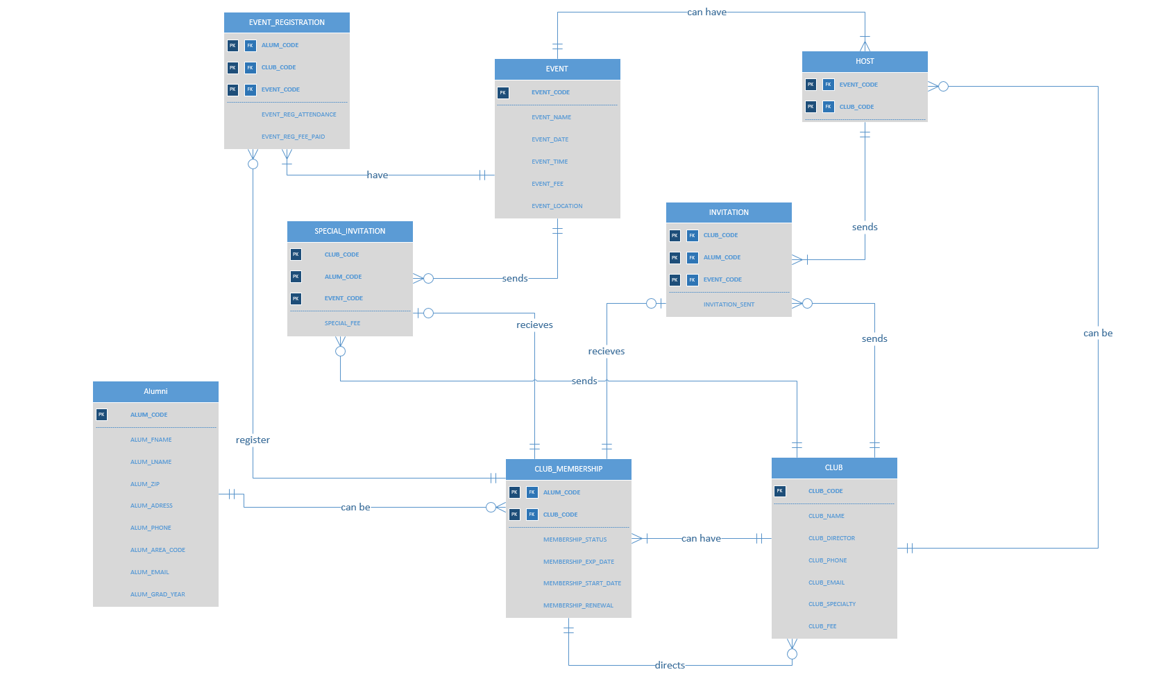

## Final ERD (conceptual model)



## Components of ERM table



There are three groups of components – entities, attributes, and relationships.

## Sample Data

### ALUMNI



### CLUB



### CLUB MEMBERSHIP



### EVENT



### EVENT REGISTRATION



### HOST



### INVITATION



### SPECIAL INVITATION



### DONATION

|  |  |  |  |  |
| --- | --- | --- | --- | --- |
| CLUB_CODE | ALUM_CODE | DONATION_NUM | DONATION_DATE | DONATION_AMOUNT |
| 101 | A025484 | 120547 | 12/05/2017 | $40 |
| 103 | A025484 | 120547 | 12/05/2017 | $30 |
| 105 | A025484 | 120547 | 12/05/2017 | $30 |
| 106 | G548824 | 120548 | 18/05/2017 | $75 |
| 106 | A452001 | 120549 | 20/05/2017 | $120 |
| 103 | S576613 | 120550 | 20/05/2017 | $200 |
| 105 | F473348 | 120551 | 21/05/2017 | $60 |

## Reports

1. Alumni club activity tracked - How many alumni are registered in GAC and how many in other clubs by graduate year.

* Purpose: help clubs keep informed about the progress of new members and support and strengthen them for the feature planning.

1. How much money each club collected in the last year?

* Purpose: financial report, taxes, and financial planning such as new equipment, event funds. It provides information about the results of operations, financial position, and cash flows of the organization. The readers of financial statements use this information to make decisions regarding the allocation of resources.

1. How much money each club received in donations?

* Purpose: financial report, taxes, and financial planning. The readers could use these to pull up individual transaction information for donations, pledges, pledge payments, soft credits and honor or memory information.

1. How many new members were registered from January 2017?

* Purpose: help clubs keep informed about the new members and pull clubs’ popularity chart.

1. Event and Attendance Reports-percentage of registered members who actually attended the single event.

* Purpose: The attending tab will keep a record of people who have registered and paid for the event. It also displays the attendance details of club members. The details include information such as the number of attendees, the number of tickets scanned, and the number of tickets sold during a selected period.

# Summary

To sum things up, designing the data managing system turned out to be quite a challenge considering the complex requirements and some ambiguous statements. However, we think, we have done a pretty good job creating it. The paper is still can be improved and perfected given more time, lifting up the limitations we mentioned above, and answering a set of extra questions we came up with after the second attempt and close to the end of our work. Please, review and advice on our weak spots and flaws so we could improve our understanding of the DB design principles.