Instructor

Mark Bacchus

COMP 1630

TERM PROJECT

By Simon Chen A01010924

July 4, 2017

Contents

Introduction 1

Part A - Database and Tables 2

Part B - SQL Statements 8

Part C - INSERT, UPDATE, DELETE and VIEWS Statements 18

Part D - Stored Procedures and Triggers 27

Table Design 35

Challenges 37

Summary 37

Copy of Script 38

# 

# Introduction

This is a individual term project of COMP1630 summer 2017. The project is about using SQL with Microsoft SQL management studio to accomplish task given by professor Mark Bacchus. By the end of this project, I should be much more familiar with using SQL.

# Part A - Database and Tables

1. Create a database called **Cus_Orders**.

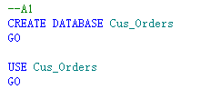

1. Create a user defined data types for all similar Primary Key attribute columns (e.g. order_id, product_id,title_id**),** to ensure the same data type, length and null ability. See pages 12/13 for specifications.

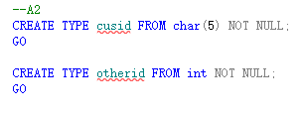

1. Create the following tables (see column information on pages 12 and 13 ):

Customers

orders

order_details

products

shippers

suppliers

titles

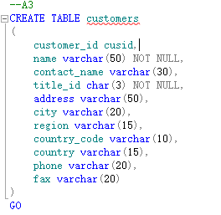

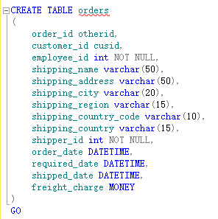

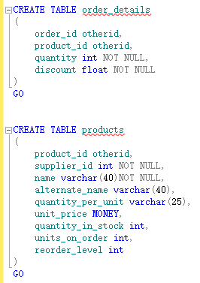

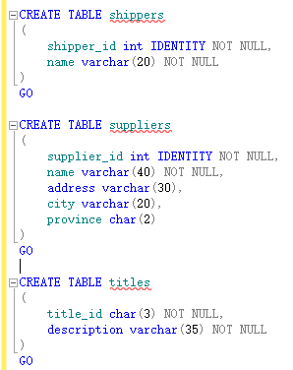

1. Set the **primary** **keys** and **foreign** **keys** for the tables.

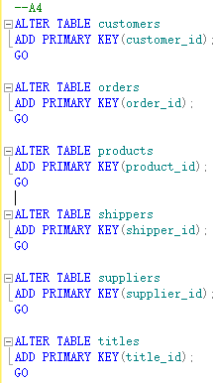

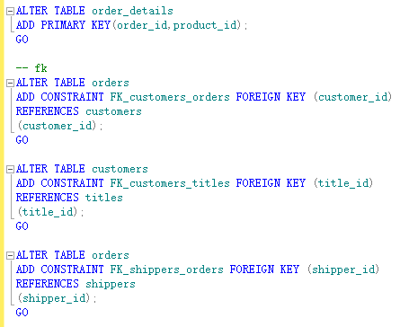

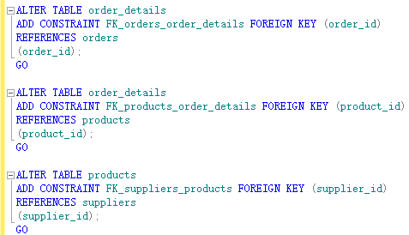

1. Set the **constraints** as follows:

**customers** **table** - country should default to Canada

**orders** **table** - required_date should default to today’s date plus ten days

**order details table** - quantity must be greater than or equal to 1

**products table** - reorder_level must be greater than or equal to 1

- quantity_in_stock value must not be greater than 150

**suppliers table** - province should default to BC

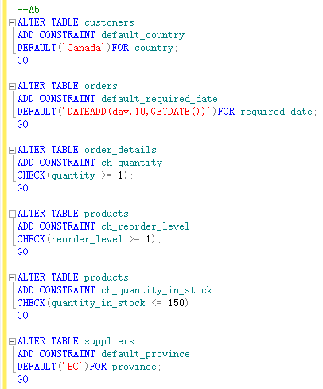

**Note: A complete database diagram will be shown at part C**

1. Load the data into your created tables using the following files:

customers.txt into the customers table (91 rows)

orders.txt into the orders table (1078 rows)

order_details.txt into the order_details table (2820 rows)

products.txt into the products table (77 rows)

shippers.txt into the shippers table (3 rows)

suppliers.txt into the suppliers table (15 rows)

titles.txt into the titles table (12 rows)

*employees.txt into the employees table which is created in Part C (See Note)*

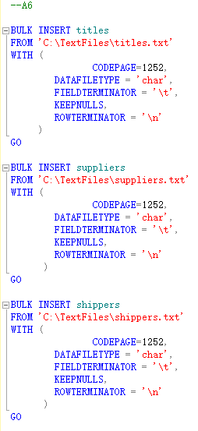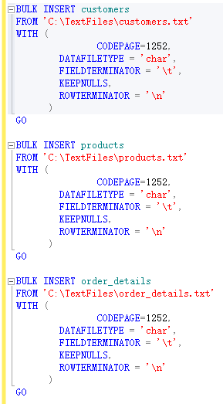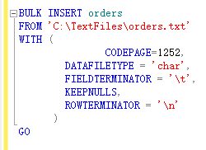

# Part B - SQL Statements

1. List the customer id, name, city, and country from the customer table. Order the result set by the **customer id**. The query should produce the result set listed below.

customer_id name city country

--------------- ---------------------------------- ------------- ---------------

ALFKI Alfreds Futterkiste Berlin Germany

ANATR Ana Trujillo Emparedados y helados México D.F. Mexico

ANTON Antonio Moreno Taquería México D.F. Mexico

AROUT Around the Horn London United Kingdom

BERGS Berglunds snabbköp Luleå Sweden

...

WHITC White Clover Markets Seattle United States

WILMK Wilman Kala Helsinki Finland

WOLZA Wolski Zajazd Warszawa Poland

(91 row(s) affected)

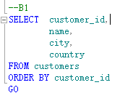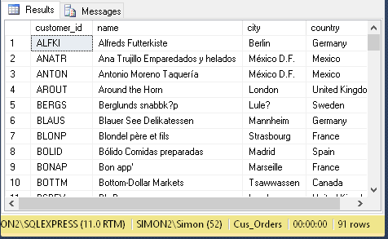

1. Add a new column called **active** to the customers table using the ALTER statement. The only valid values are 1 or 0. The default should be **1**.

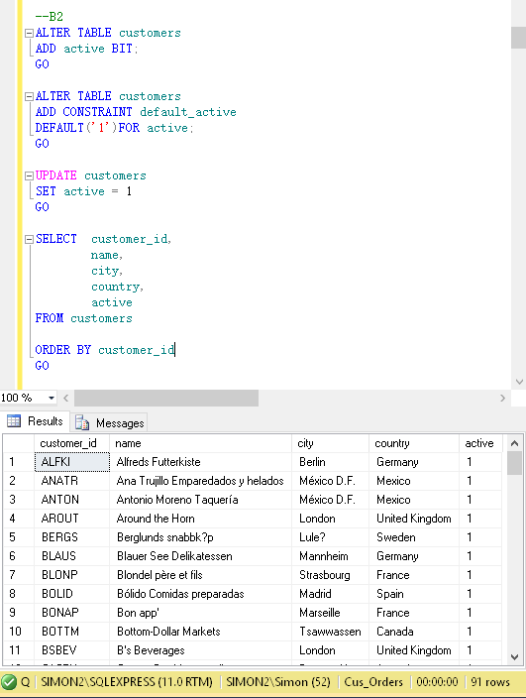

1. List all the orders where the order date is between **January 1** and **December 31, 200**1. Display the order id, order date, and a new shipped date calculated by adding 7 days to the shipped date from the orders table, the product name from the product table, the customer name from the customer table, and the cost of the order. Format the date order date and the shipped date as **MON DD YYYY**. Use the formula (quantity * unit_price) to calculate the cost of the order. The query should produce the result set listed below.

order_id product_name customer_name order_date new_shipped_date order_cost

-------- ----------------------------- ---------------- ------------------- --------------------- ----------

10000 Alice Mutton Franchi S.p.A. May 10 2001 May 22 2001 156.0000

10001 NuNuCa Nuß-Nougat-Crème Mère Paillarde May 13 2001 May 30 2001 420.0000

10001 Boston Crab Meat Mère Paillarde May 13 2001 May 30 2001 736.0000

10001 Raclette Courdavault Mère Paillarde May 13 2001 May 30 2001 440.0000

10001 Wimmers gute Semmelknödel Mère Paillarde May 13 2001 May 30 2001 498.7500

...

10138 Inlagd Sill Du monde entire Dec 27 2001 Jan 10 2002 228.0000

10138 Louisiana Hot Spiced Okra Du monde entire Dec 27 2001 Jan 10 2002 204.0000

10139 Camembert Pierrot Vaffeljernet Dec 30 2001 Jan 16 2002 680.0000

(383 row(s) affected)

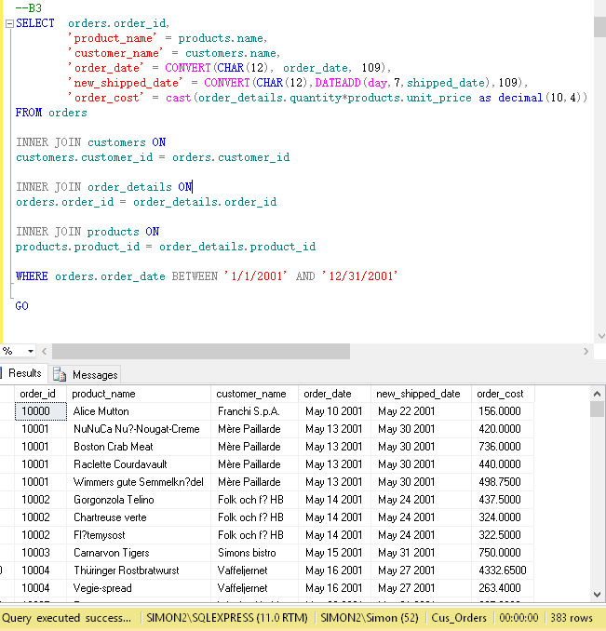

1. List all the orders that have **not** been shipped. Display the customer id, name and phone number from the customers table, and the order id and order date from the orders table. Order the result set by the customer name. The query should produce the result set listed below.

customer_id name phone order_id order_date

--------------- --------------------------- -------------- ---------- ---------------------

BLAUS Blauer See Delikatessen 0621-08460 11058 2004-03-23 00:00:00.000

BONAP Bon app' 91.24.45.40 11076 2004-03-30 00:00:00.000

ERNSH Ernst Handel 7675-3425 11008 2004-03-02 00:00:00.000

.....

RICAR Ricardo Adocicados (21) 555-3412 11059 2004-03-23 00:00:00.000

RICSU Richter Supermarkt 0897-034214 11075 2004-03-30 00:00:00.000

SIMOB Simons bistro 31 12 34 56 11074 2004-03-30 00:00:00.000

(21 row(s) affected)

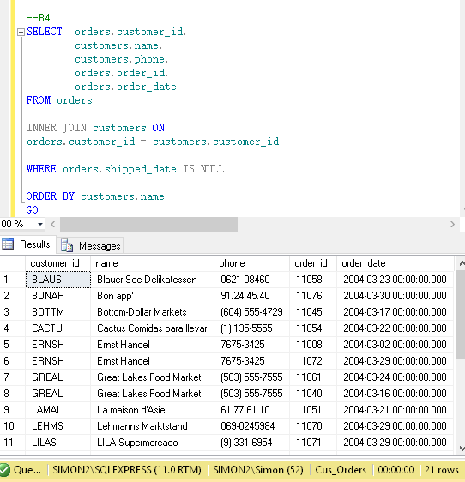

1. List all the customers where the region is **NULL**. Display the customer id, name, and city from the customers table, and the title description from the titles table. The query should produce the result set listed below.

customer_id name city description

-------------- ----------------------------------- --------------- ----------------------

ALFKI Alfreds Futterkiste Berlin Sales Representative

ANATR Ana Trujillo Emparedados y helados México D.F. Owner

ANTON Antonio Moreno Taquería México D.F. Owner

AROUT Around the Horn London Sales Representative

BERGS Berglunds snabbköp Luleå Order Administrator

...

WARTH Wartian Herkku Oulu Accounting Manager

WILMK Wilman Kala Helsinki Owner/Marketing Assistant

WOLZA Wolski Zajazd Warszawa Owner

(60 row(s) affected)

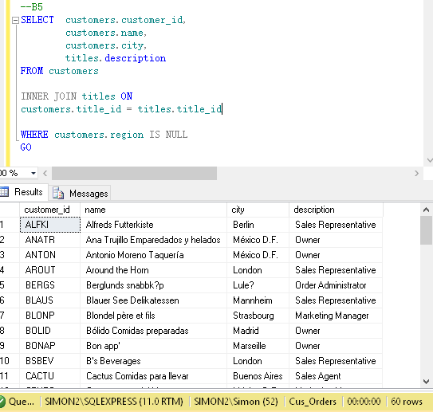

1. List the products where the reorder level is **higher than** the quantity in stock. Display the supplier name from the suppliers table, the product name, reorder level, and quantity in stock from the products table. Order the result set by the supplier name. The query should produce the result set listed below.

supplier_name product_name reorder_level quantity_in_stock

------------------------ --------------------- ---------------- -----------------

Armstrong Company Queso Cabrales 30 22

Cadbury Products Ltd. Ipoh Coffee 25 17

Cadbury Products Ltd. Røgede sild 15 5

Campbell Company Gnocchi di nonna Alice 30 21

Dare Manufacturer Ltd. Scottish Longbreads 15 6

...

Steveston Export Company Gravad lax 25 11

Steveston Export Company Outback Lager 30 15

Yves Delorme Ltd. Longlife Tofu 5 4

(18 row(s) affected)

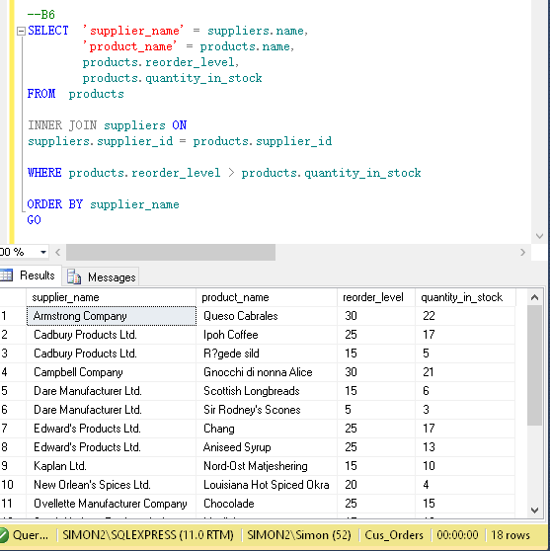

1. Calculate the length in years from **January 1, 2008** and when an order was shipped where the shipped date is **not null**. Display the order id, and the shipped date from the orders table, the customer name, and the contact name from the customers table, and the length in years for each order. Display the shipped date in the format MMM DD YYYY. Order the result set by order id and the calculated years. The query should produce the result set listed below.

order_id name contact_name shipped_date elapsed

----------- --------------------------- --------------------------- ------------ -------

10000 Franchi S.p.A. Paolo Accorti May 15 2001 7

10001 Mère Paillarde Jean Fresnière May 23 2001 7

10002 Folk och fä HB Maria Larsson May 17 2001 7

10003 Simons bistro Jytte Petersen May 24 2001 7

10004 Vaffeljernet Palle Ibsen May 20 2001 7

...

11066 White Clover Markets Karl Jablonski Mar 28 2004 4

11067 Drachenblut Delikatessen Sven Ottlieb Mar 30 2004 4

11069 Tortuga Restaurante Miguel Angel Paolino Mar 30 2004 4

(1057 row(s) affected)

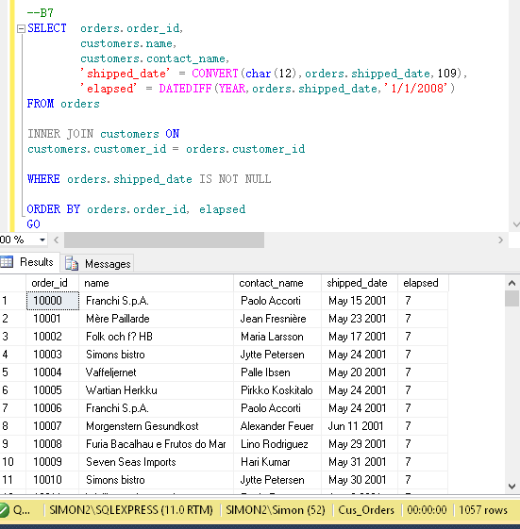

1. List number of customers with names beginning with each letter of the alphabet. Ignore customers whose name begins with the letter **S**. Do not display the letter and count unless **at least two** customer’s names begin with the letter. The query should produce the result set listed below.

name total

------ -----------

A 4

B 7

C 5

D 3

E 2

...

T 6

V 3

W 5

(17 row(s) affected)

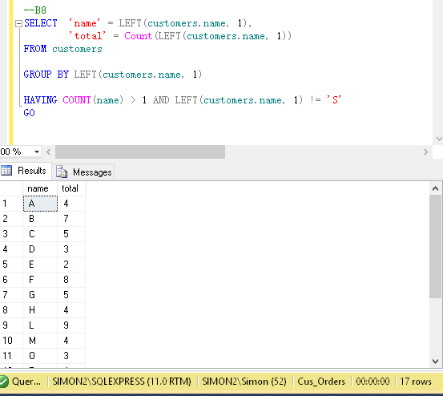

1. List the order details where the quantity is **greater than 100**. Display the order id and quantity from the order_details table, the product id and reorder level from the products table, and the supplier id from the suppliers table. Order the result set by the order id. The query should produce the result set listed below.

order_id quantity product_id reorder_level supplier_id

----------- ----------- -------------- ----------------- -----------

10193 110 43 25 10

10226 110 29 0 12

10398 120 55 20 15

10451 120 55 20 15

10515 120 27 30 11

...

10895 110 24 0 10

11017 110 59 0 8

11072 130 64 30 12

(15 row(s) affected)

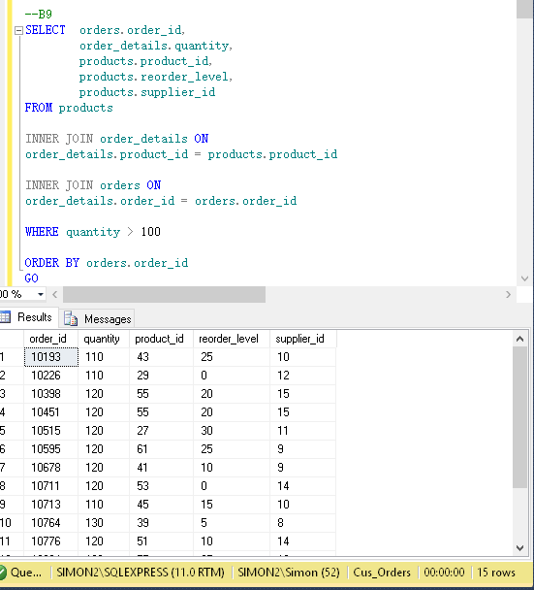

1. List the products which contain **tofu** or **chef** in their name. Display the product id, product name, quantity per unit and unit price from the products table. Order the result set by product name. The query should produce the result set listed below.

product_id name quantity_per_unit unit_price

-------------- ------------------------------------- ---------------------- --------------

4 Chef Anton's Cajun Seasoning 48 - 6 oz jars 22.0000

5 Chef Anton's Gumbo Mix 36 boxes 21.3500

74 Longlife Tofu 5 kg pkg. 10.0000

14 Tofu 40 - 100 g pkgs. 23.2500

(4 row(s) affected)

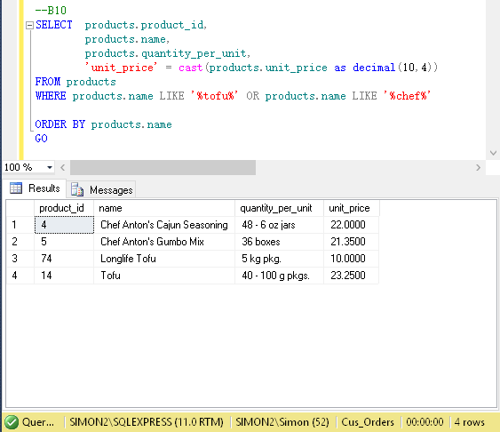

# Part C - INSERT, UPDATE, DELETE and VIEWS Statements

1. Create an **employee** table with the following columns:

|  |  |  |  |
| --- | --- | --- | --- |
| *Column Name* | *Data Type* | *Length* | *Null Values* |
| employee_id | int |  | No |
| last_name | varchar | 30 | No |
| first_name | varchar | 15 | No |
| address | varchar | 30 |  |
| city | varchar | 20 |  |
| province | char | 2 |  |
| postal_code | varchar | 7 |  |
| phone | varchar | 10 |  |
| birth_date | datetime |  | No |

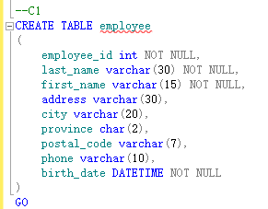

1. The **primary key** for the employee table should be the employee id.

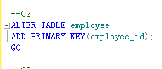

1. Load the data into the employee table using the employee.txt file; **9** rows. In addition, **create the relationship** to enforce referential integrity between the employee and orders tables.

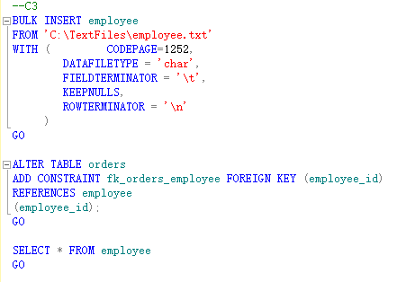

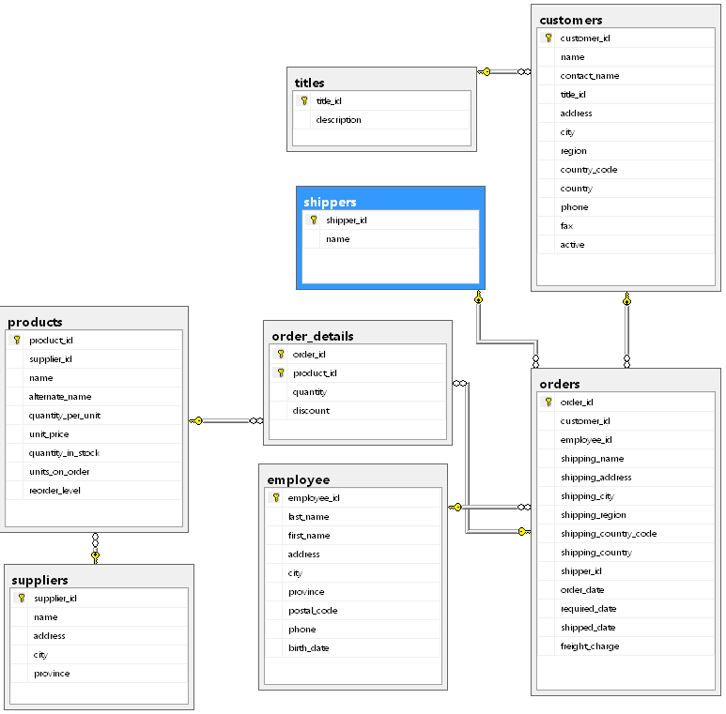

1. Using the INSERT statement, add the shipper **Quick Express** to the shippers table.

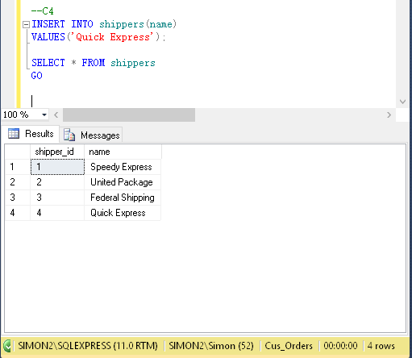

1. Using the UPDATE statement, increate the unit price in the products table of all rows with a current unit price between **$5.00** and **$10.00** by **5%**; 12 rows affected.

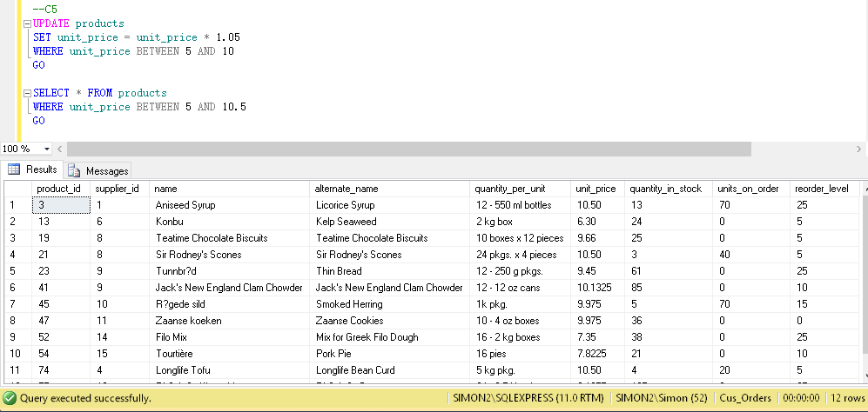

1. Using the UPDATE statement, change the fax value to **Unknown** for all rows in the customers table where the current fax value is **NULL**; 22 rows affected.

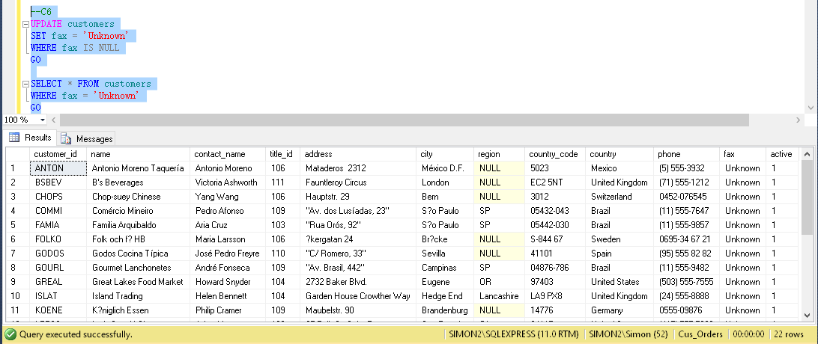

1. Create a view called **vw_order_cost** to list the cost of the orders. Display the order id and order_date from the orders table, the product id from the products table, the customer name from the customers tble, and the order cost. To calculate the cost of the orders, use the formula (order_details.quantity * products.unit_price). Run the view for the order ids between **10000** and **10200**. The view should produce the result set listed below.

order_id order_date product_id name order_cost

--------- ------------------------------ -------------- ---------------------------------- --------------

10000 2001-05-10 00:00:00.000 17 Franchi S.p.A. 156.0000

10001 2001-05-13 00:00:00.000 25 Mère Paillarde 420.0000

10001 2001-05-13 00:00:00.000 40 Mère Paillarde 736.0000

10001 2001-05-13 00:00:00.000 59 Mère Paillarde 440.0000

10001 2001-05-13 00:00:00.000 64 Mère Paillarde 498.7500

...

10199 2002-03-27 00:00:00.000 3 Save-a-lot Markets 400.0000

10199 2002-03-27 00:00:00.000 39 Save-a-lot Markets 720.0000

10200 2002-03-30 00:00:00.000 11 Bólido Comidas preparadas 588.0000

(540 row(s) affected)

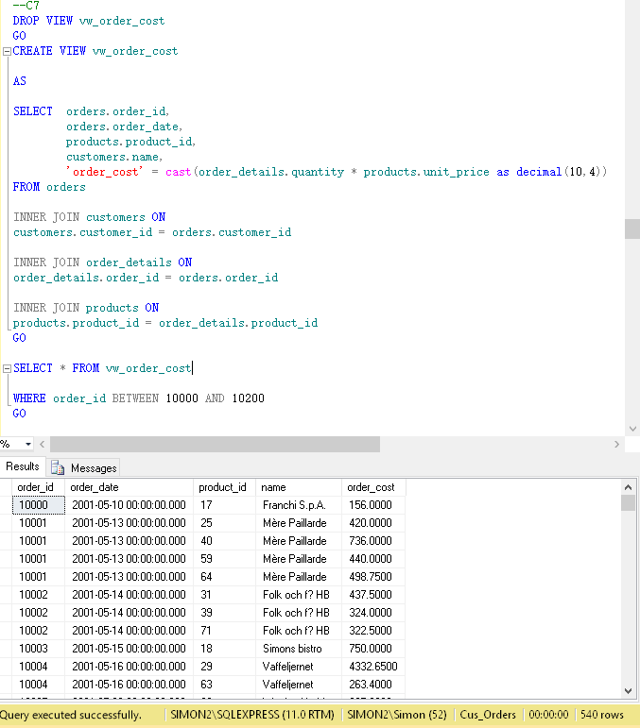

1. Create a view called **vw_list_employees** to list all the employees and all the columns in the employee table. Run the view for employee ids **5**, **7**, and **9**. Display the employee id, last name, first name, and birth date. Format the name as last name followed by a comma and a space followed by the first name. Format the birth date as **YYYY.MM.DD**. The view should produce the result set listed below.

employee_id name birth_date

---------------- -------------------------------- ------------

5 Buchanan, Steven 1955.03.04

7 King, Robert 1960.05.29

9 Dodsworth, Anne 1966.01.27

(3 row(s) affected)

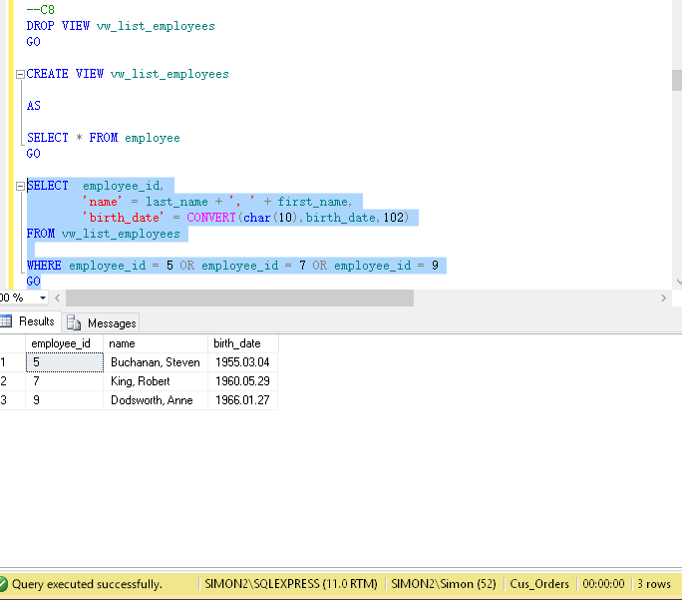

1. Create a view called **vw_all_orders** to list all the orders. Display the order id and shipped date from the orders table, and the customer id, name, city, and country from the customers table. Run the view for orders shipped from **January 1, 2002** and **December 31, 2002**, formatting the shipped date as **MON DD YYYY**. Order the result set by customer name and country. The view should produce the result set listed below.

order_id customer_id customer_name city country shipped_date

---------- --------------- ------------------------------------------- ---------------- --------------- ------------

10308 ANATR Ana Trujillo Emparedados y helados México D.F. Mexico Aug 18 2002

10365 ANTON Antonio Moreno Taquería México D.F. Mexico Oct 26 2002

10137 ANTON Antonio Moreno Taquería México D.F. Mexico Jan 22 2002

10142 ANTON Antonio Moreno Taquería México D.F. Mexico Jan 8 2002

10218 ANTON Antonio Moreno Taquería México D.F. Mexico May 25 2002

...

10344 WHITC White Clover Markets Seattle United States Sep 29 2002

10269 WHITC White Clover Markets Seattle United States Jul 3 2002

10374 WOLZA Wolski Zajazd Warszawa Poland Nov 2 2002

(293 row(s) affected)

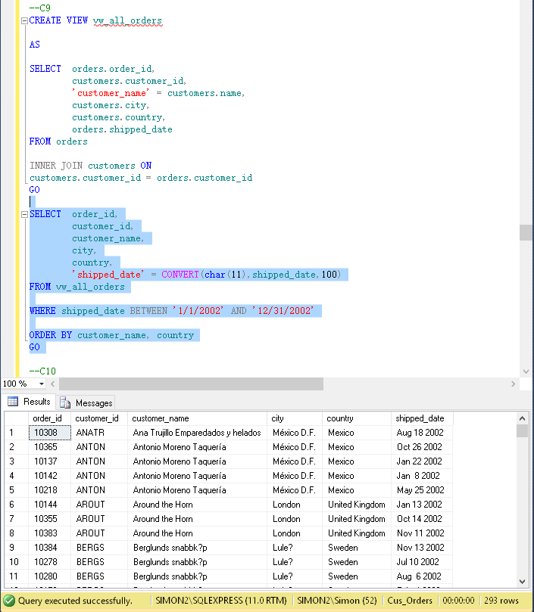

1. Create a view listing the suppliers and the items they have shipped. Display the supplier id and name from the suppliers table, and the product id and name from the products table. Run the view. The view should produce the result set listed below, *although not necessarily in the same order.*

supplier_id supplier_name product_id product_name

--------------- ---------------------------------------- -------------- ------------------------------

9 Silver Spring Wholesale Market 23 Tunnbröd

11 Ovellette Manufacturer Company 46 Spegesild

15 Campbell Company 69 Gudbrandsdalsost

12 South Harbour Products Ltd. 77 Original Frankfurter grüne Soße

14 St. Jean's Company 31 Gorgonzola Telino

...

7 Steveston Export Company 63 Vegie-spread

3 Macaulay Products Company 8 Northwoods Cranberry Sauce

15 Campbell Company 55 Pâté chinois

(77 row(s) affected)

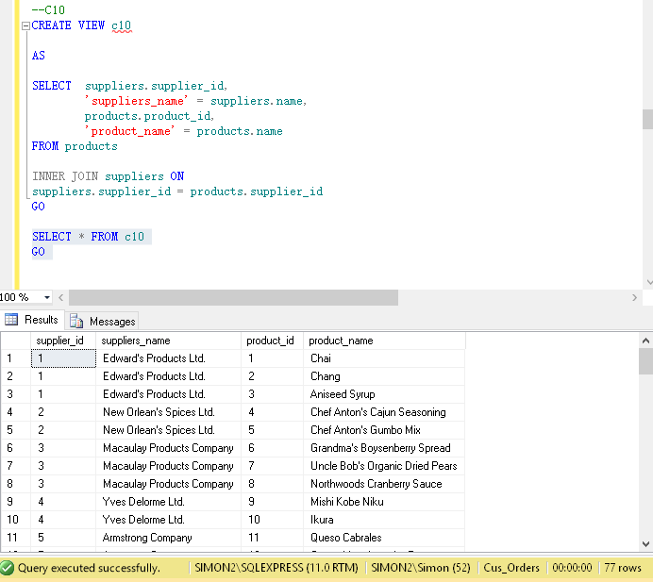

# Part D - Stored Procedures and Triggers

1. Create a stored procedure called **sp_customer_city** displaying the customers living in a particular city. The **city** will be an **input parameter** for the stored procedure. Display the customer id, name, address, city and phone from the customers table. Run the stored procedure displaying customers living in **London**. The stored procedure should produce the result set listed below.

customer_id name address city phone

--------------- ------------------------ ---------- ------------------------------------- ------ ------------

AROUT Around the Horn 120 Hanover Sq. London (71) 555-7788

BSBEV B's Beverages Fauntleroy Circus London (71) 555-1212

CONSH Consolidated Holdings Berkeley Gardens 12 Brewery London (71) 555-2282

EASTC Eastern Connection 35 King George London (71) 555-0297

NORTS North/South South House 300 Queensbridge London (71) 555-7733

SEVES Seven Seas Imports 90 Wadhurst Rd. London (71) 555-1717

(6 row(s) affected)

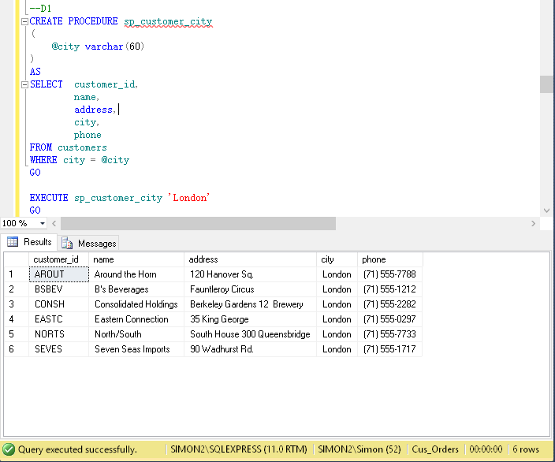

1. Create a stored procedure called **sp_orders_by_dates** displaying the orders shipped between particular dates. The **start** and **end** date will be **input parameters** for the stored procedure. Display the order id, customer id, and shipped date from the orders table, the customer name from the customer table, and the shipper name from the shippers table. Run the stored procedure displaying orders from **January 1, 2003** to **June 30, 2003**. The stored procedure should produce the result set listed below.

order_id customer_id customer_name shipper_name shipped_date

---------- --------------- ------------------------------------- -------------------- ----------------------

10423 GOURL Gourmet Lanchonetes Federal Shipping 2003-01-18 00:00:00.000

10425 LAMAI La maison d'Asie United Package 2003-01-08 00:00:00.000

10427 PICCO Piccolo und mehr United Package 2003-01-25 00:00:00.000

10429 HUNGO Hungry Owl All-Night Grocers United Package 2003-01-01 00:00:00.000

10431 BOTTM Bottom-Dollar Markets United Package 2003-01-01 00:00:00.000

...

10615 WILMK Wilman Kala Federal Shipping 2003-06-30 00:00:00.000

10616 GREAL Great Lakes Food Market United Package 2003-06-29 00:00:00.000

10617 GREAL Great Lakes Food Market United Package 2003-06-28 00:00:00.000

(188 row(s) affected)

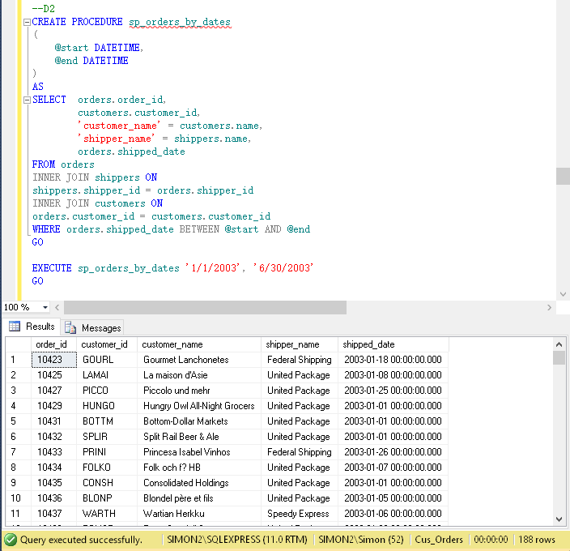

1. Create a stored procedure called **sp_product_listing** listing a specified product ordered during a specified month and year. The **product** and the **month** and **year** will be **input** **parameters** for the stored procedure. Display the product name, unit price, and quantity in stock from the products table, and the supplier name from the suppliers table. Run the stored procedure displaying a product name containing **Jack** and the month of the order date is **June** and the year is **2001**. The stored procedure should produce the result set listed below.

product_name unit_price quantity_in_stock supplier_name

--------------------------------------------- ------------- --------------------- -----------------------------------

Jack's New England Clam Chowder 10.1325 85 Silver Spring Wholesale Market

Jack's New England Clam Chowder 10.1325 85 Silver Spring Wholesale Market

Jack's New England Clam Chowder 10.1325 85 Silver Spring Wholesale Market

Jack's New England Clam Chowder 10.1325 85 Silver Spring Wholesale Market

(4 row(s) affect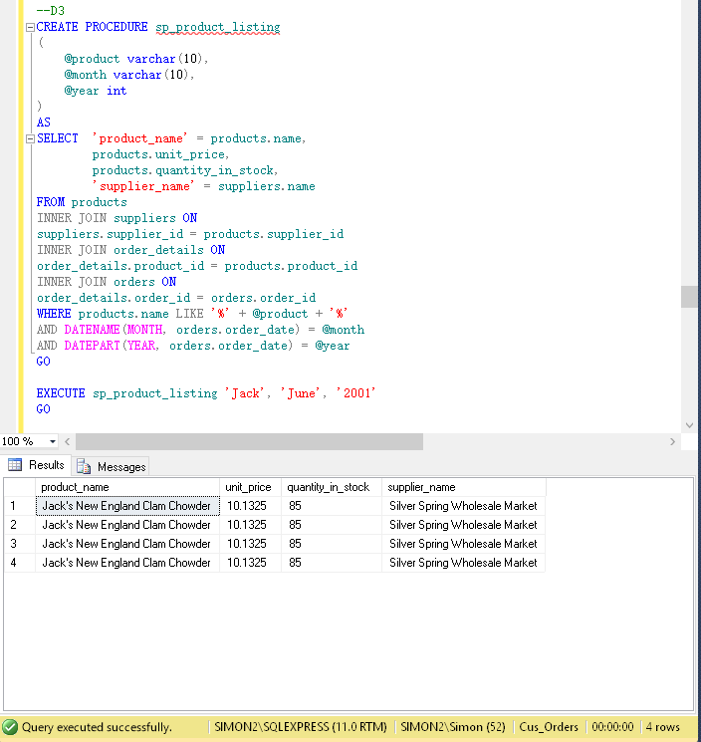

1. Create a **DELETE** trigger on the order_details table to display the information shown below when you issue the following statement:

DELETE order_details

WHERE order_id=10001 AND product_id=25

You should get the following results:

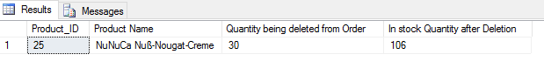

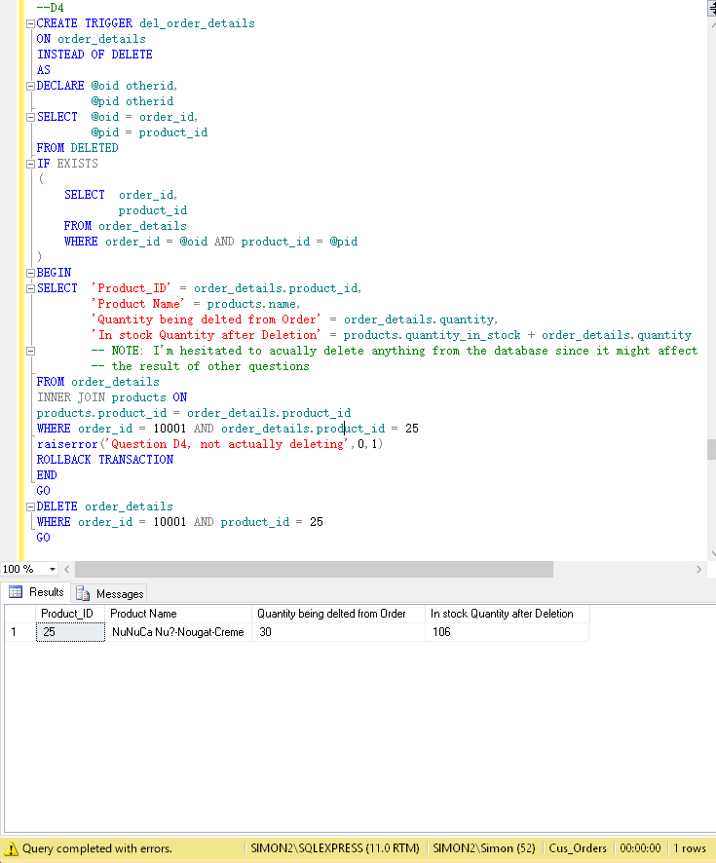

1. Create an **INSERT** and **UPDATE** trigger called **tr_check_qty** on the order_details table to only allow orders of products that have a quantity in stock greater than or equal to the units ordered. Run the following query to verify your trigger.

UPDATE order_details

SET quantity = 30

WHERE order_id = '10044'

AND product_id = 7

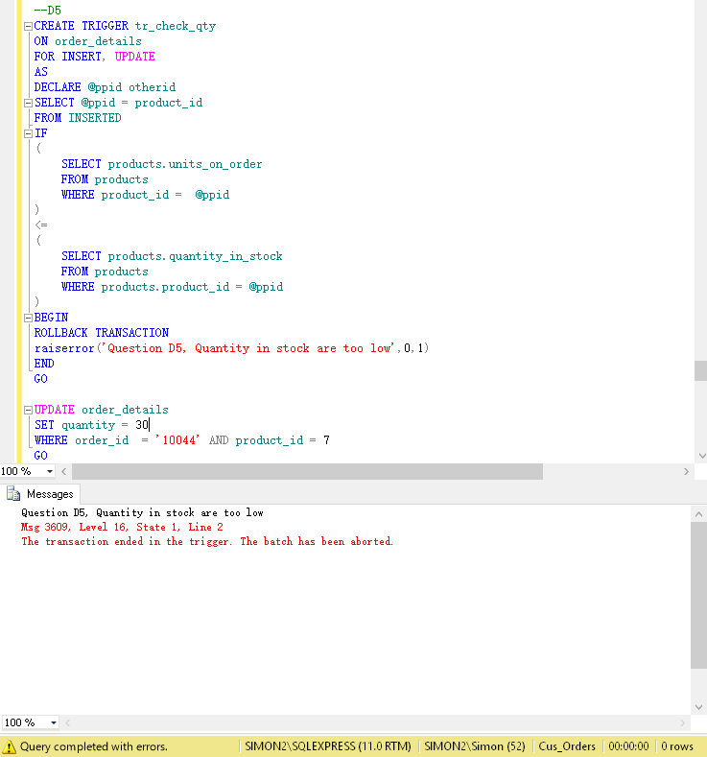

1. Create a stored procedure called **sp_del_inactive_cust** to **delete** customers that have no orders. The stored procedure should delete **1** row.

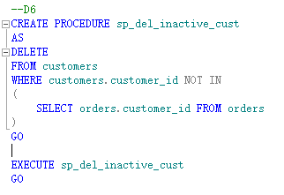

1. Create a stored procedure called **sp_employee_information** to display the employee information for a particular employee. The **employee id** will be an **input** **parameter** for the stored procedure. Run the stored procedure displaying information for employee id of **5**. The stored procedure should produce the result set listed below.

employee_id last_name first_name address city province postal_code phone birth_date

--------------- ------------- ------------- ----------------- --------------------- ---------- -------------- -------------- -------------------------------

5 Buchanan Steven 14 Garrett Hill New Westminster BC V1G 8J7 6045554848 1955-03-04 00:00:00.000

(1 row(s) affected)

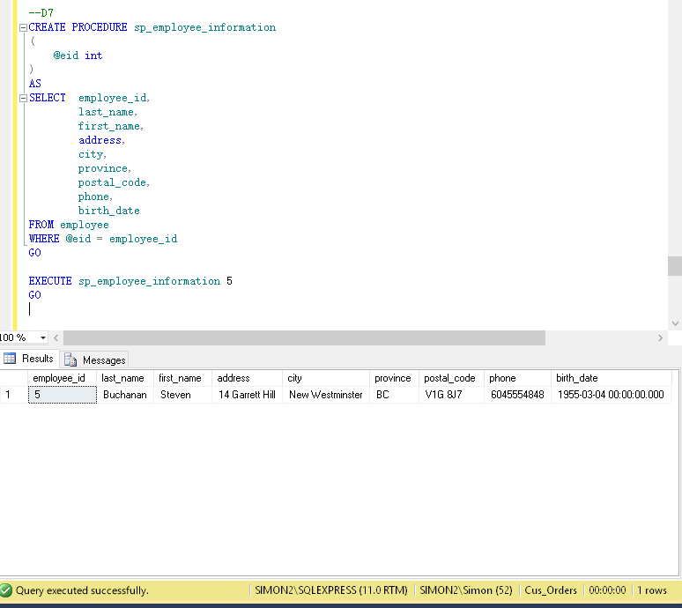

1. Create a stored procedure called **sp_reorder_qty** to show when the reorder level subtracted from the quantity in stock is less than a specified value. The **unit** value will be an **input** **parameter** for the stored procedure. Display the product id, quantity in stock, and reorder level from the products table, and the supplier name, address, city, and province from the suppliers table. Run the stored procedure displaying the information for a value of **5**. The stored procedure should produce the result set listed below.

product_id name address city province qty reorder_level

-------------- ---------------------------------- ------------------------ ------------------ -------- --- -------------

2 Edward's Products Ltd. 1125 Howe Street Vancouver BC 17 25

3 Edward's Products Ltd. 1125 Howe Street Vancouver BC 13 25

5 New Orlean's Spices Ltd. 1040 Georgia Street West Vancouver BC 0 0

11 Armstrong Company 1638 Derwent Way Richmond BC 22 30

17 Steveston Export Company 2951 Moncton Street Richmond BC 0 0

...

68 Dare Manufacturer Ltd. 1603 3rd Avenue West Burnaby BC 6 15

70 Steveston Export Company 2951 Moncton Street Richmond BC 15 30

74 Yves Delorme Ltd. 3050 Granville Street New Westminster BC 4 5

(23 row(s) affected)

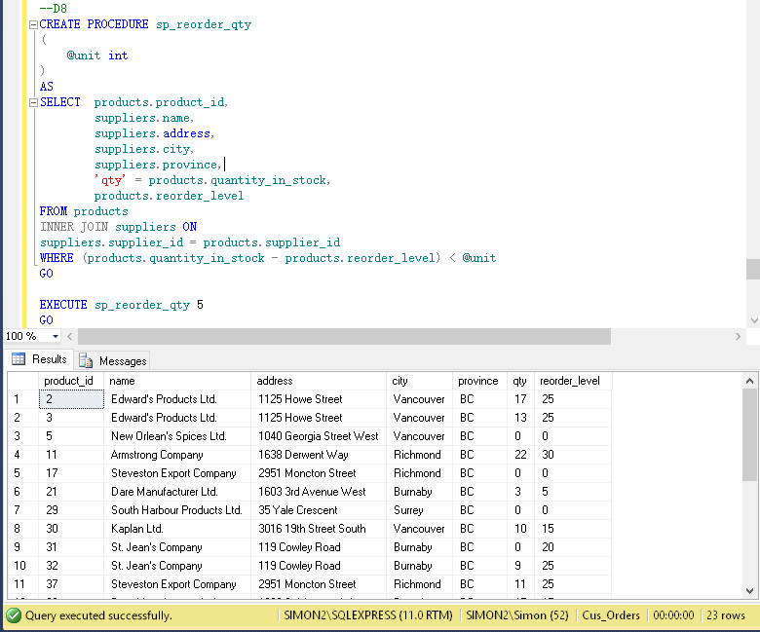

1. Create a stored procedure called **sp_unit_prices** for the product table where the **unit price** is **between particular values**. The **two unit prices** will be **input** **parameters** for the stored procedure. Display the product id, product name, alternate name, and unit price from the products table. Run the stored procedure to display products where the unit price is between **$5.00** and **$10.00**. The stored procedure should produce the result set listed below.

product_id name alternate_name unit_price

-------------- --------------------------------- -------------------------------- --------------

13 Konbu Kelp Seaweed 6.30

19 Teatime Chocolate Biscuits Teatime Chocolate Biscuits 9.66

23 Tunnbr÷d Thin Bread 9.45

45 R°gede sild Smoked Herring 9.975

47 Zaanse koeken Zaanse Cookies 9.975

52 Filo Mix Mix for Greek Filo Dough 7.35

54 TourtiÞre Pork Pie 7.8225

75 Rh÷nbrõu Klosterbier Rh÷nbrõu Beer 8.1375

1. row(s) affected)

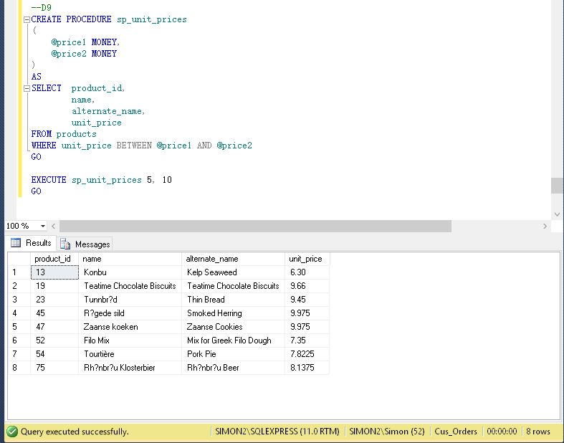

# Table Design

**customers**

|  |  |  |  |  |
| --- | --- | --- | --- | --- |
| *Column Name* | *Data Type* | *Length* |  | *Null Values* |
| customer_id | char | 5 | User-Defined Data Type | No |
| name | varchar | 50 |  | No |
| contact_name | varchar | 30 |  |  |
| title_id | char | 3 |  | No |
| address | varchar | 50 |  |  |
| city | varchar | 20 |  |  |
| region | varchar | 15 |  |  |
| country_code | varchar | 10 |  |  |
| country | varchar | 15 |  |  |
| phone | varchar | 20 |  |  |
| fax | varchar | 20 |  |  |

**orders**

|  |  |  |  |  |
| --- | --- | --- | --- | --- |
| *Column Name* | *Data Type* | *Length* |  | *Null Values* |
| order_id | int |  | User-Defined Data Type | No |
| customer_id | char | 5 | User-Defined Data Type | No |
| employee_id | int |  |  | No |
| shipping_name | varchar | 50 |  |  |
| shipping_address | varchar | 50 |  |  |
| shipping_city | varchar | 20 |  |  |
| shipping_region | varchar | 15 |  |  |
| shipping_country_code | varchar | 10 |  |  |
| shipping_country | varchar | 15 |  |  |
| shipper_id | int |  |  | No |
| order_date | datetime |  |  |  |
| required_date | datetime |  |  |  |
| shipped_date | datetime |  |  |  |
| freight_charge | money |  |  |  |

**order_details**

|  |  |  |  |  |
| --- | --- | --- | --- | --- |
| *Column Name* | *Data Type* | *Length* |  | *Null Values* |
| order_id | int |  | User-Defined Data Type | No |
| product_id | int |  | User-Defined Data Type | No |
| quantity | int |  |  | No |
| discount | float |  |  | No |

**products**

|  |  |  |  |  |
| --- | --- | --- | --- | --- |
| *Column Name* | *Data Type* | *Length* |  | *Null Values* |
| product_id | int |  | User-Defined Data Type | No |
| supplier_id | int |  |  | No |
| name | varchar | 40 |  | No |
| alternate_name | varchar | 40 |  |  |
| quantity_per_unit | varchar | 25 |  |  |
| unit_price | money |  |  |  |
| quantity_in_stock | int |  |  |  |
| units_on_order | int |  |  |  |
| reorder_level | int |  |  |  |

**shippers**

|  |  |  |  |  |
| --- | --- | --- | --- | --- |
| *Column Name* | *Data Type* | *Length* |  | *Null Values* |
| shipper_id | int |  | IDENTITY | No |
| name | varchar | 20 |  | No |

**suppliers**

|  |  |  |  |  |
| --- | --- | --- | --- | --- |
| *Column Name* | *Data Type* | *Length* |  | *Null Values* |
| supplier_id | int |  | IDENTITY | No |
| name | varchar | 40 |  | No |
| address | varchar | 30 |  |  |
| city | varchar | 20 |  |  |
| province | char | 2 |  |  |

**titles**

|  |  |  |  |  |
| --- | --- | --- | --- | --- |
| *Column Name* | *Data Type* | *Length* |  | *Null Values* |
| title_id | char | 3 |  | No |
| description | varchar | 35 |  | No |

# 

# Challenges

Part D question 4, I’m not sure whether I should delete from the database since by doing so, it might affect the result of other questions. I would also have to update the database as well which the question didn’t specify.

# 

# Summary

I’ve learned a lot throughout this project; When I first started, I didn’t even know how to use different values from different tables. However, as the project progress, I’m getting better and better at problem solving.

# Copy of Script

-- PART A

USE master

GO

IF exists (SELECT * FROM sysdatabases WHERE name='Cus_Orders')

BEGIN

raiserror('Dropping existing Cus_Orders database ....',0,1)

DROP database Cus_Orders

END

GO

--A1

CREATE DATABASE Cus_Orders

GO

USE Cus_Orders

GO

--A2

CREATE TYPE cusid FROM char(5) NOT NULL;

GO

CREATE TYPE otherid FROM int NOT NULL;

GO

--A3

CREATE TABLE customers

(

customer_id cusid,

name varchar(50) NOT NULL,

contact_name varchar(30),

title_id char(3) NOT NULL,

address varchar(50),

city varchar(20),

region varchar(15),

country_code varchar(10),

country varchar(15),

phone varchar(20),

fax varchar(20)

)

GO

CREATE TABLE orders

(

order_id otherid,

customer_id cusid,

employee_id int NOT NULL,

shipping_name varchar(50),

shipping_address varchar(50),

shipping_city varchar(20),

shipping_region varchar(15),

shipping_country_code varchar(10),

shipping_country varchar(15),

shipper_id int NOT NULL,

order_date DATETIME,

required_date DATETIME,

shipped_date DATETIME,

freight_charge MONEY

)

GO

CREATE TABLE order_details

(

order_id otherid,

product_id otherid,

quantity int NOT NULL,

discount float NOT NULL

)

GO

CREATE TABLE products

(

product_id otherid,

supplier_id int NOT NULL,

name varchar(40)NOT NULL,

alternate_name varchar(40),

quantity_per_unit varchar(25),

unit_price MONEY,

quantity_in_stock int,

units_on_order int,

reorder_level int

)

GO

CREATE TABLE shippers

(

shipper_id int IDENTITY NOT NULL,

name varchar(20) NOT NULL

)

GO

CREATE TABLE suppliers

(

supplier_id int IDENTITY NOT NULL,

name varchar(40) NOT NULL,

address varchar(30),

city varchar(20),

province char(2)

)

GO

CREATE TABLE titles

(

title_id char(3) NOT NULL,

description varchar(35) NOT NULL

)

GO

--A4

ALTER TABLE customers

ADD PRIMARY KEY(customer_id);

GO

ALTER TABLE orders

ADD PRIMARY KEY(order_id);

GO

ALTER TABLE products

ADD PRIMARY KEY(product_id);

GO

ALTER TABLE shippers

ADD PRIMARY KEY(shipper_id);

GO

ALTER TABLE suppliers

ADD PRIMARY KEY(supplier_id);

GO

ALTER TABLE titles

ADD PRIMARY KEY(title_id);

GO

ALTER TABLE order_details

ADD PRIMARY KEY(order_id,product_id);

GO

-- fk

ALTER TABLE orders

ADD CONSTRAINT FK_customers_orders FOREIGN KEY (customer_id)

REFERENCES customers

(customer_id);

GO

ALTER TABLE customers

ADD CONSTRAINT FK_customers_titles FOREIGN KEY (title_id)

REFERENCES titles

(title_id);

GO

ALTER TABLE orders

ADD CONSTRAINT FK_shippers_orders FOREIGN KEY (shipper_id)

REFERENCES shippers

(shipper_id);

GO

ALTER TABLE order_details

ADD CONSTRAINT FK_orders_order_details FOREIGN KEY (order_id)

REFERENCES orders

(order_id);

GO

ALTER TABLE order_details

ADD CONSTRAINT FK_products_order_details FOREIGN KEY (product_id)

REFERENCES products

(product_id);

GO

ALTER TABLE products

ADD CONSTRAINT FK_suppliers_products FOREIGN KEY (supplier_id)

REFERENCES suppliers

(supplier_id);

GO

--A5

ALTER TABLE customers

ADD CONSTRAINT default_country

DEFAULT('Canada')FOR country;

GO

ALTER TABLE orders

ADD CONSTRAINT default_required_date

DEFAULT('DATEADD(day,10,GETDATE())')FOR required_date;

GO

ALTER TABLE order_details

ADD CONSTRAINT ch_quantity

CHECK(quantity >= 1);

GO

ALTER TABLE products

ADD CONSTRAINT ch_reorder_level

CHECK(reorder_level >= 1);

GO

ALTER TABLE products

ADD CONSTRAINT ch_quantity_in_stock

CHECK(quantity_in_stock <= 150);

GO

ALTER TABLE suppliers

ADD CONSTRAINT default_province

DEFAULT('BC')FOR province;

GO

--A6

BULK INSERT titles

FROM 'C:\TextFiles\titles.txt'

WITH (

CODEPAGE=1252,

DATAFILETYPE = 'char',

FIELDTERMINATOR = '\t',

KEEPNULLS,

ROWTERMINATOR = '\n'

)

GO

BULK INSERT suppliers

FROM 'C:\TextFiles\suppliers.txt'

WITH (

CODEPAGE=1252,

DATAFILETYPE = 'char',

FIELDTERMINATOR = '\t',

KEEPNULLS,

ROWTERMINATOR = '\n'

)

GO

BULK INSERT shippers

FROM 'C:\TextFiles\shippers.txt'

WITH (

CODEPAGE=1252,

DATAFILETYPE = 'char',

FIELDTERMINATOR = '\t',

KEEPNULLS,

ROWTERMINATOR = '\n'

)

GO

BULK INSERT customers

FROM 'C:\TextFiles\customers.txt'

WITH (

CODEPAGE=1252,

DATAFILETYPE = 'char',

FIELDTERMINATOR = '\t',

KEEPNULLS,

ROWTERMINATOR = '\n'

)

GO

BULK INSERT products

FROM 'C:\TextFiles\products.txt'

WITH (

CODEPAGE=1252,

DATAFILETYPE = 'char',

FIELDTERMINATOR = '\t',

KEEPNULLS,

ROWTERMINATOR = '\n'

)

GO

BULK INSERT order_details

FROM 'C:\TextFiles\order_details.txt'

WITH (

CODEPAGE=1252,

DATAFILETYPE = 'char',

FIELDTERMINATOR = '\t',

KEEPNULLS,

ROWTERMINATOR = '\n'

)

GO

BULK INSERT orders

FROM 'C:\TextFiles\orders.txt'

WITH (

CODEPAGE=1252,

DATAFILETYPE = 'char',

FIELDTERMINATOR = '\t',

KEEPNULLS,

ROWTERMINATOR = '\n'

)

GO

--PART B

--B1

SELECT customer_id,

name,

city,

country

FROM customers

ORDER BY customer_id

GO

--B2

ALTER TABLE customers

ADD active BIT;

GO

ALTER TABLE customers

ADD CONSTRAINT default_active

DEFAULT('1')FOR active;

GO

UPDATE customers

SET active = 1

GO

SELECT customer_id,

name,

city,

country,

active

FROM customers

ORDER BY customer_id

GO

--B3

SELECT orders.order_id,

'product_name' = products.name,

'customer_name' = customers.name,

'order_date' = CONVERT(CHAR(12), order_date, 109),

'new_shipped_date' = CONVERT(CHAR(12),DATEADD(day,7,shipped_date),109),

'order_cost' = cast(order_details.quantity*products.unit_price as decimal(10,4))

FROM orders

INNER JOIN customers ON

customers.customer_id = orders.customer_id

INNER JOIN order_details ON

orders.order_id = order_details.order_id

INNER JOIN products ON

products.product_id = order_details.product_id

WHERE orders.order_date BETWEEN '1/1/2001' AND '12/31/2001'

GO

--B4

SELECT orders.customer_id,

customers.name,

customers.phone,

orders.order_id,

orders.order_date

FROM orders

INNER JOIN customers ON

orders.customer_id = customers.customer_id

WHERE orders.shipped_date IS NULL

ORDER BY customers.name

GO

--B5

SELECT customers.customer_id,

customers.name,

customers.city,

titles.description

FROM customers

INNER JOIN titles ON

customers.title_id = titles.title_id

WHERE customers.region IS NULL

GO

--B6

SELECT 'supplier_name' = suppliers.name,

'product_name' = products.name,

products.reorder_level,

products.quantity_in_stock

FROM products

INNER JOIN suppliers ON

suppliers.supplier_id = products.supplier_id

WHERE products.reorder_level > products.quantity_in_stock

ORDER BY supplier_name

GO

--B7

SELECT orders.order_id,

customers.name,

customers.contact_name,

'shipped_date' = CONVERT(char(12),orders.shipped_date,109),

'elapsed' = DATEDIFF(YEAR,orders.shipped_date,'1/1/2008')

FROM orders

INNER JOIN customers ON

customers.customer_id = orders.customer_id

WHERE orders.shipped_date IS NOT NULL

ORDER BY orders.order_id, elapsed

GO

--B8

SELECT 'name' = LEFT(customers.name, 1),

'total' = Count(LEFT(customers.name, 1))

FROM customers

GROUP BY LEFT(customers.name, 1)

HAVING COUNT(name) > 1 AND LEFT(customers.name, 1) != 'S'

GO

--B9

SELECT orders.order_id,

order_details.quantity,

products.product_id,

products.reorder_level,

products.supplier_id

FROM products

INNER JOIN order_details ON

order_details.product_id = products.product_id

INNER JOIN orders ON

order_details.order_id = orders.order_id

WHERE quantity > 100

ORDER BY orders.order_id

GO

--B10

SELECT products.product_id,

products.name,

products.quantity_per_unit,

'unit_price' = cast(products.unit_price as decimal(10,4))

FROM products

WHERE products.name LIKE '%tofu%' OR products.name LIKE '%chef%'

ORDER BY products.name

GO

--PART C

--C1

CREATE TABLE employee

(

employee_id int NOT NULL,

last_name varchar(30) NOT NULL,

first_name varchar(15) NOT NULL,

address varchar(30),

city varchar(20),

province char(2),

postal_code varchar(7),

phone varchar(10),

birth_date DATETIME NOT NULL

)

GO

--C2

ALTER TABLE employee

ADD PRIMARY KEY(employee_id);

GO

--C3

BULK INSERT employee

FROM 'C:\TextFiles\employee.txt'

WITH ( CODEPAGE=1252,

DATAFILETYPE = 'char',

FIELDTERMINATOR = '\t',

KEEPNULLS,

ROWTERMINATOR = '\n'

)

GO

ALTER TABLE orders

ADD CONSTRAINT fk_orders_employee FOREIGN KEY (employee_id)

REFERENCES employee

(employee_id);

GO

SELECT * FROM employee

GO

--C4

INSERT INTO shippers(name)

VALUES('Quick Express');

SELECT * FROM shippers

GO

--C5

UPDATE products

SET unit_price = unit_price * 1.05

WHERE unit_price BETWEEN 5 AND 10

GO

SELECT * FROM products

WHERE unit_price BETWEEN 5 AND 10.5

GO

--C6

UPDATE customers

SET fax = 'Unknown'

WHERE fax IS NULL

GO

SELECT * FROM customers

WHERE fax = 'Unknown'

GO

--C7

CREATE VIEW vw_order_cost

AS

SELECT orders.order_id,

orders.order_date,

products.product_id,

customers.name,

'order_cost' = cast(order_details.quantity * products.unit_price as decimal(10,4))

FROM orders

INNER JOIN customers ON

customers.customer_id = orders.customer_id

INNER JOIN order_details ON

order_details.order_id = orders.order_id

INNER JOIN products ON

products.product_id = order_details.product_id

GO

SELECT * FROM vw_order_cost

WHERE order_id BETWEEN 10000 AND 10200

GO

--C8

CREATE VIEW vw_list_employees

AS

SELECT * FROM employee

GO

SELECT employee_id,

'name' = last_name + ', ' + first_name,

'birth_date' = CONVERT(char(10),birth_date,102)

FROM vw_list_employees

WHERE employee_id = 5 OR employee_id = 7 OR employee_id = 9

GO

--C9

CREATE VIEW vw_all_orders

AS

SELECT orders.order_id,

customers.customer_id,

'customer_name' = customers.name,

customers.city,

customers.country,

orders.shipped_date

FROM orders

INNER JOIN customers ON

customers.customer_id = orders.customer_id

GO

SELECT order_id,

customer_id,

customer_name,

city,

country,

'shipped_date' = CONVERT(char(11),shipped_date,100)

FROM vw_all_orders

WHERE shipped_date BETWEEN '1/1/2002' AND '12/31/2002'

ORDER BY customer_name, country

GO

--C10

CREATE VIEW c10

AS

SELECT suppliers.supplier_id,

'suppliers_name' = suppliers.name,

products.product_id,

'product_name' = products.name

FROM products

INNER JOIN suppliers ON

suppliers.supplier_id = products.supplier_id

GO

SELECT * FROM c10

GO

--PART D

--D1

CREATE PROCEDURE sp_customer_city

(

@city varchar(60)

)

AS

SELECT customer_id,

name,

address,

city,

phone

FROM customers

WHERE city = @city

GO

EXECUTE sp_customer_city 'London'

GO

--D2

CREATE PROCEDURE sp_orders_by_dates

(

@start DATETIME,

@end DATETIME

)

AS

SELECT orders.order_id,

customers.customer_id,

'customer_name' = customers.name,

'shipper_name' = shippers.name,

orders.shipped_date

FROM orders

INNER JOIN shippers ON

shippers.shipper_id = orders.shipper_id

INNER JOIN customers ON

orders.customer_id = customers.customer_id

WHERE orders.shipped_date BETWEEN @start AND @end

GO

EXECUTE sp_orders_by_dates '1/1/2003', '6/30/2003'

GO

--D3

CREATE PROCEDURE sp_product_listing

(

@product varchar(10),

@month varchar(10),

@year int

)

AS

SELECT 'product_name' = products.name,

products.unit_price,

products.quantity_in_stock,

'supplier_name' = suppliers.name

FROM products

INNER JOIN suppliers ON

suppliers.supplier_id = products.supplier_id

INNER JOIN order_details ON

order_details.product_id = products.product_id

INNER JOIN orders ON

order_details.order_id = orders.order_id

WHERE products.name LIKE '%' + @product + '%'

AND DATENAME(MONTH, orders.order_date) = @month

AND DATEPART(YEAR, orders.order_date) = @year

GO

EXECUTE sp_product_listing 'Jack', 'June', '2001'

GO

--D4

CREATE TRIGGER del_order_details

ON order_details

INSTEAD OF DELETE

AS

DECLARE @oid otherid,

@pid otherid

SELECT @oid = order_id,

@pid = product_id

FROM DELETED

IF EXISTS

(

SELECT order_id,

product_id

FROM order_details

WHERE order_id = @oid AND product_id = @pid

)

BEGIN

SELECT 'Product_ID' = order_details.product_id,

'Product Name' = products.name,

'Quantity being delted from Order' = order_details.quantity,

'In stock Quantity after Deletion' = products.quantity_in_stock + order_details.quantity

-- NOTE: I'm hesitated to acually delete anything from the database since it might affect

-- the result of other questions

FROM order_details

INNER JOIN products ON

products.product_id = order_details.product_id

WHERE order_id = 10001 AND order_details.product_id = 25

raiserror('Question D4, not actually deleting',0,1)

ROLLBACK TRANSACTION

END

GO

DELETE order_details

WHERE order_id = 10001 AND product_id = 25

GO

--D5

CREATE TRIGGER tr_check_qty

ON order_details

FOR INSERT, UPDATE

AS

DECLARE @ppid otherid

SELECT @ppid = product_id

FROM INSERTED

IF

(

SELECT products.units_on_order

FROM products

WHERE product_id = @ppid

)

<=

(

SELECT products.quantity_in_stock

FROM products

WHERE products.product_id = @ppid

)

BEGIN

ROLLBACK TRANSACTION

raiserror('Question D5, Quantity in stock are too low',0,1)

END

GO

UPDATE order_details

SET quantity = 30

WHERE order_id = '10044' AND product_id = 7

GO

--D6

CREATE PROCEDURE sp_del_inactive_cust

AS

DELETE

FROM customers

WHERE customers.customer_id NOT IN

(

SELECT orders.customer_id FROM orders

)

GO

EXECUTE sp_del_inactive_cust

GO

--D7

CREATE PROCEDURE sp_employee_information

(

@eid int

)

AS

SELECT employee_id,

last_name,

first_name,

address,

city,

province,

postal_code,

phone,

birth_date

FROM employee

WHERE @eid = employee_id

GO

EXECUTE sp_employee_information 5

GO

--D8

CREATE PROCEDURE sp_reorder_qty

(

@unit int

)

AS

SELECT products.product_id,

suppliers.name,

suppliers.address,

suppliers.city,

suppliers.province,

'qty' = products.quantity_in_stock,

products.reorder_level

FROM products

INNER JOIN suppliers ON

suppliers.supplier_id = products.supplier_id

WHERE (products.quantity_in_stock - products.reorder_level) < @unit

GO

EXECUTE sp_reorder_qty 5

GO

--D9

CREATE PROCEDURE sp_unit_prices

(

@price1 MONEY,

@price2 MONEY

)

AS

SELECT product_id,

name,

alternate_name,

unit_price

FROM products

WHERE unit_price BETWEEN @price1 AND @price2

GO

EXECUTE sp_unit_prices 5, 10

GO

# 