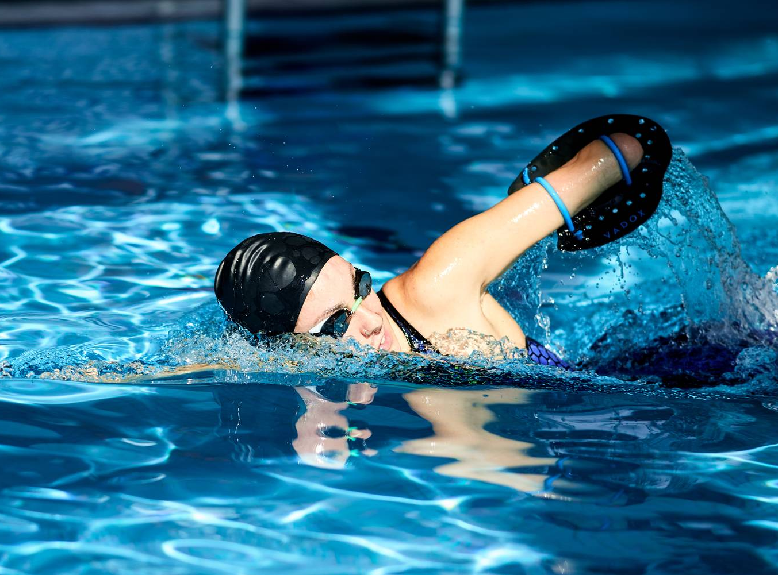

Scoring information
For individual races 1st place earns 9 points,
decreasing down by place to 1 point for 8th

Relays earn double points
The highest-scoring team wins

Event officials
Head Referee: Laura Melgar
Judge's coordinator: Shriya Nene
Meet director: Ravi Costa


Join us next year for the 20XX Women's Inter-Collegiate Swimming Championship.  Follow our journey and celebrate female athletes with  us on social media.  www.bellowscollege.com |  |  | Women's  Inter-Collegiate Swimming Championship  - August 12th - 14th  - Kristi Laar Aquatic Center  - Seattle, WA

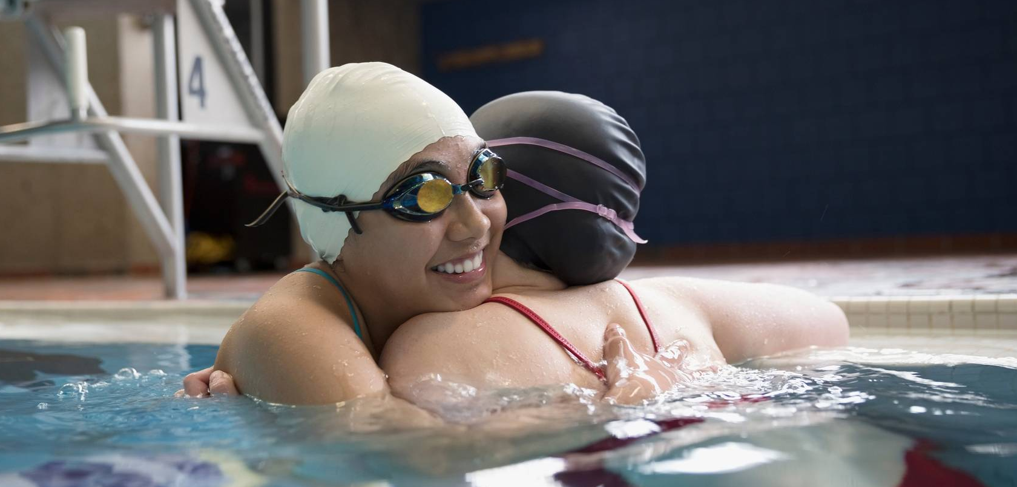
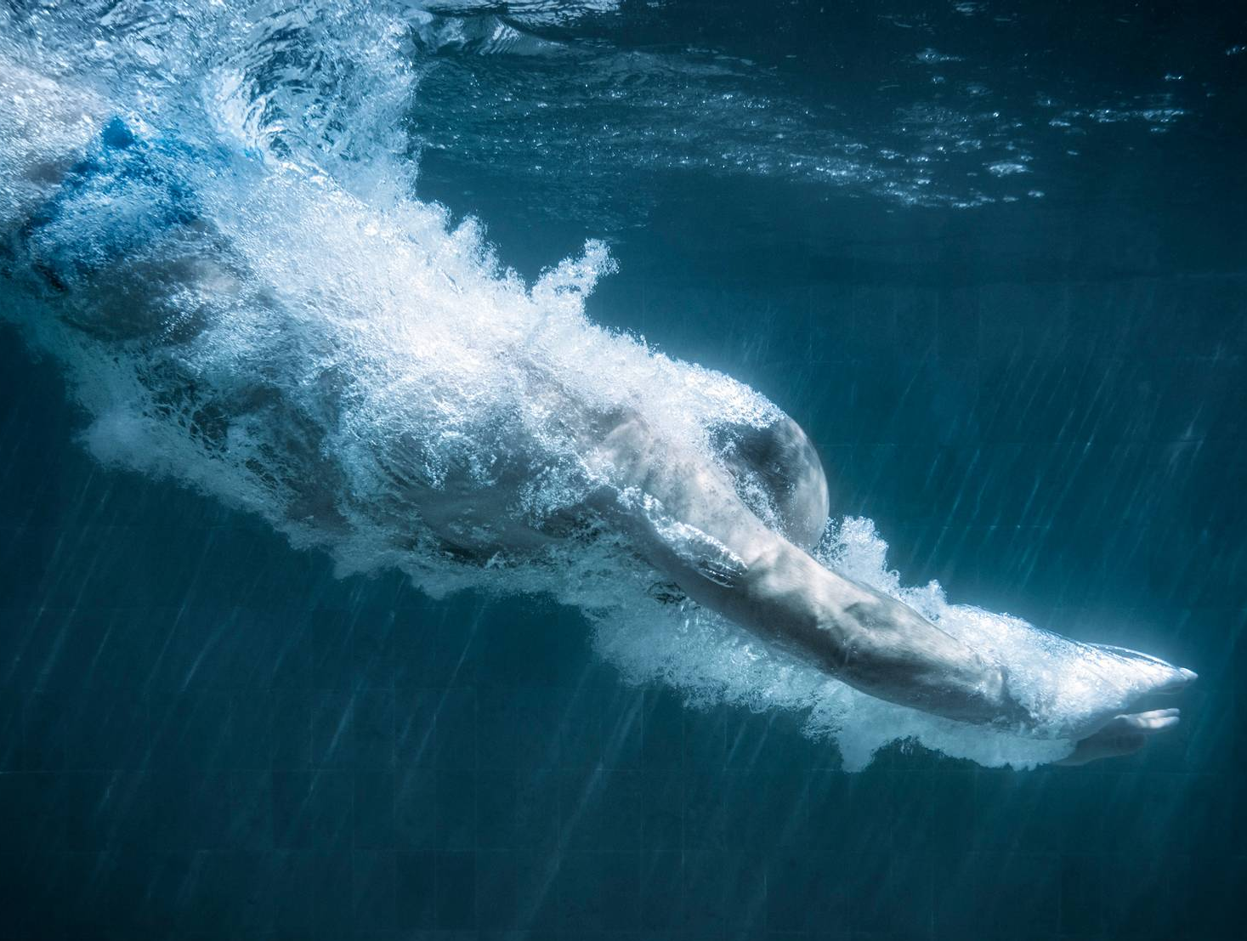

Day 2: August 13th, 20XX

Morning heats
8:00 AM: 50m Freestyle
9:30 AM: 100m Breaststroke
11:00 AM: 200m Individual Medley

Afternoon finals
2:00 PM: 50m Freestyle
3:30 PM: 100m Breaststroke
5:00 PM: 200m Individual Medley

Day 1: August 12th, 20XX  Morning heats  8:00 AM: 400m Freestyle  9:30 AM: 200m Butterfly  11:00 AM: 100m Backstroke  Afternoon finals  2:00 PM: 400m Freestyle  3:30 PM: 200m Butterfly  5:00 PM: 100m Backstroke |  |  | Day 3: August 14th, 20XX  Team relays and special events  8:00 AM: 4x100m Freestyle relay  10:00 AM: 4x100m Medley relay  1:00 PM: Awards ceremony

