

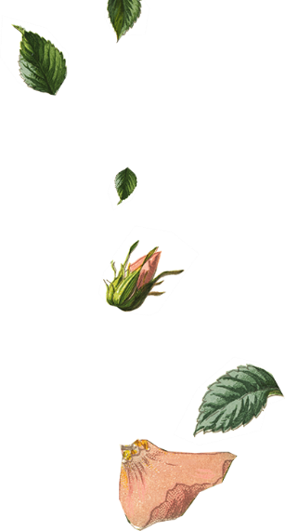
 | - You are invited to join

Robin Zupanc

Peyton Davis
 | Robin Zupanc  Peyton Davis | &
 | on our wedding day
 | - You are invited to join

Robin Zupanc

Peyton Davis
 | Robin Zupanc  Peyton Davis | &
 | on our wedding day


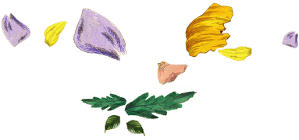
Mr. & Mrs. Robin Zupanc
Request the honor of Your Presence
At the marriage of

Robin Zupanc
To

Peyton Davis
Child of
Mr. & Mrs. Peyton Davis

Saturday the Twenty-First of June

Two thousand and [Year]

Eleven O’clock in the morning

At Location City, State.

Reception to Follow
Mr. & Mrs. Robin Zupanc
Request the honor of Your Presence
At the marriage of

Robin Zupanc
To

Peyton Davis
Child of
Mr. & Mrs. Peyton Davis

Saturday the Twenty-First of June

Two thousand and [Year]

Eleven O’clock in the morning

At Location City, State.

Reception to Follow

