Ship Game – Adding New Content
This article explains the various content types used in Ship Game, including how they are created and how they interact with the XNA Framework Content Pipeline. Using the information in this article, you will be able to create new playable spaceships, new environments, and new animated sprites.

Player Spaceships
In Ship Game, players can choose the type of spaceship they want to pilot during the game. The spaceship is an object that is represented graphically, with various effects and game objects that spawn in locations relative to it during gameplay.
To add a new selectable player spaceship to Ship Game, you must complete the following tasks.
- Create and load a 3D model to represent the ship.
  - Optionally apply: diffuse, specular, glow, and bump materials to give the ship detail.
- Create and load a ship definition XML file.
- Add the model to the Screens/ScreenPlayer.cs file.

Step 1a: Create the Ship Model and Materials
Creating the graphical representation of the ship is the first step in making a new ship available in Ship Game. You must create a 3D model of the ship, and optionally attach materials that will give the model detail.

Create the Model
Create your new ship model using a 3D content creation tool that supports exporting to .FBX format.

Create the Materials
Once you have a model created, you can optionally apply materials that will give the ship model detail in the game. Four types of texture maps are available: diffuse, specular, self-illumination, and bump (normal mapping).
From your 3D content creation tool, apply a standard Phong material, and select which of the maps you wish to apply. Any unsupported maps will be ignored when the model is loaded into Ship Game.

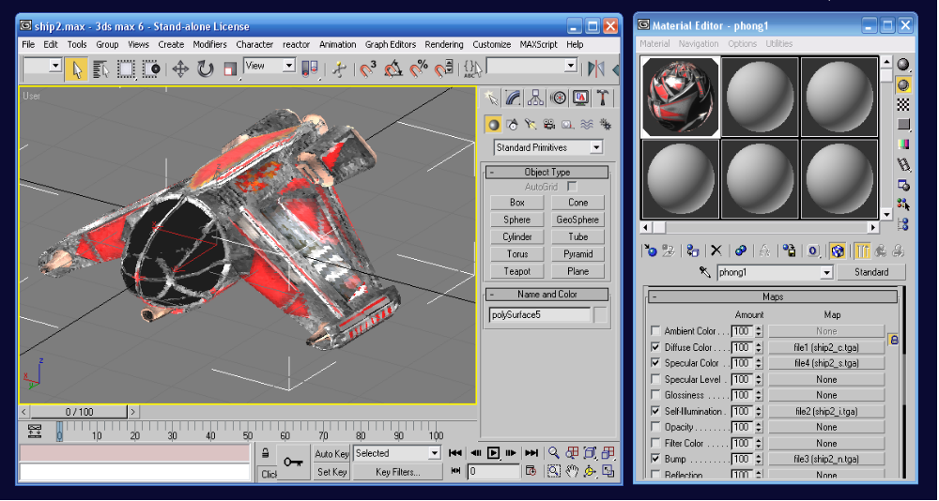
Figure 1: Material setup in 3ds max (only diffuse, specular, self-illumination, and bump map slots used)
The following maps are supported, and all are optional.
Diffuse – This map is the most basic map, it indicates the diffuse color to return when lit. General texture details and colors should be placed in this map. If no diffuse map is specified, Ship Game will default to a diffuse color of white.
Specular – This map indicates specular highlights, which are reflected when the object is lit to give a “shiny” appearance. This texture should be a 32 BPP texture with the first 24 bits used for RGB components and the last 8 bits used as an alpha channel that represents specular power from 0 to 255. If no specular map is specified, Ship Game will default to a gray specular map with a specular power of 128.
Self-Illumination – This map indicates areas that should have bright colors regardless of lighting conditions; even in dark or no lighting, all non-black pixels will show up on the model. If no self-illumination map is specified, Ship Game will not self-illuminate any part of the model.
Bump – Even though this texture map utilizes the “Bump” slot, it is actually the material normal texture, which uses tangent-space normal mapping instead of ordinary bump mapping. This texture should be a 32 BPP texture with the first 24 bits used for the normal data in RGB components and the last 8 bits used as an alpha channel to indicate the intensity of the normal mapping from 0 to 255, where 0 indicates no normal mapping, and 255 indicates full environment mapping. If no normal map is specified, Ship Game will not use normal mapping on this model.
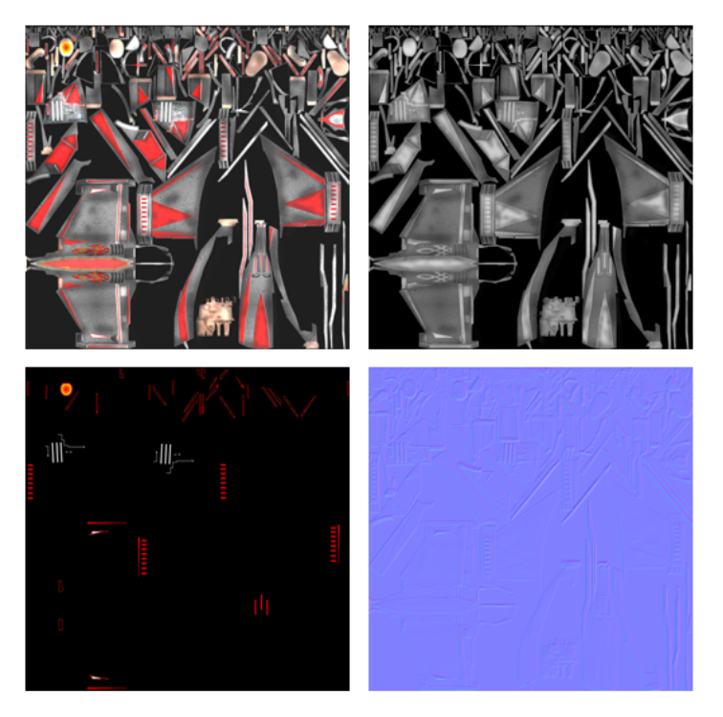
Figure 2: Top to bottom, left to right: diffuse, specular, self-illumination, and normal (bump) maps for ship model
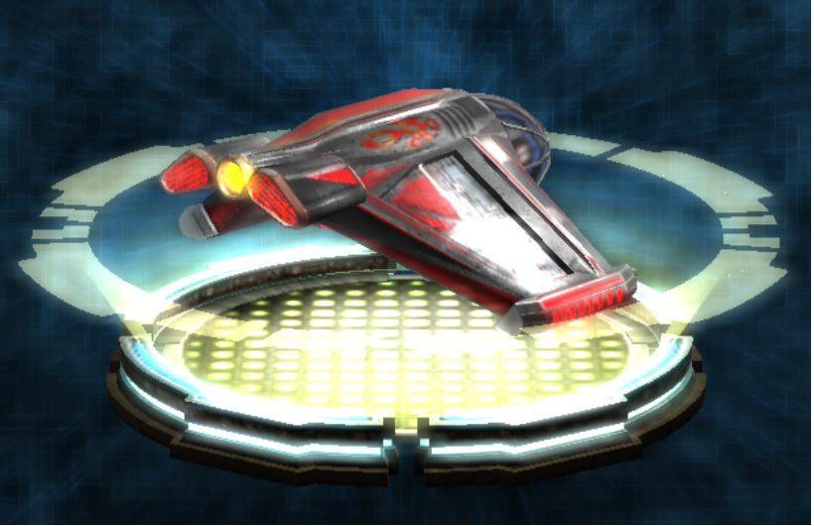
Figure 3: Final ship render with all maps in game

Export as FBX
The XNA Content Pipeline supports the Autodesk FBX format for models; you must export your new ship model and its associated materials as an FBX file.
If you are using Maya or 3D Studio Max, use the Autodesk FBX plug-in, available at http://www.autodesk.com – search for “FBX.”
Use the following settings with the Autodesk FBX plug-in.
- Under Export, place a check in the Geometry check box – all other check boxes in the section should not be checked.
- Under Misc, place a check in the Export to ASCII format check box.
- Under Misc, set Export to version to “FBX20611.”
- Under Coordinate and Unit Conversion, set Conversion Method to None.
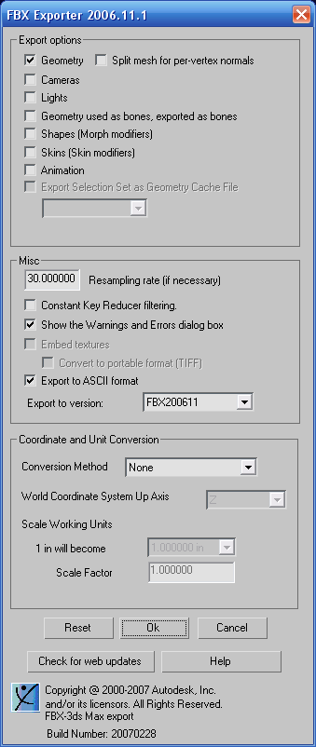
Figure 4: FBX 2006.11.1 export settings (make sure to use ASCII format)

Step 1b: Load the Ship Model into Ship Game
Once you have exported the model, you are ready to add it to the Ship Game project in XNA Game Studio. Give your model a unique name – ship1.fbx and ship2.fbx are the ships that come standard with Ship Game, so avoid those names – and add the model in Solution Explorer in the Ships folder within the content project.
Once the ship model has been added, ensure that in the Properties window for your new ship FBX file, the Content Processor property is set to Model - ShipGame Normal Mapping. This is a special processor developed for Ship Game that will process the normal mapping textures you have exported with your model.
Finally, copy any texture maps you have exported with your FBX to the Content\Ships folder – it is not necessary to add them to Solution Explorer, but they must be where the FBX expects to find them when the game is built and run.

Step 2: Create and Load the Ship Definition XML File
The ship definition XML file identifies a set of 3D transforms that are used to spawn the ship’s engine effects and the player’s blaster and missile weapons when they are fired.
Note: The ship definition XML file you create must have the same name as the model you created for the ship in Step 1, only with an .xml extension.
The markup file is in XML format and represents a list of entities. Each entity has a name and a transform matrix. Each ship markup file must include entities named: blaster_left, blaster_right, missile, and engine.
Ship Game includes two ship definition XML files. These represent the two ships that are included in Ship Game. Use these XML files as a reference when creating your ship definition XML file.
Once you have completed the ship definition XML file, add it to the content project within the Ship Game project in XNA Game Studio, in the Ships folder.
Ensure that in the Property window for your XML file, you have the following properties set:
- Build Action is set to Content.
- Copy to Output Directory is set to Copy if newer.
- Content Importer and Content Processor are blank.

Step 3: Add the Model to the ScreenPlayer.cs File
Finally, you must add the ship to the list of available ships in the Screens/ScreenPlayer.cs file in the Ship Game project.
This requires incrementing the NumberShips variable, and adding the name of the ship model to the ships array.
The below example uses a new ship that is named “newship” – this ship would use a model named “newship.fbx” and a ship definition XML file named “newship.xml”.
namespace ShipGame
{
public class ScreenPlayer : Screen
{
ScreenManager screenManager; // screen manager
GameManager gameManager; // game manager
// CHANGE:: YOU MUST CHANGE THE NumberShips CONSTANT IN THE FOLLOWING LINE
const int NumberShips = 3; // number of available ships to choose from
// name for each ship
// CHANGE:: YOU MUST CHANGE THE “newship” VARIABLE IN THE FOLLOWING LINE
String[] ships = new String[NumberShips] { "ship1", "ship2", "newship" };
...

New Levels
Levels refer to the environments that the players fly their ships in. To create a new level, you must create the following set of files.
- Level FBX geometry file
- Level FBX collision geometry file
- Level power-up placement XML file
- Level player ship spawn placement XML file
- Level light placement XML file
- Level screenshot

Step 1: Create New Level Subfolder
Using Solution Explorer in XNA Game Studio, create a new subfolder in the content project underneath the Levels folder and name it to identify your new level. All of the files you create for the level must be saved to this new subfolder.

Step 2: Create and Load the Level Geometry File
The level geometry is an FBX file, which is created and textured similarly to a new player ship model. To understand how to create and export an FBX file of this type, including the available texturing options, see the Player Spaceships – Step 1a: Create the Ship Model and Materials section earlier in this document.
When saving your FBX file, you must give it the name you gave your new subfolder, with a .FBX extension. Once you have saved your FBX file, add it to the content project within the Ship Game project using Solution Explorer. Add the file to the new subfolder you created in step 1.
Ensure that in the Properties window for this newly-added FBX file, the Content Processor property is set to Model - ShipGame Normal Mapping.
Copy all of the texture maps for your level geometry file into the new subfolder you have created in step 1, so that the FBX can reference them when loading.

Step 3: Create and Load the Collision Geometry File
The collision geometry for your level is a separate FBX file that does not need materials information, and can be reduced in polygon count from the base-level geometry file to speed up collision testing between the player’s ship and the level. Both levels need to have the same set of transformations applied to them. For testing purposes, it is often convenient to copy your base-level geometry file, created in Step 2.
Export this collision geometry file using the same name as the base-level geometry file you created and exported in Step 1, but adding a “_collision” suffix to the file name. For instance, if your base-level geometry file was named newlevel.fbx, this collision geometry file should be named newlevel_collision.fbx.
Once you have exported the FBX file, add it to the content project within your Ship Game project in XNA Game Studio, in the same subfolder under levels that you placed your base-level geometry file. Ensure that the Content Processor is set to Model - XNA Framework, as no normal mapping data is required for the collision geometry.

Step 4: Create the Level XML Files
Three XML files are required for a new level – a definition of where the power-up objects spawn, a definition of where player’s ships can spawn, and a definition of where the lights in the level are located.
Note: For each XML file, examples can be found in the Levels folder in the content project, under the level1 and level2 subfolders. Use these examples as a starting point when creating your level XML files.
Each XML file has a different naming convention based off of the name of the base-level geometry file. As an example, these would be the names of the XML files for a level with a base-level geometry file named newlevel.fbx:
Power-Up XML File: newlevel_powerups.xml
Ship Spawns XML File: newlevel_spawns.xml
Lights XML File: newlevel_lights.xml

Power-Up XML File
This file is named with a “_powerups” suffix. If your base-level geometry file is named newlevel.fbx, name this file newlevel_powerups.xml.
The power-ups markup file is an XML file, similar to the ship definition file. It contains multiple entities each with a name and transform matrix.
Each entity represents a single power-up that will be spawned in the level. The power-up type is defined by the entity name, and the power-up position and orientation is defined by the entity matrix.
There are two currently supported entity types: energy, which gives the player a 50% energy recharge; and missile, which gives the player three missiles.

Ship Spawns XML File
This file is named with a “_spawns” suffix. If your base-level geometry file is named newlevel.fbx, name this file newlevel_spawns.xml.
The ship spawns markup file is an XML file, similar to the power-up definition file. It contains multiple entities each with a name and transform matrix. The transformation matrix defines a location in the level to respawn: when a ship is destroyed, it will randomly pick one of these locations, where it will then reappear.
In this file, you must at least supply two spawn locations so that two players can spawn at the same time in different locations.

Lights XML File
This file is named with a “_lights” suffix. If your base-level geometry file is named newlevel.fbx, name this file newlevel_lights.xml.
The lights markup file is an XML file that defines a list of lights. Each light contains a name, transform matrix, color, and illumination radius.

Placing the XML Files
Once you have created the XML files, add them to your new level subfolder in the Levels folder in the content project, using Solution Explorer.
Ensure that for the XML files, the following settings are set in the Properties window:
- Build Action is set to Content.
- Copy to Output Directory is set to Copy if newer.
- Content Importer and Content Processor are blank.

Step 5: Create Level Screenshot
Create a screenshot of your level that will be displayed in the level selection screen. This screenshot must be a .TGA file at a size of 880x420 pixels.
The screenshot must have the proper menu borders and alpha values for transparency as the screenshots for the levels included in Ship Game. See the screens folder in the content project, level1_screen.tga and level2_screen.tga for reference.
Name the screenshot with the name of your base-level geometry file, appending a “_screen” suffix and a .tga extension. For instance, if your base-level geometry file is named newlevel.fbx, name this file newlevel_screen.tga.
Add the screenshot file to the screens subfolder in the content project, using Solution Explorer.

Step 6: Add Level to ScreenLevel.cs
After creating and adding your new level files, you must add the base-level geometry file name to the list of available levels in the levels array; this list is located in the beginning of Screens/ScreenLevel.cs. This will enable its selection in the level selection screen. You must also increment the NumberLevels variable.
namespace ShipGame
{
public class ScreenLevel : Screen
{
ScreenManager screenManager; // screen manager
GameManager gameManager; // game manager
// CHANGE:: YOU MUST CHANGE THE NumberLevels CONSTANT IN THE FOLLOWING LINE
const int NumberLevels = 3; // number of available levels to choose from
// name for each level // CHANGE:: YOU MUST CHANGE THE “levelname” VARIABLE IN THE FOLLOWING LINE
String[] levels = new String[NumberLevels] { "level1", "level2", "levelname" };
...

Animated Sprites
The game Animated Sprite object plays a small animation sequence by blending between frames from a texture grid. You can create textures with multiple 256x256 frames organized in any number of columns and rows.
Ship Game will play back the animation at any desired frame rate. For example, a 1024x1024 texture would contain a grid of 4x4, resulting in 16 total frames. If played at 10 frames per second, the animation would last 1.6 seconds. Ship Game blends between frames, so you will get a smooth playback even at slow frame rates.

Step 1: Create the Texture Grid
The grid should be a single .TGA file with alpha channel, organized with any number of columns and rows of 256 x 256 frames. The frames are played left to right, top to bottom.
Save the texture with any name you like.
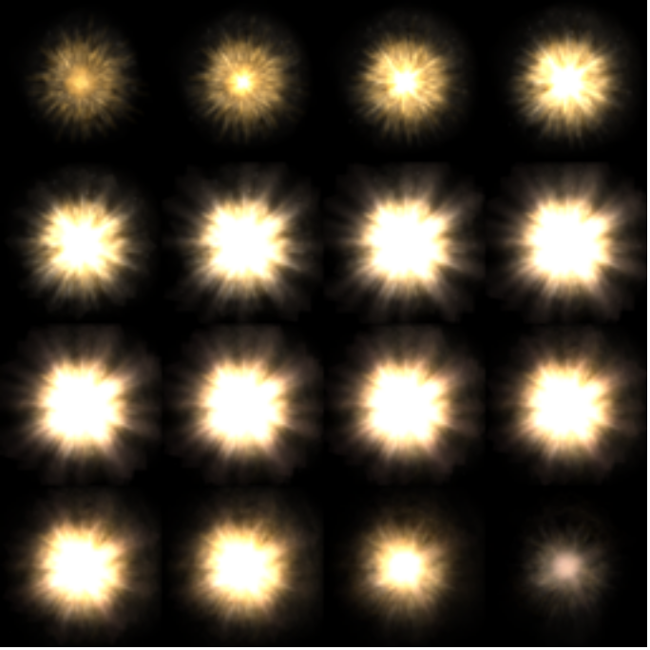
Figure 5: Texture grid with a 16 frames animation (each frame is 256x256 pixels)

Step 2: Load Texture Grid
Once you have created a suitable texture grid, add it to the Explosions folder in the content project within Ship Game. Ensure that in the Properties Window for the new texture the following properties are set:
- Content Importer set to Texture - XNA Framework.
- Content Processor set to Texture (Sprite, 32bpp) - XNA Framework.

Step 3: Reference Texture in GameManager.cs
Animated sprite textures are loaded from the explosions folder within the content project and placed in an array of Texture2D objects, referenced into by the AnimSpriteType enumeration.
Start by editing the declaration of the animatedSpriteFiles array at or around line 113 in GameManager.cs, adding the name of your new texture grid file to the end of the array.
String[] animatedSpriteFiles = new String[]
{ "BlasterGrid_16", "MissileGrid_16", "ShipGrid_32",
// CHANGE:: YOU MUST CHANGE THE “NewSprite” VARIABLE IN THE FOLLOWING LINE
"SpawnGrid_16", "ShieldGrid_32", "NewSprite" };
...
Then, edit the AnimSpriteType enumeration at or around line 38 in GameManager.cs, adding a new enumerated value to the end of the list. The position of the enumerated value in the list must match the position of the string you added to the animatedSpriteFiles array.
public enum AnimSpriteType
{
Blaster = 0, // blaster hit
Missile, // missile explode
Ship, // ship explode
Spawn, // ship/object spawn
Shield, // ship shield
// CHANGE:: YOU MUST CHANGE THE “NewSprite” VARIABLE IN THE FOLLOWING LINE
NewSprite // new animated sprite type
}
...
You can now call game.AddAnimSprite and pass in this new enumerated value to spawn an animated sprite that uses your texture grid.

