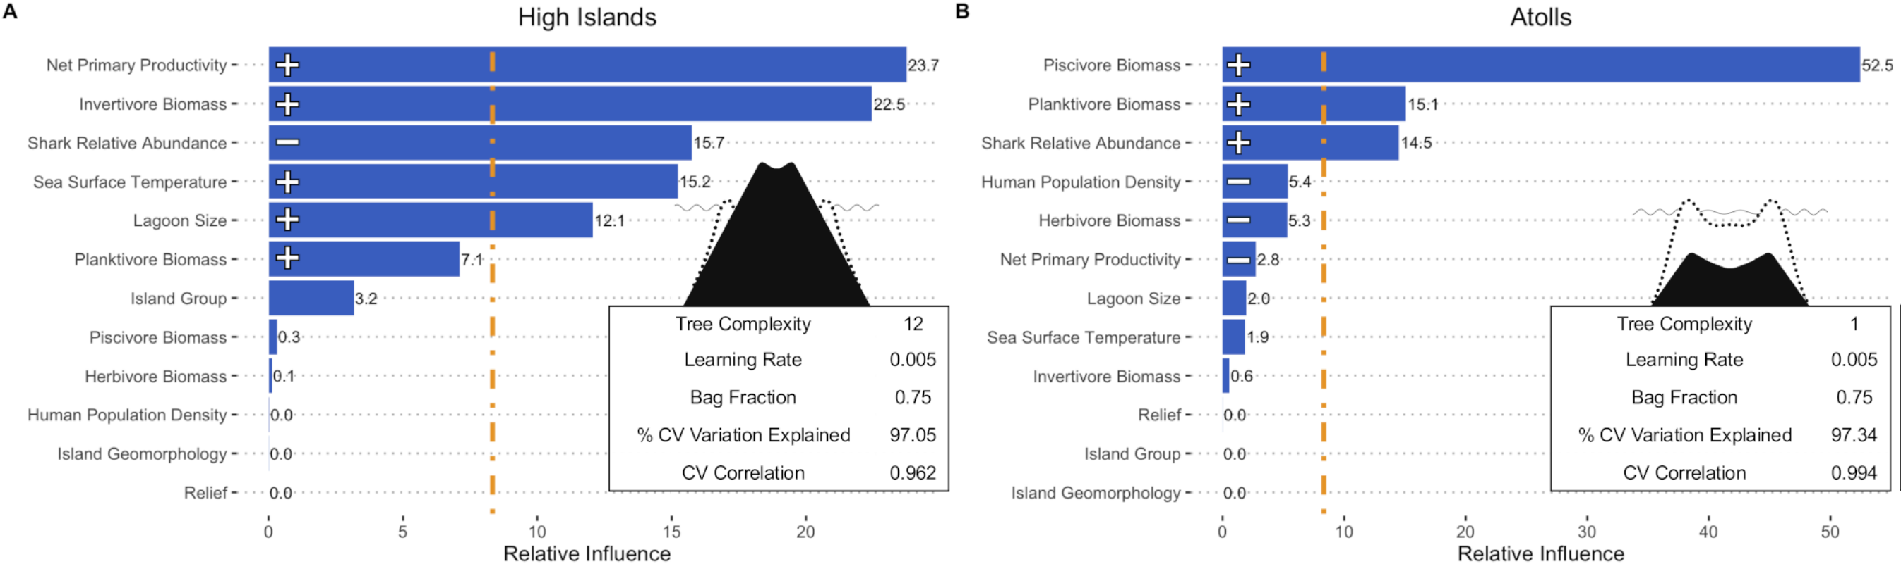
Figure 1. Relative influence of selected reef variables on models of percent of coral cover on French Polynesian reefs of high islands (left) and atolls (right). Orange horizontal dot-dashed line signifies the relative influence that would be expected by chance. +- symbols indirect positive or negative relationships.

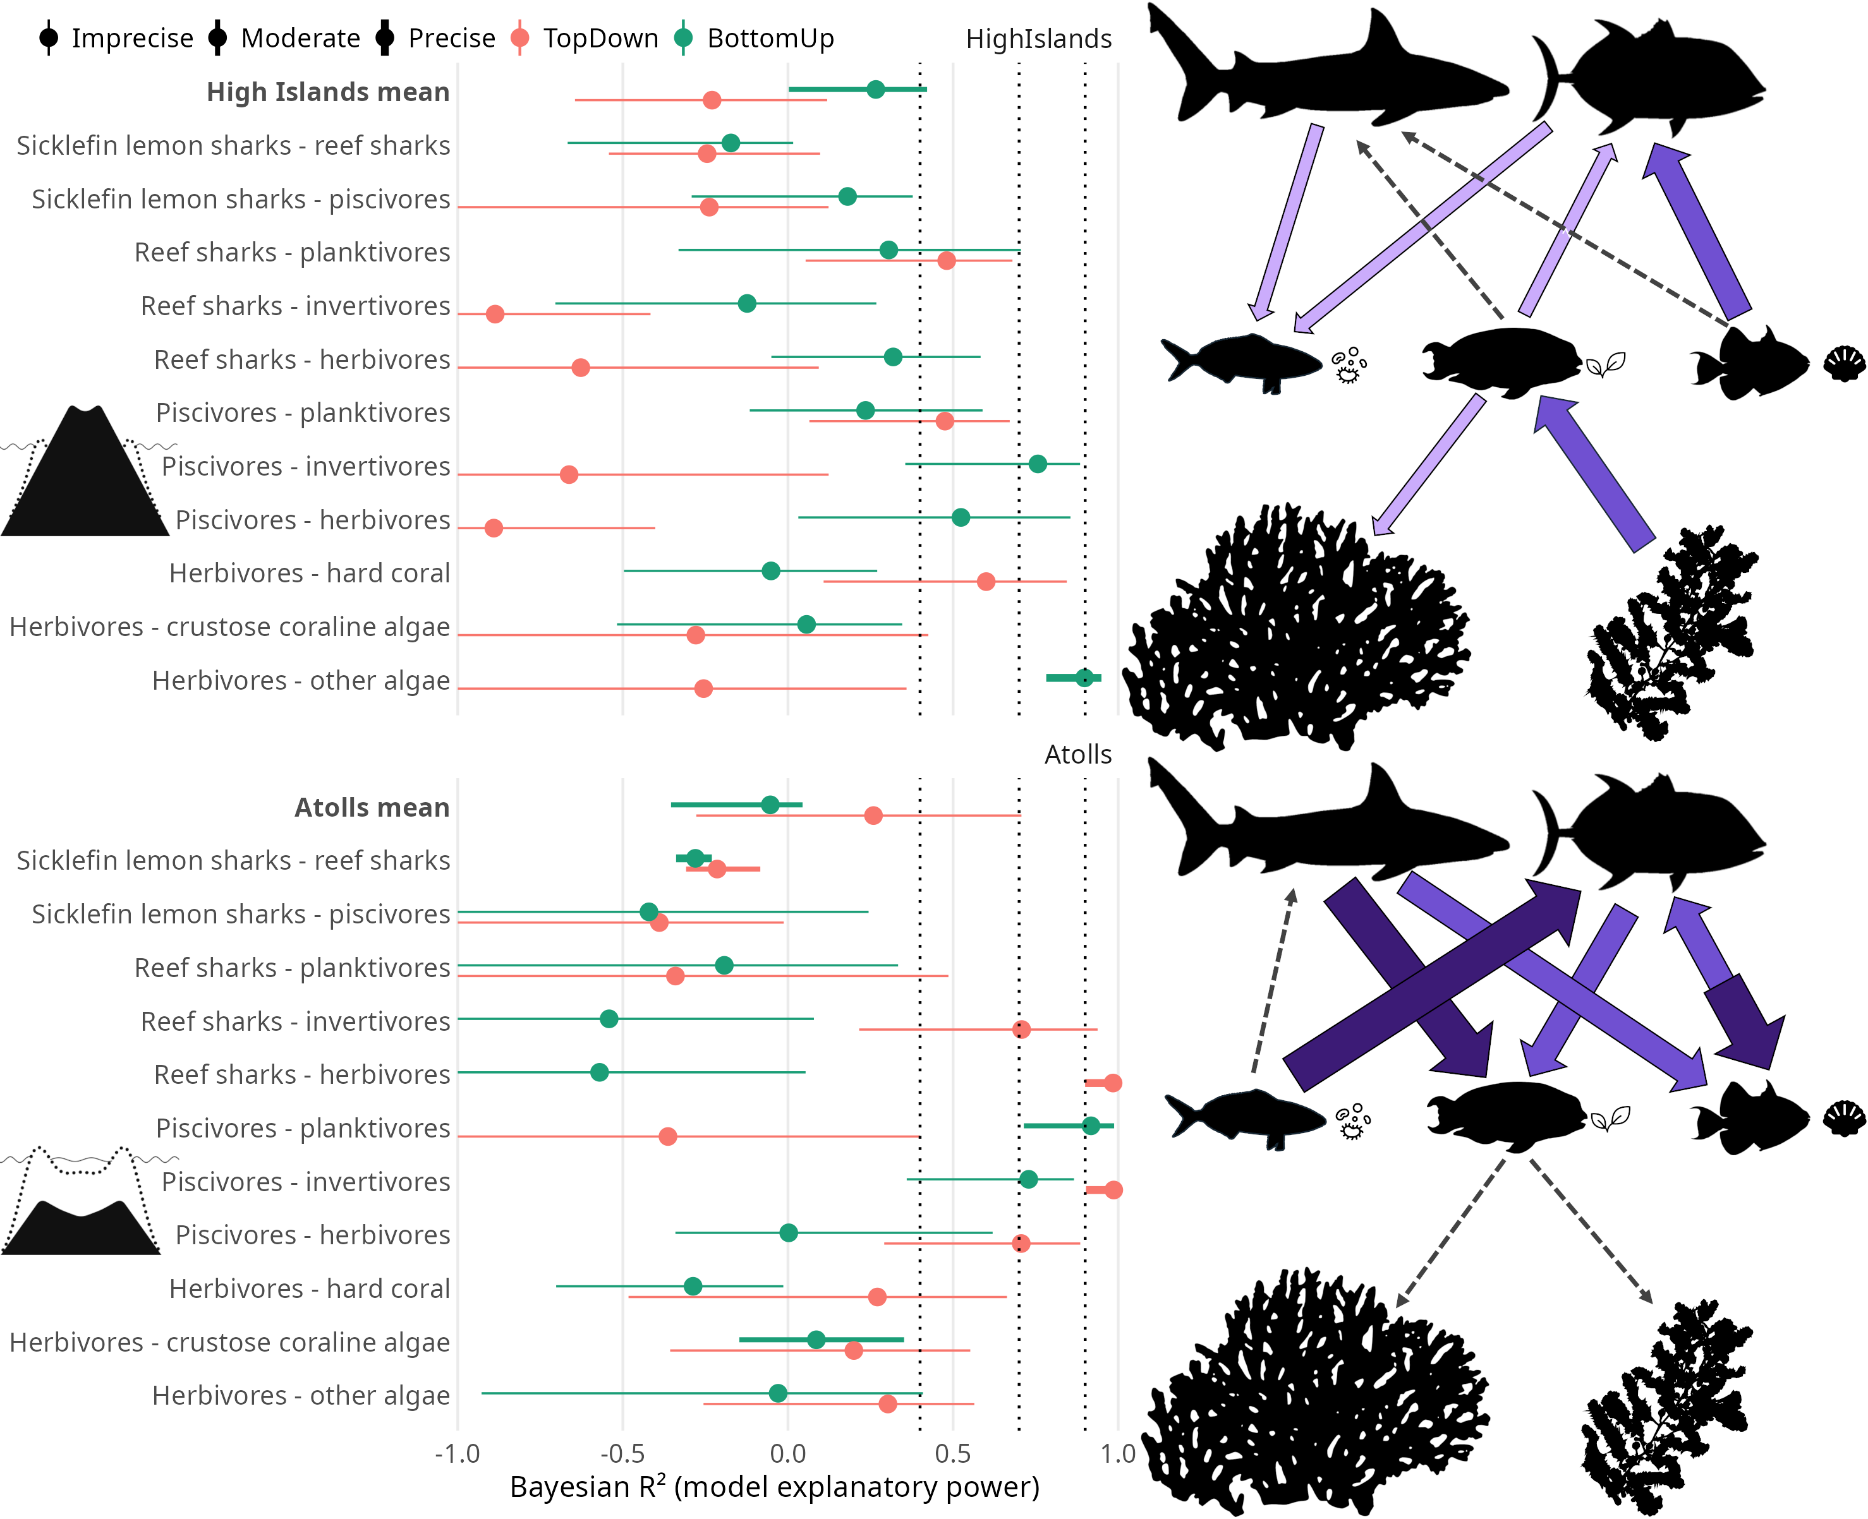
Figure 2 A: Bayesian LOO R2 values for top-down (red) and bottom-up (green) models on high islands (i) and atolls (ii). Dotted vertical lines at 0.4, 0.7, and 0.9, represent boundaries from weak, to moderate, to strong, to very strong correlations. Width of the 95% credible intervals of the posteriors are represented by horizontal lines around each R2 estimate point; narrower intervals equate to more precise estimates. Interval width precision is also represented by line thickness, with thicker lines equating to more precise estimates (i.e. short thick lines are better). B: For each animal taxa from SEMs that had at least one connection with a moderate or better Bayes LOO R2 score in at least one model, block arrows indicate the top-down and/or bottom-up relationships that were very strong (>0.9, dark purple), strong (0.7–0.9, mid purple), or moderate (0.4–0.7, light purple). Where connections were weak, the strongest (top-down vs bottom-up) relationship is shown by a grey thin dashed arrow. High islands (i) and atolls (ii).

