**Amino functionalized Ni-PyC for noble gas separation under humid condition**

Min-Bum Kima, Alexander Robinsona, and Praveen K. Thallapallya,*

a Pacific Northwest National Laboratory, Richland, Washington, 99352, United States

*Corresponding author: Fax: +1-509-371-7249; Tel: +1-509-371-7183;

E-mail: [Praveen.Thallapally@pnnl.gov](mailto:Praveen.Thallapally@pnnl.gov)

**ABSTRACT**

**Keywords:**

1. **Introduction**

Because of its high energy density, nuclear energy is regarded as one of the most efficient resources to replace conventional energy sources and it is also an important energy source to avoid the release of greenhouse gases. However, exposure to the atmosphere or sea of radioactive waste (Xe and Kr) generated during the reprocessing of used nuclear fuels can lead to fatal health problems such as cancer. Because they have a long half-life, it is very important to prevent the release of Xe or Kr into the atmosphere. Nevertheless, since reliance on nuclear energy has gradually increased over the past few decades, the amount of Xe and Kr produced is continuously increasing. Currently, energy-intensive cryogenic distillation using a difference in boiling points (Xe: -108.1 ºC and Kr: -153.2 ºC) are being used industrially to control and separate radioactive inert gases; however, this process is a highly expensive separation process. A cost and energy efficient alternative to this conventional separation process presents itself in an adsorptive separation and capture process. In order to develop an effective Xe/Kr separation process, it is necessary to develop an adsorbent with high Xe/Kr selectivity and high Xe adsorption capacity. Due to their high porosity and surface areas, and adjustable functionalization on the pore surface, metal-organic frameworks (MOFs) are a potential porous sorbent for gas separation.

Several experimental and computational studies have been conducted to develop an appropriate MOF for Xe/Kr separation. In particular, a computational high-throughput screening study was reported to find the parameters of a MOF suitable for separation and capture of noble gases, and it was suggested that MOFs with 4–8 Å and cylindrical structure are ideal for Xe/Kr separation. SBMOF-1 was identified to be an excellent porous material for Xe/Kr separation among more than 125,000 MOF structures through molecular simulation. Although high-throughput screening studies and many existing MOFs studies for Xe/Kr separation have focused on the optimization of geometric properties, few studies have been conducted to adjust adsorption sites using metal and polar functional groups. Meek et al. reported that IRMOF-1 was systematically synthesized using halogenated ligands each containing a different halogen element, and as a result, it was demonstrated that the polarizability of the halogenated ligand is correlated with Xe/Kr selectivity. Lee and Kim et al. introduced polar functional groups into the organic ligand of UiO-66 to form UiO-66-NH2(OMe)2~~,~~. The introduction of the polar functional improved the Xe/Kr selectivity due to the permanent dipole derived from the electron-rich ligand. These studies support that the control of adsorption sites in which functional group are introduced into MOF is a major strategy for improving noble gas separation.

Our purpose.

1. **Experiments**
   1. **Material syntheses**

**Ni-PyC synthesis.** Ni-PyC was synthesized according to the reported literature. About 0.249 g of Nickel acetate and 0.244 g of 4-pyridinecarboxylic acid were dissolved in solution containing 6 ml of DMF and 4 ml of acetonitrile. The mixture was stirred for 30 min at room temperature and then 75 μl of triethylamine was added to it. The solution was placed in a Teflon lined Parr stainless steel autoclave and heated at 150 ºC for 72 hrs. followed by slow cooling to room temperature for 12 hrs. The resulting solid was recovered by filtration and washed with fresh DMF, fresh MeOH and fresh acetone. The obtained Ni-PyC was dried at 60 ºC overnight.

**Ni-PyC-NH2.** The synthesis procedure for Ni-PyC-NH2 is similar to the Ni-PyC synthesis. Nickel acetate (1.245 g) and 3-aminopyridine-4-caroxylic acid (1.375 g) was added to a solution containing 30 ml of DMF and 20 ml of acetonitrile, followed by 30 min of sonication. After sonication, 0.375 mL of triethylamine was added to the solution. The solution was placed in a Teflon lined Parr stainless steel autoclave and heated at 150 ºC for 72 hr. and then was cooled down slowly to room temperature for 12 hr. The resulting dark green solid was purified with fresh DMF, fresh MeOH and fresh acetone. The obtained Ni-PyC-NH2 was dried at 60 ºC overnight.

* 1. **Characterizations**

To obtain the surface area of these materials, the nitrogen adsorption/desorption isotherms were measured at 77 K with a Autosorb-iQ system (Quantachrome Instruments, USA) to allow BET analysis.

CHN elemental analysis was carried out on a VarioMACROcube (Elementar, Germany). And the oxygen analysis was measured with a Oxycube (Elementar, Germany).

* 1. **Gas adsorption measurements**

The single-component adsorption isotherms for Xe and Kr were measured at three temperatures (278 K, 288 K, and 298 K) up to 1 bar using a Autosorb-iQ, and a constant temperature was maintained using a water circulation system. The gas adsorption experiments were performed using activated samples (approximately 100 mg), and ‘as-synthesized’ Ni-PyC and Ni-PyC-NH2. The activation of the samples was done by degassing under vacuum at 433 K for 24 h.

The water sorption experiment on Ni-PyC and Ni-PyC-NH2 were measured using a VTI-SA+ instrument (TA instruments, USA) at room temperature. For the first cycle, the activated samples were degassed at 373 K for 2 hours. After the first water adsorption experiments were done, the second water adsorption cycle required degassing for 6 hrs. at 373 K before the second adsorption cycle began.

1. **Results and discussion**
   1. **Characterizations of adsorbents**

**Fig. 1** shows the (a) powder X-ray diffraction (PXRD) patterns and (b) nitrogen adsorption/desorption isotherms at 77 K on Ni-PyC and Ni-PyC-NH2. As shown in the figure, the PXRD pattern of the Ni-PYC sample was found to be in good agreement with the published literature PXRD pattern for Ni-PyC. (Analysis of NiPYC-NH2 PXRD here)

The BET surface areas calculated from the nitrogen isotherms at 77 K were found to be 739 m2/g for Ni-PyC and 765 m2/g for Ni-PyC-NH2, respectively.

**Table 1** shows the results of elemental analysis on Ni-PyC and Ni-PyC-NH2. Both samples presented a slight decrease in C and H contents after activation. This is because the solvent (DMF and methanol) inside the pores in MOF is removed during activation process. The Ni-PyC-NH2 appears to have a higher N content than Ni-PyC because of the -NH2 group of the ligand.

Table 1. The CHN/O elemental analysis on Ni-PyC and Ni-PyC-NH2

|  |  |  |  |  |
| --- | --- | --- | --- | --- |
|  | C [%] | H [%] | N [%] | O [wt%] |
| ‘as-synthesized’ Ni-PyC | 45.24 | 1.956 | 9.9 | 23.63 |
| ‘activated’  Ni-PyC | 44.32 | 0.673 | 9.0 | 23.50 |
| ‘exposed to air’ Ni-PyC | 42.24 | 0.69 | 8.5 | 25.58 |
| ‘as-synthesized’ Ni-PyC-NH2 | 42.89 | 2.637 | 16.91 | 19.73 |
| ‘activated’  Ni-PyC-NH2 | 41.66 | 0.986 | 17.63 | 19.41 |
| ‘exposed to air’ Ni-PyC-NH2 | 41.51 | 0.928 | 16.88 | 19.49 |

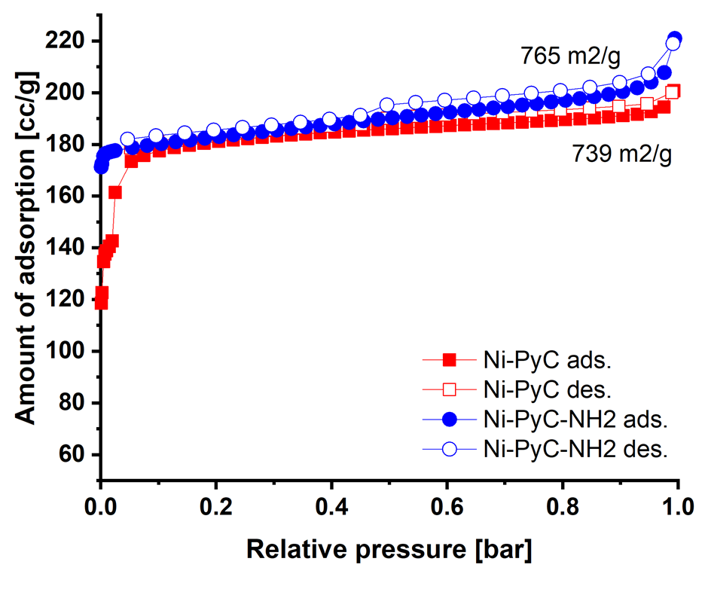

Fig. 1. The nitrogen adsorption/desorption isotherms on Ni-PyC and Ni-PyC-NH2 at 77 K.

* 1. **Xe and Kr single-component isotherms**

**Fig. 2** shows the single-component Xe, Kr and Ar adsorption isotherms of Ni-PyC and Ni-PyC-NH2 at 298 K and 1 bar. In the isotherms for each of the three gasses, Ni-PyC-NH2 has a higher gas uptake than Ni-PyC at all pressures. In the case of Xe adsorption, the amount of Xe adsorbed increased by 20% at pressures of 0.2 bar or less. As previously reported, the primary adsorption mechanism for Xe and Kr is mostly done through van der Waals forces. The London dispersion force due to the attraction between the transiently occurring induced dipole are known to contribute primarily to the adsorption of nonpolar gases, such as Xe and Kr. On the other hand, the effect of the Debye force occurring between the permanent dipole of most polar molecules and non-polar molecules has been neglected in examining the adsorption of Xe and Kr; however, it has been experimentally demonstrated that the Debye force significantly contributes to the adsorption of nonpolar gases such as Xe and Kr. Consequently, the organic ligand with polar amine groups of Ni-PyC-NH2 will induce a significant increase in Debye force in the adsorption of Xe and Kr as compared to the unfunctionalized Ni-PYC. In addition to the increase in Debye force, the amine group in Ni-PyC-NH2 has a higher atomic weight than the hydrogen atom of pristine Ni-PyC, which will increase the London dispersion force as well, enhancing the Xe and Kr adsorption even further. Therefore, the higher polarizability of -NH2 functional group increased gas-solid interaction at low pressures, and since Ni-PyC-NH2 with electron donating group is electron-rich compared to Ni-PyC, it can derive a permanent dipole that increases its interaction with Xe and Kr, thus enhancing its adsorption more when compared to Ni-PYC.



Fig. 2. Xe and Kr adsorption isotherms on Ni-PyC and Ni-PyC-NH2 at 298 K and 1 bar.

* 1. **Evaluation of Xe/Kr binary separation on amine functionalized Ni-PyC**

A sorbent with high adsorption separation selectivity and high Xe adsorption capacity are essential for efficient adsorptive separation of Xe/Kr mixture. Since the Xe/Kr mixture is present in 20/80 as a byproduct from the liquification of air, the Xe adsorption capacity is particularly important at low pressure. The ratio between Henry’s constant for Xe and Kr can be used as a simple metric to estimate the Xe/Kr selectivity. The ratio of Henry’s constant in Ni-PyC-NH2 (16.1) was higher than the original Ni-PyC (15.5) framework, indicating that the amine functionalized framework would perform better in the selective adsorption of Xe from a Xe:Kr mixture (**Table 2**). Compared to other reported materials, Ni-PyC-NH2 has a significantly higher Henry’s constant ratio value than those of previously reported materials: Co-MOF-74 (5.9), UiO-66 (7.5), HKUST-1 (6.9), UiO-66-NH2 (11.4), NOTT-100 (6.9) and SBMOF-1 (16).

Based on the Xe and Kr adsorption isotherms fitted by Langmuir-Freundlich equation, the adsorption selectivity in Xe/Kr (20/80) mixture condition, as predicted by ideal adsorbed solution theory (IAST) up to 1 bar. **Fig. 3** shows the Xe/Kr IAST selectivity of Ni-PyC-NH2 with pristine Ni-PyC at 298 K. The IAST-predicted selectivity is defined as (NXe/NKr)/(yXe/yKr), where N1 is the adsorption uptake of component 1 and y1 is the bulk phase molar fraction of component 1. As shown by the IAST results, the selectivity of both MOFs decreased with increasing pressure, indicating a heterogeneous pore surface typically seen in porous materials. The Ni-PyC-NH2 exhibit a higher Xe/Kr selectivity over all pressure intervals when compared to the pristine Ni-PyC, which can be considered to constitute a strong interaction with Xe molecule owing to the abundant electrons of -NH2 group. The IAST result clearly shows that Xe/Kr selectivity is closely related to the electron density of the ligands with functional groups, and the arrangement of the functional groups asymmetry of Ni-PyC-NH2 can contribute to the generation of strong Debye force with Xe molecule.

**Table 2**. Henry’s constants on Ni-PyC and Ni-PyC-NH2

|  |  |  |  |
| --- | --- | --- | --- |
|  | H(Xe) | H(Kr) | H(Xe)/H(Kr) |
| Ni-PyC | 49.4 | 3.19 | 15.5 |
| Ni-PyC-NH2 | 79.5 | 4.98 | 16.1 |



Fig. 3. The IAST-predicted Xe/Kr selectivity on Ni-PyC and Ni-PyC-NH2 under Xe/Kr mixture (20%/80%).

* 1. **Stability evaluation under humid condition and water adsorption**

Fig. 4 shows the structure of Ni-PyC and Ni-PyC-NH2 (‘as-synthesized’, ‘activated’, and ‘exposed to air’) through PXRD measurement. The synthesized Ni-PyC was matched well with ‘simulated’ Ni-PyC structure, and it was found that the structure was mostly maintained after activation, whereas the Ni-PyC sample exposed to air for 2 weeks showed a decomposition of the structure. In contrast, the Ni-PyC-NH2 retained most of its structure after activation and exposed to air for 2 weeks. This can be explained by the relatively higher basicity of Ni-PyC-NH2 ligand compared to that of Ni-PyC as the better stability to moisture. Furthermore, Ni-PyC-NH2, which introduced amino functional groups, caused steric hindrance around ligand and metal cluster, prevents water molecules from adsorbing to the metal cluster.

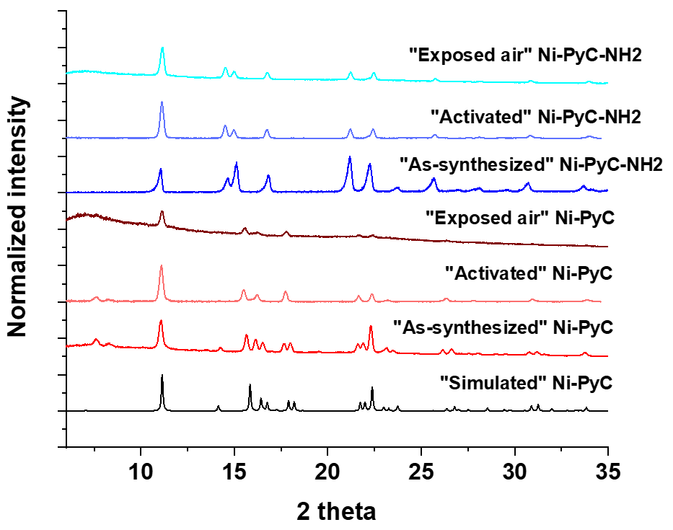

Fig. 4. PXRD patterns of Ni-PyC and Ni-PyC-NH2 status

Add the water sorption

1. **Conclusions**

**Acknowledgments**

**References**