Human trafficking

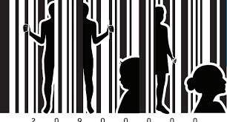

English B

Dear students,
Please make sure that you fill in every assignment in this compendium as you’ll be required to hand it in COMPLETED on Lectio when we’re done. While much of the work in the compendium will be done in groups, the hand-in is individual.

The aim is to show you the value of taking excellent notes and keeping them in one easy-to-find place. Not a bad skill to have in any case, but especially so if you’re sitting the oral English exam.

Text 1 Human trafficking
Types of forced labour

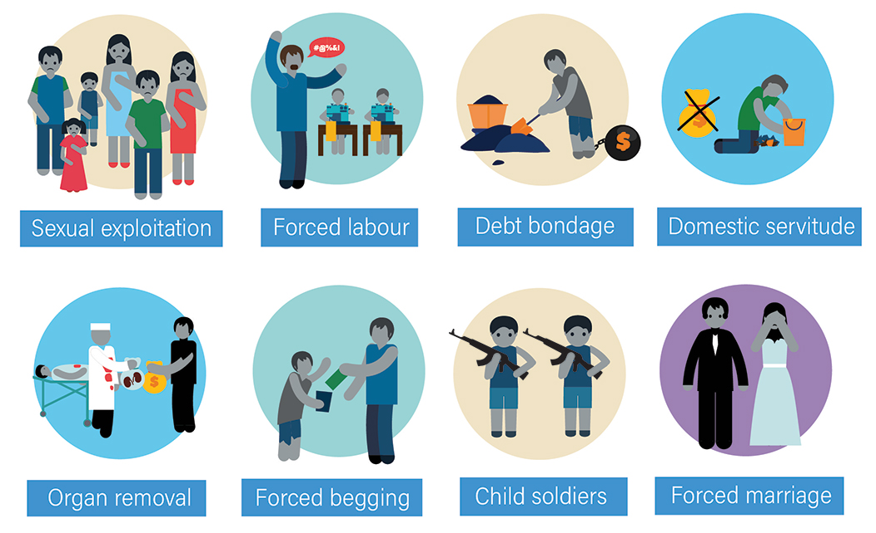

Have you ever seen a sign like this is in a low-cost house in the sticks often by the main road in Denmark? What thoughts are running through your mind now?


Text 2

Human Trafficking: Definition, Prevalence, and Causes
Human trafficking -- the sale, transport and profit from human beings who are forced to work for others -- is the modern equivalent of slavery. Against their will, millions of people around the world are forced to work for the profit of others, for example by begging, prostitution, involuntary servitude, working in sweatshops - even becoming child soldiers.
According to the Polaris Project, one of many international organizations working to end modern slavery, human trafficking is the third largest criminal industry in the world after arms and drug dealing. It is however the fastest growing criminal activity: somewhere in the order of 27 million people around the world are estimated to be victims of slavery, with approximately 50% of these victims being under the age of 18. In other words, children. UNICEF, the UN's agency for children's welfare, estimates that one million children will be forced into prostitution alone this year.
How Does Trafficking Happen?
Trafficked persons are often enslaved or in situations of debt bondage that are fraudulent and exploitive: traffickers will take away or abuse the basic human rights of their victims, who have most likely been tricked and lured by false promises or physically forced into their situation.
Trafficking can work like this: "It is a common practice to persuade a young woman to leave home and to move to a wealthier neighboring country where she can work in domestic service, child or adult care, or as a waitress in a restaurant or a bar, or perhaps as a dancer. Upon arrival, her passport, visa, and return tickets are taken from her and, effectively, she is imprisoned, either physically or financially or mentally. She is made to work as a domestic slave or as an agricultural or factory worker, under slave-like conditions, or in a brothel. She sees virtually none of the money that she earns, and eventually she will be sold."

A Global Snapshot
Slavery takes place within and across borders. The US State Department estimates that 600,000 to 820,000 men, women, and children (are) trafficked across international borders each year. Many millions more never cross an international border. Nearly 80 percent of trafficked persons are women and girls and up to 50 percent are children (anyone under 18 years old). It is estimated that upwards of 17,000 people are trafficked into the United States each year; an additional 200,000 American children are considered "at risk" for trafficking in the sex industry. In 2004, the Royal Canadian Mounted Police (RCMP) estimated that 600-800 persons are trafficked into Canada annually and that additional 1,500-2,200 persons are trafficked through Canada and into the United States.
Russia is a major source of women trafficked globally for the purpose of sexual exploitation. Russia is also a significant destination and transit country for persons trafficked for sexual and labor exploitation from regional and neighboring countries into Russia, and on to the Gulf states, Europe, Asia, and North America. The International Labor Organization (ILO) estimates that 20 percent of the five million illegal immigrants in Russia are victims of forced labor, which is a form of trafficking. There have been numerous reports of trafficking of children and of child sex tourism in Russia. The Government of Russia has made some effort to combat trafficking but has also been criticised for not complying with the minimum standards for the elimination of trafficking.

A Sketch of Child Trafficking
The majority of child trafficking cases are in Asia, although it is a global problem. In Thailand, non-governmental organisations (NGO) have estimated that up to a third of prostitutes are children under 18, many trafficked from outside Thailand. In Ukraine, a survey conducted by the NGO “La Strada-Ukraine” in 2001-2003, based on a sample of 106 women being trafficked out of Ukraine found that 3% were under 18, and the US State Department reported in 2004 that incidents of minors being trafficked was increasing.

What Causes Trafficking?
In a nutshell, there is a demand for it. Men around the world profit in pleasure and in price from the exploitation of women and children. Poverty and global disparities in the rule of law are conditions in which human trafficking, like HIV/AIDS and other killers of the poor, thrives. In poorer regions of the world where education and employment opportunities are limited the most vulnerable in society -- runaways, refugees, or other displaced persons-- are the most common victims of human trafficking. People who are seeking opportunity and entry to other countries may be picked up by traffickers and misled into thinking that they will be free after being smuggled across the border. In other cases, such as armed conflict, some trafficked humans are captured through slave raiding.
Trafficking of children often involves exploitation of the parents' extreme poverty. The latter may sell children to traffickers in order to pay off debts or gain income or they may be deceived concerning the prospects of training and a better life for their children. In West Africa, trafficked children have often lost one or both parents to the African AIDS crisis. Reporters have witnessed a rapid increase in prostitution in Cambodia, Bosnia, and Kosovo after UN and, in the case of the latter two, NATO peacekeeping forces moved in. Peacekeeping forces have been linked to trafficking and forced prostitution. Proponents of peacekeeping argue that the actions of a few should not incriminate the many participants in the mission, yet NATO and the UN have come under criticism for not taking the issue of forced prostitution linked to peacekeeping missions seriously enough.
(Source: http://www.urbanministry.org/wiki/human-trafficking-definition-prevalence-and-causes)
Assignment 1 Go to your dictionary: Cambridge Learner’s Dictionary: Definitions & Meanings
First, explain the 12 words below in plain English (don’t copy and paste from the dictionary 😊)
Then write down their word class (in English or in Danish) as the word appears in the sentence
 | Word: | Meaning in plain English | Word class/ ordklasse
1 | Slavery | Forced unpaid labor | noun
2 | Debt bondage | Coercion by the power of dept | noun
3 | Fraudulent | Maliciously untruthful | adjectiveR
4 | Exploitive | Taking advantage | adjective
5 | Abuse | Maltreatment | noun/verb
6 | Lured | Tricked | verb
7 | Persuade | Trick | verb
8 | Wealthier | More rich | adjective
9 | Domestic service | Labor service in the home | noun
10 | Imprisoned | Forced to stay | adjective
11 | Mentally | In the mind | adverb
12 | Brothel | A place for prostitution | noun
Assignment 2
Now, go back to the article and highlight a number of the most important points, for example ten. Then use those ten highlights to sum up the article up in about 200 words (plus/minus 10%).
The crime of human trafficking is on the rise. There’s a demand for trafficked people, especially women and children. The people are most often used for forced labor including prostitution. Traficked people often come from countries of poverty. Trafficked children are often taken or sold by parents in extreme poverty, in order to pay off depts or get a better life. Trafficking most often happens to vulnorable people, such as people in poverty or immigrants.
Some countries are more promonent when it comes to human trafficking. 20 percent of Russian immugrants have been victims of human trafficking, and Russia also has greater amount for childsex turism. In Thailand, up to a third of prostitues are children below 18. Between 600.000 and 820.000 are trafficked into the United States every year. Of whom 80 percent are women and children. About 50 percent of the immigrants are children below the age of 18.
Peacekeeping forces such as those sent by NATO or the UN to poor unstable countries are notorious for increasing the amount of human trafficking. This has been recorded happening in Cambodia, Bosnia and Kosovo. The UN and NATO have come under critique for not doing enough to stop this problem.
Assignment 3
Exam practice:
Læs disse sætninger igen og skriv hvad der er grundled og udsagnsled i sætningen. Skriv også om udsagnsleddet er i ental eller flertal. Den første er gjort for dig.

In a nutshell, there is a demand for it.
Grundled | Udsagnsled | Person og tal?
There | is | 3. person ental

Men around the world profit in pleasure and in price from the exploitation of women and children.
Grundled | Udsagnsled | Person og tal?
Men around the world | profit | 3. person flertal

In other cases, such as armed conflict, some trafficked humans are captured through slave raiding.
Grundled | Udsagnsled | Person og tal?
some trafficked humans | are | 3. person flertal

Assignment 4 Exam practice
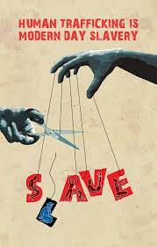
Beskriv billedet med mellem 75 og 125 ord. Brug simpel tid (i grøn) og udvidet tid (i lilla) mindst to gange hver. Brug gerne din grammatibog, hvis du ikke kan huske hvad simpel tid og udvidet tid er.
There are two hands. One is holding 5 strings with letters hanging from them. The letters spell ”Slave”. The other hand is holding a pair of scissor. The letter L has been cut off, and is falling. The other strings still hold up the letters. The text at the top of the image spells out ”HUMAN TRAFFICKING IS MODERN DAY SLAVERY”. The two hands holding and cutting the strings come from each side of the image. The letters on the strings is trapping people inside them.

Text 3: Frontline: “Trafficked in America” (made available to you on CFU)

Watch the documentary and take notes in the form of a problem tree, like this one https://images.app.goo.gl/59Fzzi6zLkg6ftWM9

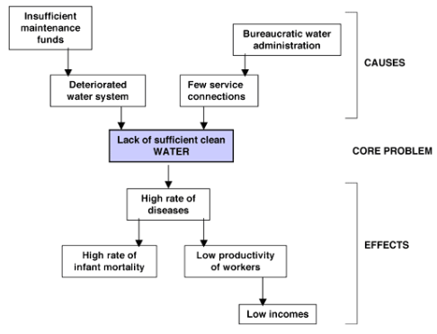

When you’re done, sum up what characterizes a trafficked woman.

Text 4: Special Report: Exploited: Britain's Hidden Slaves

Special Report: Exploited: Britain's Hidden Slaves - YouTube

Assignment

Watch the documentary and write down 15 bullits about what you find the most important information in this documentary.

Vulnerable people are easily exploited

Juristic pursuit is very hard

Immigrants are often victims

Conviction rates are low, 1.(7|9)%

They are often lied to about work opportunities

Psychological exploitation

Police distrust

Doesn’t have to be sexual, can also be regular laborous work.

Mental toll

People from poorer countries

The victims have to seek help by themselves

The fear of the exploiters never goes away.

Entire families are sometimes trafficked

Trafficked people are sold for millions

100 million pounds of profit

Text 5 The United Nations Declaration of Human Rights

Assignment

Who wrote this declaration? The United Nations, Eleanor Roosevelt

When? 1948

What was the context for it? WW2, 4 freedoms

And what does it have to do with human trafficking? It makes many of the parts of human traficking illegal.

Preamble
Whereas recognition of the inherent dignity and of the equal and inalienable rights of all members of the human family is the foundation of freedom, justice and peace in the world,
Whereas disregard and contempt for human rights have resulted in barbarous acts which have outraged the conscience of mankind, and the advent of a world in which human beings shall enjoy freedom of speech and belief and freedom from fear and want has been proclaimed as the highest aspiration of the common people,
Whereas it is essential, if man is not to be compelled to have recourse, as a last resort, to rebellion against tyranny and oppression, that human rights should be protected by the rule of law,
Whereas it is essential to promote the development of friendly relations between nations,
Whereas the peoples of the United Nations have in the Charter reaffirmed their faith in fundamental human rights, in the dignity and worth of the human person and in the equal rights of men and women and have determined to promote social progress and better standards of life in larger freedom,
Whereas Member States have pledged themselves to achieve, in co-operation with the United Nations, the promotion of universal respect for and observance of human rights and fundamental freedoms,
Whereas a common understanding of these rights and freedoms is of the greatest importance for the full realization of this pledge,
Now, therefore,
The General Assembly,
Proclaims this Universal Declaration of Human Rights as a common standard of achievement for all peoples and all nations, to the end that every individual and every organ of society, keeping this Declaration constantly in mind, shall strive by teaching and education to promote respect for these rights and freedoms and by progressive measures, national and international, to secure their universal and effective recognition and observance, both among the peoples of Member States themselves and among the peoples of territories under their jurisdiction.

Assignments:
Go to your dictionary: Cambridge Learner’s Dictionary: Definitions & Meanings
- Look up the pronunciation in American English and in British English of every single word below, even if you know how to say them. This is to help you get better at distinguishing between the two variants of English.
- Also look up the definition of the 10 words below and explain them in plain English (don’t copy and paste from the dictionary 😊. The purpose is to help you get familiar with using a dictionary regularly)

Word from the declaration | Meaning in  plain English | Ordklasse  (skriv altid grammatik på dansk!)
preamble | An introductory section to a media. | Navneord
inherent | Traits derived from a particular context | Tillægsord
inalienable | Cannot be removed | Tillægsord
disregard | Not caring about something | Udsagnsord
contempt | Disliking something | Navneord
barbarous | Unacceptably cruel | Tillægsord
to proclaim | To state something | Udsagnsord
to pledge | To promise | Udsagnsord
observance | Following law | Navneord

Then go to the Declaration itself Universal Declaration of Human Rights | United Nations

How many articles are there? 30

How many articles are about freedom? Depending on how you define freedom, you could argue all of them.

Which specific articles ban human trafficking? Article 4, 9, 23

Which articles do you recognize from your studies at school, for example social studies? And from your life in general as a student, your role in your family, your role in your social circle, your part-time job, your news sources, your holidays abroad and so on (No fewer than 400 words on 4.)

I recently got an apprenticeship, and in that process, there’s a lot of regulation about labor conditions. There are certain amounts of pay I have to get, and a certain amount of holidays I’m entitled to. Some of this has relevance in article 23. The article states some things about choice of employment, no discrimination of pay, enough pay to support the family and freedom to join trade unions.

Now, let’s go deeper into several articles. In the left hand column, choose an article and copy paste it from the Declaration of Human Rights. Then explain it in plain English on the right. This process has been started for you; please complete it so that you have five articles in their original wording as well as your own interpretation.

Article | Plain English
Article 1: All human beings are born free and equal in dignity and rights. They are endowed with reason and conscience and should act towards one another in a spirit of brotherhood. | Article 1 says that all people are born equal and free. It also says that they have common sense and a conscience and must behave accordingly.
Article 4: No one shall be held in slavery or servitude; slavery and the slave trade shall be prohibited in all their forms. | Slavery is illegal. Having as slaves or in servitude is illegal.
Article 6: Everyone has the right to recognition everywhere as a person before the law. | Everyone should be treated as a person

Article 5: No one shall be subjected to torture or to cruel, inhuman or degrading treatment or punishment.

Article 9: No one shall be subjected to arbitrary arrest, detention or exile.

Bonus question: go back up to the sentence in green. What US president is associated with these four basic freedoms? Hint: 1941 😊 Franklin D. Rossevelt
Now, let’s listen to this wonderful piece of legislation: Universal Declaration of Human Rights -- Articles 1-30 -- Hear and Read the Full Text - YouTube

Text 6: TED talk: What if a single human right could change the world?

Kristen Wenz: What if a single human right could change the world? | TED Talk
Before you listen to the TED talk
Discuss this with your study buddy: When’s your birthday? And your birthplace? Are you sure? How do you know? If you’d like to double check it, how would you go about it? How is this knowledge valuable to you? To your sense of identity? Who are your parents? Biological and/or adopted parents? Are you sure? What’s your nationality? Do you know this for a fact?

Now listen to the TED talk and try to answer these two questions:
What single human right is Dr. Kristen Wenz talking about?
Article 6. She says that everybody needs a birth certificate. These are ways to get more people to register their children:
- Reduce how far parents have to travel to register their children
- Make it free or very cheap to register children
- Simplify the process
- Remove discrimination for mothers who aren’t able to get birth certificates without the farthers.
- Increase the demand for birth certificates, by education people on what meaning it can have for their childrens life.
What are the five proven interventions?
How’s this related to human trafficking?

After the TED talk
What do you reckon now about the importance of human rights in general and one or two of them in particular? Write no fewer than 300 words with outstanding grammar and vocabulary.
If you can’t prove who you are, you are more vulnurable to human traficking, and it is harder to help you. Not being able to show documentation, makes you very vulnurable. Parents in poor countries who’s children are taken away and sold to orphanages, have a hard time getting their children back, because they can’t prove it’s their children.

Text 7 P.I.M.P. by 50 Cents

[Chorus]
I don't know what you heard about me
But a bitch can't get a dollar out of me
No Cadillac, no perms, you can't see
That I'm a motherfuckin' P-I-M-P
I don't know what you heard about me
But a bitch can't get a dollar out of me
No Cadillac, no perms, you can't see
That I'm a motherfuckin' P-I-M-P (Now, shawty)
[Verse 1]
Now, shawty, she in the club, she dancin' for dollars
She got a thang for that Gucci, that Fendi, that Prada
That BCBG, Burberry, Dolce & Gabbana
She feed them foolish fantasies, they pay her, 'cause they want her
I spit a little G, man, and my game got her
A hour later have that ass up in the Ramada
Them trick niggas in her ear sayin' they think about her
I got the bitch by the bar tryna get a drink up out her
She like my style, she like my smile, she like the way I talk
She from the country, think she like me 'cause I'm from New York
I ain't that nigga tryna holla 'cause I want some head
I'm that nigga tryna holla 'cause I want some bread
I could care less how she perform when she in the bed
Bitch, hit that track, catch a date, and come and pay the kid
Look, baby, this is simple, you can't see
You fuckin' with me, you fuckin' with a P-I-M-P
[Chorus]
[Bridge]
I'm 'bout my money, you see, girl, you can holla at me
If you fuckin' with me, I'm a P-I-M-P
Not what you see on TV, no Cadillac, no greasy
Head full of hair, bitch, I'm a P-I-M-P
Come get money with me if you curious to see
How it feels to be with a P-I-M-P
Roll in the Benz with me, you could watch some TV
From the backseat of my V, I'm a P-I-M-P
[Verse 2]
Girl, we could pop some champagne and we could have a ball
We could toast to the good life, girl, we could have it all
We could really splurge, girl, and tear up the mall
If ever you needed someone, I'm the one you should call
I'll be there to pick you up if ever you should fall
If you got problems, I can solve 'em, they big or they small
That other nigga you be with ain't 'bout shit
I'm your friend, your father, and confidant, bitch
[Chorus]
I don't know what you heard about me
But a bitch can't get a dollar out of me
No Cadillac, no perms, you can't see
That I'm a motherfuckin' P-I-M-P
I don't know what you heard about me
But a bitch can't get a dollar out of me
No Cadillac, no perms, you can't see
That I'm a motherfuckin' P-I-M-P (Now, shawty)
[Verse 3]
I told you fools before, I stay with the tools
I keep a Benz, some rims, and some jewels
I holla at a ho 'til I got a bitch confused
She got on Payless, me? I got on gator shoes
I'm shoppin' for chinchillas, in the summer they cheaper
Man, this ho, you can have her, when I'm done I ain't gon' keep her
Man, bitches come and go, every nigga pimpin' know
This ain't no secret, you ain't gotta keep it on the low
Bitch, choose on me, I'll have you strippin' in the street
Put my other hoes down, you get your ass beat
Now Niki my bottom bitch, she always come up with my bread
The last nigga she was with put stitches in her head
Get your ho out of pocket, I'll put a charge on a bitch
'Cause I need four TVs and AMGs for the six
Ho, make a pimp rich, I ain't payin', bitch
Catch a date, suck a dick, shit (Trick)
[Chorus]
I don't know what you heard about me (Yeah)
But a bitch can't get a dollar out of me (Woo!)
No Cadillac, no perms, you can't see (Huh-uh)
That I'm a motherfuckin' P-I-M-P
I don't know what you heard about me (Huh-uh)
But a bitch can't get a dollar out of me (Yeah)
No Cadillac, no perms, you can't see
That I'm a motherfuckin' P-I-M-P
[Outro]
Yeah
In Hollywood they say, "There's no b'ness like show b'ness"
In the hood they say, "There's no b'ness like ho b'ness," you know?
They say I talk a little fast, but if you listen a little faster
I ain't got to slow down for you to catch up, bitch
Ha-ha-ha, yeah

(Source: 50 Cent – P.I.M.P. Lyrics | Genius Lyrics)
- Listen to the song a couple of times while you’re reading the lyrics.
- Look words up you don’t understand. If you don’t know stores like “Payless” and words “gator” your analysis will be superficial.
- Analyse the song by filling in the right hand column below. Write in full sentences in your normal, formal English. Use quotes when necessary. It’s important that you write your usual English and don’t downgrade to gangster level.
- Some jobs on the left have a minimum word requirement while others don’t. Use valid sources only, needless to say 😊
Background information on the artist 50 Cents  Write 200+ words in the righthand column and remember to insert a footnote whenever necessary. | Curtis Jackson is an American rapper. He is famous for his early 2000’s gangster-rap. He grew up with drugs, crime and gang wars, but turned to rap, earning him his fame. Curtis Jackson was born in 1975 in the borough of Queens in New York City. He was raised until 8 years old by his mother, who worked as a drug dealer, but died in an unexplained fire. After his mothers death, he was raised by his grandmother. Curtis Jackson began sellling drugs at 12 and was arrested by a police officer when he was 19. He went to a boot camp where he took the name 50 Cent and further developed his rapping skills. The name “50 cents” comes from the Brooklyn slang meaning crook.  His first important contact in the New York hip-hop scene was Jam Master Jay, from the group “Run-DMC”. They produces an unreleased album, because Jay was impressed by Jackson’s rapping talent.  In the year 2000, Curtis Jackson was caught up in a shooting incident, leaving him with multiple injuries. After recovering, he started a hip-hop group called “G-Unit” with Lloyd Banks and Tony Yayo. Their mixtape came to the attention of Eminem and Dr. Dre, they then procedeed to sign to their respective labels, Shady Recods and Aftermath Entertainment.  https://www.biography.com/musicians/50-cent
Background information on the era post year 2000 that is relevant to this song. Write 200+ words in the righthand column and remember to insert a footnote whenever necessary. | The era post year 2000 was marked by significant changes in hip-hop music, culture, and society. This period saw the emergence of a new generation of rappers who brought a fresh perspective to the rap genre. The influence of the internet and the rise of digital media platforms such as Napster and iTunes changed the way people consumed music. In this era, hip-hop culture became more mainstream, and its fashion, slang, and style began to influence popular culture. The song "P.I.M.P." by 50 Cent reflects these changes in hip-hop culture. However, in the context of the song, the term is used more broadly to describe a lifestyle of wealth, power, and control over women. The song's chorus, "I don't know what you heard about me, but a bitch can't get a dollar out of me," reflects the misogynistic attitudes prevalent in some hip-hop music at the time. Despite its controversial content, "P.I.M.P." was a commercial success, reaching the top 10 on the US Billboard Hot 100 chart and becoming one of 50 Cent's signature songs. It remains a popular and influential song in hip-hop culture, though it has also been criticized for its negative portrayal of women and glorification of a criminal lifestyle.
What is the musical genre (rap, rock, country etc.) What are the genre characteristics and how does this song adhere to them? 150+ words and footnotes. | The genre is a combination of rap and hip-hop. The lyrics contains ending rhymes like “street” – “beat”, “head” – “bread”. This genre typically discuss topics such as drugs, crime and gang violence.
What does the title mean? Why is it an abbreviation? Why not title the song simply ”Pimp”? | A pimp is someone who sells prostitution of others. The abbriviation is him putting himself above other pimps.
Explain how the power balance between the pimp and his prostitute is created, maintained and ended. | The power balance between the pimp and the prostitue is unbalanced. The pimp usually has a lot more power than the prostitue. It’s often because the pimp controls the the prostitutes money and other important aspects of life. Violence between the pimp and prostitue is not uncommon. Emotional abuse and manipulation also occurs, for example, when he explains all the things they could have together. The pimp in this text also shields the prostitue away from other people.
As an extension of the power balance, muse on the change of tone in the second verse.

What rhetorical devices are used and how do they affect the listener?
Choose five adjectives to describe the language and explain how they support the theme and message.
Choose five adjectives to describe the tone and explain how they support the theme and message.
What’s the theme and message in the song?

Now, over to you 😊
Choose a method from chapter 6.3 in The English Handbook and choose an analysis object. For example, you may want to find a commercial for an anti-trafficking organization and analyse it using chap. 6.12. Or choose a film about this issue and analyse it using chap. 6.7.
Present your idea to me and then we’ll set up a framework for your group and you’re ready to get started.

Finally, an essay assignment. Prepare by reading chapter 7.4.3 in The English Handbook about how to write an argumentative essay.
Essay requirements:
Using the given material, write an argumentative essay in which you account for and discuss the issues raised in human trafficking.
Give your essay a headline.
Word count: 700-1000 words.
Source material: All materials from class. You may use all of them if you like but no fewer than three. No outside research allowed.
Your essay must include references (footnotes) to the source material.
All sources must be documented in a literature list at the end.

Women's Shoes: Athletics, Casuals and Boots | Payless - Online Store
GATOR | English meaning - Cambridge Dictionary
May be found in 4.1 Rhetoric - the art of speaking | The English Handbook (systime.dk)

