20 ia English B
Midtbyens Gymnasium Viborg

Psychopathy
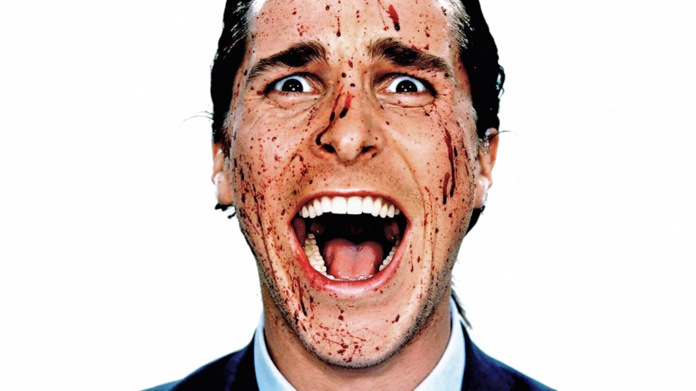

Contents:
Text 1 Psychopathy (article from Psychologytoday.com)
Text 2: Documentary “What makes me a psychopath?”
Text 3: Journalist Ron Johnson: Strange answers to the psychopath test
Text 4: Movie American Psycho (made available to you on CFU)
Text 5: Exam text: Killing Child at Zoo
Text 6: Ted Bundy Grammatik

Text 1 Psychopathy (article on Psychologytoday.com)
Psychopathy is a condition characterized by the absence of empathy and the blunting of other affective states. Callousness, detachment, and a lack of empathy enable psychopaths to be highly manipulative. Nevertheless, psychopathy is among the most difficult disorders to spot.
Psychopaths can appear normal, even charming. Underneath, they lack any semblance of conscience. Their antisocial nature inclines them often (but by no means always) to criminality.
Psychopaths spark popular fascination and clinical anguish: Adult psychopathy is largely resistant to treatment, though programs exist to treat callous, unemotional youth in hopes of preventing them from maturing into psychopaths.
Brain anatomy, genetics, and a person’s environment may all contribute to the development of psychopathic traits.

The Signs of a Psychopath
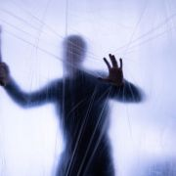
Psychopathy is a spectrum disorder and can be diagnosed using the 20-item Hare Psychopathy Checklist, which features traits such as lack of empathy, pathological lying, and impulsivity, each scored on a three-point scale based on whether the item does not apply (0), applies to a certain extent (1), or fully applies (2) to the individual. The bar for clinical psychopathy is a score of 30 or higher; serial killer Ted Bundy scored 39.
The checklist was developed in the 1970s by the Canadian researcher Robert Hare. A true assessment should be conducted by a mental health professional.
The revised version of the checklist includes the following characteristics:
- Glibness/superficial charm
- Grandiose sense of self-worth
- Need for stimulation/proneness to boredom
- Pathological lying
- Conning/manipulative
- Lack of remorse or guilt
- Shallow affect (i.e., reduced emotional responses)
- Callous/lack of empathy
- Parasitic lifestyle
- Poor behavioral controls
- Promiscuous sexual behavior
- Early behavioral problems
- Lack of realistic, long-term goals
- Impulsivity
- Irresponsibility
- Failure to accept responsibility for one's own actions
- Many short-term marital relationships
- Juvenile delinquency
- Revocation of conditional release (from prison)
- Criminal versatility (i.e., commits diverse types of crimes)

What percentage of people are psychopaths?
Psychopaths exist across cultures and ethnic groups. It has been estimated that approximately 1 percent of males and 0.3-0.7 percent of females could be classified as psychopaths. An individual may show elevated levels of multiple traits associated with psychopathy without qualifying as a psychopath according to a measure such as the Hare checklist.

When does psychopathy begin?
An individual may exhibit early characteristics associated with psychopathy—called “callous-unemotional traits”—as early as childhood (before age 10) and may receive a formal diagnosis such as conduct disorder. However, showing psychopathic features in childhood does not mean that a person will necessarily become an adult psychopath.

What causes someone to become a psychopath?
Like other personality traits, psychopathic traits are substantially influenced by genetics, though research suggests that non-genetic factors are involved as well. Scientists have observed signs of atypical functioning of particular brain areas (such as the amygdala) in people with psychopathic traits. But there is much to be learned about the causes of such differences.

How is a psychopath diagnosed?
The Psychopathy Checklist-Revised (PCL-R) and the Psychopathic Personality Inventory (PPI) are the tests used by clinicians and forensic psychologists to assess antisocial behavior. Both focus on criteria that capture a callous unconcern for others, or what the PPI terms “coldheartedness.”

Can a psychopath be cured?
A high score on an established measure of psychopathy signals traits (such as callousness) that could pose a serious obstacle to successful therapy. There is evidence that psychopathic traits and associated antisocial behaviors can wane over the lifespan, but the extent to which psychopathic traits can be altered by therapy is not fully known.

How do I know whether I’m a psychopath?
The classic adage is that if you have to ask whether you’re a narcissist, you aren't. Not so with psychopathy. Some suspect that they have the condition because they lack appropriate empathic and affective responses from a young age. The only way to be certain is to consult a mental health professional and seek testing.

Psychopathy, Sociopathy, and Antisocial Personality Disorder (ASPD)
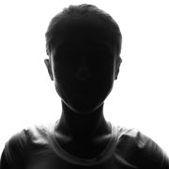

Individuals with antisocial personalities have distinct histories and combinations of traits—and their misbehavior can vary in nature and severity—so the terminology used to describe such people can get a little complicated. People often conflate the terms “psychopath” and “sociopath” or use both of them to describe those who flagrantly disregard moral rules.

What is the difference between a psychopath and a sociopath?
The terms “psychopath” and “sociopath” are often used interchangeably, but a “sociopath” refers to a person with antisocial tendencies that are ascribed to social or environmental factors, whereas psychopathic traits are thought to be more innate. That said, both genetic and non-genetic causes likely play a role in shaping any person with antisocial traits.

What is the difference between psychopathy and antisocial personality disorder?
Antisocial personality disorder overlaps with psychopathy, but is not the same condition. A person can meet the criteria for antisocial personality disorder—which focus largely on antisocial behaviors—without showing core traits associated with psychopathy. Psychopaths are thought to comprise just a fraction of people with antisocial personality disorder.

Is there more than one kind of psychopath?
One conception of psychopathy separates “primary psychopathy” and “secondary psychopathy,” with the latter type showing more anxiety and emotional instability and attributed to environmental factors such as early mistreatment. Psychopaths can show significant temperamental differences and may come in distinct variants; it is unlikely, however, that any type is caused solely by genetics or parenting.

Are female psychopaths different from male psychopaths?
Men are more likely than women to meet the clinical bar for psychopathy, but even among psychopaths, females appear to be distinct in some ways. For example, research suggests that female psychopaths tend to be less physically violent than males and may have more anxiety and worse self-image.

Psychopaths and Violence

For some, “psychopath” may seem synonymous with “criminal” or “killer," but the reality of psychopathy is more complicated. Scientists have indeed found statistical associations between psychopathy scores and violent behavior, as well as other forms of criminality. Elevated impulsiveness, tendency to deflect blame, and other antisocial traits may make a psychopath more inclined than other people to cross moral boundaries and threaten, hurt, or kill.
Yet the link between psychopathy and violence is far from one-to-one. Not all psychopaths are killers or even criminals, and there are other personality traits and forms of pathology aside from psychopathy that may contribute to aggressive behavior.

How many psychopaths are killers?
It is unknown how many psychopaths commit severe acts of violence. Among convicted killers, more than a quarter could be considered psychopaths (compared to about 1 percent of the general population), according to one estimate—and there’s evidence that psychopathic criminals are more likely to re-offend. But many psychopaths do not have histories of violence.

Are all serial killers psychopaths?
Not necessarily—though many (perhaps most) serial killers exhibit psychopathic personalities, showing a lack of empathy for their victims and no remorse for their crimes.

Do psychopaths feel fear?
While psychopaths do not seem to completely lack the ability to experience fear, research suggests that they have a muted fear response to threats, which may make them more likely to engage in risky behavior. “Fearlessness” is one of the traits assessed by an alternative psychopathy test called the Psychopathic Personality Inventory.

(Source: https://www.psychologytoday.com/us/basics/psychopathy)

Tasks:
1 Look up words you don’t know and insert a comment with their definition
2. Highlight key words, ideas, people and years in the text above. PS: You’ll meet Robert Hare later on ☺
3. Create some sort of visual/creative product that illustrates what you’ve learned so far.
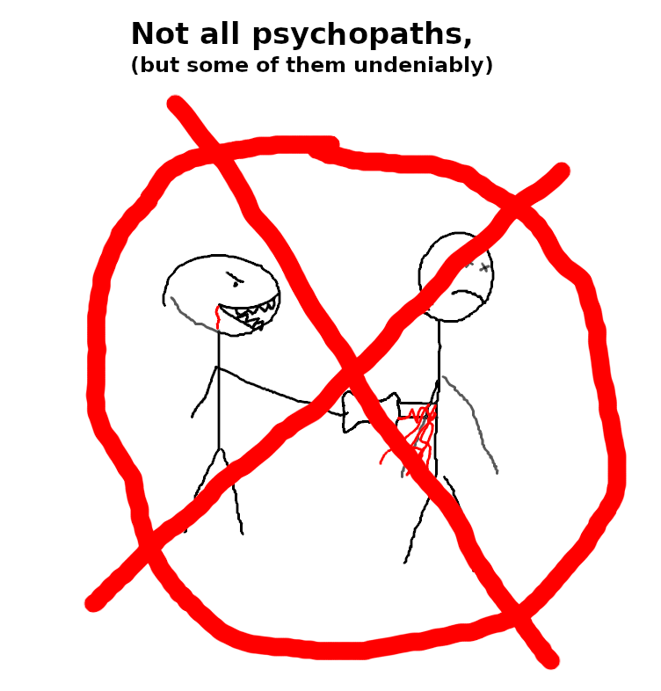

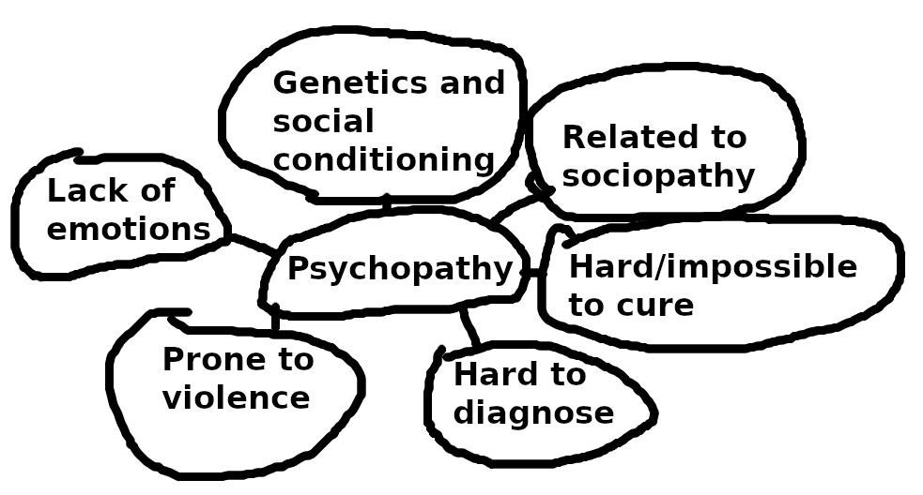

You may take the psychopathy test online if you like. Whatever your result, it’ll be invalid as these tests should be carried out by professionals 😊
Hare Psychopathy Checklist (Original) (PCL-22) (psychology-tools.com)

Text 2: Documentary “What makes me a psychopath?”
https://www.youtube.com/watch?v=WB9FeGTi5Uk&ab_channel=RealCrime

Answers the questions in writing and insert your answers below each question.

- From the start till 1:33: Quickly characterize Wayne, the speaker, by writing down five+ words that spring to mind. Here’s one from your teacher: well spoken. Now jot down at least four more.
  - Convincing
  - Relaxed
  - Emotionless
  - Apathetic
- 2:25: What are scientists discovering about the nature-nurture debate?
  - That it’s possible that psychopaths are a product of genetics rather than social conditionings
- 3:18: What’s the correlation between psychopaths and serial killers?
  - Many serial killers are psychopaths, but not all psychopaths are serial killers. There isn’t an exact corrolation
- 4:28 What are the number of psychopaths in the UK?
  - 1 in every 200 of the population are psychopathic
- 5:00 Sum up what Prof Cooke says about psychopaths.
- 6:18 Why put so much effort into studying psychopathy, according to Dr. Thornton? PS: “recidivist” means to “re-offend”
  - They inflict a disproportionate amount of violence and damage
- 8:00 According to Prof Cooke what’s the advantage of a diagnostic system such as that devised by Prof Robert Hare?
  - Everyone talks about the same idea of a psychopath
- 8:40 Note down the voice over and main ideas about the measuring tool which Hare devised.
  - Multiple different personality traits
- Explain “cluster combination of characteristics that hang together” in your own words.
  - Multiply personality traits that combined can resemble the description of a psychopath
- 12:15. We’re back with Wayne. Add more adjectives to your list of words that characterize him.
  - Self glorifying
  - Serious
  - Appears sincere
  - Striving
- 16:05 What are the numbers about psychopaths in the US?
  - 1 in every 100 in the general population, 20 percent of prison population
- 17:55 This is a note for you, not a question: The woman from the FBI uses the term “crazy”; she presumably means “psychotic” which psychopaths are not.
- 18.30 Info coming up about O. J. Simpson ☺ No need to take notes about him.
- 23:02 According to Paul Barbiak, what’s worrying about psychopaths in suits?
  - Traditionally ruthlessness verges on a virtue
- 27:38 What are the differences between American and British psychopaths? (NB: Prof Cooke is British)
  - American psychopath’s are more likely to be charming, extroverted and have a high sense of self glorification
- 29:40 What does Dr Hare say about showering a psychopath with love?
  - It’s more like being colorblind, so it’s not treatable that way
- 30:45 What does Dr Raine say about the nature-nurture debate?
  - Some psochopaths come from fantastic backgrounds
- 31:10 What does Dr Martin Smedley say about the same topic?
  - Psychopathy is not caused, it’s mostly nature
- 33: 00 What are the ethical considerations in diagnosing a child with psychiatric difficulties?
  - There’s an incurableness about it, one doesn’t want to look at children that way
- 34:25: Good question: If part of the cause of psychopathy is biological, can they then be held responsible for their actions? Your thoughts, please.
  - They know that it’s wrong, therefore we’ll argue they’re deliberately making a choice against the good of will. This doesn’t mean they should be locked up for eternity, if they learn how to properly respect common peoples morality.
- What are the differences in brain scans of psychopaths and non-psychopaths?
  - The non-psyc activates more for emotions
  - The amygdala is underdeveloped
- 38:18 What do you learn about the amygdala from Dr James Blair?
  - Housed below the temporal cortex, in the middle of the brain
  - Crucial for emotion
- 38.40 What is Dr Hare’s response to Dr Blair’s findings?
  - He’s not convinced, he doesn’t think it’s that simple. There are also anomalies in the frontal and temporal cortex and maybe the connections
- 40:40 But Blair and Reine are on to the frontal cortex. What do they say may be the cause of psychopathy?
  - There are also anomalies in the frontal and temporal cortex and maybe the connections
- 43: 30 “Not only does treatment not work, it seems to exacerbate the condition” (Said about psychopaths in prisons after they’ve had therapy for their syndrome) Comment, please.
  - Stop doing it then, and try something else; do whatever the research says
- 45:33 According Dr Raine what good will a microchip do?
  - Replace dysfunctional mechanisms in the brain
- What’s the programme’s attitude to the microchip? Do you find that the final comments made by the narrator add to or take away from its objectivity?
  - He makes positive statements for brain-chips

Text 3: Journalist Ron Johnson: Strange answers to the psychopath test

BEFORE watching, look up and write down the meaning of these words. Be aware that you’re expected to remember AND use most of the words.
I’ve done a couple of them for you.

Vocab from the documentary | Explained in plain English (no copy/paste from the dictionary)
DSM | Diagnostic and Statistic Manual of Mental Disorders
Scientology | A search for self knowledge by studying or training
Malingering | Pretending to be ill to avoid work
Pseudo-science | A system or theory which is not scientific
CCHR: Citizens Commission on Human Rights: https://www.cchr.org/about-us/what-is-cchr.html | CCHR: Citizens Commission on Human Rights: https://www.cchr.org/about-us/what-is-cchr.html
Docile | Being quiet and easy to influence
Cushy | Very easy
Ted Bundy | He was an american serial killer
Clinician | A skilled individual in health such as a doctor
Adept | Having a natural ability to do something that requires skill
Carnage | Violent killing of large amount of people
Ruthless | No worry about hurting others
To change tack | Trying a different method to deal with a problem
Asset stripper | Someone who buys a company for cheap and sells its assets for profit
Corporate | A large group – a company
Anomaly | A thing that is different from the norm
Predatory | A predatory person who tries to get something that belongs to someone else
Effeminate | A man that acts and looks similar to a woman
Grandiose | Something larger intended to be important
Juvenile delinquency | Crime against young people
Temper tantrums | Unpleasant disruptive behaviour or emotional outbursts
Remorse | Feeling bad for something you have done
Tribunal (going to court) | A specialist at examining problems of a particular type
Recidivism | The act of continuing crimes after being punished
Ominous | suggesting that something unpleasant is likely to happen
Fracas | A loud argument

https://www.ted.com/talks/jon_ronson_strange_answers_to_the_psychopath_test#t-226782

WHILE watching:
- At about 30 seconds into the talk, Ronson begins to reveal the central issue in the talk. What is it?
  - More aggressive diagnosis
- At about 13 to 14 minutes he talks about selecting information about what goes into his book. What’s the significance of these considerations?
  - Only the edges, most extreme traits, come into considerations
- At the end: why did Ronson decline the offer of a drink? What’s the point he’s trying to make?
  - Psychopaths are scary

Text 4: Movie “American Psycho”
(Directed by Mary Harron who wrote the script with Guinevere Turner, 2000)
American Psycho
Book written by Brent Easton Ellis in 1991, published by Vintage
Film directed by Mary Harron and distributed by Lionsgate

This worksheet helps you analyse the film. Please note that you’re supposed to analyse the elements below, not describe them 😊 There are hints or assignments in the left column, and you’re to write your best English in the right column.

Type of film
5.1 Film | The English Handbook (systime.dk) | drama

Genre og and subgenre
Genre: Historical
Subgenre: Post-modern horror  Read about postmodernism here: 1.2.7 Postmodernism (1945-) | The English Handbook (systime.dk)  Highlight the central terms, forexample pastice, intertextuality etc.  In the right hand column, explain how you can see these terms at play in the film. | Intertextuality.  Pastiche.  Fragmentation - rejection of traditional narrative forms, narrative disrupted into fragments, there may be multiple endings.  No ultimate truth.  Irony, black humour.  Variety in writing style, narrative forms.

Examples of intertextuality | Explain the reference here
“Just say no” (to drugs, said by famous American woman.) | This phrase, associated with the anti-drug campaign of the 1980s in the United States, is referenced in "American Psycho" to satirize the hypocrisy of the consumerist culture depicted in the novel. The intertextuality here lies in the comparison of the anti-drug message with the excessive drug use and debauchery indulged in by the protagonist, Patrick Bateman.
Annie Leibovitz | Annie Leibovitz, a renowned photographer, is referenced in "American Psycho" as part of the protagonist's obsession with appearances and the culture of image and status. The intertextuality may highlight the shallow nature of the characters' preoccupation with superficial beauty and the idealized images they strive to create.
Cliff Huxtable | The reference to Cliff Huxtable, a fictional character from the television show "The Cosby Show," is used in "American Psycho" to emphasize the stark contrast between the wholesome, family-oriented values associated with the character and the dark, violent nature of Patrick Bateman's thoughts and actions. This intertextuality serves to heighten the sense of unease and incongruity in the narrative.
Les Miserable (A musical, but what is it about and how is it relevant to American Psycho?) | "Les Misérables" is a musical based on the novel by Victor Hugo, focusing on themes of social inequality, justice, and redemption. In "American Psycho," the intertextual reference to "Les Misérables" highlights the stark contrast between the compassion and social consciousness depicted in the musical and the lack of empathy, narcissism, and materialism exhibited by Patrick Bateman and the society he represents. The reference may serve as a critique of the shallowness and moral bankruptcy of the characters in "American Psycho."
“The Texas chainsaw massacre” (on video while Bateman’s doing sit-ups) | "The Texas Chainsaw Massacre" is a horror film known for its violence and the iconic chainsaw-wielding antagonist. In "American Psycho," the inclusion of the film through the video playing during Bateman's exercise routine creates a juxtaposition between the brutal violence depicted in the film and Bateman's own violent tendencies. This intertextuality adds to the atmosphere of horror, disorientation, and detachment in the narrative.
Donald Trump and his then wife Ivana Trump | Excessive Wealth and Materialism: The characters in "American Psycho" are obsessed with luxury brands, expensive possessions, and extravagant lifestyles. This mirrors the conspicuous consumption associated with Donald Trump and his real estate empire. The intertextuality lies in the portrayal of a culture that values wealth and material possessions above all else.

Setting
Work | The workplace is a prominent setting in "American Psycho." The story primarily revolves around Patrick Bateman's professional life as an investment banker on Wall Street. The office environment reflects the competitive and cutthroat nature of the business world, where appearances and status are highly valued.
Home | Bateman's apartment is portrayed as luxurious and strangely decorated. The setting represents the excessive materialism and obsession with appearances prevalent in the novel. It also serves as a contrast to the dark and violent activities that take place within the protagonist's private life.
New York | The novel is primarily set in New York City, particularly in the affluent neighborhoods of Manhattan. The city itself becomes a character, embodying the decadence, wealth, and frenetic energy of the 1980s. It serves as a backdrop to the characters' superficial lifestyles and the excesses of the era.  Throughout the novel, various high-end restaurants in New York City are depicted. These establishments represent the elitist dining culture and serve as sites for social interactions, power dynamics, and displays of status. The descriptions of elaborate meals and the characters' obsession with reservations and menus highlight their preoccupation with appearances and the fine details of their privileged lifestyles.
Restaurants | Bathrooms hold a significant presence in "American Psycho." Bateman often retreats to these private spaces to engage in his dark and violent acts. The bathrooms symbolize the duality and hypocrisy of the characters' lives, as they present themselves as polished and successful in public while engaging in disturbing behavior in private.
Various bathrooms

Character analysis
Patrick Bateman
External characteristics | Handsome Well-groomed Fashion-conscious Fit and athletic Charismatic
Internal characteristics  (Write about ten adjectives that characterize the main character)  There can be little doubt that Bateman is a psychopath, but is he a killer? Or is he so psychotic that all these murders took place in his mind, not in reality? | Psychopathic Narcissistic Sadistic Obsessive Superficial Emotionless Delusional Detached Intelligent Manipulative  Regarding whether the murders in the story are real or imagined, "American Psycho" intentionally leaves the interpretation open-ended. The narrative suggests that Patrick Bateman may be so mentally disturbed that some or all of the murders occur solely within his own mind. The ambiguity surrounding the killings contributes to the novel's exploration of Bateman's fractured psyche and the blurred line between fantasy and reality.
Social scene:  Family, friends, colleagues, hobbies and so on. What’s the quality of the relationships? How well do they know and respect one another? What do they talk about? | relationships depicted in "American Psycho" are characterized by shallowness, superficiality, and a lack of genuine connection. The characters, including Bateman's family, friends, and colleagues, primarily interact within the framework of social status, materialism, and appearances. They engage in empty conversations revolving around fashion, restaurants, and consumerism, lacking true emotional intimacy or understanding.
Is Bateman a static or a dynamic character? | Bateman is primarily portrayed as a static character, meaning that he undergoes little significant change or growth throughout the novel. He remains trapped within his psychopathic mindset, with his internal traits and behaviors remaining consistent. The lack of character development reflects the stagnant and morally bankrupt nature of the world portrayed in the novel.

Include these two quotes by Patrick Bateman in your characterization
“I’m having lunch with Cliff Huxtable” (Relates well to the fantasy vs reality theme)
“There is a moment of sheer panic when I realized that Paul’s apartment overlooks the park and is obviously more expensive than mine.”
Cinematic techniques
Insert one still image here and analyse it in depth in the right hand column. Remember to show how your still characterizes Bateman or explains the theme or the setting.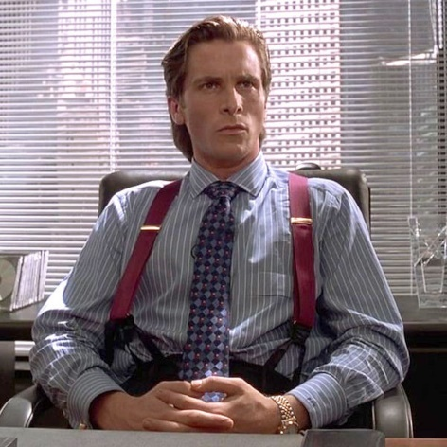 | Here we see a proud Bateman and he´s about to say “I’m having lunch with Cliff Huxtable” to the detective. This statement demonstrates Bateman's propensity for creating illusions and blurring the lines between reality and fantasy. By dropping the name of a fictional character from a popular TV show, Bateman showcases his desire to escape his own world and immerse himself in a constructed reality.  Another quote “There is a moment of sheer panic when I realized that Paul’s apartment overlooks the park and is obviously more expensive than mine.” that reveals Bateman's preoccupation with social status and material wealth is when he experiences a moment of intense panic while visiting his acquaintance Paul's apartment. In this instance, he becomes acutely aware of his own insecurities and feelings of inferiority when he realizes that Paul's apartment overlooks the park and is evidently more luxurious and costly than his own. This quote highlights Bateman's obsession with material possessions and his constant comparison of himself to others, indicating his desperate need for validation and acceptance within the confines of his shallow and image-obsessed social circle.

Sound
Choose one of each type of sound  - Diegetic  - Non-diegetic  - Contrapuntal  Explain in the right hand column how each type of sound contributes to the film (PS: You may have to research one or two of the artists/albums mentioned in the film as they were before your time 😊 ) | Non-diegetic as we have background music.  The song called Walking on Sunshine, starts playing as Bateman is walking into his office. It proudly represent the eagerness to work at Wall Street.

Other characters
Sum up how the other male characters are portrayed in the film
Sum up how the female characters are portrayed in the film

Narrator
First or third person? Reliable or not? Omniscient? Stream-of-concsciouness? Effect on viewer? | third person as we follow Bateman around

Plot
Find the plot model in The English Handbook and analyse it here.
6.7 Film | The English Handbook (systime.dk)
Elements in the plot model | How can it be seen in the film
Introduction and plot point | Business card
Rising action and point of no return
Resolution and new normal

Symbols
Mirrors | That Bateman is obsessed with his looks
Business cards | Obsession over smallest
Credit cards | A credit card back in the day represented mass wealth

Motifs
Names of famous brands, people and places | Wallstreet, Trump, New York, London, Paris
Mistaken identities | Non accruing

Themes in the film
Consumerism | It shows how people always buy things to make them happy
Fantasy vs reality | There is some fantasy where Bateman shots at the cop cars and they explode that’s fantasy.  But most of the film is reality, because there is people just like Bateman.
Violence and dehumanisation | Bateman stabs a homeless to death while saying that he reeks of shit

Message (how do the theme and all the other elements in this worksheet combine to create the message?

Text 5: Exam text
Psychopathy (fiction)

Denne eksamensopgave består af en enkelt skønlitterær tekst. Den er forkortet. Når du ser ”…” betyder det, at noget tekst er blevet fjernet.

Forberedelsestid: 60 minutter
Eksamenstid: 30 minutter, hvoraf de første 8 er din præsentation af teksten.

Ved den mundtlige prøve lægges der vægt på, at du
̶ behersker et flydende og nuanceret engelsk med høj grad af grammatisk korrekthed og evne til selvkorrektion
̶ giver en velstruktureret præsentation
̶ analyserer, fortolker og perspektiverer prøvematerialet med anvendelse af fagets analytiske begreber og metoder
̶ anvender den viden, der er opnået i arbejdet med det studerede emne. Der lægges i bedømmelsen vægt på, at eksaminanden kan indgå i uddybende samtale om præsentationen.

Exam text : American Psycho, by Bret Easton Ellis
Chapter title “Killing child at Zoo” not found in the film.
- Characterise the main character, Patrick Bateman, with particular emphasis on how he views himself and other people
- Analyse what psychopathic traits you see in him, according to the relevant criteria.
  - He appears very apathetic. ”And I have a vague awareness during the minutes I hold the child’s head, reverently, careful not to bloody myself, that if someone makes a phone call or if a real doctor is at hand, there’s a good chance the child can be saved. But this doesn’t happen. Instead I hold it, mindlessly, (…)”. He shows no remorse for killing the child, instead he makes sure the child dies. He cares more for his clothes than the boy or the mother.
  - Manipulative. “A cop pushes me away, even though I tell him I’m a physician.”
  - Self glorifying.
- Relate this text to the psychopathy topic studied in class.
  - Text 2: Documentary “What makes me a psychopath?”
  - Bateman is very similar to the prisoner Wayne.
    - They both describe their good ”normal life” behaviour.
    - They both talk about their brutal murders the same manner as their everyday routine
  - Many of the topics discussed in the documentary Bateman .

“Killing child at Zoo” by Brett Easton Ellis, taken from the novel American Psycho (1991)

A string of days pass. During the nights I’ve been sleeping in twenty-minute intervals. I feel aimless, things look cloudy, my homicidal compulsion, which surfaces, disappears, surfaces, leaves again, lies barely dormant during a quiet lunch at Alex Goes to Camp, where I have the lamb sausage salad with lobster and white beans sprayed with lime and foie gras vinegar. I’m wearing faded jeans, an Armani jacket, and a white, hundred-and-forty-dollar Comme des Garcons T-shirt. I make a phone call to check my messages. I return some videotapes. I stop at an automated teller. Last night, Jeanette asked me, “Patrick, why do you keep razor blades in your wallet?” The Patty Winters Show this morning was about a boy who fell in love with a box of soap.
Unable to maintain a credible public persona, I find myself roaming the zoo in Central Park, restlessly. Drug dealers hang out along the perimeter by the gates and the smell of horse shit from passing carriages drifts over them into the zoo, and the tips of skyscrapers, apartment buildings on Fifth Avenue, the Trump Plaza, the AT&T building, surround the park which surrounds the zoo and heightens its unnaturalness. A black custodian mopping the floor in the men’s room asks me to flush the urinal after I use it. “Do it yourself, nigger,” I tell him and when he makes a move toward me, the flash of a knife blade causes him to back off.
All the information booths seem closed. A blind man chews, feeds, on a pretzel. Two drunks, faggots, console each other on a bench. Nearby a mother breast-feeds her baby, which awakens something awful in me. The zoo seems empty, devoid of life. The polar bears look stained and drugged. A crocodile floats morosely in an oily makeshift pond. The puffins stare sadly from their glass cage. Toucans have beaks as sharp as knives. The seals stupidly dive off rocks into swirling black water, barking mindlessly. The zookeepers feed them dead fish. A crowd gathers around the tank, mostly adults, a few accompanied by children. On the seals’ tank a plaque warns: COINS CAN KILL—IF SWALLOWED, COINS CAN LODGE IN AN ANIMAL’S STOMACH AND CAUSE ULCERS, INFECTIONS AND DEATH. DO NOT THROW COINS IN THE POOL. So, what do I do? Toss a handful of change into the tank when none of the zookeepers are watching. It’s not the seals I hate—it’s the audience’s enjoyment of them that bothers me.
The snowy owl has eyes that look just like mine, especially when it widens them. And while I stand there, staring at it, lowering my sunglasses, something unspoken passes between me and the bird—there’s this weird kind of tension, a bizarre pressure, that fuels the following, which starts, happens, ends, very quickly. In the darkness of the penguin habitat—Edge of the Icepack is what the zoo pretentiously calls it—it’s cool, in sharp contrast to the humidity outside. The penguins in the tank glide lazily underwater past the glass walls where spectators crowd in to stare. The penguins on the rocks, not swimming, look dazed, stressed out, tired and bored; they mostly yawn, sometimes stretching. Fake penguin noises, cassettes probably, play over a sound system and someone has turned up the volume because it’s so crowded in the room. The penguins are cute, I guess. I spot one that looks like Craig McDermott.
A child, barely five, finishes eating a candy bar. His mother tells him to throw the wrapper away, then resumes talking to another woman, who is with a child around the same age, the three of them staring into the dirty blueness of the penguin habitat. The first child moves toward the trash can, located in a dim corner in the back of the room, that I am now crouching behind. He stands on tiptoes, carefully throwing the wrapper into the trash. I whisper something. The child spots me and just stands there, away from the crowd, slightly scared but also dumbly fascinated. I stare back. “Would you like… a cookie?” I ask, reaching into my pocket. He nods his small head, up, then down, slowly, but before he can answer, my sudden lack of care crests in a massive wave of fury and I pull the knife out of my pocket and I stab him, quickly, in the neck. Bewildered, he backs into the trash can, gurgling like an infant, unable to scream or cry out because of the blood that starts spurting out of the wound in his throat. Though I’d like to watch this child die, I push him down behind the garbage can, then casually mingle in with the rest of the crowd and touch the shoulder of a pretty girl, and smiling I point to a penguin preparing to make a dive. Behind me, if one were to look closely, one could see the child’s feet kicking in back of the trash can. I keep an eye on the child’s mother, who after a while notices her son’s absence and starts scanning the crowd. I touch the girl’s shoulder again, and she smiles at me and shrugs apologetically, but I can’t figure out why. When the mother finally notices him she doesn’t scream because she can see only his feet and assumes that he’s playfully hiding from her. At first she seems relieved that she’s spotted him and moving toward the trash can she coos, “Are you playing hide-and-seek, honey?” But from where I stand, behind the pretty girl, who I’ve already found out is foreign, a tourist, I can see the exact moment when the expression on the mother’s face changes into fear, and slinging her purse over her shoulder she pulls the trash can away, revealing a face completely covered in red blood and the child’s having trouble blinking its eyes because of this, grabbing at his throat, now kicking weakly. The mother makes a sound that I cannot describe—something high-pitched that turns into screaming.
After she falls to the floor beside the body, a few people turning around, I find myself shouting out, my voice heavy with emotion, “I’m a doctor, move back, I’m a doctor,” and I kneel beside the mother before an interested crowd gathers around us and I pry her arms off the child, who is now on his back struggling vainly for breath, the blood coming evenly but in dying arcs out of his neck and onto his Polo shirt, which is drenched with it. And I have a vague awareness during the minutes I hold the child’s head, reverently, careful not to bloody myself, that if someone makes a phone call or if a real doctor is at hand, there’s a good chance the child can be saved. But this doesn’t happen. Instead I hold it, mindlessly, while the mother—homely, Jewish-looking, overweight, pitifully trying to appear stylish in designer jeans and an unsightly leaf-patterned black wool sweater—shrieks do something, do something, do something, the two of us ignoring the chaos, the people who start screaming around us, concentrating only on the dying child. Though I am satisfied at first by my actions, I’m suddenly jolted with a mournful despair at how useless, how extraordinarily painless, it is to take a child’s life. This thing before me, small and twisted and bloody, has no real history, no worthwhile past, nothing is really lost. It’s so much worse (and more pleasurable) taking the life of someone who has hit his or her prime, who has the beginnings of a full history, a spouse, a network of friends, a career, whose death will upset far more people whose capacity for grief is limitless than a child’s would, perhaps ruin many more lives than just the meaningless, puny death of this boy. I’m automatically seized with an almost overwhelming desire to knife the boy’s mother too, who is in hysterics, but all I can do is slap her face harshly and shout for her to calm down. For this I’m given no disapproving looks. I’m dimly aware of light coming into the room, of a door being opened somewhere, of the presence of zoo officials, a security guard, someone - one of the tourists? - taking flash pictures, the penguins freaking out in the tank behind us, slamming themselves against the glass in a panic.
A cop pushes me away, even though I tell him I’m a physician. Someone drags the boy outside, lays him on the ground and removes his shirt. The boy gasps, dies. The mother has to be restrained. I feel empty, hardly here at all, but even the arrival of the police seems an insufficient reason to move and I stand with the crowd outside the penguin habitat, with dozens of others, taking a long time to slowly blend in and then back away, until finally I’m walking down Fifth Avenue, surprised by how little blood has stained my jacket, and I stop in a bookstore and buy a book and then at a Dove Bar stand on the corner of Fifty-sixth Street, where I buy a Dove Bar Ice cream —a coconut one—and I imagine a hole, widening in the sun, and for some reason this breaks the tension I started feeling when I first noticed the snowy owl’s eyes and then when it recurred after the boy was dragged out of the penguin habitat and I walked away, my hands soaked with blood, uncaught.
(3,6 ns)

Text 6: Ted Bundy Grammatik baseret på artiklen nedenfor ”Ted Bundy – the first televised television trial”
Opgave 1: Ordklasse og synonymer
I teksten er seks ord understreget. Identificer ordklassen og foreslå to synonymer for hvert ord. Brug enten Oxford, Cambridge eller Merriam Webster.
Ord | Ordklasse | Synonym
Murders | Navneord | 1. Killings  2. Slaugthers
Handsome | Tillægsord | 1. Fine  2. Pretty
Mother | Navneord | 1. Mom  2. Maternal figure
Embarked | Udsagnsord | 1. Started  2. Began
He | Stedord | 1. They  2. The guy
Kidnapping | Navneord | 1. Abduction  2. Taking

Opgave 2: Sætningsanalyse
I teksten er tre sætninger markeret med fed. Analyser sætningernes led.
- Ted Bundy seemed the unlikeliest of serial killers.

- Which made his decade-long, multi-state killing spree all the more surprising -

- He was executed in the electric chair in 1989

Opgave 3: Uregelmæssige udsagnsord
Find fem unikke, uregelmæssige udsagnsord i teksten og bøj dem i nutid, datid og kort tillægsform.
Ord  (som det står i teksten) | Nutid | Datid | Kort tillægsform
Was | It is | It was | Been
Became | Become | Became | Become
Have | It has | I had | Had
Driving | Drive | Drove | Driven
Stolen | Stole | Stole | Stolen
Didn’t | Do not/Don’t | Did not/Didn’t | Not done

Opgave 4: Sætninger
Hvad er en helsætning? | Alt fra punktum til punktum (eller semikolon :nerd:)

Forklar forskellen mellem en hovedsætning og en bisætning
Hovedsætning | Kan stå alene
Bisætning | Kan ikke stå alene, men giver mening til en hovedsætning

Forklar forskellen mellem en bisætning og et biled
Bisætning | Giver mening til en hovedsætning
Biled | Uddyber sætningen

Find tre eksempler på helsætninger, der indeholder både en hovedsætning og et biled eller en bisætning. Understreg bileddet og lav bisætningen fed.
1.
2.
3.
Opgave 5: Ing-former
I teksten er fem eksempler på ing-former highligted med gult. For hver ing-form, forklar hvorfor ordet står i ing-form.
Ord | Forklaring
Brimming | Lang tillægsform
Following | Lang tillægsform
Kidnapping | En udsagnsord der bliver til et navneord
Driving | Lang tillægsform
Delaying | Lang tillægsform

Opgave 6: Tillægsord og biord
Identificer fem tillægsord og fem biord. For hvert, beskriv hvilket ord de modificerer i sætningen og ordets ordklasse.
Tillægsord | Modificerer (+ ordklasse) | Biord | Modificerer (+ ordklasse)

Ted Bundy: The first televised murder trial
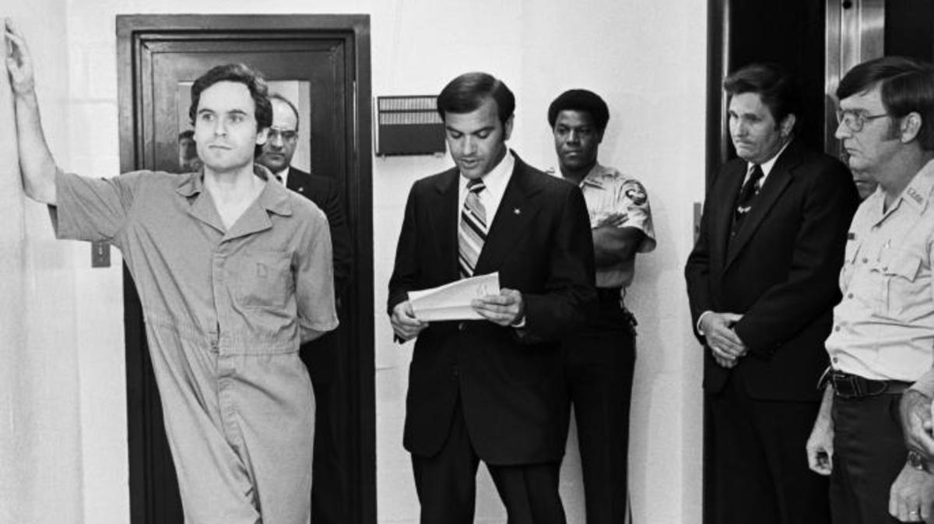
Theodore (Ted) Bundy in Leon County jail as the indictment charge is read, charging him with the murders of two FSU students at the Chi Omega house. (Credit: Bettmann/Getty Images)

Handsome, well-educated and brimming with charm, Ted Bundy seemed the unlikeliest of serial killers. Which made his decade-long, multi-state killing spree all the more surprising—and to some, appealing. Born to an unwed, teenaged mother, Bundy never learned his father’s identity and was raised believing that his grandmother was actually his mother (and his mother actually his sister).
Following a difficult adolescence, Bundy graduated from the University of Washington—and soon embarked on his murderous spree, killing his first victim in Seattle in 1966. Focusing primarily on attractive college co-eds, Bundy committed a series of murders across the Pacific Northwest. He continued on to Utah and Colorado, killing several more women before being arrested. Despite being convicted of kidnapping, he managed to escape police custody not once, but twice, while awaiting trial in Colorado. He moved to Florida, where he killed several members of a sorority and his final victim, a 12-year-old girl who he raped and murdered.
When Bundy was finally apprehended while driving a stolen car a week after his last murder, his trial quickly became a media sensation. It was the first murder trial to be fully televised, and featured Bundy front-and-center acting as one of his own defense attorneys. He became a media star, welcoming journalists to his cell, receiving letters of admiration from lovelorn fans (and even marrying one of them) and providing an endless list of clues about additional murders he may have committed, in the hopes of delaying his execution. It didn’t work; he was executed in the electric chair in 1989, with the true number of his victims unknown.
(https://www.history.com/news/8-of-historys-most-notorious-serial-killers)

