# Space Pirates

## Team

* + - Team Name: Team Venus
    - Who’s in our team: Chris Greenan, Simon Finnie and Reuben Hilder.
    - Who’s doing what role:
      * Chris Greenan – Player Mechanics, GUI, Documentation, Testing and Boss Design.
      * Simon Finnie – Maps (Level) & Wave generation, Graphics, Music, Testing and Boss Design.
      * Reuben Hilder – Maps (Level) & Wave generation, Maps (World), Testing and Boss Design.

## Core concept

* + - Space Pirates is a unique, non-linear arcade style shoot-em-up that blends the classic gameplay aspects of the genre with RPG style customization and freedom of choice to suit the individual’s playstyle.

## Story

As a rebellious space pirate, yours is a modest dream: the total domination of the known universe. Unfortunately, there are those who will stop at nothing to prevent you from achieving this goal. From pesky space bandits, to opposing space pirate factions, to self-righteous space nations with contrary beliefs like democracy, peace, and that space pirates shouldn’t fly in, destroy their bases and steal their stuff, the galaxy if full of miscreants hell-bent on keeping from you what is rightfully yours. Namely, everything. So fire up your engines, charge your laser cannons, and get ready for an adventure of epic proportions. In space. With pirates. Arrrrr!

## Game Overview

The game is essentially a blend of two distinct game perspectives:

The first is in the vein of classic arcade shoot ‘em up games. The player controls a ship in a 2d side-scrolling world, where they must shoot at oncoming enemies while dodging enemy fire. When the enemies are killed they drop a variety of useful items (temporary power-ups, and health boosts), which helps the player survive until the end of the stage. At the end of each stage the player must defeat a powerful boss, pushing the player to do well earlier in the stage to make sure they have enough health to take it on. The player can fire from weapons in up to three weapon slots using individual buttons. Each weapon has its own properties such as projectile type, damage, and cooldown time.

In between stages the RPG elements come into play. The player is move to a menu interface where they can select their ship and weapons from those they have unlocked through game progression. Each ship has a unique play style, so players can choose between larger ships with a lot of health, or smaller but more powerful ships. The player will also be shown a level selection map. This displays all the levels the player can access, and informs them which faction owns it, letting the player plan out who they will attack and when. The game is won when the player conquer each faction.

World Map View (rough draft)

Names are not as they will appear in the final product.

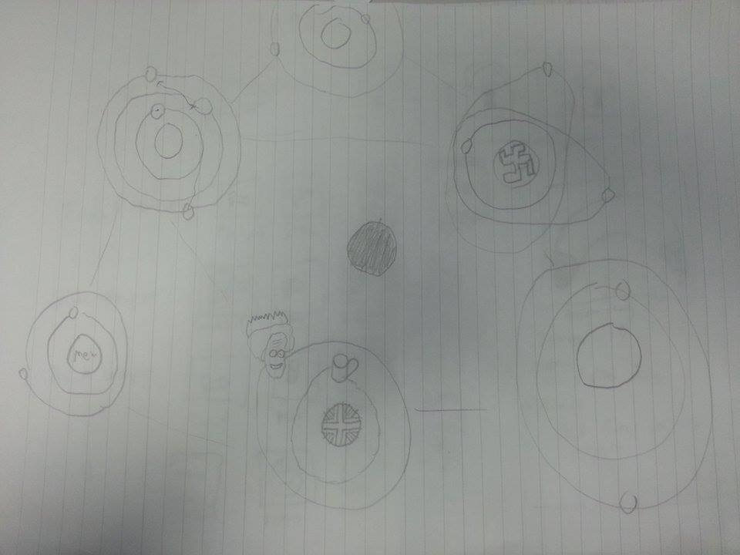

Space Nazis

Space British

Another faction 3

Another faction 3

Another faction 3

The games fun derives from the fast-paced intensity of the combat and from the sense of freedom and achievement given to the player through the customization and territory gaining mechanics.

## Goals

We have four main goals we’d like to achieve with our game. Since our game is aimed at casual gamers our main goal is to focus on simple game play that easy to understand. Our second goal relates to our first one, which is to make the game very immersive for the user and hard to stop playing. We hope to achieve this by having intense levels and player progression with a shop and upgrade system. Similar to our second goal we hope to have a good difficulty curve, which starts out pretty straight forward and ends up being a big challenge. Our last goal is to have unique hand drawn art as the background.

## Non Goals

Although there are many directions we could take with this game, in the name of focus, we have decided on some gameplay elements we don’t want to become too dominant in the final game.

* + - Strategy (Tactics, yes. Strategy, no. The game will be action oriented)
    - Exploration / Sandbox
    - Complex, decision based RPG gameplay (the choices left open focus on tailoring the experience, not gaining an advantage)
    - Highly technical battle simulator
    - Paperwork simulator (minimal management elements)

## Feature List

* + Core Features:
    - Unlockable ships:
      * Basic start ship
      * Small and fast with low resistance
      * Large but slow with high resistance
      * Slow and medium resistance with extended weapon capacity.
    - Side scrolling 2D environment.
    - Enemies
      * Procedurally generated
      * Attack in waves
      * Multiple behaviors types
        + Shoot straight
        + Shoot directly at player
        + Shoot in multiple directions
        + Travel in straight line
        + Travel directly towards the player
        + Travel in set path (side to side etc.)
        + Circle the player
    - Unlockable weapons (see spreadsheet)
      * Basic single shot
      * Arc shot
      * Beam shot
      * 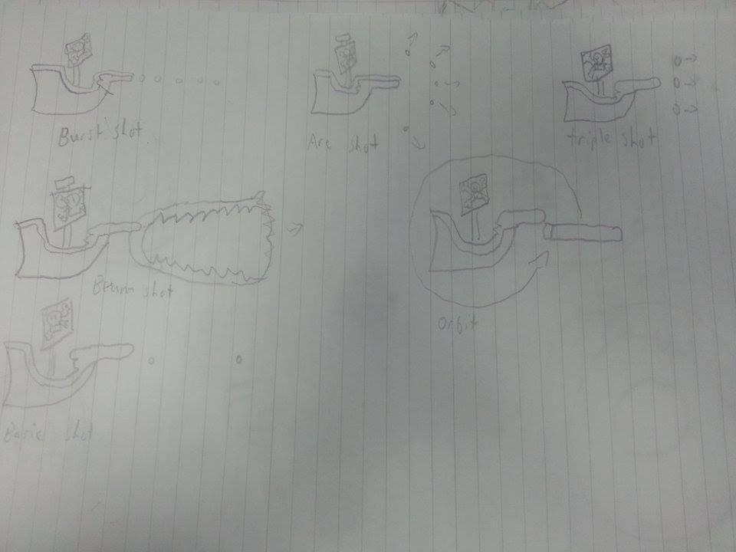Wave shot
    - Bosses
    - Save / Load Game
    - Territory System
    - Environmental objects
      * Laser walls
      * Debris
      * Asteroids

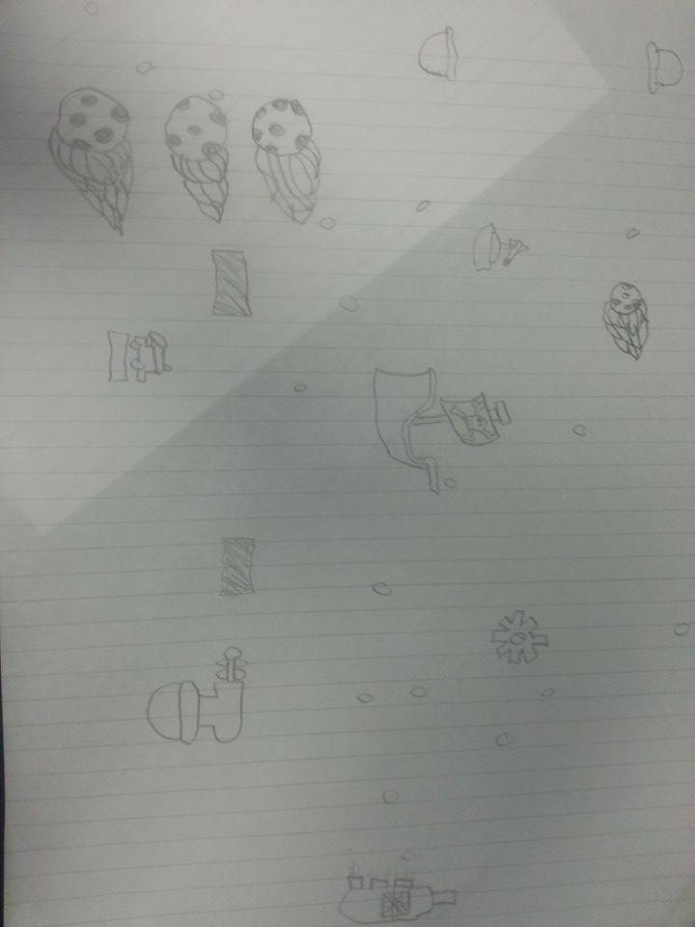

Asteroids – Small amount of damage on contact

Laser – Large amount of damage.

Player Ship - Concept

Spinning gun – Shoots multiple shots out in all directions. Medium damage

* + Nice Features (If we have time):
    - Humor
    - Moral system
    - Research (for better upgrades)
    - Store
    - Port System
    - Character creation (Gender and Race)
    - Difficulty options

## Aesthetic

We are aiming for a relatively simple cartoon style look with a steampunk aesthetic for the sprites to capture visual elements of both pirates and sci-fi. The backgrounds will be hand drawn starscapes and nebulas. The overall look will attempt to imitate the future as it was imagined in the 50s.

## Risks

Our biggest risk is that since we’re doing a shoot-em-up then the gameplay can become very repetitive very easy. We are hoping to use procedural generation for our levels so we can create a lot of them easily but we’ll be trying it out in our prototypes if we can get working or not so we don’t waste time further into the project. We also will be running the risk of not adding another features and the gameplay becomes boring so we have decided or a minimum amount of core features that we believe will make the game fun. On top of these we also have:

* + - Empire system being limited by level count
    - Game mechanics becoming repetitive.
    - Gameplay becoming too technical.

## Tech overview -

* + Graphics
    - Basic pixel-art sprites with minimal animation
    - Focus on particles for bullets and explosions.
    - Scrolling backgrounds with parallax.
    - Backgrounds that develop as the stage progresses.
  + AI
    - Enemies will use very basic AI with the focus being on number and shoot style creating variation and challenge.
    - A large amount of effort will be put into intelligent enemy spawning.
  + We are planning to implement a load save option which writes / reads from a file.

## Plan (Overview)

* + Week 24th – 29th will be working on the prototypes.
    - Maps
    - Basic player/ enemy movement mechanics
    - Wave generation
    - Shooting
    - Upgrades (Low priority)
  + Week 1st – 5th will be working on a playable version.
    - Not polished or all features implemented.
    - Integration of existing features from prototypes.
  + Week 8th – 12th will be polishing the game.
    - Menus
    - Art
    - Music
    - Tuning
    - Testing
    - Fleshing out features

## Detailed Plan

Prototyping week (24th-29th Jan):

In the prototyping week our first goal is to get the basic game mechanics running. For this we want the player to have full two-dimensional movement and have the basic shooting mechanic working (player can shoot out front). This we expect to have done by the end of the first day. Reuben will be working on this.

The Major the goal of the week is to see if creating levels using procedural generation is feasible. This will cover the first, second and third day and will be split into two sections: Simon will be working on level and enemy design, focusing on how to make a level interesting using procedural generation; while Reuben and Chris will be working programming a procedural generator.

If the procedural generator isn’t working well on the fourth day we will switch to plan B and use the base design Simon was working on to build a basic level from there. In either plan the fourth day would involve implementing the creature designs and place them in the level.

Depending on the plan, this might be by using the procedural generator, or using Simon’s designed map. This will take up the next two days. If on the fourth day the procedural generator isn’t finished, but seems close, Simon will work on building the level while Chris and Reuben continue to work on the procedural generator. This will guarantee that a basic design of a single level is finished by the end of the week.

First Week of Full design (1st - 5th Feb):

If procedural level building is working, all three of us will be working on enemy and boss design and weapon design. The group will set out on designing enemies on the first day, and from there they will split into two groups. Simon will work on boss design and implementation, while Reuben and Chris’s main focuses will be on implementing the enemies and weapons into the game and attempt to balance them as best they can.

If the procedural generation is not working then Simon will focus primarily on Level design. In this case the group will work on enemy design for the first day and then split into three groups for the rest of the week. Reuben and Chris will work on implementing the enemies and weapons into the game and attempt to balance them as best they can. Simon will work on level design, and produce a set of interesting designed levels based on the enemies they have created over the next three days. Then Simon and Chris will both work on boss design on the last day of the week, while Reuben continues to work on enemy implementation.

Second Week of Full game design (8th – 12th Feb):

If procedural level building is working then Simon will move on to enemy and background art design for the first 3 days of the week as well as selecting music from an allowed source. Reuben will spend the first week implementing a well-designed menu user interface for the game. Over the week Chris will work testing and fine-tuning to make sure that enemy and player weapons are balanced, and deciding the validity of enemy design. Simon will join Chris on the fourth day.

If procedural level building isn’t working then Simon will move on to enemy and background art design for the first 3 days of the week as well as selecting music from an allowed source. Reuben will spend the first week implementing a well-designed menu user interface for the game. Over the week Chris will work testing and fine-tuning to make sure that enemy and player weapons are balanced, and deciding the validity of enemy design. On the fourth day Simon will continue to work on boss design.

Last Week of full game design (15th – 19th):

This week is used as a safety net as any task may take longer than we expected. It will also be used for testing and fine-tuning, as any game can always use more testing.

## Control scheme

* + - Full 2d movement (w, a ,s d)
    - Weapons selection / Multiple shoot buttons
    - Special action button (maybe)

## Game Mechanics

* + Shoot ‘em Up Combat
  + Ship Customization
  + Gaining Territory
    - Upgrades will be balanced by the increase in difficulty in level as the player comes closer to their goal.
    - Levels will be balanced with responsive movement combined with quick responsive movement and quick and challenging enemies, which push for players to react.

## Sample Users

* + - Us
    - Classmates
    - Friends
    - Family
    - Teachers

## Demographic / target audience

* + - Shoot-em-up players
    - Pirate enthusiast
    - Casual gamers

# MacintoshHD:Users:local360:Downloads:12584089_919366938179024_1274109171_n.jpgSample Upgrade Menu