Math-a-Mole

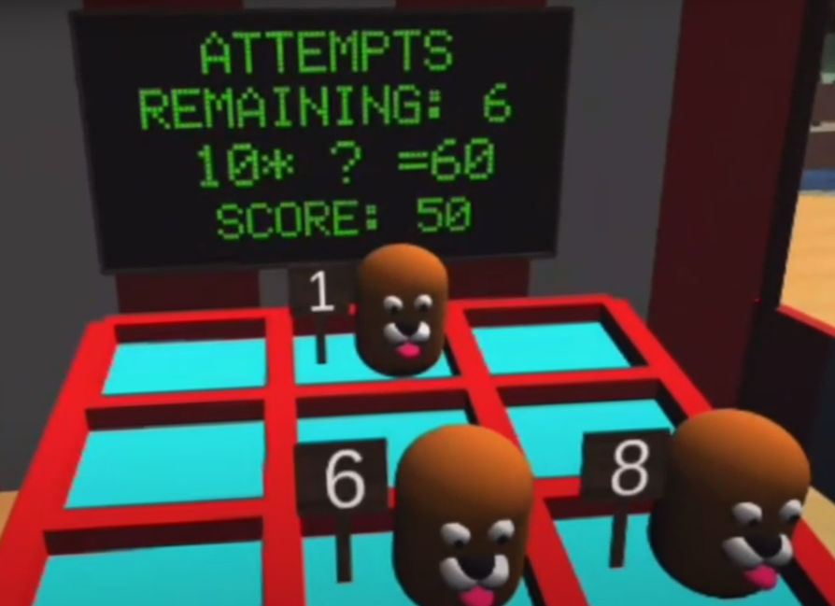

By:

Simon Forinash, Sam Jerijervi,   
John David Gruber, Diego Valdez, Jared Elliott

What is This?

Math-a-Mole is a fun and educational game where you can play the popular carnival game whack-a-mole while also practicing your math skills! Hit the moles with the right answers to get points and go for a high score!



How to Play

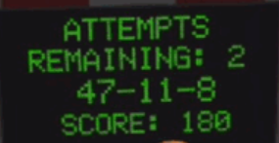  
Look at the prompt on the screen…

  
And hit the right number!

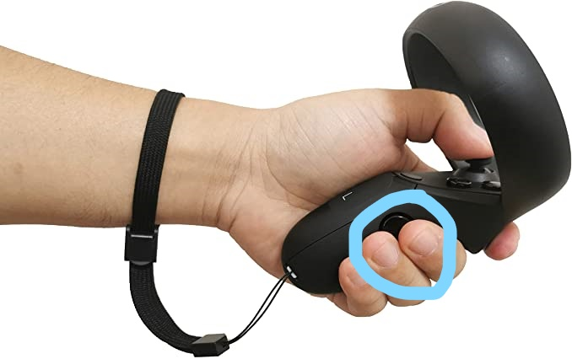

Grip Press to   
grasp the mallet!

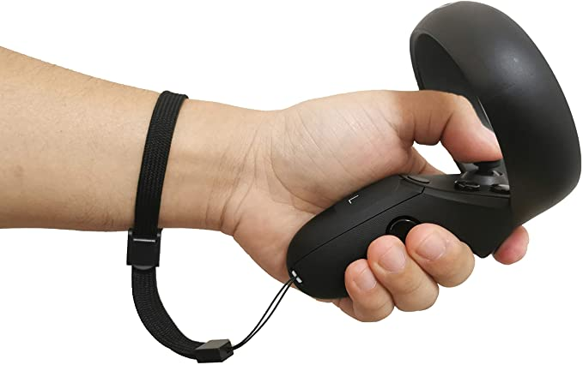Use your VR motion controller

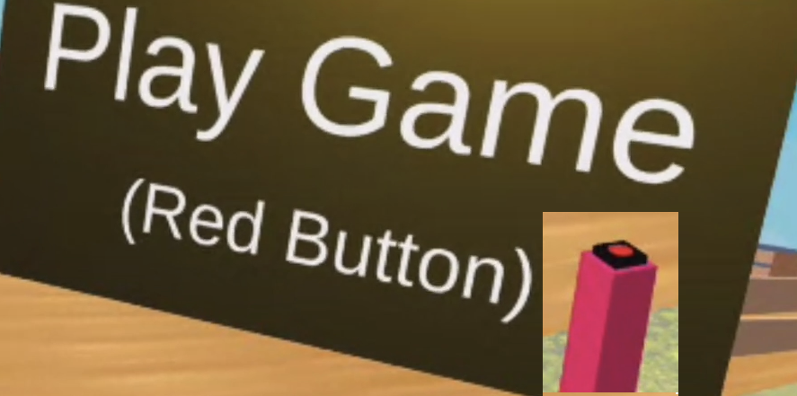

Hit this button to start!

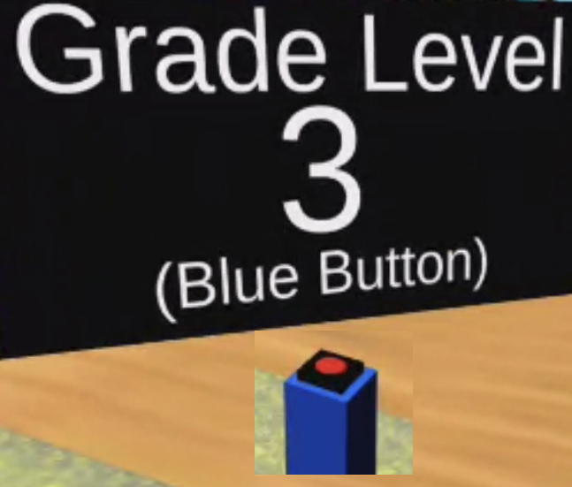  
Hit this button to change grade level