Report of Predictive Maintenance
Dataset :
S. Matzka, "Explainable Artificial Intelligence for Predictive Maintenance Applications," 2020 Third International Conference on Artificial Intelligence for Industries (AI4I), 2020, pp. 69-74, doi: 10.1109/AI4I49448.2020.00023.
Meaning of variables :
- UID: unique identifier ranging from 1 to 10000
- product ID: consisting of a letter L, M, or H for low (50% of all products), medium (30%) and high (20%) as product quality variants and a variant-specific serial number
- type: just the product type L, M or H from column 2
- air temperature [K]: generated using a random walk process later normalized to a standard deviation of 2 K around 300 K
- process temperature [K]: generated using a random walk process normalized to a standard deviation of 1 K, added to the air temperature plus 10 K.
- rotational speed [rpm]: calculated from a power of 2860 W, overlaid with a normally distributed noise
- torque [Nm]: torque values are normally distributed around 40 Nm with a SD = 10 Nm and no negative values.
- tool wear [min]: The quality variants H/M/L add 5/3/2 minutes of tool wear to the used tool in the process.
- a 'machine failure' label that indicates, whether the machine has failed in this particular datapoint for any of the following failure modes are true.
The machine failure consists of five independent failure modes
- tool wear failure (TWF): the tool will be replaced of fail at a randomly selected tool wear time between 200 - 240 mins (120 times in our dataset). At this point in time, the tool is replaced 69 times, and fails 51 times (randomly assigned).
- heat dissipation failure (HDF): heat dissipation causes a process failure, if the difference between air- and process temperature is below 8.6 K and the tools rotational speed is below 1380 rpm. This is the case for 115 data points.
- power failure (PWF): the product of torque and rotational speed (in rad/s) equals the power required for the process. If this power is below 3500 W or above 9000 W, the process fails, which is the case 95 times in our dataset.
- overstrain failure (OSF): if the product of tool wear and torque exceeds 11,000 minNm for the L product variant (12,000 M, 13,000 H), the process fails due to overstrain. This is true for 98 datapoints.
- random failures (RNF): each process has a chance of 0,1 % to fail regardless of its process parameters. This is the case for only 5 datapoints, less than could be expected for 10,000 datapoints in our dataset. If at least one of the above failure modes is true, the process fails and the 'machine failure' label is set to 1. It is therefore not transparent to the machine learning method, which of the failure modes has caused the process to fail.

Data Overview

Shape and structure
- Identification of the target : Machine failure
- Numbers of rows and columns : 10000, 14
- Variables types :
  - Discret :
- Not usefull (Id variables): “UID”, “Product ID”
- Type,
- Machine failure,
- *TWF,
- *HDF,
- *PWF,
- *OSF,
- *RNF

*These variables are logically correlate with Machine failure, so because I need only one target and to don’t have data leak I will drop all these columns.

- Continuous :
    - Air temperature [k],
    - Process temperature [K],
    - Rotational speed [rpm],
    - Torque [Nm],
    - Tool wear [min],

Quality of Data
- Identifications of the missing values :
  - No missing values detected in this dataset
- Identification of duplicate values
  - No duplicate values

Target visualization :
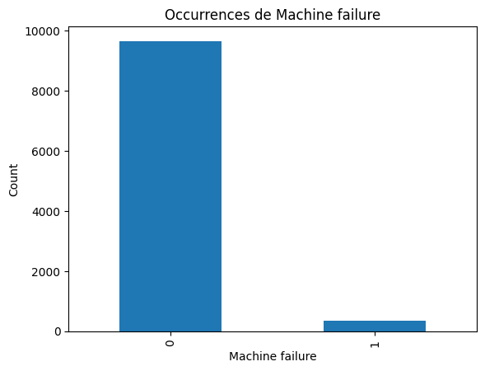

Machine failure
0 - 96.61%
1 - 3.39%

The dataset is unbalance, this is an important information to choose the criteria of evaluation of the Machine Learning model.

Distribution of the machines by type :
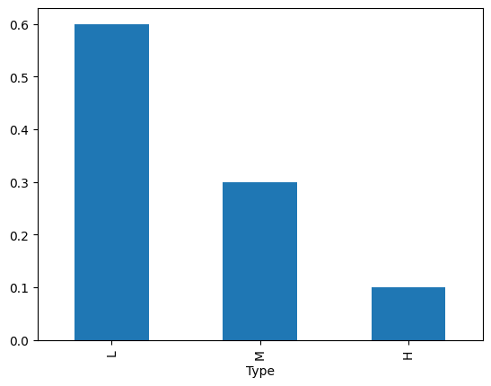
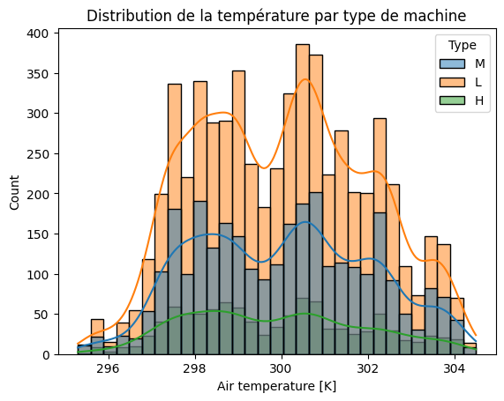
6000 (~60%) machines of TYPE L,
2997 (~30%) machines of type M,
1003 (~10%) machines of Type H.
While all machines operate within the same ranges of Torque and Speed, the Air Temperature distribution reveals a fundamental difference in quality.
- Type L (Low Quality): Exhibits a jagged, bimodal distribution with sharp peaks, indicating poor thermal regulation.
- Type H (High Quality): Shows a much flatter and smoother distribution, suggesting superior heat dissipation capabilities.

This confirms that the 'Quality' of a machine is largely defined by its thermal stability."

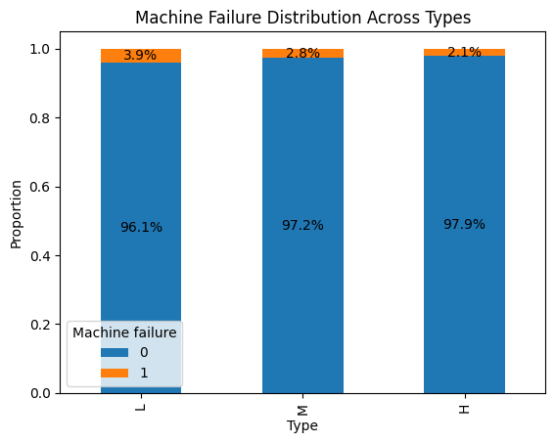
Relation : Type / Machine Failure :

The failure rates are low for all machine types (below 4%). Type L shows a slightly higher failure rate (~3.9%) compared to types H (~2.1%) and M (~2.8%).
This difference remains moderate and would require a statistical to assess whether it is statistically significant.

Global Exploration of interactions

Correlation matrix (heatmap)
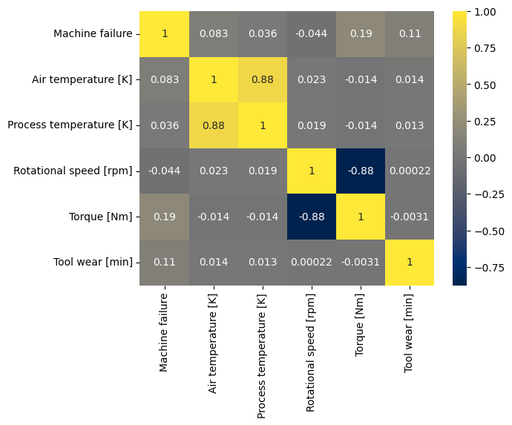

- The Air temperature and Process temperature have a strong correlation (0.88)
- Torque and rotational speed are strongly correlate (-0.88)

Pairplot for Feature Relationships and correlation
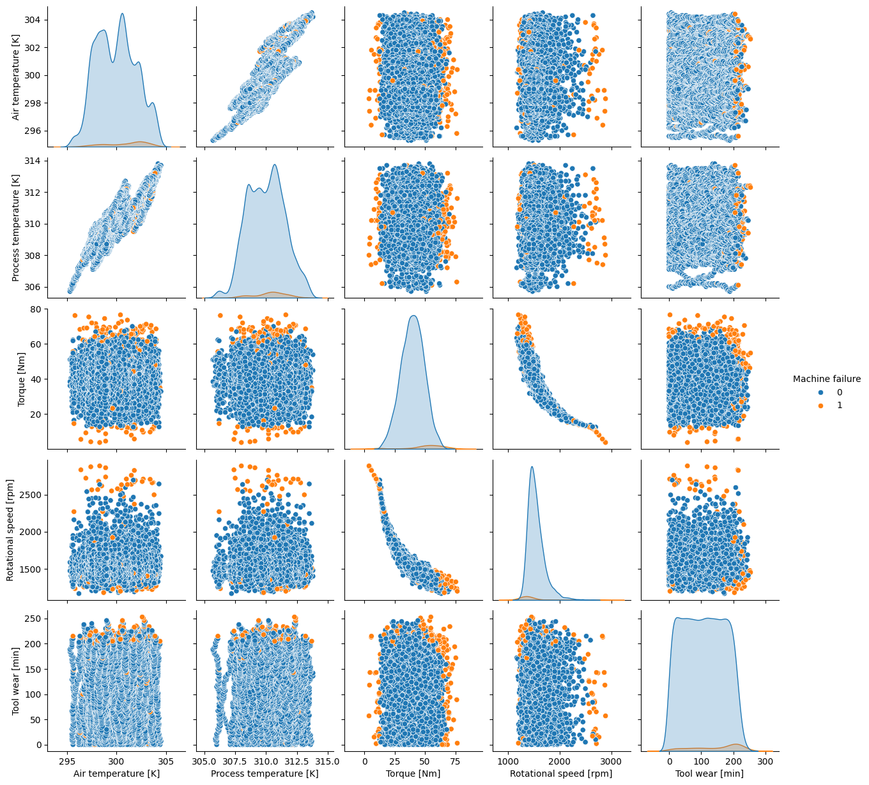

This graph confirm a linear correlation between :
- Air temperature [k] and Process temperature [K]
- Torque [Nm] and Rotational speed [rpm]

In the following analysis, I will combine these variables in feature engineering.
Temp_diff = Process temperature [K] - Air temperature [k]
Machine_power = Torque [Nm] * [pi() * Rotational speed [rpm] / 30]

In-depth Thematic Analysis

Thermal Analysis

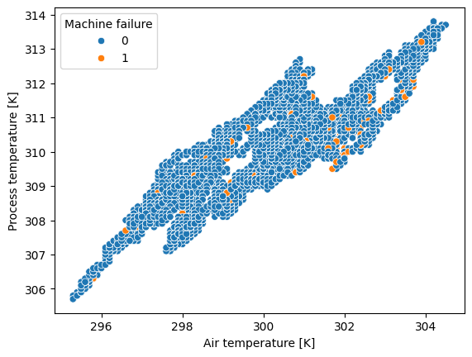
A preliminary analysis of the raw variables Air temperature and Process temperature was conducted (details in Appendix A). While these variables follow stable distributions, they exhibit a significant overlap between normal operations and failures, limiting their individual predictive power.

As suggested by the correlation matrix, the scatter plot above confirms a strong linear relationship (0.88) between the two temperatures. This redundancy implies that monitoring both variables independently adds little value.

Based on the physical properties of the system (Heat Dissipation Failure - HDF), the critical risk factor is not the absolute temperature, but the machine's inability to dissipate heat. Therefore, we engineered a new feature: temp_diff (Process - Air).

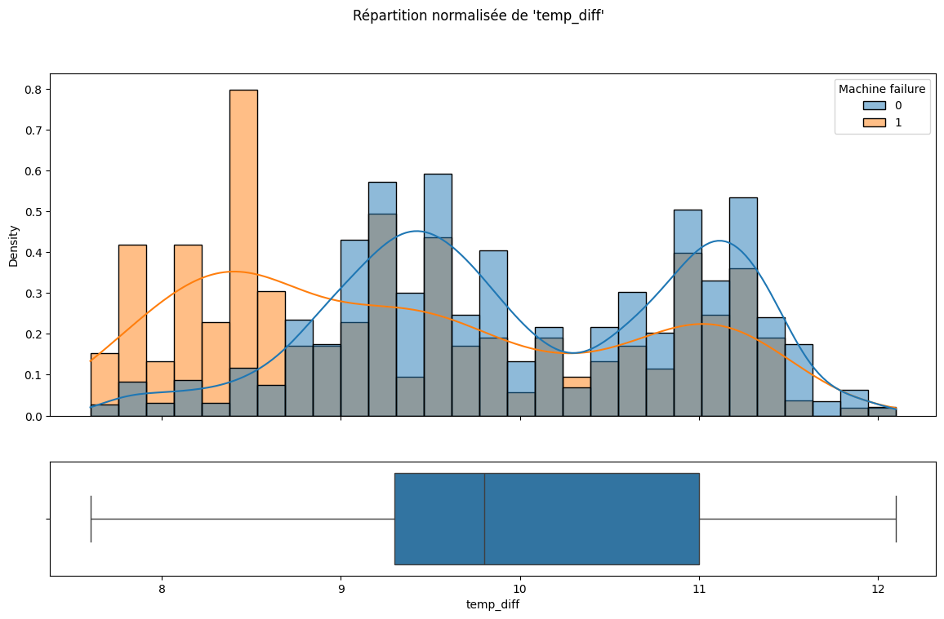

The 8.6 K threshold is critical. As the graph demonstrates, a temperature difference below this value drastically increases the risk of failure.
The distribution above visually confirms this theory. To rigorously validate it, we will now verify if the failures strictly fall below the 8.6 K threshold mentioned in the domain documentation.

Mecanique and power analysis
A preliminary analysis of the raw variables ‘Torque [Nm]’ and ‘Rotational speed [rpm]’ was conducted (details in Appendix B).
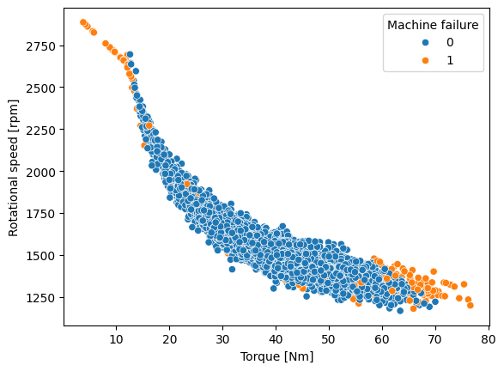

As suggested by the correlation matrix, the scatter plot above confirms a strong linear relationship (-0.88) between the Torque and RPM. This redundancy implies that monitoring both variables independently adds little value.
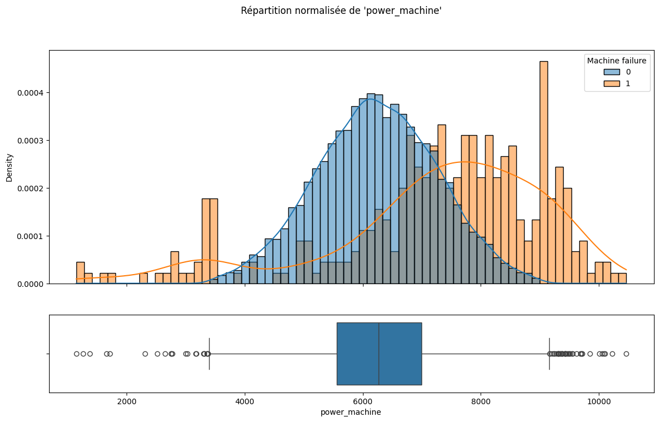

This graphic is normalize to make easier the analysis. Clearly it appear that the outlier are outside of the normal range of the machines and correspond to failure points

Maintenance and Wear Analysis

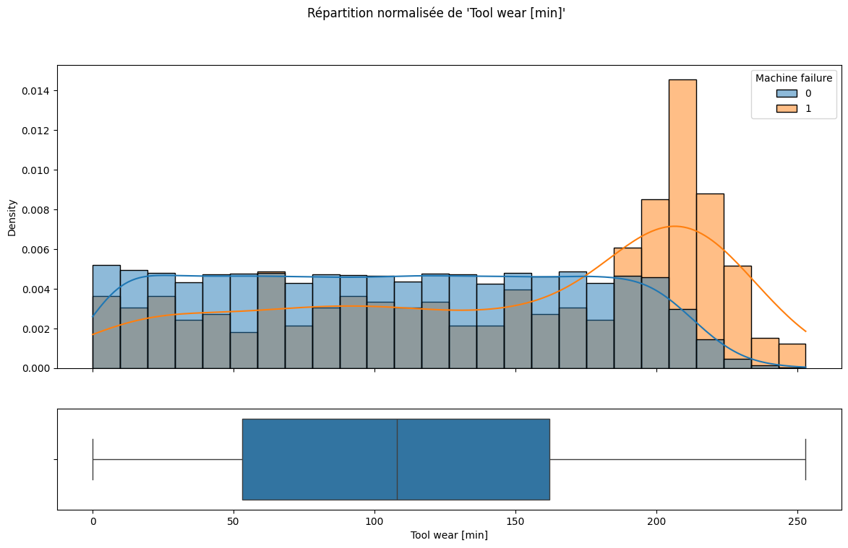
- A preliminary analysis of the raw variable ‘Tool wear [min]’ was conducted (details in Appendix C). Tool Wear follows a Uniform Distribution, the Mean (107.9 min) and Median (108.0 min) are identical, confirming the symmetry of the uniform distribution. The maximum value is of 253 minutes.

This normalized visualization highlights a clear pattern: while normal operations are evenly distributed, failures drastically spike after 200 minutes. This confirms the existence of a specific 'Risk Zone' for tool wear.

Synthesis and features selection

Deleted variables
- UID,
- Product ID
- TWF,
- HDF,
- PWF,
- OSF,
- RNF
- Air temperature
- Process temperature
- Rotational speed [rpm],
- Torque [Nm]

Useful variables
- Type
- Diff_temp
- Power_machine
- Machine failure
- Tool wear [min]

Conclusion

Annexe A :

Detailed Analysis of Raw Temperature Variables
1. Global Distribution & Statistics (Univariate)
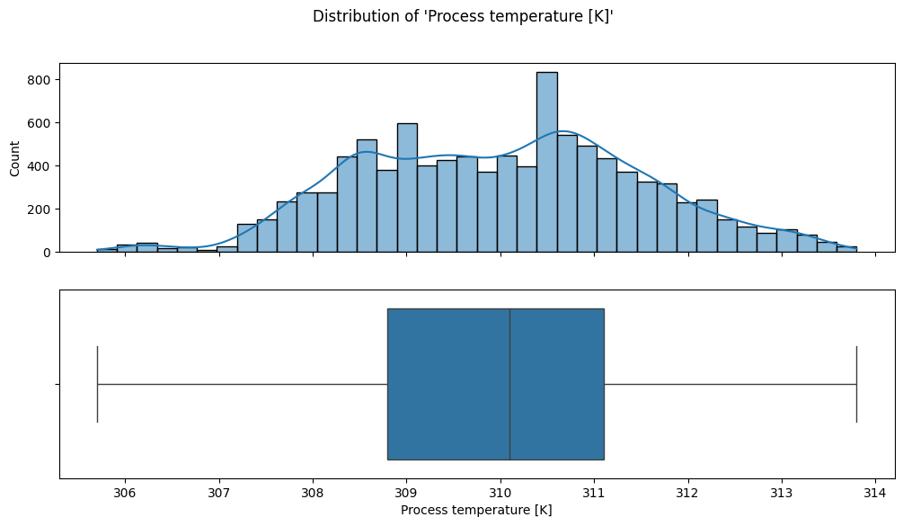
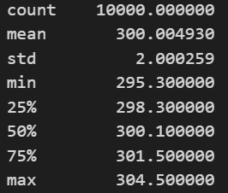
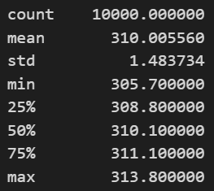
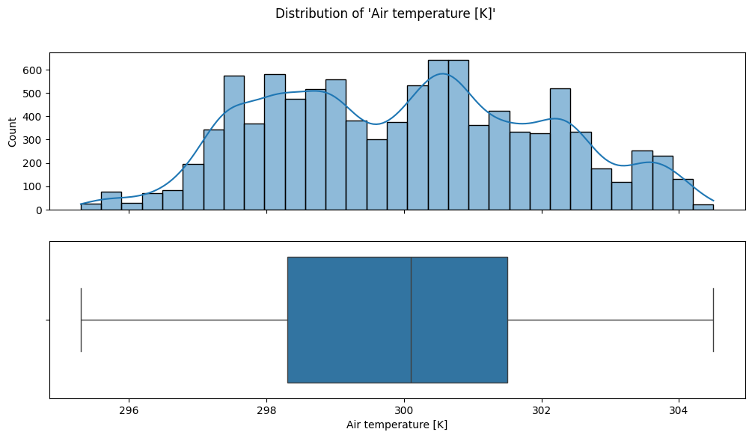

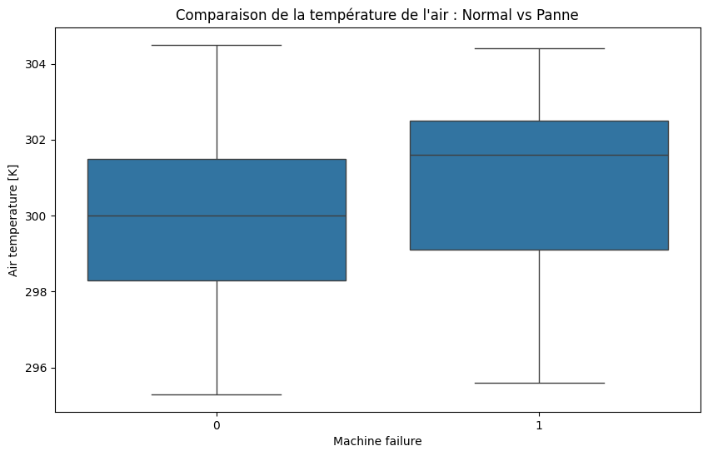
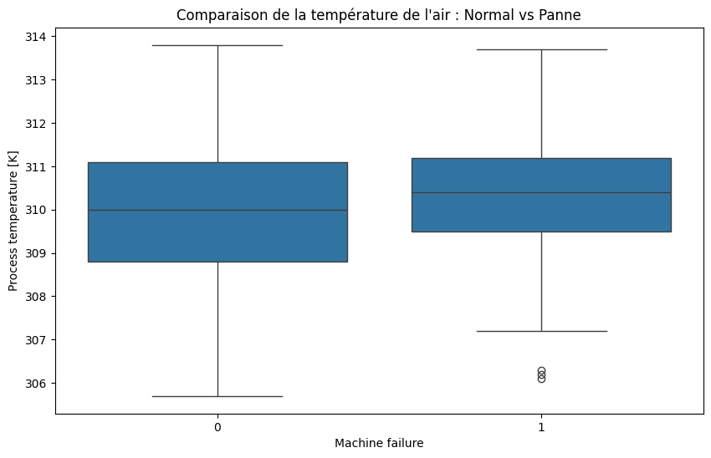
2. Discrimination Capability vs. Machine Failure (Feature-Target)
Observation: The univariate analysis (top) confirms that both Air and Process temperatures are stable and follow a multimodal distribution. However, the Feature-Target analysis (bottom) reveals a significant overlap between the interquartile ranges of normal operations and machine failures.
Conclusion: This confirms that raw temperature values lack sufficient discriminative power to predict failures on their own. This observation justifies the Feature Engineering strategy (creation of the temp_diff variable) presented in the main body of the report.

Annexe B :

Detailed Analysis of Raw Torque and RPM Variables
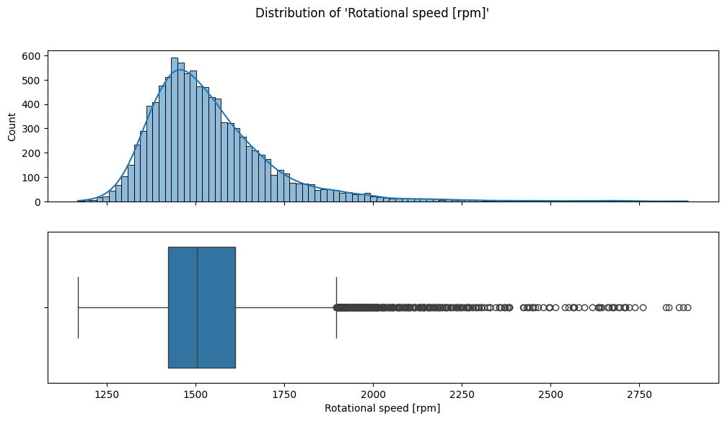
1. Global Distribution & Statistics (Univariate)
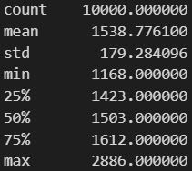

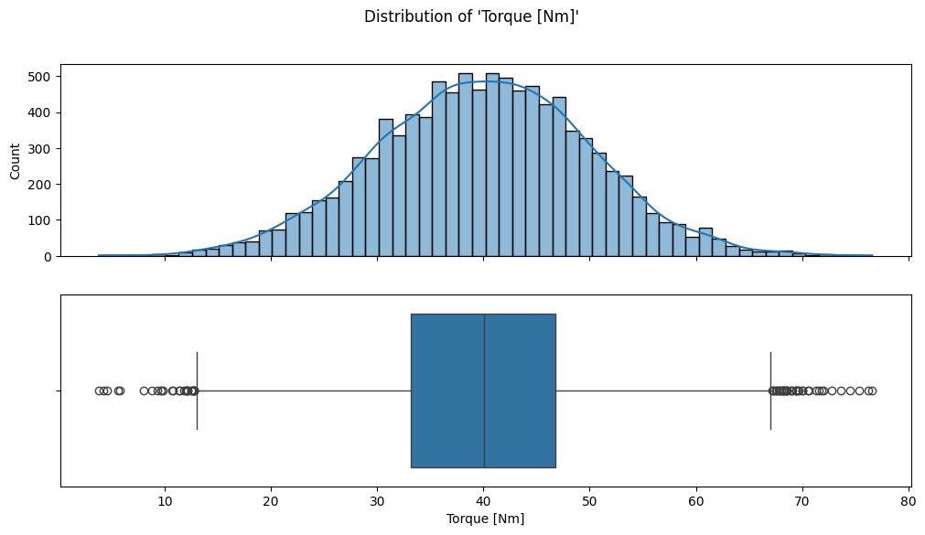
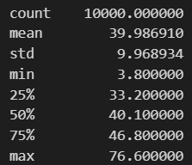

2. Discrimination Capability vs. Machine Failure (Feature-Target)

Annexe C :

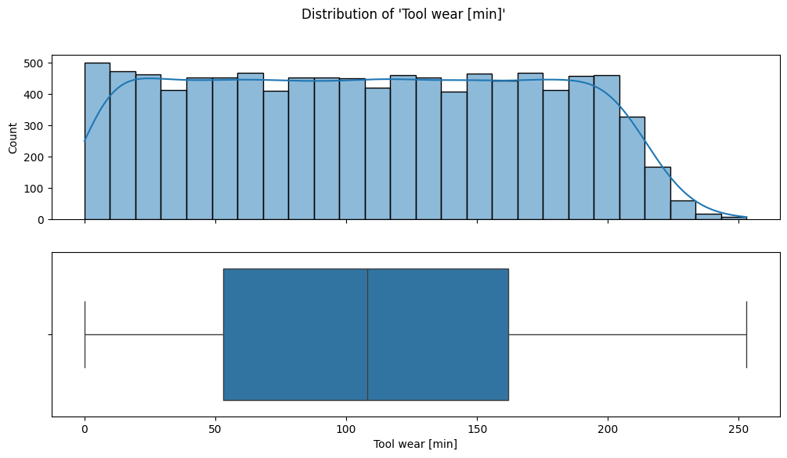
Detailed Analysis of Raw Tool wear Variable

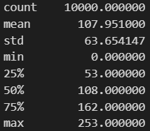

- Distribution: Tool Wear follows a Uniform Distribution. The frequency is roughly constant from 0 to 200 minutes. The Mean (107.9 min) and Median (108.0 min) are identical, confirming the symmetry of the uniform distribution. The maximum value is of 253 miutes.

