**Zombie Smasher Overview**

**Breakdown:**

This game is a basic survival shooting game, as the zombies come on the screen the player’s job is to kill as many as he/she can. To aid in his/her kill spree the player has a gun and a riot shield in which they use to survive, without their health bar hitting zero (of course). The score system is in kill units and so is the timeline. Once the player reaches x amount of kills a health or a Blow-up pack appears to assist the player. However, the dog will also appear through out the game and will paralyze the player, increase damage, and become vulnerable. The dog can not be killed but the player can use the riot shield when he does show up. If they did well the player is placed on the high score at the end of the game. The health bar will increase if player is not being shot at.

* The game has the label ready player one as it was a title of a book I read and the plot connected to gaming.

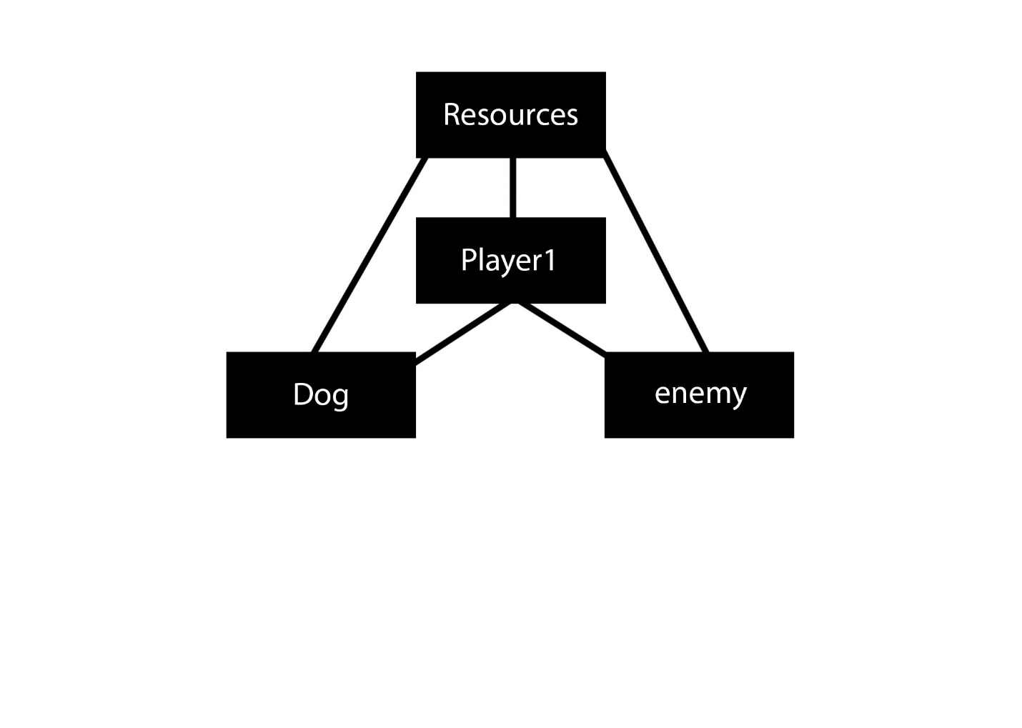

**Classes:**

**Player1: -** This class holds the players data through the game

**Enemy: -** This class contains the data of the zombie creatures. Then multiplied to X amount.

**Dog: -** the dog behaves differently compared to zombies.

**recourses: -** This class holds all the variables and objects. This class was made due to how many I had.

**Resources:**

https://stackoverflow.com/